National Park Service News Release

Canaveral National Seashore
7611 S. Atlantic Ave.
New Smyrna Beach, FL 32169
386-428-3384 phone
386-426-7973 fax www.nps.gov

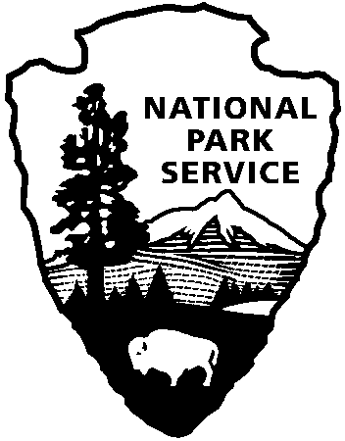
National Park Service
U.S. Department of the Interior

Release Date: Immediately
Contacts: Laura Henning – 321-267-1110 Ext. 25

APOLLO DISTRICT
INTERPRETIVE PROGRAMS
DECEMBER 2019

PLEASE NOTE: All programs are subject to cancellation and/or rescheduling due to staff limitations, weather conditions, or other factors. Some programs require reservations, a minimum age, or a cost-recovery fee. Call 386-428-3384 ext. 0 for program information during Visitor Center hours (9:00AM to 5:00PM) or visit www.nps.gov/cana. Entrance fees apply to all interpretive program participants. All programs meet the requirements for the Canaveral National Seashore Junior Ranger program.

PLANT WALKS
WEDNESDAYS, DEC. 4TH & 11TH - (Locations vary. ) 10:00AM - “PLANTS OF THE PARK” Join us for a series of plant walks to learn how plants in the park were used by Native Americans and early settlers. Discover their unique botanical characteristics and their areas of adaptation. (Each walk lasts 2 hours.)
Dec. 4th: Meet at beach parking area #3 to explore the flora and diverse habitat on the Castle Windy Trail. This trail crosses the barrier island, from the dune area to Mosquito Lagoon. Total distance - 1 mile. (2 hours)
Dec. 11th: Meet in parking area #1 to explore the beach dune flora and the old road to the parking area of Turtle Mound. (2 hours)

GUIDED CANOE EXPERIENCE
WEDNESDAYS, DEC. 11TH, 18TH - 9:00AM - “CANOE MOSQUITO LAGOON” Reservations will be accepted a week prior. Join a guide as you explore this rich and diverse estuary up close. Some experience is preferred. You must be at least 8 years old and able to paddle. You must wear covered shoes (no sandals or flip-flops). Bring water, sunscreen and a hat. Dress to get wet. Individuals with their own kayaks/canoes are welcome to join in. There is no charge for the program. However, if you need to rent a canoe/kayak, there is a rental charge of $25/vessel. Call (386) 428-3384 ext. 0 to reserve your spot. Meet at the Visitor Center at 8:45AM. We will leave promptly at 9:00AM. (2 hours)

THURSDAY, DEC. 12TH - 10:00AM - “ENDANGERED SPECIES OF CANAVERAL” Learn about the endangered animals who call Canaveral National Seashore home. The diversity includes mice, birds, reptiles, and aquatic mammals. Explore why this barrier island is vital to their survival and how you can help. Meet at the Visitor Center at 10:00AM. (1 hour)

SATURDAY, DEC. 14TH - 11:00AM - “SOUND WALK” Atlantic Center for the Arts presents a series of programs to “explore the sounds and rhythms of our urban and natural world. Each walk is beneficial for people of all ages to relieve stress, gain focus, and develop a deeper understanding of how we fit into the ecosystem of our environment.” Meet at the Visitor Center. (1 hour)

SUNDAY, DEC. 15TH - 1:00PM-4:00PM - “ELDORA HOLIDAY OPEN HOUSE AND TURTLE DERBY” The Friends of Canaveral invite you to join them for an afternoon of holiday spirit, refreshments, crafts, music... and more! The Eldora State House will be decorated for the season and the Eldora dock will be the staging area for the 3rd annual Turtle Derby fundraiser. Come join in the fun! (3 hours)

TUESDAY, DEC. 17TH - 10:00AM - “BEACH ARTS AND CRAFTS” Create a beautiful ocean-inspired shell necklace or ornament. All supplies are provided. Meet at the Visitor Center. (1 hour)

