National Park Service News Release

Canaveral National Seashore
7611 S. Atlantic Ave.
New Smyrna Beach, FL 32169
386-428-3384 phone
386-426-7973 fax www.nps.gov

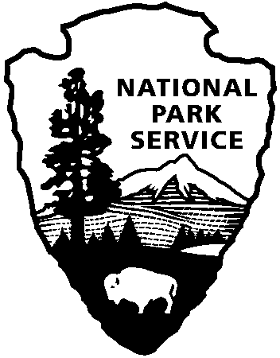
National Park Service
U.S. Department of the Interior

Release Date: Immediately, Oct 29, 2018
Contacts: Laura Henning – 321-267-1110 Ext. 25

APOLLO DISTRICT INTERPRETIVE
PROGRAMS
April 2019

PLEASE NOTE: All programs are subject to cancellation and/or rescheduling due to staff limitations, weather conditions, or other factors. Some programs require reservations, a minimum age, or a cost-recovery fee. Call 386-428-3384 ext. 0 for program information during operating hours (9:00 a.m. to 5:00 p.m.), or visit www.nps.gov/cana. Entrance fees apply to all interpretive program participants. All programs meet the requirements for the Canaveral National Seashore Junior Ranger program.

SATURDAY 6TH – 10:00 AM - “TURTLE TALK” Learn about the endangered sea turtles of Canaveral National Seashore. Meet at the Visitor Center at 10:00 a.m. (1 hour)

WEDNESDAY 10TH – 11:00 AM - “CLAMMING 101” Learn how to collect this delicious bi-valve from the waters of Mosquito Lagoon. Gathering clams has been an activity conducted in this area for thousands of years. Learn tips, techniques and recipes along with the Florida bag and size limits. Saltwater fishing license is required. Covered shoes required (no sandals or flip-flops). Meet at Parking Lot #1B near the south dune crossover. When the group has assembled, we will cross the road to the clamming area. Parking is limited. Please park only in designated parking spots. Meet at 11:00 a.m. (1 hour)

SATURDAY 13TH – 10:00 AM - “CAST NETTING” – Join a ranger at the edge of the lagoon. Practice casting and see what may be caught in this area of Mosquito Lagoon. Bring your own cast net or borrow one of ours (limited supply). Meet at the Apollo Visitors Center at 9:45 a.m. (1 hour)

MONDAY 15TH -– 10:00 AM - “BEACH CLEAN-UP” Help keep our beaches clean. Join us to clean Apollo Beach. Bring water, sunscreen, bug repellant, work gloves and a hat. We provide trash bags. Meet at the Visitor Center at 10:00 a.m. (3 hours)

WEDNESDAY 17TH – 11:00 AM - “BROWN BAG LUNCH PRESENTATION” Please join us on the third Wednesday of each month for a special presentation by a carefully selected speaker regarding conservation and environmental issues. Please bring a bag lunch to enjoy with the speaker after the program. This month’s program will be presented by Donald J. Spence, PhD, a professor of plant pathology at Bethune-Cookman University. Dr. Spence recently published a book: Plants of Canaveral National Seashore. He will be discussing some of the amazing plants to be found in the Seashore. Meet at the Visitor Center at 11:00 a.m. (1 hour)

FRIDAY 26TH -- 10:00 AM - “BEACH TREASURE HUNT” Join an experienced leader to walk the beach and see what treasures the tides have provided. Bring a hat, sunscreen, insect repellent and water. Meet at Parking Lot #1B near the top of the south dune crossover at 10:00 a.m.(1 hour)

SATURDAY 27TH – 10:00 AM TO 4:00 PM - JR. RANGER DAY! “LEARN TO FISH CLINIC” Junior Ranger anglers are invited to learn basic fishing techniques from members of the International Game Fish Association. Join us between 10:00 a.m. and 4:00 p.m. at the Eldora dock. (6 hours)

MONDAY 29TH – 10:00 AM - “SEA LEVEL AND COASTAL EROSION” Emily Jane Murray, Coordinator for the Florida Public Archaeology Network, will lead a discussion concerning how to talk about our heritage of issues surrounding sea level, coastal erosion and the potential for site loss. Meet in the Visitor Center at 10:00 a.m. (2-1/2 hours)

