National Park Service News Release

Canaveral National Seashore
7611 S. Atlantic Ave.
New Smyrna Beach, FL 32169
386-428-3384 phone
386-426-7973 fax
www.nps.gov
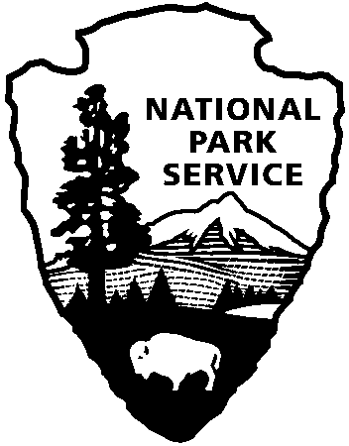
National Park Service
U.S. Department of the Interior

Release Date: April 2, 2019
Contacts: Laura Henning
321-267-1110

Construction of Boardwalk at Turtle Mound in Apollo District of Canaveral National Seashore

Canaveral National Seashore is set to begin construction to rehabilitate a key public access
area in the Apollo District, New Smyrna Beach. The boardwalk located at Turtle Mound will be closed, effective Monday, April 15th, 2019. This closure is expected to last 3 to 5 months. The closure may be extended due to inclement weather. The Turtle Mound parking area and shoreline will remain open and accessible, unless needed for staging materials. Turtle Mound is an archaeological site of national significance and extreme care is taken in design and construction, allowing visitors an outstanding view of Canaveral National Seashore from the top of the mound. We appreciate your patience as our skilled National Park Service workers complete this complicated job. This project is funded using your recreational fee dollars.

About the National Park Service. More than 20,000 National Park Service employees care for America’s 408 national parks and work with communities across the nation to help preserve local history and create close-to-home recreational opportunities. Learn more at www.nps.gov.

