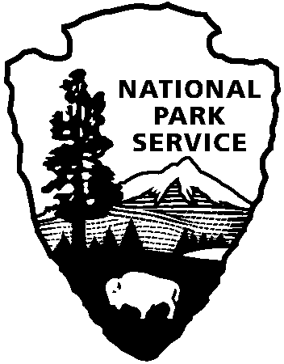 | National Park Service  U.S. Department of the Interior |  | Canaveral National Seashore  212 S. Washington Ave.  Titusville, FL 32796  321-267-1110 phone  321-264-2906 fax
National Park Service News Release

FOR IMMEDIATE RELEASE – July 27, 2017
CONTACT: 321-267-1110 Laura Henning

CANAVERAL NATIONAL SEASHORE HAS RUN OUT OF
AMERICA THE BEAUTIFUL SENIOR PASSES
INFO FOR ONLINE PURCHASING
Earlier this month, it was announced that in order to meet legislation passed by Congress in December 2016, the price of the America the Beautiful-National Parks and Federal Recreational Lands Lifetime Senior Pass, will increase from $10 to $80 on August 28, 2017; there will also be an annual option for $20. U. S. citizens and permanent residents who are 62 years or older can purchase the lifetime pass for the current price of $10 until August 27, 2017.

Since that announcement, our public lands and website that sells these passes have been overwhelmed with requests to purchase passes before the price change goes into effect. Because of this demand there is a 12 week backlog in receiving passes by online purchase and at public land sites.

Canaveral National Seashore is now out of these passes. The most efficient way to purchase this pass before the deadline is to order online. Lifetime Senior Passes may be purchased online for $10 with an additional $10 servicing fee until August 27. While there may be a 12 week delay in receiving the pass, the printed email confirmation may be used to allow entry to Canaveral National Seashore and the other 2000 public land sites that honor this pass. Please access the website at http://store.usgs.gov/senior.

