National Park Service News Release

Canaveral National Seashore
212 S Washington Ave.
Titusville, FL 32796
321-267-1110 ext. 25 phone
Laura_Henning@nps.gov
www.nps.gov

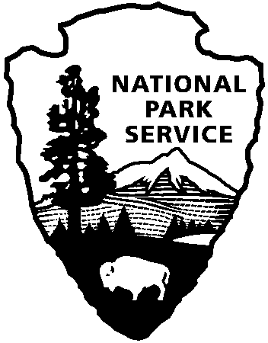
National Park Service
U.S. Department of the Interior

Release Date: September 19, 2018
Contacts: Laura Henning

Special Use Permit Changes at Canaveral National Seashore
Beginning October 1, 2018, the following changes will be made to Special Use Permits in Canaveral National Seashore. Backcountry Hiking Permits will increase from $2 per day to $5 per day. All of the previous held rules and capacity will be the same. Visitors may obtain Backcountry Hiking permits between the hours of 6:00 am and 2:00 pm, or until the capacity of 25 is reached. This is same in both Apollo and Playalinda districts. The backcountry in Canaveral National Seashore is designated as Klondike Beach and begins ¼ mile north of parking area #13 in Playalinda and ¼ mile south of parking area #5 in Apollo. There are signs in both areas designating where a permit is required. This pristine portion of the seashore is approximately 12 miles in length with no public road access. Utilizing this area requires planning and preparation, users are advised to have a working cell phone, plenty of water, sunscreen and mosquito repellant. Always let friends or family know when to expect your return if you are hiking into Klondike Beach.

Why do I need a permit?
Backcountry permits protect your experience by preventing overcrowding and provides for a unique seashore experience, providing for opportunities for solitude and a quality backcountry experience, and protecting natural resources so that all visitors – including future generations – can enjoy them. Permits also serve an important safety function in the event of an emergency or wildfire, and allow Park managers to gather data important for planning and decision making.

The other change in seashore Special Use Permits will be to the interpretive paddling tours. Staff and volunteers conduct paddling tours in Playalinda and Apollo districts, these tours are part of the monthly list of activities. Beginning October 1, 2018, there will be a fee of $25 to use one of the seashore’s canoes or kayaks for this program. Visitors having their own canoe or kayak are invited to join the program at no charge. The Special Use Permit is for the use of the equipment only, there is no cost for the program. Each visitor using seashore equipment will be issued paddles, seat cushions and a Personal Flotation Device for the duration of the program. The money from this permit fee will be used to maintain and replace equipment for this program. Please note that reservations are required. For details please call the Visitor Center at 386-428-3384 ext 0.

www.nps.gov

About the National Park Service. More than 20,000 National Park Service employees care for America’s 408 national parks and work with communities across the nation to help preserve local history and create close-to-home recreational opportunities. Learn more at www.nps.gov.

