Dear Friends,
A programmatic environmental assessment (PEA) assesses potential impacts from policies, programs, and plans, in contrast with other National Environmental Policy Act (NEPA) documents which focus on site-specific projects. Such programmatic documents are inherently broader in scope, as they typically could affect a larger geographic area, compared with site-specific projects. An advantage of this programmatic approach is that it could result in a decision regarding which tools and methods may be used in NPS Southeast Region park units and the programmatic NEPA review contains impact analyses for those tools and methods. Once a decision is made, individual park units could incorporate these methods and tools into parkspecific NEPA compliance, which would address where and when each park would use them.
The National Park Service (NPS) recently announced the availability of the Southeast Region Coastal Species of Concern Predation Management Plan and Programmatic Environmental Assessment.
Early in this process, we (the NPS) asked for public input regarding issues of concern and feedback on the preliminary alternatives we developed. Using the feedback we received during that initial public scoping effort, and input from an interdisciplinary planning team, we considered a range of alternatives and analyzed the potential impacts of those alternatives in the programmatic environmental assessment. All of this information is now presented for your review in the programmatic environmental assessment, available at: https://parkplanning.nps.gov/sero.

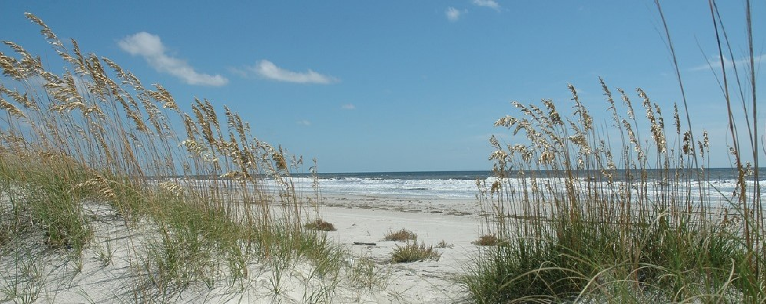
The programmatic environmental assessment is available for public review and comment through October 26, 2018. During the public comment period, we will be hosting two webinars. See page 3 for full details on the webinars and instructions on how to submit your comments.

Southeast Regional Office

September 2018

Southeast Region Coastal Species of Concern Predation Management
Plan and Programmatic Environmental Assessment

National Park Service

U.S. Department of the Interior

We look forward to your thoughtful comments on the document. Thank you for your interest and participation in the Coastal Species of Concern Predation Management Plan!
Sincerely,
Bob Vogel
NPS Southeast Regional Director
1
Why are you proposing to take action?
The NPS is proposing to establish tools and methods for park units in the NPS Southeast Region to use when conducting predation management in order to protect coastal species of concern and contribute to the recovery of those species listed under the Endangered Species Act. The NPS recognizes that depredation is a natural process. Nevertheless, coastal species of concern are often at very low population numbers, and predation management can be used to help achieve species or ecosystem management objectives, including recovery of federally-listed species. There is a need to develop a predation management toolbox that can be used across the NPS Southeast Region to facilitate and streamline planning, interagency coordination, and program management for the protection and recovery of coastal species of concern.
What alternatives are analyzed in the PEA?
Alternative A: No-Action Alternative
Under the no-action alternative, parks currently using predation management to protect coastal species of concern in the NPS Southeast Region would continue to control predators threatening these species on a case-by-case basis following unit-specific guidance and need. Not every park unit uses each of the methods and tools described. A detailed description of each nonlethal and lethal control method currently used is provided in Chapter 2 of the programmatic environmental assessment.
Nonlethal control methods currently used in the NPS Southeast Region include: relocating feral cats; fencing single shorebird nests and colonies; installing screens or cages on sea turtle nests; installing perch deterrents; providing chick shelters; and using effigies, conditioned taste aversion, biological odor repellants, disruptive harassment, and frightening devices.
Lethal control methods include: foothold traps; snares; walk-in cage traps; dog-proof traps; box, cage, and corral traps; shooting; and euthanasia.
Alternative B: Proposed Action
Under the proposed action, all park units in the NPS Southeast Region would have a suite of tools available to control predators threatening coastal species of concern, including tools that were not previously used by some park units in the region. The proposed action would streamline the approach for predation management by providing programmatic NEPA compliance across the region, resulting in the timely implementation of the tools and methods presented in Chapter 2 of the PEA.
Nonlethal control methods would be mostly the same as those described for Alternative A; however, the following tools would not be implemented under the proposed action: effigies, conditioned taste aversion, biological odor repellant, disruptive harassment, and frightening devices.
Lethal control methods would be the same as those described for Alternative A, with the addition of a toxicant, DRC-1339, to remove avian predators and the removal of ghost crabs via Fripp traps or manual removal.
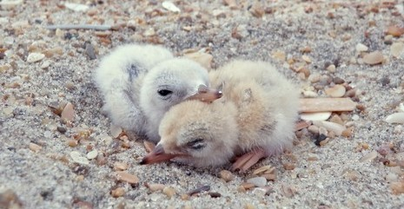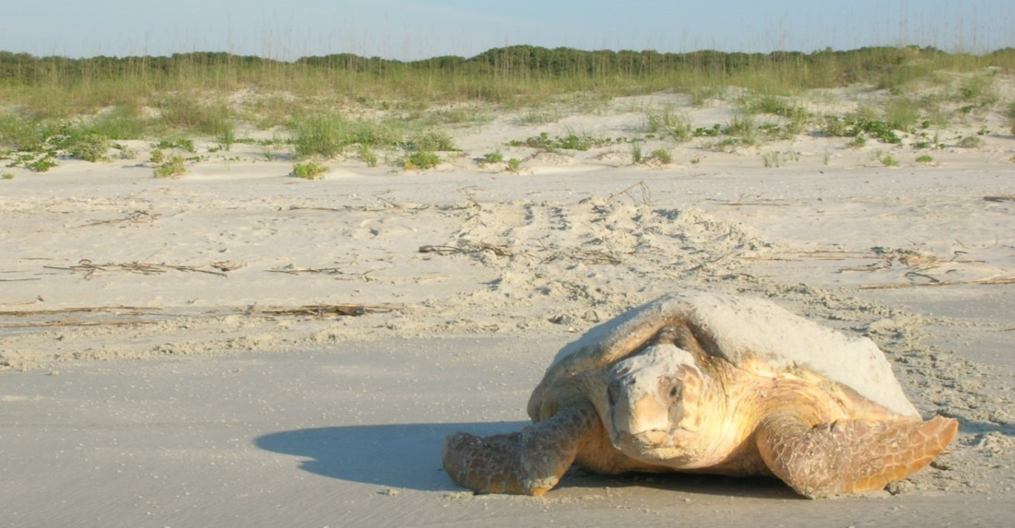
Least tern chicks (left) and loggerhead sea turtle (right) at Cape Hatteras and Cumberland Island National Seashores
Species of concern are those in need of conservation actions, based on their rarity, declining population trends, or susceptibility to threats. These species may be included on state or federal lists of threatened or endangered species, or they may be protected by other laws or regulations, such as the Migratory Bird Treaty Act.
2
How can I comment on the Programmatic Environmental Assessment?
Hard copies of the programmatic environmental assessment are available for review at coastal park unit headquarters. 
Submit comments online at: https://parkplanning.nps.gov/ sero

Mail comments to:
National Park Service
Planning and Compliance
Division
ATTN: SERO PEA
100 Alabama Street
Atlanta, GA 30303

Before including your address, telephone number, electronic mail address, or other personally identifying information in your comments, you should be aware that your entire comment may be made publicly available at any time. While you can ask us to withhold your personally identifiable information from public review, we can’t guarantee that we will be able to do so.
Please submit comments by
October 26, 2018

To be most helpful, the NPS is seeking your input on:
· the purpose and need for action;
· environmental issues / impact topics analyzed;
· alternatives, including best management practices which could reduce adverse impacts; and
· the information used to describe the affected environment and environmental consequences.
Prior to developing and signing a decision document, we will review every comment submitted during the open comment period and prepare responses to substantive comments. Responses to substantive comments will be appended to the decision document and made available to the public.
Substantive comments are defined as those that do one or more of the following:
· question, with reasonable basis, the accuracy of information in the
PEA;
· question, with reasonable basis, the adequacy of the analysis;
· present reasonable alternatives other than those presented in the PEA; or
· cause changes or revisions to the management actions proposed in the alternatives.
When preparing your written comments, provide as much detail as possible and relate your comments back to the PEA. This will ensure that your comments are understood, and your concerns are fully addressed in the responses.
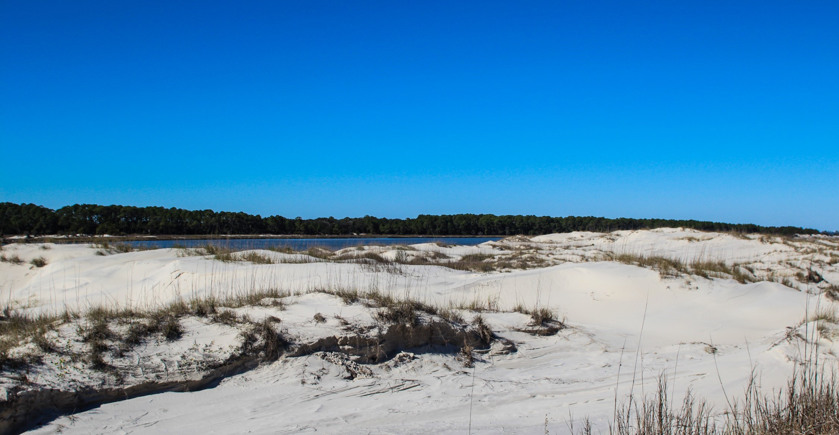
3
United States Department of the Interior
National Park Service
FIRST-CLASS MAIL
U.S. POSTAGE & FEES PAID
NATIONAL PARK SERVICE
PERMIT NO. G-83
Environmental Quality Division
PO Box 25287
Denver CO 80225-0287

OFFICIAL BUSINESS
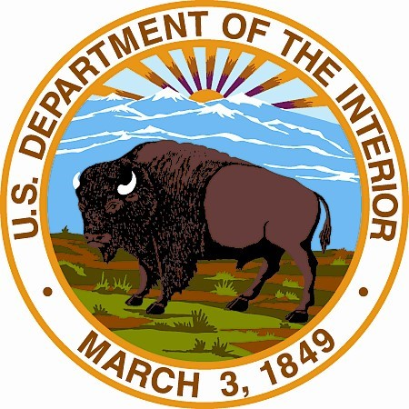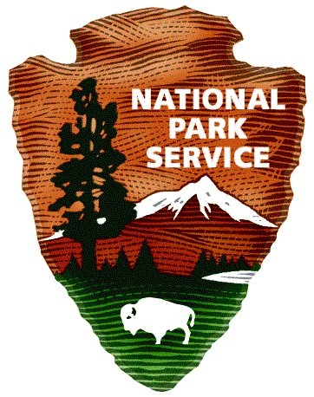

What is the public webinar schedule?
The NPS will be holding two webinars to present information related to the project and answer your questions about the programmatic environmental assessment and NEPA process. To register for the webinars, visit:
https://parkplanning.gov/sero, locate this project, and click on the “Meetings” link for the project. Since the NPS would like as much input as possible, recorded sessions can be accessed at: https://parkplanning.nps.gov/sero under the project link for Coastal Species of Concern Predation Management Plan.

Tuesday, October 9, 2018 https://parkplanning.nps.gov/sero
5 - 6 pm EDT
Thursday, October 11, 2018 https://parkplanning.nps.gov/sero 6 - 7 pm EDT

What are the next steps in the process?
Fall 2018 | Public comment analysis/response
Winter 2018 | Preparation of a Finding of No Significant Impact
Winter 2018—2019 | Anticipated signing of Finding of No Significant Impact

