National Park Service News Release

Canaveral National Seashore
7611 S. Atlantic Ave.
New Smyrna Beach, FL 32169
386-428-3384 phone
386-426-7973 fax www.nps.gov
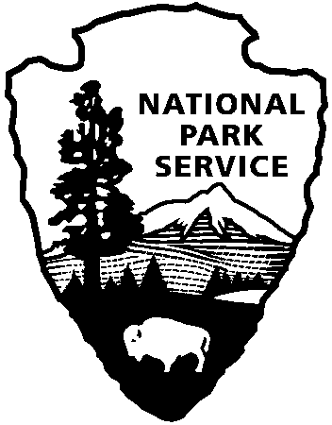
National Park Service
U.S. Department of the Interior

Release Date: May 4, 2017
Contacts: Laura Henning
321-267-1110

Playalinda Beach District of Canaveral National Seashore
For Falcon 9 at Kennedy Space Center

Canaveral National Seashore’s Playalinda Beach, located in Brevard County, will close at 5:00 pm EST, Monday May 15, 2017 due to a Falcon 9 rocket launch at Kennedy Space Center. The launch window is now set to open at 7:20 pm EST and lasts until 8:10 pm EST. The seashore will open at scheduled time of 6:00 am EST on Tuesday, May 16, 2017. There is an opportunity for a 24 postponement if needed. The same procedure will be followed in the event of a delay. This closure will include all National Park Service areas from parking area 13 south to the Playalinda Beach Road Gate, near the intersection with State Road 3.

Park staff have conducted an Operational/Mission Risk Assessment and will implement strategies to increase communications and update current operating procedures to manage visitor use and assure the safety of visitors and staff.

Visitors to the Playalinda Beach District, located in Brevard County, may experience additional closures in the future due to missions conducted at the Kennedy Space Center.

All other areas of the park, including the Apollo Beach District, Apollo Visitor Center, and Seminole Rest will remain open. For future rocket launch alternate viewing sites please consider the following: Apollo Beach which can be accessed via New Smyrna Beach, Space View Park located in downtown Titusville, and Jetty Park located in Cape Canaveral.

For updated closure information please call (321) 867-4077, see website www.nps.gov/cana, FaceBook@CanaveralNatlSeashore.

About the National Park Service. More than 20,000 National Park Service employees care for America’s 408 national parks and work with communities across the nation to help preserve local history and create close-to-home recreational opportunities. Learn more at www.nps.gov.

