National Park Service News Release

Canaveral National Seashore
7611 S. Atlantic Ave.
New Smyrna Beach, FL 32169
386-428-3384 phone
386-426-7973 fax www.nps.gov
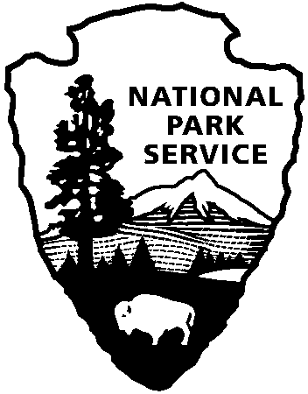
National Park Service
U.S. Department of the Interior

Release Date: February 15, 2018
Contacts: Laura Henning
386-428-3384

Construction of Boardwalk #3 in Apollo District of Canaveral National Seashore

Canaveral National Seashore is set to begin construction to rehabilitate a key public access
area in the Apollo District, New Smyrna Beach. The boardwalk and parking area # 3 will be closed, effective February 20, 2018. This closure is expected to last 10 to 12 weeks. The closure may be extended due to inclement weather. Upon completion, the new boardwalk will include handicapped accessible ramps as well as stairs to the beach. This project is funded using your recreational fee dollars.

About the National Park Service. More than 20,000 National Park Service employees care for America’s 408 national parks and work with communities across the nation to help preserve local history and create close-to-home recreational opportunities. Learn more at www.nps.gov.

