National Park Service News Release

Canaveral National Seashore
212 S Washington Ave
Titusville, FL 32796
www.nps.gov

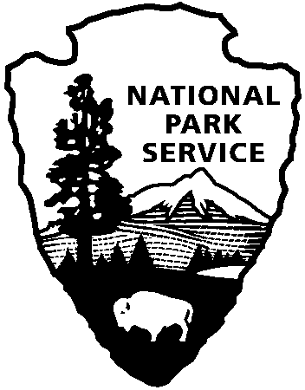
National Park Service
U.S. Department of the Interior

Release Date: October 26, 2016
Contact: Laura Henning
(321) 229-3766
Laura_Henning@nps.gov

Canaveral National Seashore Matthew Recovery Update

Canaveral National Seashore continues to recover from hurricane Matthew. Beginning with the reopening of the seashore on October 15th, things are getting back to normal. The national seashore sustained considerable damage as Category 4 hurricane Matthew swept past on October 7th. Many of the boardwalks, docks, facilities and roadways will need repair and rehabilitation for several weeks, or even months to come. Both districts have reopened with a few areas still closed. In the Apollo district (New Smyrna Beach) only Parking area 3, Castle Windy trail and the Eldora fishing dock remain closed. In the Playalinda district (Titusville) Parking areas 7-10 are closed completely and Parking #11 & 12 are open for parking only, no beach access. These closures are for all access, including pedestrians and bicycles. There will be limited bathroom facilities in some areas and as always bring your own water. Backcountry Camping reservations and Backcountry Beach day only permits will resume on November 1. Seminole Rest Historic site is reopened to walkers and the house will be open Friday-Sunday, regular schedule 12-4 pm, as will the Eldora house. Recovery teams are still working in many areas, so please avoid those areas where equipment is being used. With the safety of employees and visitors being NPS’ top priority, please be mindful of closed area signs and heavy debris on the beaches. We ask that no debris be removed by visitors as there is no space to put the trash at this time. The staff of Canaveral National Seashore will schedule a volunteer beach cleanup as soon as can be accommodated.

www.nps.gov/cana

About the National Park Service. More than 20,000 National Park Service employees care for America’s 413 national parks and work with communities across the nation to help preserve local history and create close-to-home recreational opportunities. Learn more at www.nps.gov.

