National Park Service News Release

Canaveral National Seashore
212 S Washington Ave
Titusville, FL 32796
www.nps.gov

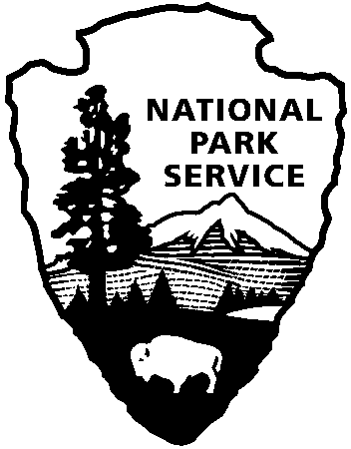
National Park Service
U.S. Department of the Interior

Release Date: October 14, 2016
Contact: Laura Henning
(321) 229-3766
Laura_Henning@nps.gov

Canaveral National Seashore Reopens after Hurricane Matthew

Canaveral National Seashore will reopen the park on Saturday, October 15, 2016 at 8:00 AM. The national seashore sustained considerable damage as Category 4 hurricane Matthew swept past on October 7th. Many of the boardwalks, docks, facilities and roadways will need repair and rehabilitation for several weeks to come. Both districts will be opening with limited access to the beach; some parking areas and roads will be closed completely to access. There will be limited bathroom facilities in some areas and as always bring your own water. No backcountry or camping permits will be issued for either district. Seminole Rest, Oak Hill, will remain closed due to power outage and dangerous tree limbs. Recovery teams are working in the seashore to cleanup and restore areas to reopen for public use. With the safety of employees and visitors being NPS’ top priority, please be mindful of closed area signs and heavy debris on the beaches. We ask that no debris be removed by visitors as there is no space to put the trash at this time. The staff of Canaveral National Seashore will schedule a volunteer beach cleanup as soon as can be accommodated.

www.nps.gov/cana

About the National Park Service. More than 20,000 National Park Service employees care for America’s 413 national parks and work with communities across the nation to help preserve local history and create close-to-home recreational opportunities. Learn more at www.nps.gov.

