National Park Service News Release

Canaveral National Seashore
7611 S. Atlantic Ave.
New Smyrna Beach, FL 32169
386-428-3384 ext. 0 phone
386-427-1921fax
www.nps.gov

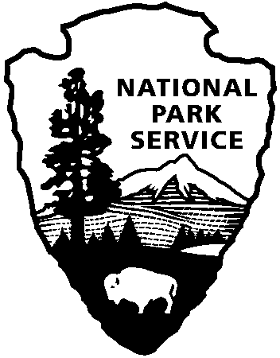
National Park Service
U.S. Department of the Interior

Release Date: February 21, 2018
Contacts: Laura Henning

Canaveral National Seashore invites the public to visit the former home of artist Doris Leeper in March.

Doris Leeper: Environmentalist / Visionary (1929 – 2000)

On exhibit: March 2 – March 25, 2018
Canaveral National Seashore, Apollo Beach – Northern access, A1A at the southern-most end in New Smyrna Beach.
A resident of New Smyrna Beach since 1958, the late Doris Leeper’s lifelong interest in the relationship of natural and built environments has created three testimonials to her vision – Canaveral National Seashore, the Doris Leeper Spruce Creek Preserve, and the Atlantic Center for the Arts, an artist community responsible for giving New Smyrna Beach an international arts reputation. In 1999, she was inducted into the Florida Artists Hall of Fame, the highest and most prestigious cultural honor that can be bestowed upon an individual in the State of Florida.
Explore the life of this forthright and determined woman through an exhibition featuring personal letters, photographs, and memorabilia in the remote home within the Canaveral National Seashore.
On Sunday, March 4th, join the Friends of Canaveral for an opening reception from 2-4. Information on joining the Friends and volunteering will be available.
The exhibit will be open to the public each Friday –Sunday, March 2- 25. Directions and access information can be obtained at the entrance station to the Apollo district of Canaveral National Seashore, 7611 S Atlantic Ave., New Smyrna Beach, FL 32169
About Canaveral National Seashore: Canaveral National Seashore was authorized as a unit of the National Park Service on January, 3rd 1975. It was through efforts of concerned citizens such as Doris Leeper that it is now preserved and protected for future generations. www.nps.gov/cana

About Atlantic Center for the Arts: Atlantic Center for the Arts is a nonprofit 501 (c)(3), interdisciplinary artists-in-residence community and arts education facility dedicated to promoting artistic excellence by providing talented artists an opportunity to work and collaborate with some of the world's most distinguished contemporary artists in the fields of music composition and the visual, literary and performing arts. Community interaction is coordinated through on-site and outreach presentations, workshops and exhibitions. Atlantic Center for the Arts, 1414 Art Center Avenue, New Smyrna Beach, FL 32168. AtlanticCenterfortheArts.org

www.nps.gov/cana

About the National Park Service. More than 20,000 National Park Service employees care for America’s 408 national parks and work with communities across the nation to help preserve local history and create close-to-home recreational opportunities. Learn more at www.nps.gov.

