Canaveral National Seashore News Release

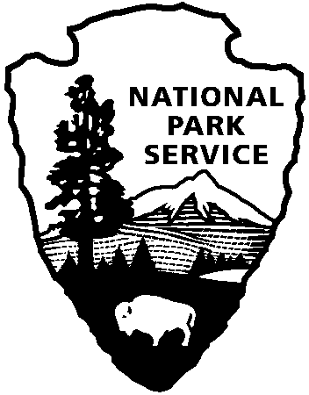
Canaveral National Seashore
Department of Interior

Release Date: September 10, 2016
Contact: Laura Henning, (321) 229-3766
Laura_Henning@nps.gov

Canaveral National Seashore/Merritt Island National Wildlife Refuge Proposes Fee Increase

Canaveral National Seashore and Merritt Island National Wildlife Refuge will hold public input meetings to discuss possible fee increases in 2017. The current park entrance fees have been in place since 2011. Entrance fees at the seashore and refuge are collected according to the Federal Lands Recreation Enhancement Act (FLREA). Vehicle entrance fees will increase for both seashore and refuge from $5 per vehicle to $10 per vehicle. The Canaveral/Merritt Island Annual Pass will increase from $35 to $40 per calendar year. Merritt Island National Wildlife Refuge (only) Annual Pass will increase from $15 to $25. Visitors with a Refuge only pass or a Federal Duck Hunting Pass may upgrade to include the seashore for $15.

Meetings will be for public input on September 19, 5:30 pm at the Titusville, Library and on September, 21, 5:30 pm at the New Smyrna Beach Utilities Commission, DeBerry Room.

Entrance fees are not charged to persons under 16 years of age or holders of the America the Beautiful National Parks and Federal Recreational Senior, Access or Military Passes as well as the Every Kid in the Park pass for fourth graders. These passes may be obtained at the Park offices aa well as the Refuge visitor center.

“We are committed to keeping the park affordable but we also want to provide visitors with the best possible experience,” said seashore Superintendent Myrna Palfrey. “The money from entrance fees is used to maintain maintenance on buildings, provide visitor services, repair and replace boardwalks and preserve historic structures.”

Additional revenue raised by a fee increase would help provide funding for a surplus of deferred maintenance on historic structures, trails and for a Visitor Contact Station in the Playalinda district of Canaveral National Seashore

Similarly, the U.S. Fish & Wildlife Service uses the fee money it collects on facility improvements such as the recently renovated Biolab boat ramp and maintenance of scenic driving roads including the Black Point Wildlife Drive. Planned projects include the installation of a fully accessible kayak dock, renovations to the Beacon 42 boat ramp, and improved signage throughout the Refuge.

