National Park Service News Release

Canaveral National Seashore

7611 S. Atlantic Ave.

New Smyrna Beach, FL 32169

386-428-3384 phone

386-426-7973 fax www.nps.gov

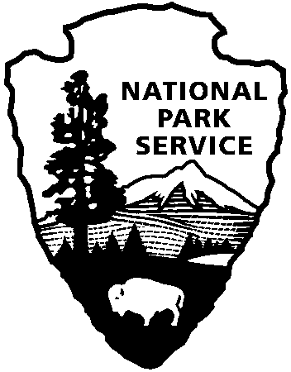

National Park Service

U.S. Department of the Interior

Release Date: May 8, 2017

Contacts: Laura Henning

321-267-1110

**Recreational Crab Fishing Closes in Playalinda District of Canaveral National Seashore**

**Effective May 22, 2017**

Effective May 22, 2017, recreational crab fishing along Mosquito Lagoon in the Playalinda district of Canaveral National Seashore will be prohibited. Park staff is evaluating associated safety concerns and the activity’s impact to park resources. The protection of visitors and wildlife is paramount to the mission of Canaveral National Seashore.

Beginning at the entrance to the seashore and along the beach road including Eddy Creek, this activity will no longer be permitted. Hand-held crab lines attract alligators and increase interactions with those crabbing. Abandoned crab lines have entangled wildlife, and threatens their safety. Alligators have become accustomed to visitors crabbing or stopping along the roadway, associate food with the visitors and lose their fear of humans. There have been documented confrontations and near misses including an alligator that was entangled in crab lines and was euthanized.

For updated closure information please call (321) 267-1110 ext. 14, see website [www.nps.gov/cana](http://www.nps.gov/cana), FaceBook@CanaveralNatlSeashore. If you wish to comment, please see <https://parkplanning.nps.gov/projectHome.cfm?projectID=72663>

*About the National Park Service. More than 20,000 National Park Service employees care for America’s 408 national parks and work with communities across the nation to help preserve local history and create close-to-home recreational opportunities. Learn more at* [*www.nps.gov*](http://www.nps.gov)*.*