National Park Service News Release

Canaveral National Seashore
7611 S. Atlantic Ave.
New Smyrna Beach, FL 32169
386-428-3384 ext. 0 phone
386-427-1921fax
www.nps.gov

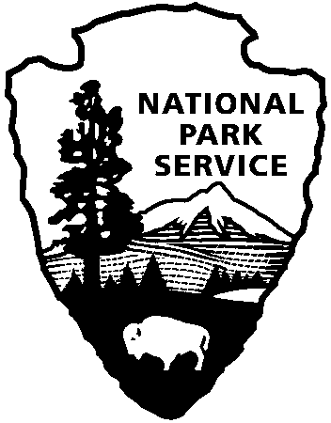
National Park Service
U.S. Department of the Interior

Release Date: February 21, 2018
Contacts: Laura Henning
Laura_Henning@nps.gov

News Release Date: March 11, 2019
Annual Visitation to National Parks Exceeds 318 Million
WASHINGTON - Visitation to America’s national parks in 2018 exceeded 300 million recreation visits for the fourth consecutive year. The 318.2 million recreation visits total is the third highest since record keeping began in 1904.
Your local national park unit, Canaveral National Seashore marks 1.637 million visits in 2018. This the second highest number of visitors since the seashore was authorized in 1975. The highest year of visitation, 1.69 million, was in 2015 leading up to the National Parks Centennial celebration.
“America’s national parks are national treasures that tell the story of our nation and celebrate its beauty, history and culture,” said Acting Secretary of the Interior David Bernhardt. “I am pleased that so many Americans and visitors from around the world continue to take advantage of the affordable and accessible recreational opportunities provided by these sites.”
“The visitation to our national parks continues to affirm that Americans are in love with their public lands and hold dear the stories of our nation embodied in the natural, cultural and historic landscapes we protect in the National Park System,” National Park Service Deputy Director Dan Smith said.
The 418 national parks throughout the country provide a vast array of opportunities for recreation and inspiration for visitors of all ages. With at least one located in every state, national parks are easily accessible and affordable destinations. In the past five years there have been about 1.6 billion recreational visits to national parks.
In 2018, Golden Gate National Recreation Area reclaimed the top spot for highest visitation in the National Park System from the Blue Ridge Parkway. These two parks have been trading places at one and two since 1979. In the national parks category, Great Smoky Mountains National Park (11.4 million) and Grand Canyon National Park (6.4 million) continue to hold the top two spots, as they have since 1990.
For an in-depth look at 2018 visitation, including individual park figures, please visit the NPS Social Science web site.

www.nps.gov/cana

About the National Park Service. More than 20,000 National Park Service employees care for America’s 408 national parks and work with communities across the nation to help preserve local history and create close-to-home recreational opportunities. Learn more at www.nps.gov.

