CANAVERAL NATIONAL SEASHORE
Environmental Education Programs
2019-2020

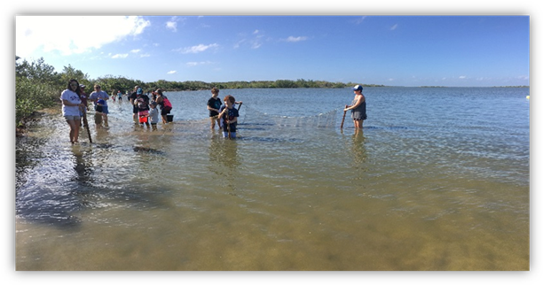

A MESSAGE FROM THE SUPERINTENDENT

Congratulations on selecting Canaveral National Seashore as one of your education destinations for the school year 2019/20. In this teacher’s guide you will find instructions on how to make the most of our Environmental and Cultural Education Program. Please follow these instructions to ensure an enjoyable and fulfilling seashore experience.

Contact the Interpretive Park Ranger Avia Woulard for Apollo Beach at (386)428-3384 Ext. 240 and Interpretive Park Ranger Ashley Lord for Playalinda Beach at (321)403-9334. Please schedule with a ranger before filling out a fee waiver to ensure the dates are available.

Enclosed is a sample letter of a fee waiver request that must be submitted by each school. Please allow two to three weeks between the time of your visit and the point at which you send your fee waiver request. This will ensure that we can process and send the proper document to you in time. Once you have received the fee waiver please remember to bring it with you to the park on the day of your program.

To attain a better understanding of the program you will be attending and gain the most from your time at Canaveral National Seashore, we encourage you to review these materials with your students. If more than one trip is scheduled please share all of this information with the other teachers.

With your assistance, we anticipate that your students will enhance their classroom activities with their park experience. Your participation and the preparation of your class are essential to the student’s safety, learning experience and the success of this program.

Thank you for your interest in Canaveral National Seashore and our Environmental and Cultural Education Program. Have a safe and educational National Park experience.

Jay Grass
Superintendent

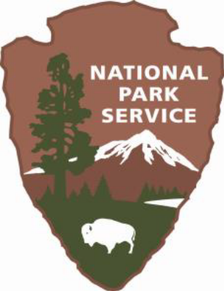

MISSION
STATEMENTS

THE NATIONAL PARK SERVICE
The mission of the National Park Service is to promote and regulate the use of federal areas known as National Parks. We conserve the scenery and the natural and historic objects and wildlife within. We provide for the enjoyment of them in such a manner as will leave them unimpaired for the enjoyment of future generations.

CANAVERAL NATIONAL SEASHORE
Canaveral National Seashore is administered by the U.S. Department of the Interior, National Park Service. It is one of over 400 National Parks and one of 10 National Seashores in the United States.

Canaveral National Seashore was established in 1975, “to preserve and protect the outstanding natural, scenic, scientific, ecologic, and historic values of certain lands, shorelines, and waters of the State of Florida, and to provide for the public outdoor recreation use and enjoyment of the same…”

YOUR EDUCATIONAL TRIP TO CANAVERAL NATIONAL SEASHORE
This Environmental and Cultural Education Program at Canaveral National Seashore will introduce 4th and 5th grade students to its fragile and varied environments. What they will see and experience will help them appreciate and protect this unique and special place. Before visiting the site teachers should review and discuss the following information with the students.

Program Descriptions
All programs meet state education standards for target audiences

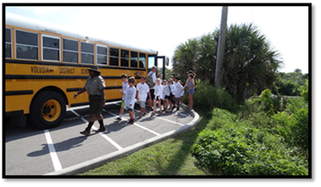

Apollo Beach (located in Volusia County):
Avia Woulard (386) 428-3384 ext 240; Avia_Woulard@NPS.GOV

Turtle Mound Simulated Dig
Students participate in a mock archeological dig and find artifacts that have been found in the area. They will explore the 35 foot high ancient shell mound the Timucuan people built over 2,000 years.

Lagoon Experience
Students work in small groups with an adult chaperone using a seine net to capture animal species found in the Mosquito Lagoon. Captured animals are studied and identified and placed back in the lagoon.

Barrier Island Habitat
Students explore the barrier island ecosystem and the unique challenges its inhabitants overcome for survival. Explore the lagoon and beach habitats.

Students will simulate a sea turtle stranding recording the data and taking proper measurements of model sea turtles. They will learn about our nesting sea turtles and how Canaveral National Seashore protects them.

Sea Turtle Stranding
Students will simulate a sea turtle stranding recording the data and taking proper measurements of model sea turtles. This program can be done in the classroom or out in the park. They will learn about our nesting sea turtles and how Canaveral National Seashore protects them.

Playalinda Beach (located in Brevard County): Ashley Lord (321) 403-9334; Ashley_Lord@NPS.GOV

Lagoon Experience
Students work in small groups with an adult chaperone using a seine net to capture animal species found in the Mosquito Lagoon. Captured animals are studied and identified and placed back in the lagoon.

Barrier Island Habitat
Students explore the barrier island ecosystem and the unique challenges its inhabitants overcome for survival. Explore the lagoon and beach habitats.

Students will simulate a sea turtle stranding recording the data and taking proper measurements of model sea turtles. They will learn about our nesting sea turtles and how Canaveral National Seashore protects them.

Sea Turtle Stranding
Students will simulate a sea turtle stranding recording the data and taking proper measurements of model sea turtles. This program can be done in the classroom or out in the park. They will learn about our nesting sea turtles and how Canaveral National Seashore protects them.

Resources and Scheduling

Bus Assistance Funding Available
All education programs are at no cost to students or teachers, and to offset bus costs, The Friends of Canaveral – the nonprofit friends group of Canaveral National Seashore, offers assistance programs for Title 1 schools who otherwise would be unable to attend.

Service Learning
Need volunteer hours? Conduct a beach cleanup with your class. Get the opportunity to give back to your community. Servicing learning is an option at both Apollo Beach and Playalinda Beach.

Class Visit
Are you unable to schedule a field trip? Would you like a ranger visit to your class? We will be happy to come to your class and talk about Canaveral National Seashore, its inhabitants and what makes this place so special. Call to find out more specific programming available for your students.
Every Kid in a Park
All fourth graders for 2019-2020 are eligible for the Every Kid in a Park program where students receive a free pass for them and their families to get into any federal lands like National Parks and National Wildlife Refuges until the end of August the following year.

For more information visit, https://everykidinapark.gov/how-it-works/.

Program Logistics

We offers free guided or self-guided programs that can be scheduled by contacting Avia Woulard for Volusia County (386) 428-3384 ext 240 & Ashley Lord for Brevard County & Seminole Rest (321) 403-9334. Email contacts: Avia_Woulard@nps.gov, Ashley_Lord@nps.gov. The 2 hours long programs are available to public, private, homeschool and scout groups.

Please schedule your program three weeks in advance. Programs are Thursdays and Fridays; alternate days may be appropriate if resources are available.

ENVIRONMENTAL AND CULTURAL EDUCATION PROGRAM PREPARATIONS

Prior to your visit to Canaveral National Seashore, we ask that you carefully read over the following information to prepare you and your students for this field trip.

STUDENTS SHOULD WEAR (For Lagoon Programs)

- COVERED SHOES. (no sandals or flip-flops) You will not be allowed to participate in the water part of the program if your shoes are unsuitable. The students should be wearing the shoes they are going to get wet when they get off the bus. This will speed things up.

- Chaperones will be expected to participate and should also dress appropriately.

- Shorts and short-sleeve shirts.

- If rain is forecast you may wear rain gear.

- Hats and sunscreen.

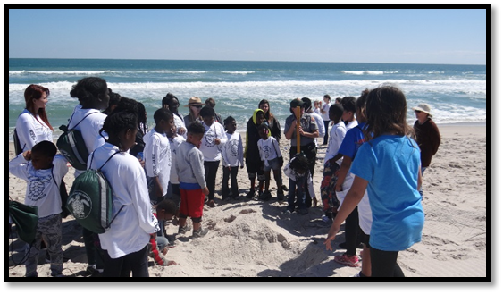
STUDENTS SHOULD BRING

- Water bottle, insect repellant and sunscreen.

- Lunch and drink. (no glass please)

Lagoon Program Only – bring the following:
- Towel and a set of dry clothes for the ride home.
- An extra pair of shoes for after the program.

RESTROOM FACILITIES

- In Apollo Beach they are available after the program at the Visitor Information Center. Do not rinse off in the restrooms. A hose is available behind the visitor information center.
- In Playalinda Beach the restrooms are located at the Eddy Creek parking lot. There is no running water. So if you want to rinse your feet you may want to bring water to rinse with.

Recommendations

- We encourage you to send back the evaluation sheet. Your feedback and suggestions will help make these programs better for everyone.

- Share the information packet and worksheets with all participating classes.

PLEASE REMEMBER

- Emphasize to the students that all plants and animals in the park are protected. The dunes are fragile and are protected from foot traffic.

- Only seashells with no inhabitants may be taken from the seashore.

EDUCATIONAL FEE WAIVER CRITERIA

All educational groups seeking fee waivers are required to provide documentation of their official recognition as an educational institution by a Federal, State or local government entity. An applicant who has been granted an educational tax exemption by the Internal Revenue Service or similar state tax authority, qualifies as a bona fide educational institution for the purpose of a fee waiver. Non-school groups or organizations officially recognized by a school or scientific institution for the purpose of providing educational credit hours based on a specific course of instructions also qualify for a fee waiver when official documentation attesting to the official recognition or affiliation is provided. [NPS-22, Ch.3]

WITHOUT THIS FEE WAIVER YOUR SCHOOL WILL BE EXPECTED TO PAY THE FULL ENTRANCE FEE. PLEASE FOLLOW THE INSTRUCTIONS AND REQUEST YOUR WAIVER IN A TIMELY MANNER. ALLOW TWO WEEKS FOR THIS PROCESS.

SAMPLE FEE WAIVER REQUEST LETTER
(SCHOOL LETTERHEAD)

Date:

Laura Henning
Canaveral National Seashore Headquarters
212 S. Washington Ave.
Titusville, FL 32796

Dear Chief of Interpretation:

We request our classes be exempt from paying the daily use fee into Canaveral National Seashore, for the purpose of attending your Environmental and Cultural Education Program. The classes will be attending programs on: List all dates and location (Apollo or Playalinda).

The Environmental and Cultural Education Program will support our curriculum as we study the beach, barrier island, lagoon systems and Florida history.

I have contacted Ranger _______________, and have scheduled our field trip for the date(s) of, ________________.

Sincerely,

Principal or Teacher

HELPFUL CHECKLIST

- Programs are scheduled for the months of September, October and November then again in March, April and May.

- You must send a fee waiver, on school letterhead, to the superintendent of Canaveral National Seashore, at least two weeks, before your field trip.

- Group size is limited to 60 students. If there are more than 2 classes, additional days may be scheduled.

- Students are asked to be in the park no later than 10:00 a.m. Programs last 2 hours. If you are late this will take away from your program time because we will still end at 12:00 p.m.

- Arrive ready to go in the water. (Shoes, clothes, sunscreen, etc.) (for lagoon program only)

- Please inform of cancellation as soon as possible so we may book another group.

- If you are going to be late. Avia Woulard for Apollo (386)428-3384 Ext. 0 or Ext. 240, or Ashley Lord for Playalinda (321)403-9334.

- Lightening or other extreme weather will cause the program to be cancelled.

- All food must remain on the bus until after the program.

- The bus must be parked and shut off for the duration of the program.

ADDITIONAL PROGRAM INFORMATION

LAGOON EXPERIENCE VOCABULARY

Brackish water- a mixture of salt and fresh waters
Detritus- bits of animal and plant matter broken down by bacteria; this forms the base of the lagoon’s food chain
Estuary- the part of a wide lower course of a river where it’s current meets and mixes with the salt water of the ocean and is influenced by the tides; Mosquito Lagoon is an estuary.
Food Chain- the process by which animals and plants feed on lower groups of animals and plants; Green plants form the base of most food chains.
Habitat- the area where an organism is supplied with food, shelter, water and space
Lagoon- body of water separated from the ocean by a barrier island. Lagoons are typically very shallow with some tidal flow

TURTLE MOUND PROGRAM

Archaeologist- a scientist that studies historic areas such as Turtle Mound
Artifact- a man-made object of historic interest; usually a tool or weapon
Mound- a man-made elevation with a specific purpose, i.e. burial mound, ceremonial mound
Midden- a mound made from discarded shells from the processing of edible shellfish
Timucuan- a group of Native Americans that occupied Central Florida and Southern Georgia prior to Ponce de Leon’s arrival in Florida

EXPLORING THE WATERSHED

Salinity – the measure of salt dissolved in water
PH- the scale that tells whether a solution is acid or alkaline
Acid- a corrosive or sour tasting liquid
Alkaline- a caustic substance that neutralizes acids
Water Column- vertical section of water from the surface to the ground
Watershed- an area of land that separates waters flowing to different rivers, basins, or seas.

OCEAN AND DUNE HABITAT

Shoreline – The area affected by tidal fluctuations
Intertidal Zone – The area of the beach between low and high tide
Wrack Line – Plants, animals and debris found at the high tide line
Beach Erosion – movement of sand by ocean currents
Sea foam – wave washed diatoms generated by rough surf

PREVISIT QUESTIONAIRE

- Who owns the park?

- Why is it important to protect our natural, historic, scientific and scenic areas?

- Name an endangered species that lives in the park.

- What year was Canaveral National Seashore established?

- What would the seashore look like if it was not designated a park?

THIS IS YOUR NATIONAL PARK!
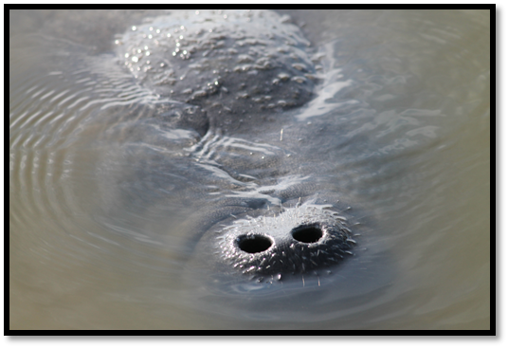
TAKE PRIDE IN KEEPING IT LITTER FREE!

TEACHER EVALUATION OF ENVIRONMENTAL AND CULTURAL EDUCATION PROGRAM

Please return to:
Canaveral National Seashore
Laura Henning
Canaveral National Seashore Headquarters
212 S. Washington Ave.
Titusville, FL 32796

1. Was the teacher’s guide sufficient before your visit?

2. Did your program start and end on time?

3. Were the ranger and volunteers knowledgeable about the resources that were covered in the program?

4. Were the various safety issues addressed at the beginning of the program?

5. Any suggestions to improve this program for the future.

6. Would you recommend this program to other teachers, if not why?

On behalf of the Staff and volunteers of Canaveral National Seashore we would like to thank you for your preparation and participation in our Environmental and Cultural Education Programs for the school year 2019/2020. Only through the education of our youth will we be able to make a difference. Canaveral National Seashore will continue to protect and preserve as long as there are caring individuals, such as all of you.

Thank You,

Laura Henning
Chief of Interpretation & Visitor Use

