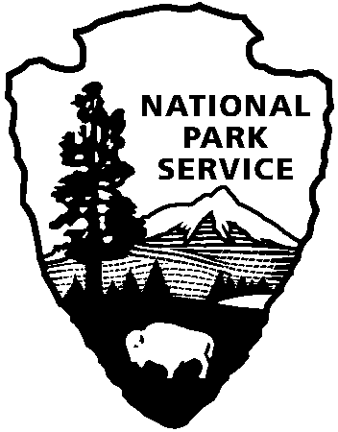 | National Park Service  U.S. Department of the Interior  Canaveral National Seashore  212 S. Washington Ave.  Titusville, FL 32796

CRIMINAL BACKGROUND CHECK
RELEASE FORM

Name: ______________________________________ Date of Birth: ___________
(Last Name, First Name, Middle Initial) (DD/MM/YY)

Other Names Used (if any): ________________________________________________

Email address: _____________________________________________________

Address: _________________________________ State: ________

Drivers License # _____________________ State: ____ SSN#:_______________

Sex: _____ Height: _______ Weight: ______ Eye Color: ________ Hair Color: ______

*Under 43 C.F.R. § 20.511, Departmental volunteers in the course of their official duties are prohibited from possessing firearms on property under control of the Department. Because of the stated purpose of the sponsors of Section 512 to provide uniformity under applicable state law from bureau-to-bureau, the potential liability issues that could result, and the absence of any criminal penalties applicable to this regulation, this Departmental policy continues to apply to all NPS/FWS employees and volunteers during their official duties. Volunteers who are not on official duty may possess firearms on Departmental lands under the same conditions applicable to members of the general public, according to P.L. 111-24, Section 512. For this purpose, volunteers are considered the same as other employees when engaged in their official activities. _______ Initials

By my signature below, I hereby acknowledge that a criminal background check will be completed by a duly authorized Law Enforcement Ranger as a prerequisite of being accepted into the volunteer program at Canaveral National Seashore.

Signature Date

