September 3, 2025

Dear Hunter:

Here is the Bodie Island Waterfowl Hunt Lottery information and application package for the 2025-2026 waterfowl hunting season.

HUNT SEASONS

In accordance with the North Carolina Wildlife Resources Commission the following hunt seasons are as indicated:

The October duck hunting season is scheduled for October 24th & 25th, 2025.

The regular waterfowl hunting seasons are November 8 - 29, 2025 and December 18, 2025 - January 31, 2026.

Youth Waterfowl Days (includes coots, ducks, geese, brant, tundra swans, and mergansers) and Veterans/ Military Waterfowl Days are December 6th, 2025, and February 7th, 2026.

RESERVATION PROCESS

Reservation applications will be accepted ONLY through the mail and reservations will ONLY be assigned by using a lottery system. Telephone calls for reservations will not be accepted. As in past years, reservations will be accepted only for the most popular hunt dates. This year’s dates are as follows:

November: 8, 11, 15, 22, 2025 December: 18, 20, 27, 2025 January: 1, 3, 2026

Reservation applications must not be postmarked prior to September 25th, 2025, and will not be accepted after October 6th, 2025. A self-addressed stamped envelope must be returned with each application to be considered for the waterfowl lottery.

See application below for reservations. Application packets may be emailed to you if requested, please confirm your email on your application. If you do not have an email, please contact us, at 252-473-2111.

I WAS SELECTED, NOW WHAT?

On the day of the hunt, all hunters will be required to register on a first-come, first-served, basis at the Whalebone Information Station.

Hunt sites will be assigned the day of the hunt by lottery. Registration for sites will begin at 4:30 a.m. and the hunt site assignment will be held at 5:00 a.m. each day of this hunt. If it is a reservation day, that lottery will be done first and then the non-reservation lottery. Some NPS maintained blinds are currently unavailable and all hunters should bring man-made materials for constructing temporary blinds each hunt day. All temporary blind material will be removed by the hunter each day.

Happy hunting!

Mike Henry, Chief Ranger
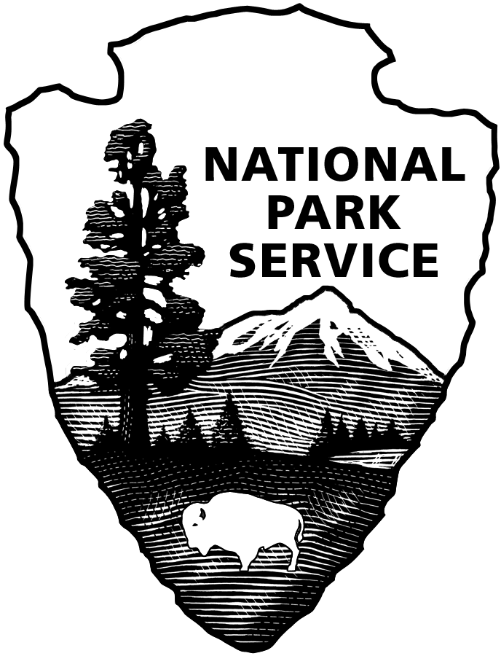
Applications postmarked prior to 9/25/2025 will not be accepted!

Mail To: Bodie Island Hunt
Cape Hatteras National Seashore
1401 National Park Drive
Manteo, North Carolina 27954

Name: __________________________________________________

Address:

Phone:

Date of Birth: Driver’s License # and State:
(Hunters under 16 must be accompanied by a responsible adult)

Emergency Contact:

A maximum of six days during the season may be reserved.

November: 8, 11,15, 22, 2025 December: 18, 20, 27, 2025 January: 1, 3, 2026

Preferred Dates:
___________ ___________ ___________ ___________ ___________ ___________

SUBMIT ONLY ONE APPLICATION PER PERSON. Duplicated applications will be discarded. Failure to comply with instructions can result in disqualification of application.

EMAIL
Please provide your email below for next year’s 2026 – 2027 Bodie Island Hunt and future Bodie Island hunts.

Your email address is: ________________________________________________________________________________________

(Please print clearly)

