Parks as Classrooms
Beaches in Motion-Coastal Vulnerability
National Park Service
U.S. Depart of the Interior
Cape Cod National Seashore

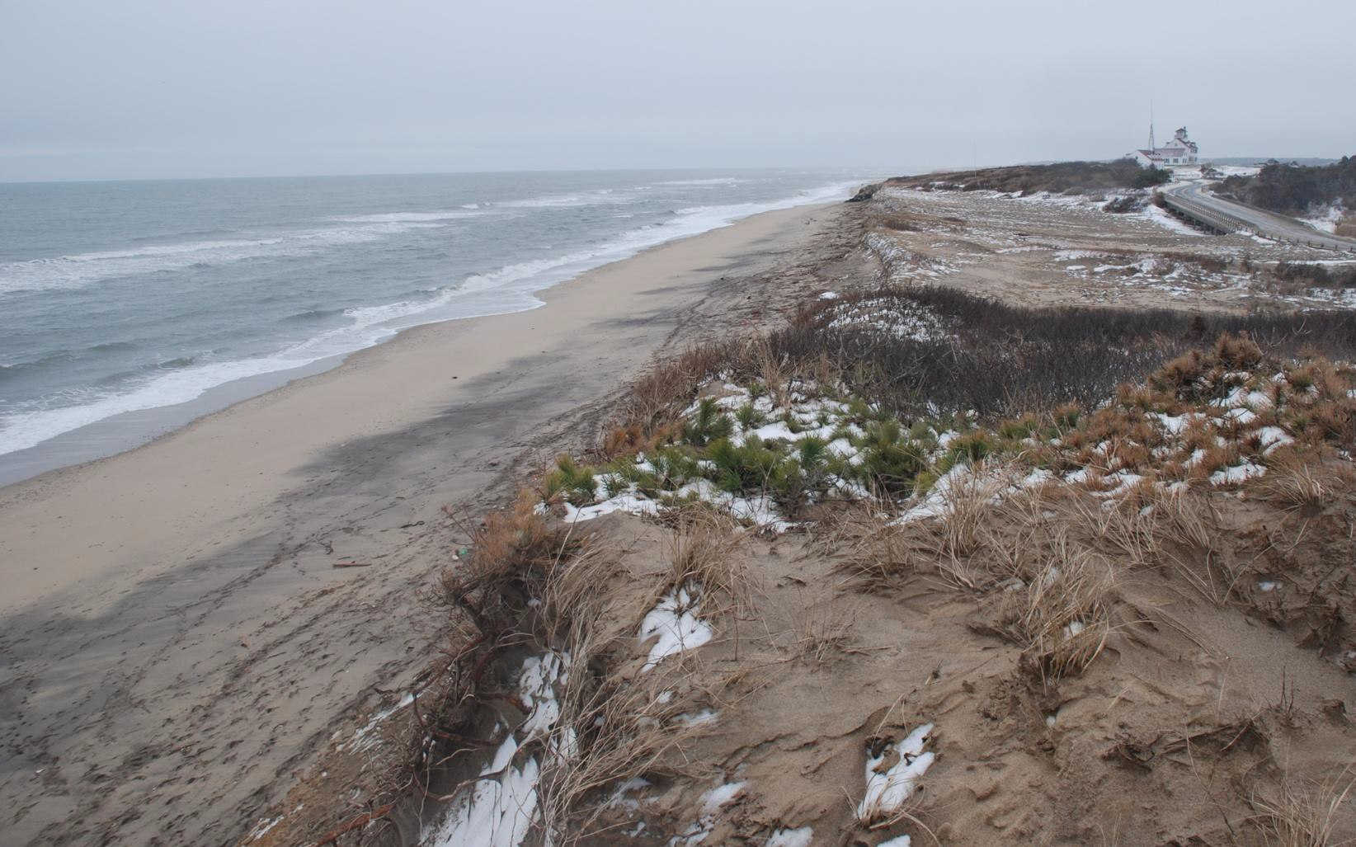

Coast Guard Beach, Eastham, MA- Cape Cod National Seashore

Beaches in Motion-Coastal Vulnerability
Beach Field Trip Activities
Cape Cod National Seashore

Beaches in Motion-Coastal Vulnerability Beach Field Trip Activities

Table of Contents p.1

Activity 1 -Investigating Beaches- Activity Plan and How to Do It p. 2-3

Activity 1- Investigating Beaches- Datasheet p. 4 Activity 2- Longshore Transport– A River of Sand Activity Plan and How to Do It p. 5 Activity 2-Longshore Transport-Datasheet p. 6
Activity 2- Beaufort Wind Scale p. 7

Activity 3- Sediment in Motion Activity Plan and How to Do It p. 8-9

Activity 3- Sediment in Motion Datasheet p. 10

Safety First:
Be aware of tides, especially an incoming tide.
If there are large waves, the teacher or group leader should demonstrate activities for students
to keep students away from the surf zone.
Footwear is recommended as there can be sharp shells and litter such as broken glass or sharp metal objects mixed in the beach sand.
Use sun protection and ensure students bring water.

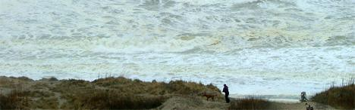

Check for beach current conditions before your field trip. Rough surf can occur a few days before and after storms.

Activity 1 Beach Field Trip: Beaches in Motion-Investigating Coastal Vulnerability

Location: High energy ocean beach, if possible, visit a barrier beach or a beach backed by a coastal bank/cliff.

Duration: 25 minutes Recommend this activity be combined with 2 other 25 minute activities for a 2 hour field trip.

Central Question: How will coastal ecosystems respond to climate change predictions of increased storm frequency, and intensity, and sea level rise?

Overview:
Students identify, locate, and measure the width of beach zones. Observe slope, and elevation of beach, dunes or coastal banks. Students will sample and compare sediment from each zone, identify and name sediment by size, mineral density. Students will evaluate coastal vulnerability (erosion potential) of the site. Discussion questions should include response of the beach to climate change predictions- increased frequency, and intensity of storms, and sea level rise.

Preparation:
Complete the Beaches in Motion – Coastal Vulnerability classroom lesson and activities. The classroom Sediment Classification Activity one includes making a sand classification card that should be used during this field activity.
Copy Field Trip Beaches in Motion-3 Coastal Vulnerability Datasheets for each student team. Also copy the Beaufort Wind Scale document for each team if anemometers not available.

Materials and Tools- for each team of students
Long measuring tape (optional.) Tape can be in meters or feet, your choice of measuring unit.
Datasheets ,Beaufort wind scale document, one clipboard/group, pencils One anemometer
One sediment classification chart (students make an ID chart in this lesson classroom activity 1.) or bring another guide that identifies sediment by the Wentworth Grain Scale.
One or more magnifying lenses
Optional: One roll of clear duct tape, small scissors to make sand slides to view with
magnifiers of under a microscope in the classroom. If bringing back to classroom- pre-labeled 3 small zip lock sandwich baggies: foreshore, berm crest, backshore/dune toe. For respective samples. Bring back sediment samples to identify minerals, measure size, and angulation, compare results from each zone. This option reinforces learning outcomes form classroom activity about sediment classification.)

What to Do and How to Do It:
- Start at the backshore of the beach- Introduce the activity by asking students if they have ever been to a beach, then ask:
What did the “shape of the beach, dunes, look like, where there cliffs behind the beach, was there a wide tidal flat, was the tide high?
If there were cliffs. Were they made of solid material like granite or mainly loose sand like Cape Cod’s cliffs?
Ask if they can identify the zones of the beach and other beach features (dines and cliffs) for where they are standing.
Ask what type (size) of sediment the beach was made of- sand, cobbles, a mix of sizes? Were the sediments of each zone the same or different?
Ask students how sediment can be different. Focus on differences in angulation and density. Angulation is important as it influences how sediment rolls/washes or does not roll/wash off the beach easily and thus remains longer. (Students can hunt for round sediment in the surf zone- the rounds ones rolled off the beach and mostly flatter/angular ones remain in the surf zone.) Density is important as the lighter grains of quartz blow or wash away first leaving the denser grains of sand behind.
- Tell the students they will be starting their study at the top of the foreshore and walking to the backshore towards the dunes or cliffs. Remind the not to go on the dunes or cliffs and why.
- Walk to the top of the foreshore, if students are not already in teams, then group the in teams now. Each team needs equipment, see materials list.
- Students then walk through each beach zone, , and complete the datasheet.. Optional sediment sampling using clear duct tape is suggested for study back in the classroom.(see materials section for more info.)
- Lead a summary discussion with students after they complete the datasheet.

Student Assessment:
Teacher observation of student participating in the activity and discussion.
Students write a paragraph summarizing the activity that includes grain size names and
other characteristics discovered.

Other National Parks with Connections: Cape Hatteras National Seashore www.nps.gov/caha, Assateague Island National Seashore www.nps.gov/asis, and Sandy Hook www.nps.gov/gate have similar sandy beaches and erosion dynamics.

Resources:
http://pubs.usgs.gov/of/2002/of02-233/images/pdf/CapeCod_CVI.pdf The figure on the page 16 page of this report pulls coastal vulnerability variables together.

Name(s): Date: Location:

Draw the beach/dune/coastal cliff profile, label zones, wrack line position/s and record width of each zone and distance from the coastal bank. Record your estimate the elevation of the crest of the dunes and the top of coastal banks.
Below: Record info and circle the number to rate each zones’ vulnerability.
Name of Beach: | Foreshore | Berm Crest  Area | Back of Berm  (Backshore) | Foredune/cliff
Beach/Dune/Cliff slope Draw the slope and write the word that describes the slope. Steep, Gradual, Flat  Vulnerability to storm waves | Low Medium High 1 2 3 | Low Medium High 1 2 3 | Low Medium High 1 2 3 | Low Medium High 1 2 3
Elevation of dune crest/cliff Rate the vulnerability of a washover of the dune or cliff  based on its elevation. | Low Medium High 1 2 3 | Low Medium High 1 2 3 | Low Medium High 1 2 3 | Low Medium High 1 2 3
Describe sediment from duct tape sampling:  Size/s, minerals, angulation.  Size vulnerability-easily eroded? | Low Medium High 1 2 3 | Low Medium High 1 2 3 | Low Medium High 1 2 3 | Low Medium High 1 2 3
Rate this areas vulnerability to strong storm and wave occurrence/year? | Low Medium High 1 2 3 | Low Medium High 1 2 3 | Low Medium High 1 2 3 | Low Medium High 1 2 3
Average the numbers in each column to rate the
vulnerability of each beach zone
Final average for all zones (add numbers for above row, divide by 4)
Discussion: Predict how sea level rise will change the position of zones in relationship to the dune or coastal bank toe. Think of methods people have tried to stop erosion. Were they successful?

Activity 2 Beach Field Trip: Longshore Drift – A River of Sand Activity Location: Beach that has waves approaching at an angle.
Duration: 25 minutes

Overview: This group activity demonstrates longshore drift. Longshore drift is the movement of sediment by water parallel to the shoreline. The direction and movement is dependent on wind conditions, wave energy, and sediment size. Discuss the response of the beach to climate change predictions- increased frequency, and intensity of storms, and sea level rise.

Materials and Tools:
Two-three oranges or grapefruit, or other colorful buoyant item that floats and is easy to throw past breaking waves. Item should be natural and not harmful to the environment.
Compass
Anemometer or print and use the Beaufort Wind –Wave Chart to estimate wind
speed.
Lightweight streamer or piece of cloth to observe wind direction Print 1 worksheet/group, 1 clipboard, pencils
Activity 2: What to Do and How to Do It:
Gather your class or group by the berm of the beach to :
  - Observe weather, wind and wave direction. Hold up the streamer to detect wind, then use compass to identify direction of wind.
  - Observe waves and ask students: how do the waves move? What direction, how do they hit the beach then what happens to them?
  - Discuss the amount of wave or water energy needed to transport sediment.
  - Select students to throw the orange(s) into the water as far as they can. Observe the direction the orange moves and discuss how the direction relates to the wind and waves. Sediment, like the orange, is transported along the shoreline. The movement of sediments along the shore is called LONGSHORE DRIFT. The longshore drift or currents carry great loads of sand and sediments along our coastline. The term a “river of sand” is sometimes used to describe the process.

Student Assessment:
Teacher observation of student participation in the activity and discussion.
Students write a paragraph summarizing the activity that includes grain size names and
other characteristics discovered.

Researching Coastal Vulnerability: Longshore Transport

Name(s): Date:

Beach Location:

Name of beach:
Wind direction and speed
Yes or no, is the direction the waves are coming from the same direction as the wind? | Yes No
Estimate wave height in meters
What direction are the waves coming from?
After the wave breaks on the forebeach, what direction does the water move?
Longshore Transport Experiments #1 and #2, #3 is optional  Lay out a measuring tape about 100 feet or 30 meters. Throw and orange or a buoyant object into the water just beyond the breaking waves-(know water movement direction -throw in at the end of the meter so orange will be moved to the opposite end of meter tape).  How many seconds did it take the orange to be transported the length of the meter tape? | Trial #1- meters/seconds Trial #2- meters/seconds  Trial #3- meters/seconds
Read the questions below. Then make some observations to help you answer the following questions:

If sand is moved away from where you are standing, how does it get replaced?

Do you see any erosion controls on this beach? Or jetties, groins? What affect might they have on the river of sand (longshore transport)?

What is the source of new sand on Cape Cod?

What would happen to the beach zones and conditions if revetment walls covered the glacial cliffs?
Predict how climate change predictions of sea level rise and an increase in storm frequency and severity will affect this beach as well as beaches around the world?

 |  |  | Beaufort Wind Scale
# | Speed [mph] | Category | Effects at Sea | Effects on Land
0 | <1 | calm | Sea like mirror | Calm; smoke rises vertically
1 | 1-3 | light air | Ripples with appearance of “fish scales”; no foam crests | Smoke drift indicates wind direction; wind vanes do not move
2 | 4-7 | light breeze | Small wavelets; crests if glassy appearance not breaking | Wind felt on face; leaves rustle; wind vanes begin to move
3 | 8-12 | gentle breeze | Large wavelets; crests begin to break; scattered | Leaves and small twigs in constant motion; light flags
 |  |  | whitecaps | extended
4 | 13-18 | moderate breeze | Small waves; becoming longer; numerous whitecaps | Dust, leaves and loose paper raised up; small branches move
5 | 19-24 | fresh breeze | Moderate waves; becoming  longer; many whitecaps; some spray | Small trees in leaf begin to sway
6 | 25-31 | strong breeze | Larger waves forming; whitecaps everywhere; more spray | Large branches of trees in motion; whistling heard in wires
7 | 32-38 | near or moderate gale | Sea heaps up; white foam from breaking waves begins to be blown in streaks | Whole trees in motion; resistance felt in walking against wind
8 | 39-46 | gale or fresh gale | Moderately high waves of greater length; foam is blown in well-marked streaks | Twigs and small branches broken off trees
9 | 47-54 | strong gale | High waves, sea begins to roll; dense streaks of foam; spray may reduce visibility | Slight structural damage to homes occurs; slate blown from roofs
10 | 55-63 | storm or whole gale | Very high waves with overhanging crests; sea takes white appearance; visibility reduced | Seldom experienced on land; trees broken; structural damage occurs
11 | 64-72 | violent storm or storm | Exceptionally high waves; sea covered with white foam patches | Very rarely experienced on land; usually with widespread damage
12 | >72 | hurricane | Air filled with foam; sea  completely white with driving spray; visibility greatly | Violence and destruction
 |  |  | reduced

Activity 3 Beach Field Trip- Sediment in Motion

Location: High energy ocean beach with a sloped foreshore zone. This activity will not work on beach exposures that are flat with little to no wave energy in the swash zone.

Duration: 25 minutes

Overview: Students conduct experiments with 2-3 inch pebbles of various angulations (shapes) to observe cycling of sediment on and off the shore - our moving shorelines. Students collect data that can be analyzed and graphed back in the classroom. (20 minutes)

Optional: Sand Castles in Motion. Students sand castles being lost to wave action to Cape Cod- also made of sand- being vulnerable to erosion forces (waves.) (5 minutes)

Preparation:
Complete Cape Cod National Seashore’s Beaches in Motion-Coastal Vulnerability Classroom Lessons and classroom activities.
Important reading: SWASH
Print lesson so each leader has a copy of the “what to do and how to do it section.” Make 1 datasheet for each team and one for each leader.
Collect pebbles for this activity the same time you collect sand for the classroom sediment classification activity or, ask students to collect and bring to school pebbles 2-3 inches in size, request they collect ones with different angulations.
Each team of students needs three sets of pebbles. These sets should be grouped prior to the field trip- or find pebbles on the beach and try and try to group the pebbles as below to match datasheet observations. See the materials section for how to group pebbles and paint.

Materials and Tools-Sediment in Motion Activity
Pebbles (2-3 inches) total number depends on the number of student teams. Each team needs 3 sets of 2 pebbles grouped by size and angulation. Pebbles should be 2-3 inches.
- Two pebbles the same size and same angulation
- Two pebbles same size, one round , one flat
- Two pebbles of any combination, but record for later discussion
- Optional- spray paint pebbles of same size and angulation the same color to make them easier to through dark ocean water - yellow or orange works well. Spray painting is quick.
One person with a timer, a watch with seconds and minutes or a stop watch. Datasheet/clipboard/pencil for each team

No additional materials are needed for the sand castle in motion activity, use sand and pebbles found on the beach.

Activity 3: Sediment in Motion- What to Do and How to Do It:
Show students painted rocks, describe how they will be placed in the surf edge, ask them to predict how the waves/surf will move the rocks and if size of sediments will affect outcome. Then walk to the edge of the surf. Have students stand back so all can see this demonstration.
- Place the painted rocks, observe long enough for successive waves to move them
- Discuss whether/how shape and size affected the movement of sediment.
Assign small groups of students to a location along the surf, this location will be their study/experiment area.

Follow data sheet (3 sets of experiments). Experiments with pebbles can be done as a group or by small teams of students.

Optional Activity: Sand Castles in Motion if surf conditions are safe- What to do and How to Do it:

If the tide is coming in, build a sand castle with a 12 inch base just above the swash zone. If the tide is going out- a teacher should build one castle for the group in the swash zone, if students are allowed in the swash zone they need to build the castle between waves-so they need to be quick!
Place a few pebbles or cobbles on the castle. Bye the way- no moat building or dunes to protect castles in this experiment!

Students record experiment results on the datasheet:
Number of waves you predict needed to wash away your castle: . Wait until the first wave hits your sand castle before students start counting.
Record the number of waves it actually took: .
Discussion questions:
What happened to the pebbles and or cobbles you decorated your castle with? Did their size make a difference in the rate of their movement compared to the sand?
Make connections:
Ask students to-turn around and identify the sediment Cape Cod’s land is made of? Make a connection to the sediment type (size) and erosion potential by waves or wind and Cape Cod’s coastal vulnerability rate.

Student Assessment:
Teacher observation of student participating in the activity and discussion. Students write a paragraph summarizing:
- The activity that includes grain size names and other characteristics discovered.
- Why scientists would be interested in knowing the information they discovered about composition and movement of beach sediment.
- How data is used to make decisions about managing beaches for natural resources and public use, for example, where could you build a parking lot or stairway that would not be washed away?

Sediment in Motion: Waves

Team members: Date:

Location: High /Low Tide Times:

Experiment | Size in CM or inches, and Shape- round, flat, angular,  other | Record what happens after hit by wave– roll up/down foreshore-  stay in place? | Distance Transported after 60 sec | Distance Transported after 2 minutes | Distance Transported after  minutes | Observation Notes:
1. Two pebbles same size, and same angulation
2. Two pebbles the same size and one round , one
flat
3. Try your own combination

Sand Castle in Motion -optional activity if surf conditions are safe-
If the tide is coming in, build a sand castle with a 12 inch base just above the swash zone. If the tide is going out- a teacher should build one castle for the group in the swash zone between incoming waves. If students are allowed in the swash zone, they need to build the castle quickly so they do not get wet from incoming waves! Place a few pebbles or cobbles on the castle. Bye the way- no moat building or dunes to protect castles in this experiment!

Record number of waves you predict needed to wash away your castle: . Wait until the first wave hits your sand castle before you start counting
Record the number of waves it actually took: .

What happened to the pebbles and or cobbles you decorated your castle with? Did their size make a difference in the rate of their movement compared to the sand?

Now-turn around and identify the sediment Cape Cod’s land is made of? Make a connection to Cape Cod’s coastal vulnerability rate!

