

Parks as Classrooms

Beaches in Motion-Coastal Vulnerability

National Park Service

U.S. Depart of the Interior

Cape Cod National Seashore

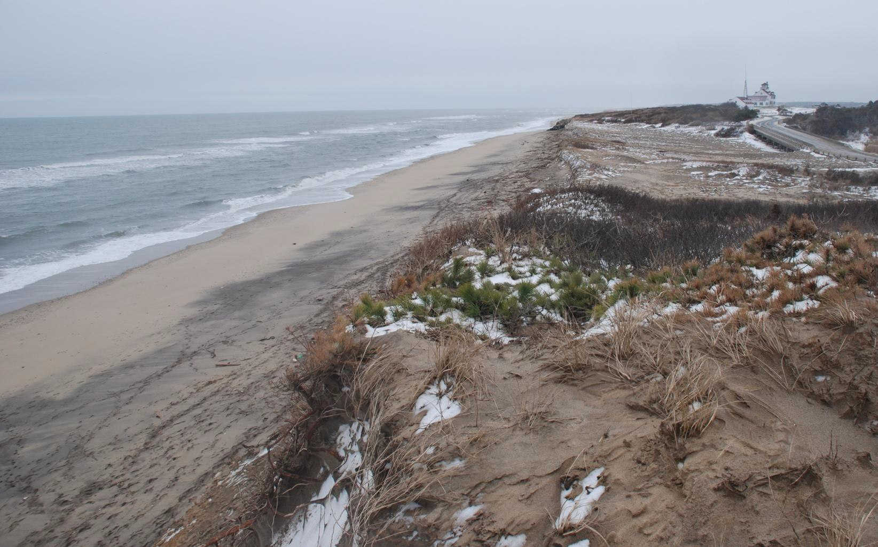



*Coast Guard Beach, Eastham, MA- Cape Cod National Seashore*



**Beaches in Motion-Coastal Vulnerability**

**Pre-Site**

**Classroom Lessons and Activities**

**Cape Cod National Seashore**

# Beaches in Motion-Coastal Vulnerability Beach Field Trip Activities

**Table of Contents** p.1

Lesson Plan: Beaches in Motion-Coastal Vulnerability p. 2-5

Reading 1: Outer Cape Cod p. 6

Reading 2:SWASH a New Method for Quantifying Coastal Change p. 7-11 Classroom Activity 1 Sediment Classification – Sand is a Size p. 12-16

Sediment Classification Worksheet p. 17

Sediment: Minerals and Density p. 18 Classroom Activity 2 Sediment in Suspension p. 19-21

**Safety First:**

When collecting materials, be aware of tides, especially an incoming tide.

 Footwear is recommended as there can be sharp shells and litter such as broken glass or

sharp metal objects mixed in the beach sand. Use sun protection and bring water.

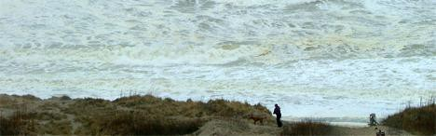

*Check for beach current conditions before visiting the beach. Rough surf can occur a few days before and after storms.*

# Title: Beaches in Motion- Coastal Vulnerability Level: Grades 5-8

**Central Question:** Will the 100 year historic rate of coastal erosion increase in response to

climate change predictions: increased storm frequency and intensity, and sea level rise?

**Overview:** Students will learn to identify beach and dune features and attributes to predict vulnerability to erosion forces and further their knowledge of sediment cycling on and off beaches.

This classroom lesson includes background material and hands-on activities to provide knowledge of beach zones, sediment transport by water, sediment classification skills, and the importance of beach morphology (elevation, slope) as it relates to coastal vulnerability. The field trip activities include: identifying major beach features, longshore transport experiments, and a fun sediment in motion study using pebbles. The past assessment activity requires students to demonstrate their understanding of beach processes in a model.

**Duration Time:** 6 classroom periods about 6 hours for all, pre and post assessment activity, 2 hours on-site for field trip

## Student Outcomes:

 Students will be able to sort and classify by size at least 3 particle (grain) sizes of beach sediment, then discuss how size relates to erosion potential by waves and wind.

 Students will be able to list three features/attributes of a beach that determine its coastal vulnerability or erosion potential.

 Students will be able to predict beach and dune response to various climate change scenarios.

## Massachusetts Science and Technology Standards:

Earth and Space Science

**Cape Cod National Seashore Goals:** Natural Resources- Coastal Processes

1. Students will visit a National Park to increase their understanding of the National Park Service mission, and that parks are part of their community.
2. Students will understand shoreline processes and predict change as managers do for decision making purposes.
3. Other National Park Connections: Cape Hatteras National Seashore [www.nps.gov/caha,](http://www.nps.gov/caha) Assateague Island National Seashore [www.nps.gov/asis,](http://www.nps.gov/asis) and Sandy Hook [www.nps.gov/gate](http://www.nps.gov/gate) have similar sandy beaches and erosion dynamics.

**Classroom Lessons and Activities-** This lesson includes:

 Classroom materials: two Powerpoints, two readings, two classroom activities. one activity includes viewing a YouTube video, an additional recommended reading- hyperlink provided



Field Trip activity suggestions: three activities with datasheets. Post Assessment Model Activity

## Presentation Procedure- How to Do It Suggestion:

1. Preview the full version of materials for the classroom, field trip, and post assessment activity: open files Classroom-Beaches in Motion-Coastal Vulnerability, Field trip- Beaches in Motion-Coastal Vulnerability, and Post Field Trip- Models Beach.

Determine which activities you will do with your class, collect all sediment needed for the classroom activities and possible the post assessment activity prior to starting the classroom lessons.

1. Read: Geology of Outer Cape Cod: [http://www.coastalstudies.org/what-we-do/land- sea/outercape.htm](http://www.coastalstudies.org/what-we-do/land-sea/outercape.htm) and discuss the importance of coastline, how understanding coastal process are relevant to students lives.
2. View: Powerpoint- Beaches in Motion-Coastal Vulnerability (about 45 minutes with discussion.)
3. View: Powerpoint- Beach Zones (about 45 minutes with discussion.)
4. Read and spend time interpreting the graphs in the document: SWASH: a New Method for Quantifying Coastal Change.
5. Activity-Sediment sorting and Classification (30 -45 minutes)

Classroom Activity 1 (or can be done on field trip) Sediment Classification (45 minutes): Not all the particles of sediment on the beach are ―snad‖. Particles are named for their size according to the Wentworth Grain Size Scale. Sediment ranges in size from silt to boulders. The size and shape of the particles affects the ―strucutre‖ or slope and zones of the beach which in turn affects the beaches’ rate of erosion. The smaller the sediment size, the easier it is for it to be removed and transported by wind or waves. See activity plan. Sediment sorting worksheet, mineral color and density chart.

1. Classroom Activity 2: Sediment in Suspension (45 minutes with 20 minute YouTube video) - see lesson plan. Learn about wave energy and long shore transport, ―Beach: A River of Sand.‖
2. Reading in preparation for beach Field trip Activity 1- Coastal Vulnerability Assessment of Cape Cod National Seashore (CACO) to Sea-Level Rise<http://pubs.usgs.gov/of/2002/of02-233/images/pdf/CapeCod_CVI.pdf>*The figure on page 16 page of this 23 page report pulls coastal vulnerability variables together. Students will be evaluating coastal vulnerability factors in Beach Field Trip Activity 1. Recommend the teacher preview this document and use information appropriate to the class.*
3. Open the file: Field trip-Beaches in Motion-Coastal Vulnerability. This file contains the full description and datasheets for the beach field trip activities. Below is a summary of the three activities. Duration: 2 hours.

**Activity 1 Beaches in Motion - Investigating Coastal Vulnerability** (25 min).Students identify and locate different beach and dune zones, slope, elevation of dunes or coastal banks. Compare sediment samples from each zone, identify and name sediment by size, identify minerals, discuss mineral density, evaluate erosion potential.

Discuss the response of the beach to climate change predictions- increased frequency, and intensity of storms, and sea level rise.

**Activity 2 Longshore Drift – A River of Sand Activity** (25 min). is a group activity that demonstrates longshore drift. Longshore drift is the water transport of sediment parallel to the shoreline. The direction and movement is dependent on wind conditions, wave direction, wave energy, and sediment size. Discuss the response of the beach to climate change predictions- increased frequency, and intensity of storms, and sea level rise.

**Activity 3 Sediment in Motion** (25 min). Best location is a high energy beach with a sloped forebeach zones and waves. Observe movement of sediment on and off the beach, sand bar formation and location. This activity works best on incoming tides but can be adapted for outgoing tides. Discuss the response of the beach to climate change predictions- increased frequency, and intensity of storms, and sea level rise.

1. **Post Field trip Assessment Activity- view file: Post** Assessment -Beaches in Motion-Coastal Vulnerability

## Student Assessment:

 Students write a paragraph that relates sediment size to wave energy, and longshore transport (erosions and accretion). Students should use grain size names, zones of the beach, and other beach features.

 Students should study and interpret the graphs, figures 1 and 2 in the reading; USGS_SWASH.doc

Draw a profile of the beach and label zones and 3 other minor beach features.

 Write a paragraph discussing why beaches have sand? Why doesn’t the sand wash off

the beach and just disappear off shore? ( a few hints: water pushes sand up the beach as well as pulls it of. Some water passes down through the sand after it runs onto the beach, so not as much water runs off the beach as ran on. More ideas? What role might sediment size and angulation play?

 Compare Cape Cod’s coastal vulnerability factors (high wave energy) to other geographic locations: rock-granite backed beaches, low wave energy beaches (inside a protected salt marsh or estuary, Cape Cod Bay etc.)

Students complete the Post Assessment Modeling Activity with realistic outcomes.

# Explore Further:

 <http://www.nature.nps.gov/views/Classic/Index_Coastal.htm>

# Resources:

 USGS Study, Relative Coastal Vulnerability Assessment of National Park Units to Sea- Level Rise: [**http://woodshole.er.usgs.gov/project-pages/nps-cvi/**](http://woodshole.er.usgs.gov/project-pages/nps-cvi/)

USGS Marine Geology Program; <http://marine.usgs.gov/index.php>

*At the Sea’s Edge*, William T. Fox, Prentice Hall, 1983.

*Geologic Story of Cape Cod* by Robert Oldale. This book is online at [www.nps.gov/caco](http://www.nps.gov/caco) then click on ―Nautre and Science‖ link.

 Video- *The Sands of Time,* A 12 minute film shown at the Salt Pond Visitor Center, Cape Cod national Seashore or can be purchased at the visitor center’s *Eastern National* bookstore or by calling the bookstore at

508-255-6860.

 National Park Service Coastal Geology Program: <http://www.nature.nps.gov/geology/coastal/index.cfm>

 Provincetown Center for Coastal Studies- Marine Geology Studies: <http://www.coastalstudies.org/what-we-do/land-sea/land-sea.htm>

## Reading One : Outer Cape Cod

Cape Cod's ocean coastline presents a naturally dramatic and strikingly beautiful moving picture formed by a continual interplay of earth, sea, atmosphere, and life. These interactions produce the landforms, and the landforms alter the interactions in an endlessly compelling dynamic. The resulting landforms-sea cliffs, dunes, spits, barrier beaches, salt marshes and estuaries-provide habitats for an amazing array of coastal plants and animals. The habitats, their inhabitants, and the interacting environmental factors controlling them constitute the Cape's ecosystems.

The Center's coastal geology program focuses on the landforms that provide the physical framework for those ecosystems. The outer coast of Cape Cod, extending from Long Point in Provincetown for over 60 miles to Monomoy Point in Chatham and named the "Great Beach" by Henry David Thoreau when he walked the greater part of its length in 1849 and again several years later constitutes a single system of sediment transported by wave and tidal action. Although it appears little changed since the Pilgrims' landfall 350 years ago, it is in fact the most dynamically changed of all of Cape

*Barrier beaches -Nauset Spit, Eastham Race Point Light area. Light color is sediment in suspension.*

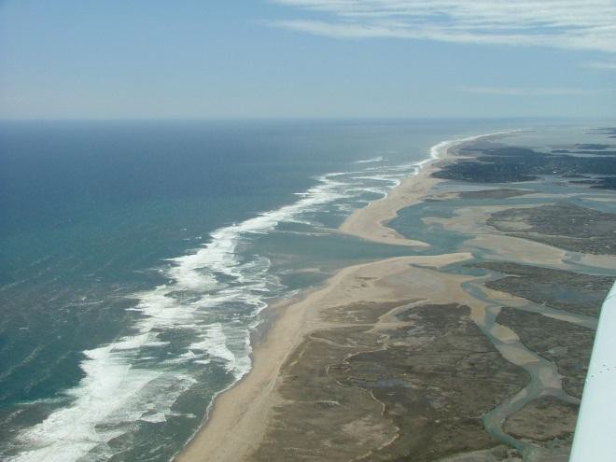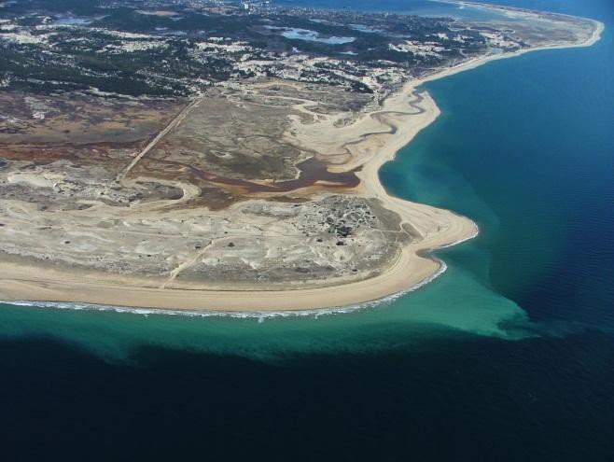Cod's many shores. Its notoriety for quickly shifting shoals in response to vicious Northeast storms

comes mainly from the scores of 17th, 18th and 19th century ship wrecks that litter its bottom, and which earned it the nickname "Graveyard of the Atlantic;" home to perhaps the most notorious of all Cape Cod shipwrecks, the pirate ship "Whydah," which ran aground in 1717 during just such a northeast gale. Largely for this reason, the outer Cape Cod coast, or "backside," as it is known locally, ranks as one of the world's most thoroughly studied by geologists and physical geographers.

The basic sedimentation system is straightforward: the central coast consists of sea cliffs-made up of sand and gravel deposited by retreating glaciers-which, when eroded by storm waves, dump tons of sand to construct the beaches that front them as well as the spits and barrier beaches that extend to their north and south. This coastal system produces an incredibly diverse set of landforms and habitats that contribute to its enormous popularity with all forms of beachgoers: surf-casters, sunbathers, surfers, birdwatchers and hikers. This leads to complex management issues further complicated by the many different political jurisdictions in which they lie. These jurisdictions consist of five Barnstable County towns, each charged with enforcing State environmental regulations as well as their own, and two federal agencies — the Cape Cod National Seashore and the Monomoy Wildlife Refuge — with overlapping boundaries and potentially conflicting priorities.

Provincetown Center for Coastal Studies | Land-Sea Interaction <http://www.coastalstudies.org/what-we-do/land-sea/outercape.htm>

## Reading Two: SWASH: a New Method for Quantifying Coastal Change

*For discussion, comments, or questions on the SWASH system contact: Jeff List (jlist@usgs.gov),U.S. Geological Survey, 384 Woods Hole Road, Woods Hole, MA 02543- 1598 |*

## Introduction

Coastal erosion is a serious national problem with long-term economic and social consequences. Developed areas are threatened with billions of dollars in property damage as a result of storm impacts and long-term erosion. Over the last few decades, data on the position of the shoreline has emerged as the principal source of information for local, state, and federal government agencies charged with managing coastal erosion.

This measure of the shifting land/water interface is also an important source of information for scientific investigations of coastal change, for determinations of the sediment budget, and for conducting numerical simulations of shoreline change.

Despite the importance of this measure of coastal change, the methods available for collecting shoreline position data are very limited. The most commonly applied method- shoreline interpretation from aerial photography-is expensive, labor-intensive, and involves a considerable amount of subjectivity in identifying the shoreline. There is a significant need for a method that can provide an unambiguous and repeatable measure of shoreline position, can cover large sections of coast within a single low tide period, is inexpensive to operate, and can be used for both long-term monitoring and rapid-response surveys of storm impacts. In response to this need, the USGS developed SWASH, a vehicle-based system for measuring shoreline position which utilizes recent advances in the Global Positioning System (GPS).SWASH stands for "Surveying Wide-Area Shorelines."

## Methodology

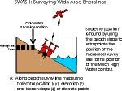The SWASH system is mounted on a six-wheel amphibious all-terrain vehicle. As the vehicle transits the coast, an array of GPS sensors are used to make high-accuracy measurements of horizontal position, vertical position, and beach slope.

Following the field survey, position and slope data are combined to compute shoreline position, defined as the horizontal location of a target elevation contour's intersection with the beach. In keeping with historical sources on shoreline information, the Mean High Water (MHW) contour is usually chosen as the definition of the shoreline.

In contrast to shorelines derived by most previous methods, SWASH shorelines have well- defined error bars, important for determining the statistical significance of shoreline change. Error bars are calculated on a point-by-point basis as a function of beach slope and the deviation between the elevation driven and MHW. SWASH can survey more than 70 km of shoreline within a single low tide period and provide near real-time information on shoreline changes during storms. SWASH is also very inexpensive to operate relative to previous methods for obtaining shoreline position.

**Current Survey Program and Example Results**

The SWASH system is currently being applied to study storm-induced and fair weather shoreline change on beaches in North Carolina and Massachusetts. The most extensive set of measurements are within the Cape Cod National Seashore, where both the short-term impact of storms and the longer seasonal cycle of change has been measured in a continuing survey program initiated in April 1998.

Map 1 shows the along-coast reference line used in the following example results. An example of the short-term impact of a Northeaster storm on 45 km of Cape Cod's outer coast is given in figure 1. The shoreline erosion response was extraordinarily non-uniform, with zones of significant erosion (more than 20 m of shoreline recession) alternating with zones of virtual stability (less than 2 m of change). In the period of decreasing waves following the storm, the pattern of change almost entirely reversed, with the erosional zones showing strong accretion and the stable zones still exhibiting no significant change. Similar results have been obtained for other storms on Cape Cod, as well as along the Outer Banks of North Carolina. Although the processes responsible for these erosional "hotspots" are unknown, their identification has important implications for management of both cultural and environmental resources along the coast. Research is ongoing to better characterize the locations and persistence of erosional hotspots and to understand their cause or causes.

The seasonal cycle of shoreline position variability on Cape Cod is given in

figure 2. Shoreline position is averaged over the "bluff-backed coast" (kilometers 17.5 to

45.0 on the Cape Cod study area map) and plotted as a function of time since the first survey in April 1998. Although much variability exists from survey to survey, there is a clear yearly signal of erosion and accretion which is tied to variations in overall storminess between winter and summer. This data series, when extended for several more years, will help characterize the natural high-frequency variability of shoreline position, both in winter and summer, information important for quantifying the error in estimates of long-term shoreline change.



Map 1

Cape Cod Study Area

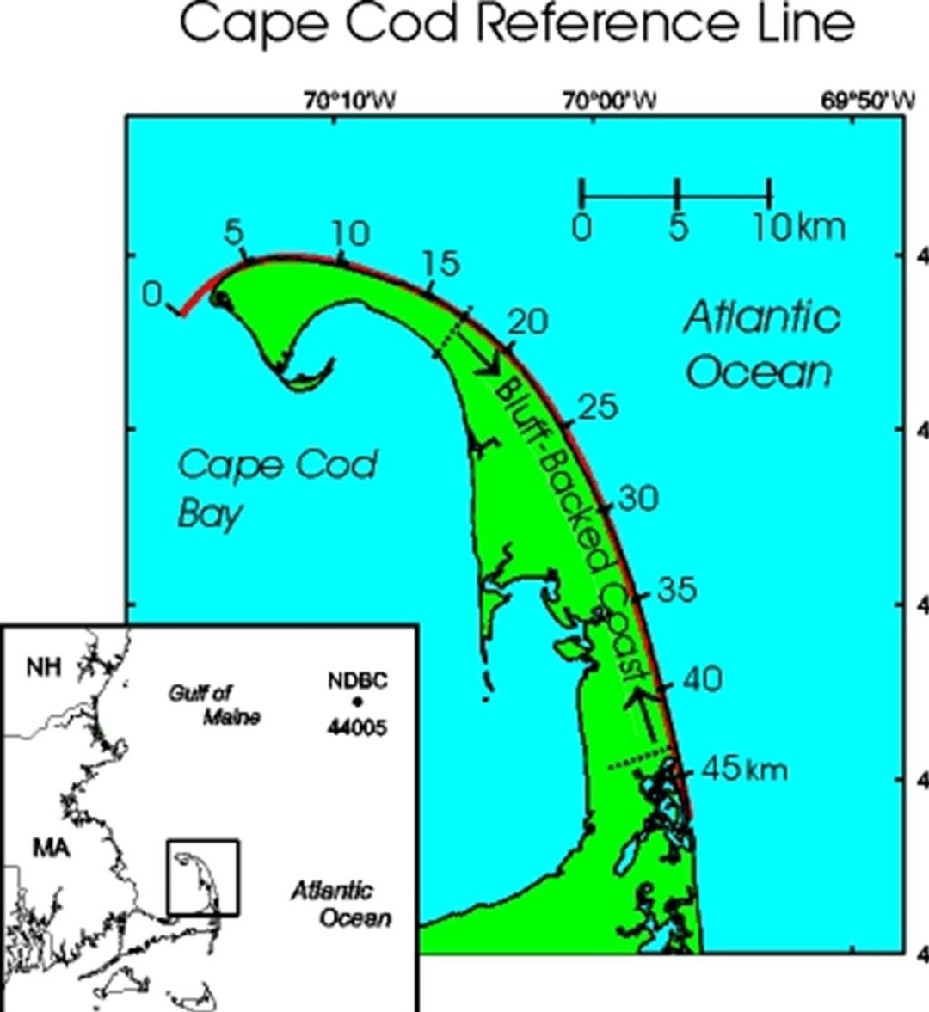

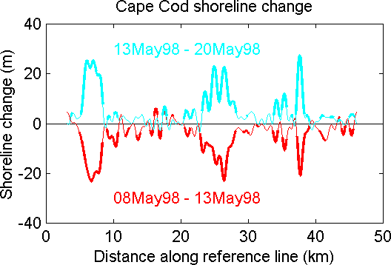



**Figure 1**

**Short Term Change**

*MORE*

***Figure 2***

***Cape Cod Seasonal Change***

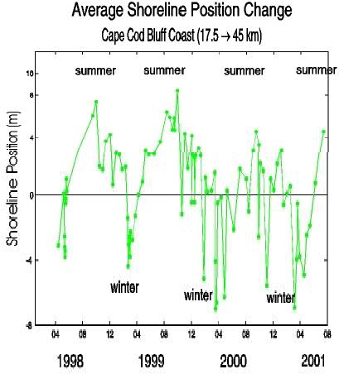

This figure shows seasonal and storm-induced changes in shoreline position averaged over the Cape Cod bluff-backed coast (from 17.5 to 45 km on the along-coast reference scale shown on the Cape Cod study area map). The horizontal scale is time labeled in month/year since April 1988, and the vertical scale is the shoreline position relative to the first survey.

Each point on the figure represents a shoreline survey from a biweekly sampling program initiated in April 1988. A decrease in shoreline position indicates a landward shift in the position of the mean high water contour, which is inferred to be associated with beach erosion.

END Reading Two

## Classroom Activity 1 Sediment Classification – Sand is a Size

Location: Classroom or can be done on field trip Duration: 45 minutes

**Background:** Sand is a size. Not all the particles of sediment on the beach are ―snad‖. Particles are named for their size according to the Wentworth Grain Size Scale and can range in size from silt to boulders. The size and shape of the particles affects the ―strutcure‖ or slope and zones of the beach which in turn affects the beaches’ rate of erosion. The smaller the sediment size, the easier it is for it to be removed and transported by wind or waves. Mineral density is also important in understanding sediment erosion from wind and waves, denser materials require more energy to transport them.

Groups responsible for beach management use vulnerability assessments to help make management decisions about fixed structures such as buildings, parking lots and stairways- build, don’t build, or remove the structures before a storm.

**Student Outcomes**: Students will be able to identify by size at least 3 particle (grain) sizes of beach sediment. Students will know that beach sediment is composed of a variety of minerals and that each mineral has different properties.

Students can make a sand gauge card to bring on the field trip to the beach. **Massachusetts Science and Technology Standards:** Earth and Space Science **Prerequisites:** Complete the main lesson plan (Powerpoints, readings. Both classroom activities, this one and the *Sediments in a Bottle Activity* could be done in the field as well as the classroom. Decide what will work best for your class.

## Materials and Tools

 Sediment sifters, a minimum of 3-level sediment sifters capable of sorting fine sand, course sand, small pebbles 1/ group or have one or more for the class. See Resource Section for purchase sources.

 With permission from manages of the beach location you plan to visit, collect 4-5 cups of sediment from the different zones of the beach. Purposely collect a variety of sizes. It’s easiest to gently sweep samples from the surface into a baggie or container with your hand. If the park you r existing does not allow you to take samples for classroom use, then do this activity while on the beach.

 If planning to do the pebble activities on the field trip (Field Trip activity 3), now is a good time also collect enough pebbles and include these in the sediment sorting activity. Paint or mark prior to field trip.

Sediment_Classification_worksheet- copy 1/student or one per group. T Mineral color and density chart.

Magnifying lenses for each group of students (optional)

Optional: Materials for each student to make their own sediment chart to bring on the beach field trip:

 One for each student: Cut tag board, markers to label chart, clear drying craft glue, clear sandwich size baggie too keep finished card stored in as glued sediment may fall off.

## What to Do and How to Do It:

1. Introduce the activity by asking students if they have ever been to a beach, then ask what did the ―sadn‖ look like?

 Describe how the ―sadn‖ is made up of particles of different sizes and each size has a name. Sand ranges in size and is names accordingly.

 Ask students how else the particles can be different: shape, color, luster, density.

1. Divide the class into small work groups

 Each group should have: unsorted sediment, a copy of the Sediment_Classification_worksheet, Mineral color-Density Chart, a pencil, and a few magnifiers, a minimum of a 3 –tier sifter able to sorts granules (pebbles), course sand, fine sand, one cup of unsorted beach sand

Teams will each receive one cup of unsorted beach sediment to sift.

 After sifting, teams a ―picnh‖ of sediment on the data sheet to identify grain sizes by name,

then record by circling the name on the Wentworth Grain Size Scale.

 Use the data sheet with magnifiers to explore color and luster, and shape of the particles; circle or check the characteristics they find.

1. If students would like to save their sorting worksheet with sediment, use clear duct tape to tape down sediment in place OR students can make their own sand gauge cards with oak tag, sorted and named grain sizes, glue, and magic marker for labeling.

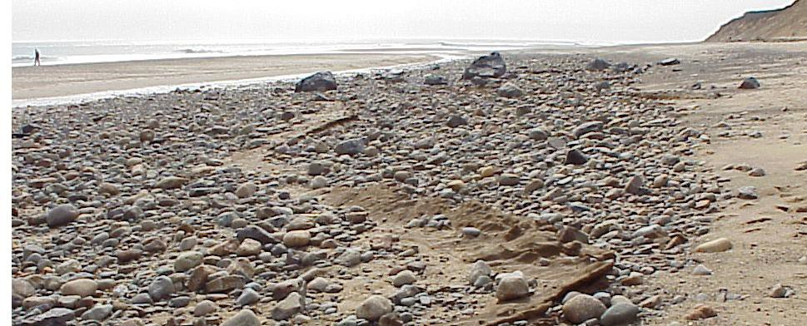

*High energy winter storm waves transport a lot of sand sized sediment off the beach leaving larger sediments exposed. Most summer visitors never see these larger sediments as sand is moved back into the beach by good weather day waves before summer.*



***Grain size Identification Cards****. The card on the right was purchased through the Forestry Supplier Catalog. The card in the left was made by a student.*

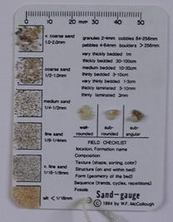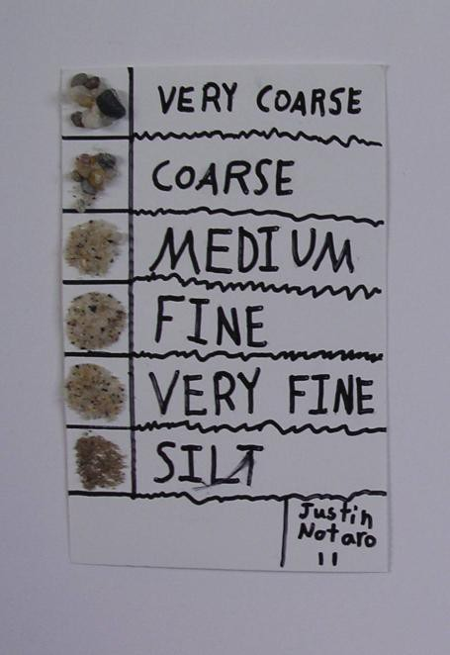

Discussion:

Sand grains are made of various minerals. Although the grains might be the same size, each mineral has a different density. Ask students if the density differences mean wind and wave s act on the minerals differently.

Denmark tested an erosion control method to pack the beach surfaces with heavy minerals so lighter quartz grains would be protected and not wash or blow away. Ask students to discuss the conditions of beaches, sea level rise rates and wave energy of beaches in Denmark, predict the results if capping the beaches with heavy minerals was successful.

Would that methods of erosion control work on Cape Cod National Seashore’s high energy beaches?

Climate change: Sea level rise impacts? Your favorite beaches will change- get over it. People have to plan for smart building away from flood zones along with other smart solutions to loss of property and structures built along the coast.

After students compete activity- Teacher might quiz students to assess students’ ability to apply knowledge of sediment size to real life situations. Sample questions:



What size sed. was and is still used to ―hrad-pave‖ streets (cobblestones‖)

What size sediment might make a good driveway? More than one size might be given. Large pebbles are also called gravel.

 Ask about clay- what would they do with clay? Can water pass through a layer of clay? Is soil with a lot of clay good as garden soil? A good place to place a septic tank?

 Compare to granite coast of NH and Maine. Ask how many waves will it take to wash away a sand castle? Cape Cod is like a giant sand castle- it will wash away.

## Student Assessment:

Teacher observation of student participating in the activity and discussion.

 Students write a paragraph summarizing the activity that includes grain size names and

other characteristics discovered.

**Explore Further:** Look for future lesson plan postings- from Cape Cod National Seashore.



Weathering: Rocks Can Change –field trip (grades 3-12)

Rock Basics: Identifying Igneous, Sedimentary, Metamorphic - classroom (grades 3- 5)

## Resources:

Sand Gauge Card from Forestry Suppliers: [http://www.forestry-](http://www.forestry-suppliers.com/product_pages/View_Catalog_Page.asp?mi=30801&amp;title=Sand%2BGauge) [suppliers.com/product_pages/View_Catalog_Page.asp?mi=30801&title=Sand+Gaug](http://www.forestry-suppliers.com/product_pages/View_Catalog_Page.asp?mi=30801&amp;title=Sand%2BGauge)e $15.95 approximate price (image below on left) or Sand Grain Sizing Folder $7.95 (image below on right) [http://www.forestry-](http://www.forestry-suppliers.com/product_pages/View_Catalog_Page.asp?mi=30771&amp;title=Sand%2BGrain%2BSizing%2BFolder) [suppliers.com/product_pages/View_Catalog_Page.asp?mi=30771&title=Sand+Grain+Sizing+Folder](http://www.forestry-suppliers.com/product_pages/View_Catalog_Page.asp?mi=30771&amp;title=Sand%2BGrain%2BSizing%2BFolder)

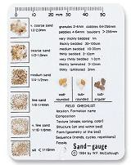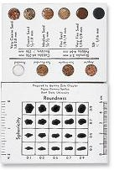

Sand Shaker with multiple size grids

[http://www.forestry-](http://www.forestry-suppliers.com/product_pages/View_Catalog_Page.asp?mi=31791&amp;title=Keck%2BSand%2BShaker&amp;itemnum) [suppliers.com/product_pages/View_Catalog_Page.asp?mi=31791&title=Keck+S](http://www.forestry-suppliers.com/product_pages/View_Catalog_Page.asp?mi=31791&amp;title=Keck%2BSand%2BShaker&amp;itemnum) [and+Shaker&itemnum](http://www.forestry-suppliers.com/product_pages/View_Catalog_Page.asp?mi=31791&amp;title=Keck%2BSand%2BShaker&amp;itemnum) $ 120.00

Three level sediment sorter.

 [http://www.delta-](http://www.delta-education.com/productsearch.aspx?search=sieve) [education.com/productsearch.aspx?search=sieve](http://www.delta-education.com/productsearch.aspx?search=sieve) $25.00

any rock and mineral identification guide

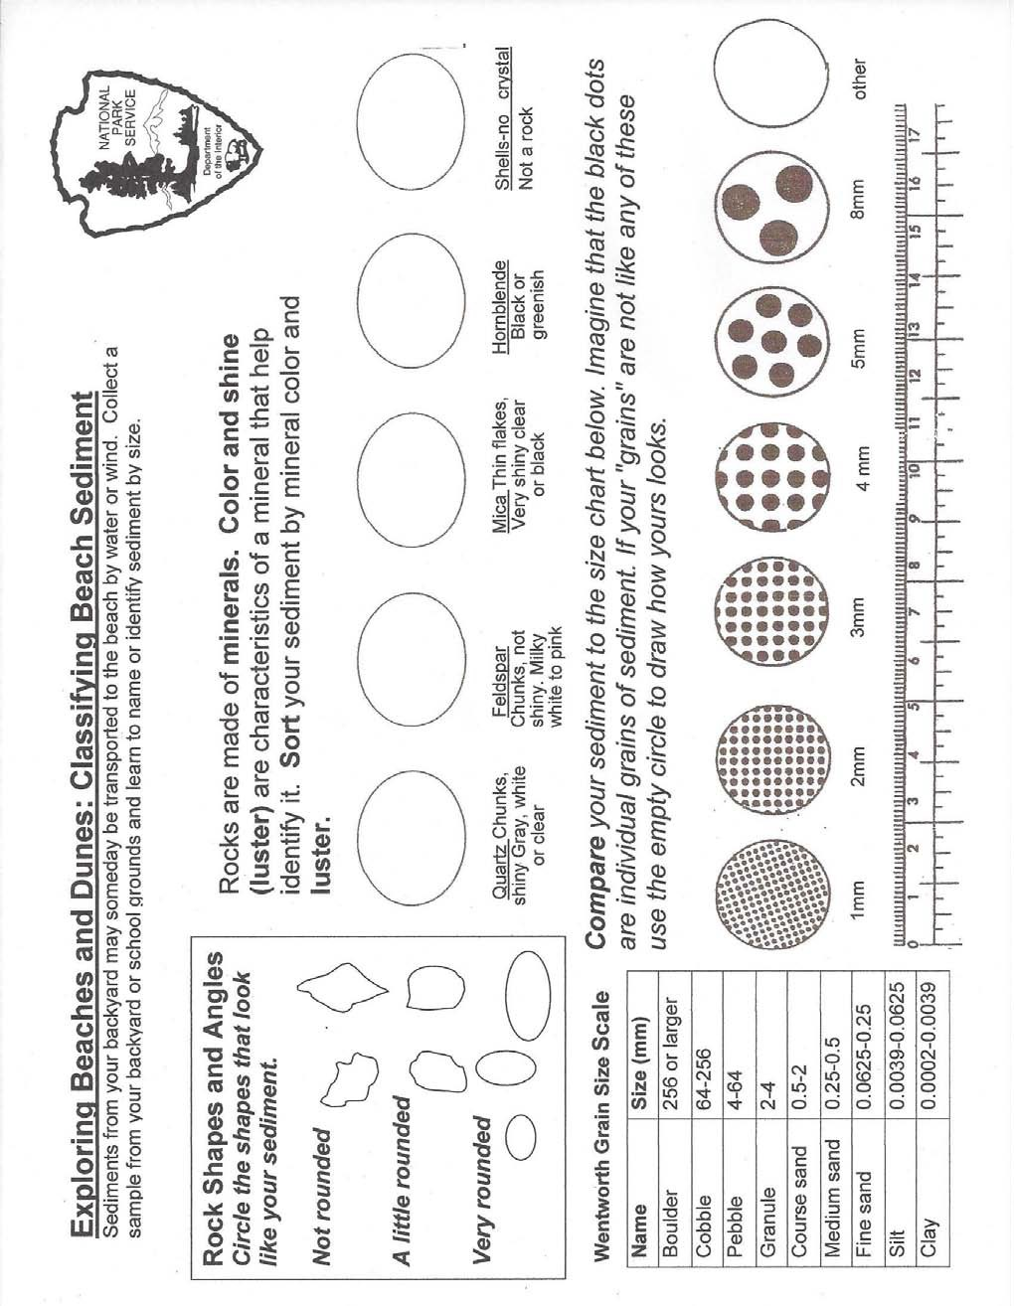

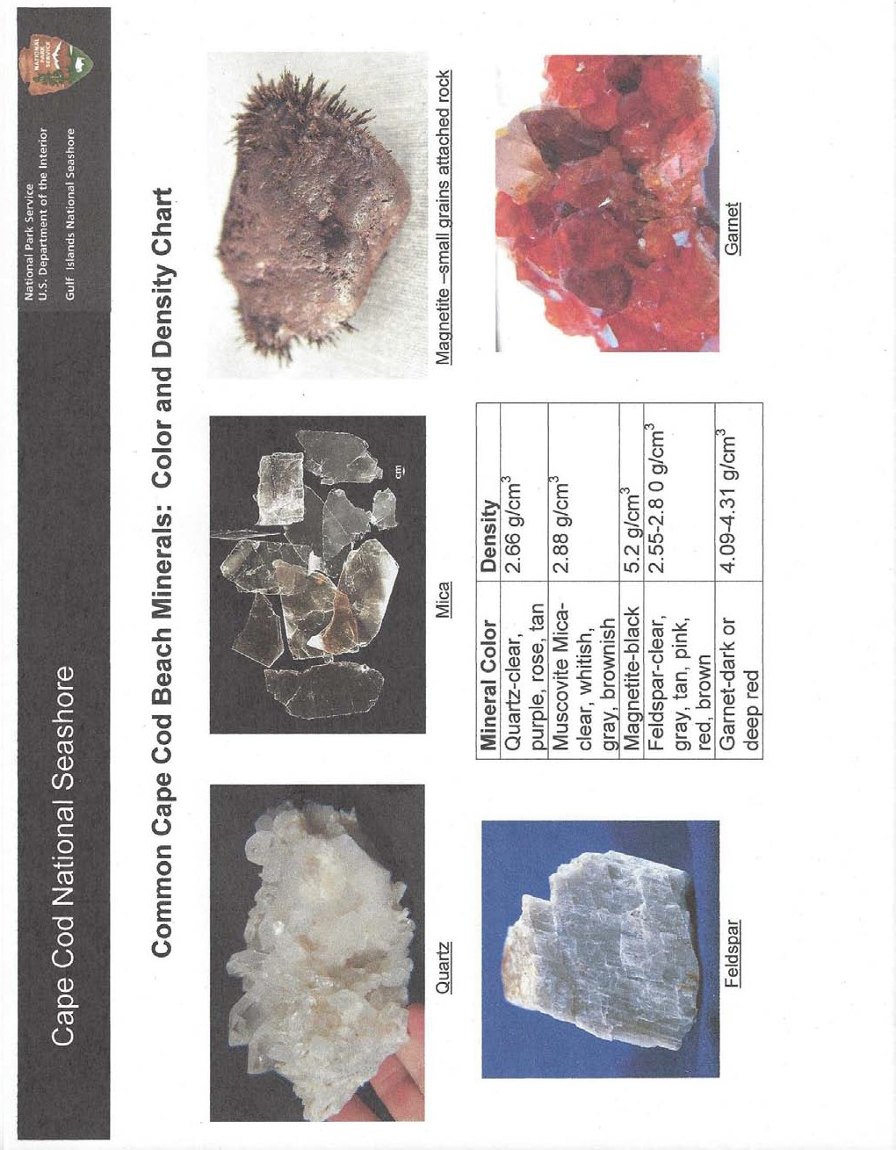

**Classroom Activity 2 Sediment in Suspension** (hands –on portion of activity can be done on the beach)

Duration: 30 minutes including 20 minute YouTube video, *Beach: A River of Sand*

## Background:

Moving water can suspend sediment in the water column. Currents then move the sediment (erosion) and can later deposit it (accretion) in another location. Scientists complete coastal vulnerability assessments to provide park and town mangers, and citizens information for planning where to build or remove structures, parking lots and stairways. Long term studies (100 plus years) of erosion rates on Cape Cod have resulted in average erosion rates/year. However, if using data from only the past 10 years, the rate of erosion per year is higher.

Managers and homeowners must keep in mind that any one storm can cause significant erosion in a single event.

## Objectives/Student Outcomes:

 Students will be able to describe: what is a river of sand is and how it includes both erosion and accretion functions.



Students will increase their understanding of sediment cycling on and off the beach. Students will increase their knowledge of the role sand bars play in breaking waves – decreasing energy before reaching beach in winter (by watching YouTube video link)

**Massachusetts Science and Technology Standards:** Earth Science:

## Prerequisites:

 Complete the Beaches in Motion-Coastal Vulnerability lesson (2 Powerpoints and the Sediment Classification Activity.)

 Watch YouTube video, *Beach: A River of Sand :*

[*http://www.youtube.com/watch?v=FqT1g2riQ30*](http://www.youtube.com/watch?v=FqT1g2riQ30)

 Important to have completed the SWASH reading and discussed the two figures at the end of the document: Figure 1-Short Term Change and Figure 2 -Cape Cod Seasonal Change.

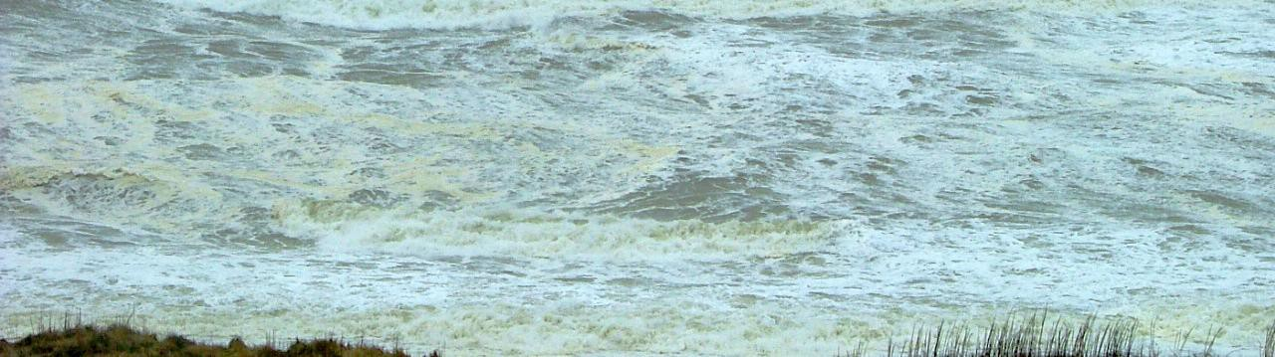

*Sediment in suspension:-the brownish tone is sand suspended in the moving water.*

## Materials and Tools:

 For each team of students: 2 liter size clear plastic soda bottles with caps. Fill bottles about ½ full with water.

 1/8 cup of different sized sediment samples from the sediment classifying activity. Example: clay, fine sand, course sand, and granules. Be sure granules or small pebbles can fit into soda bottles. Note-too much sediment produces poor demonstration results.

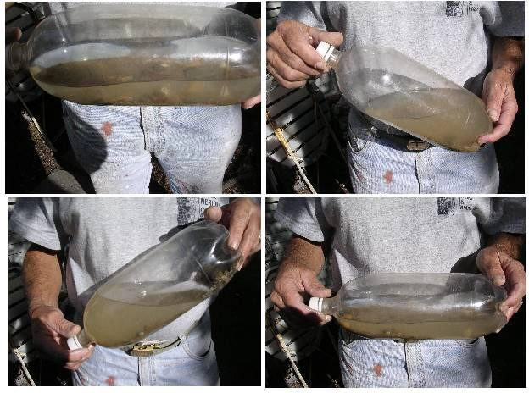

## What to Do and How to Do It:

Organize students into small work groups for the activities.

 Explain that they will simulate waves at the beach; they should observe carefully and

record observations.

* 1. Give each team a clear plastic liter soda bottle filled about 1/2 with water, and
  2. Students add sediment one size sediment at a time to the bottle. Put the cap on securely, and then tip the bottle horizontally.
  3. Gently agitate the bottle, students observe and record.
  4. Repeat with until some of each sediment size has been added.
  5. Change velocity of agitation, what happens?
  6. Ask students what other factors could affect sediment transport by waves: sediment size and shape (angulation), beach slope, wind direction and speed.

 Summarize student observations and relate to real life, every wave moves sediment around, the beach changes with every wave and every time the wind blows.

1. Discuss in relationship to sea level rise; how that would affect where people should build and the ways it affects how parks manage their beaches and facilities bear the beach.
2. Discuss how scientists measure changes on the beach.

## Student Assessment:

Teacher observation of student participating in the activity.

 Student can write a summary report of the experiment.

## Explore Further:

 Design and carry out experiments to measure sand transport by wind- erosion and accretion experiments.

## Resources:

<http://www.nature.nps.gov/geology/tour/index.cfm>

*At the Sea’s Edge*, William T. Fox, Prentice-Hall, 1983.

*Cape Cod and the Islands: The Geologic Story*, Robert Oldale, Parnassus Imprints, 1992.