CLASH OF THE TITANS

Booker T. Washington
and
W.E.B. DuBois

CURRICULUM-BASED EDUCATION PROGRAM
GRADE 11
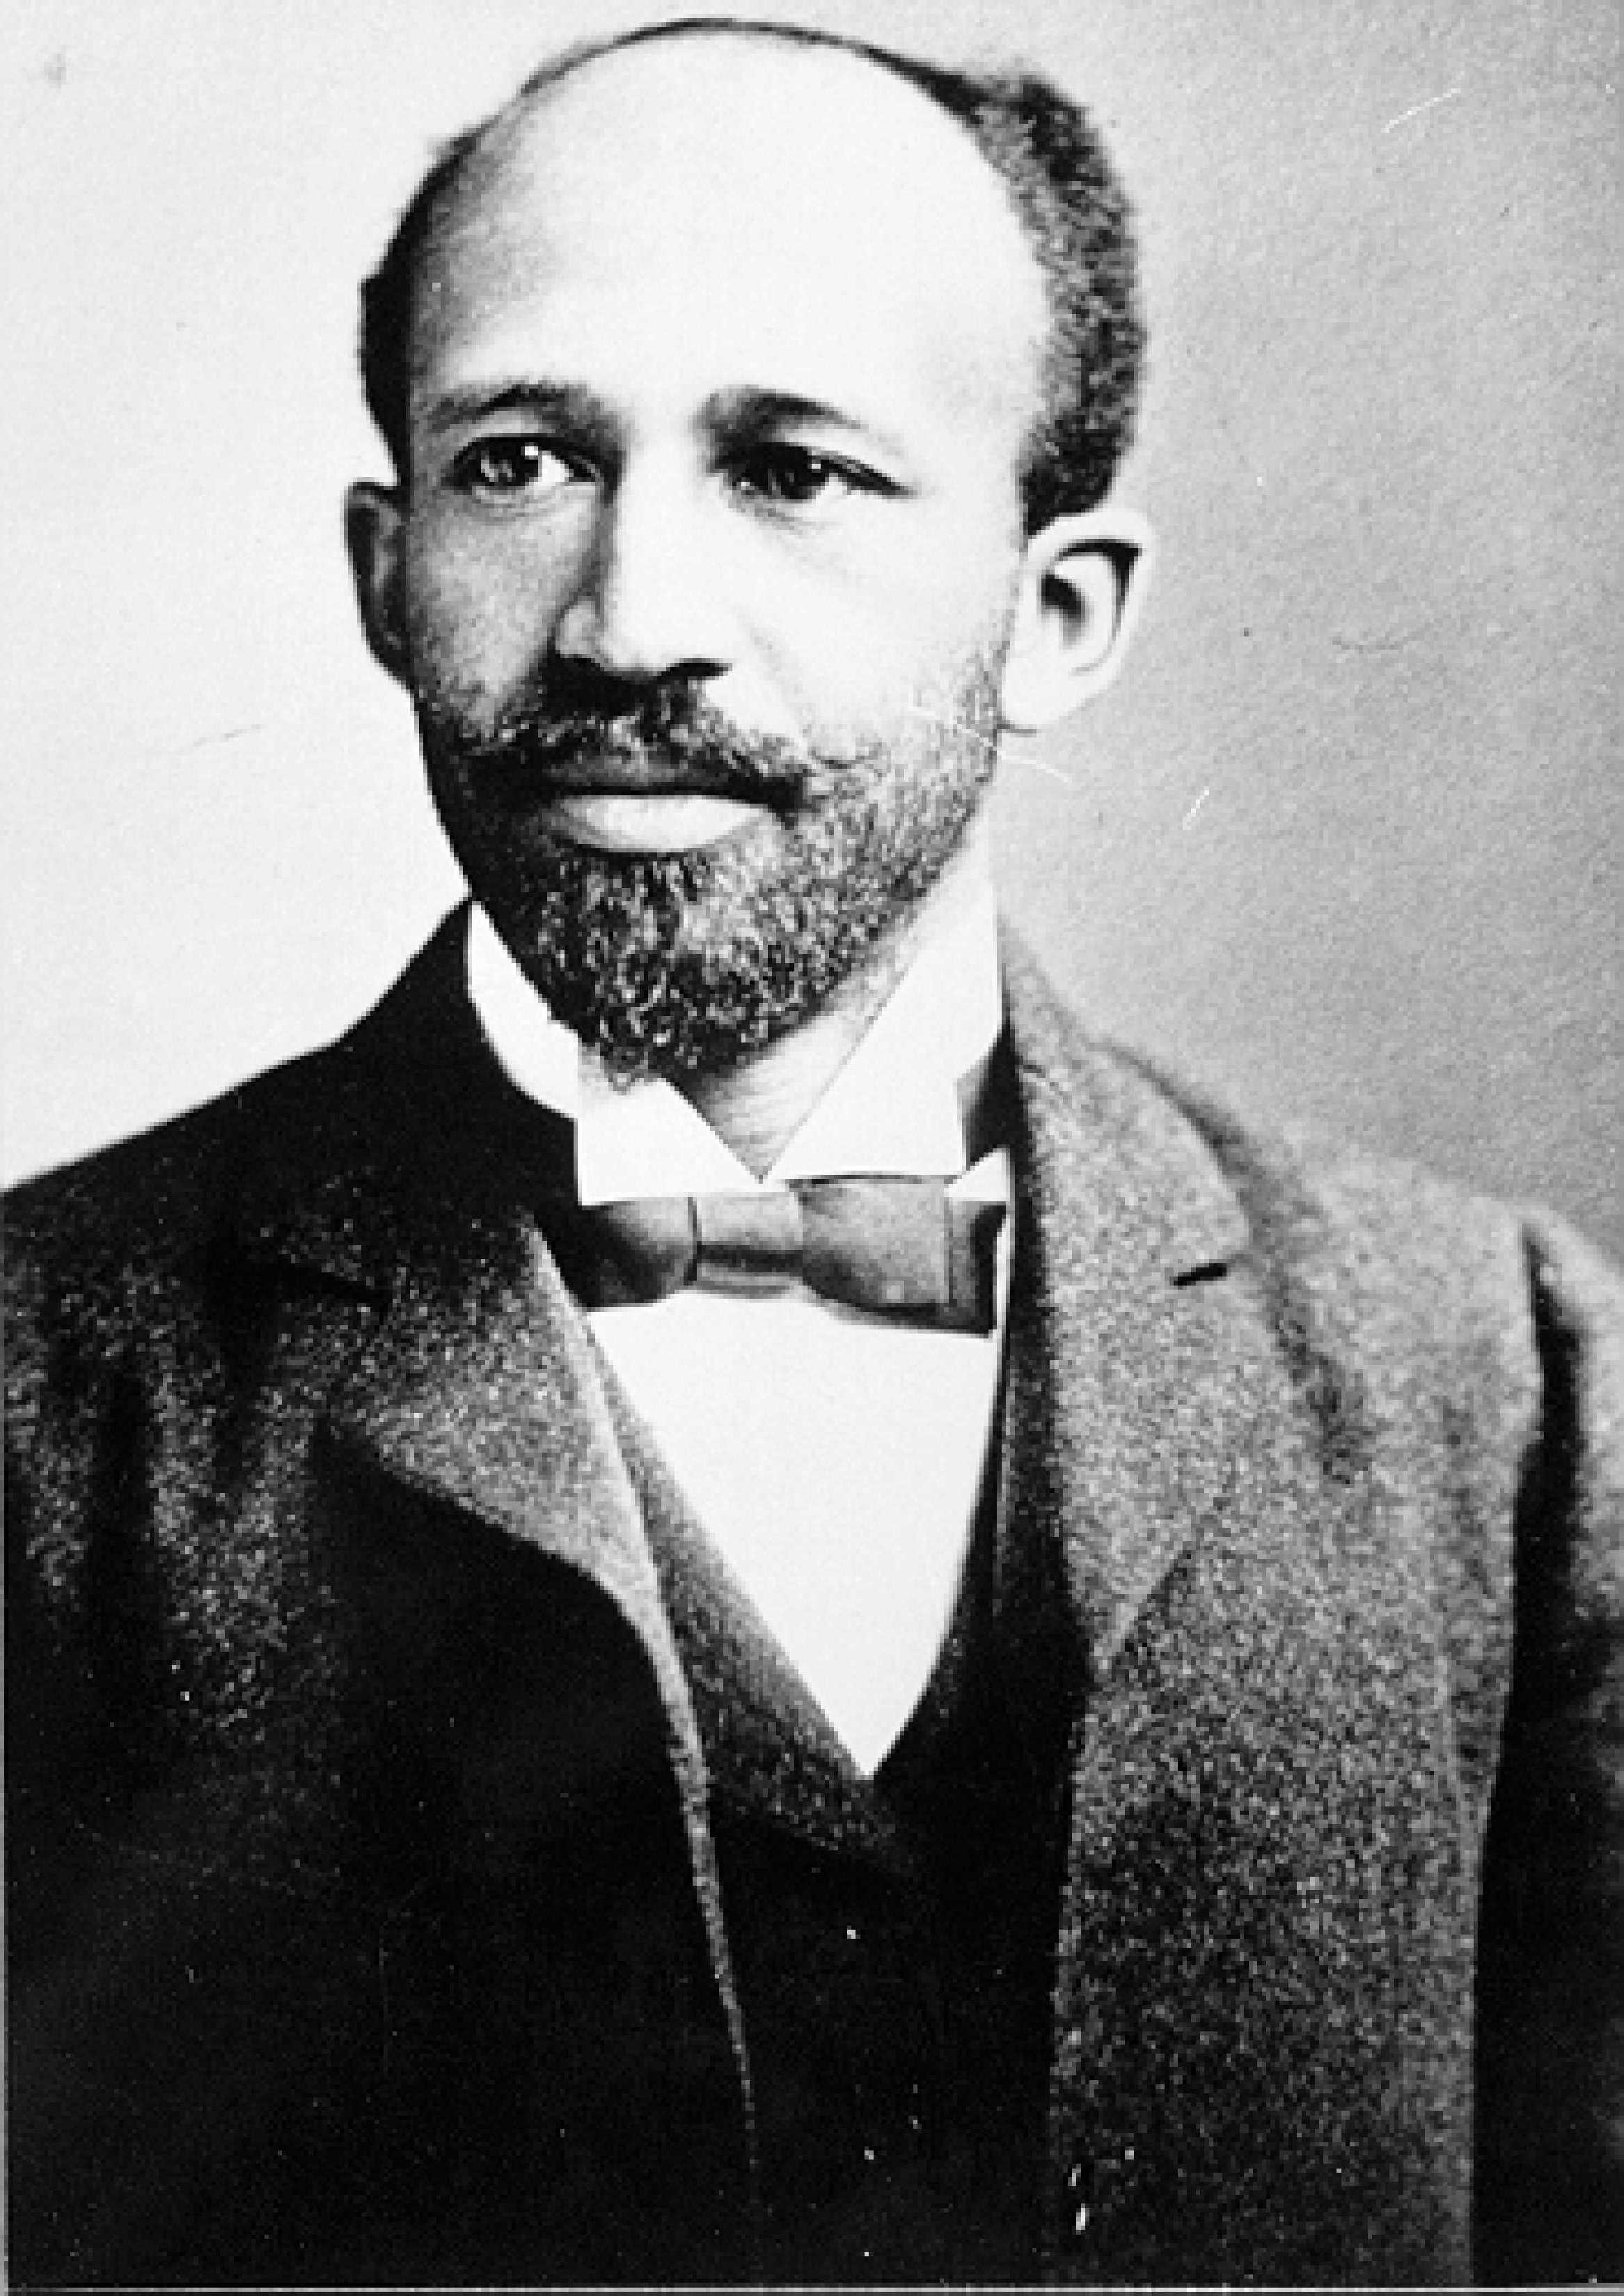
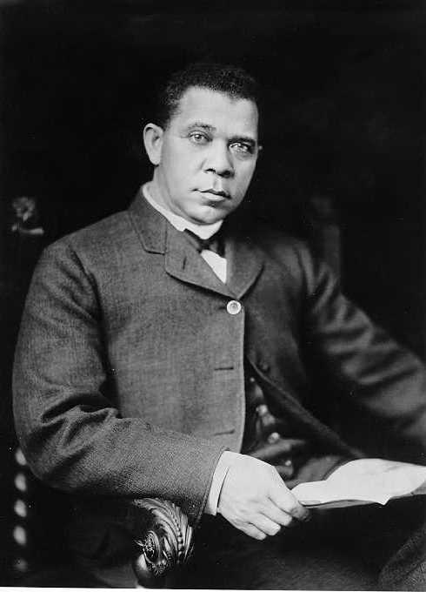

BOOKER T. WASHINGTON NATIONAL MONUMENT
HARDY, VIRGINIA
MISSION STATEMENT FOR EDUCATIONAL PROGRAM

It is the mission of Booker T. Washington National Monument's education program to satisfy the curriculum needs as specified in the Standards of Learning for Virginia Public Schools utilizing the park as a classroom. The programs and activities included in Booker T. Washington National Monument's Clash of the Titans educational packet are designed to meet these requirements while introducing students to the philosophical differences between Booker T. Washington and W.E. B. DuBois.

By engaging in classroom activities that are appropriate to their grade level, students will examine in depth Booker T. Washington and W.E.B. DuBois and gain insight into what motivated these men to act, in what they felt was the best interest of African Americans of the period.

The activities included in this packet enable students to investigate, research, and participate in meaningful learning experiences. They will build a strong foundation in communication skills, research techniques, computer skills, writing, and thinking in terms of multiple points of view.

At Booker T. Washington National Monument, students can learn about the cultural diversity that makes up Franklin County, Virginia. It is the hope of Booker T. Washington National Monument's educational staff that by learning about the past and the life of Booker T. Washington that we can evolve in our understanding of the context of race in American society.

11TH GRADE PROGRAM

THEME: Although Booker T. Washington was a nationally respected African American leader, there were many of his own race who opposed his views, especially W.E.B. DuBois.

GOALS:
- To learn Booker T. Washington's philosophy of education and his hopes for African Americans.

- To learn the philosophy of those who opposed him, especially W.E.B. DuBois.

- To understand how both of these men's philosophies contributed to the Civil Rights movement.

OBJECTIVES:
- Students will analyze Booker T. Washington's "Atlanta Address."

- Students will analyze W.E.B. DuBois' speech at Harpers Ferry, West Virginia. (1906)

- Students will compare the philosophies of Booker T. Washington with W.E.B. DuBois.

- Students will research Washington's and DuBois' points of view by using primary sources and computer technology.

- Students will compare the philosophies and styles of Washington and DuBois with the leaders of the Civil Rights movements from the 1950's to the present.

TABLE OF CONTENTS
FOR
11TH GRADE PROGRAM

The 11th grade program at Booker T. Washington National Monument is designed to compare and contrast Booker T. Washington and W.E.B. DuBois, the men and their philosophies. The program also includes an examination of these figures and their effects on the modern Civil Rights movement. There are eight suggested lesson plans that teachers can utilize as they teach students about the conflict between Washington and DuBois. A trip to Booker T. Washington National Monument is recommended for further study.

Standards of Learning for Virginia Public Schools that are met by the learning activities are history and social science 11.16, 11.17, and 11.18.

ACTIVITIES

- The Atlanta Address
Students will analyze the "Atlanta Address" and fill out a speech analysis form.

- "The Atlanta Exposition Address"

- Debate
Students will analyze the philosophies of Booker T. Washington and W.E.B. DuBois and argue which benefited African Americans more.

- DuBois' Thoughts on Washington
Students will analyze and discuss a critique of Mr. Washington by an African American contemporary, W.E.B. DuBois, then write reaction papers.

- Harpers Ferry Speech
Students will analyze the speech given by W.E.B. DuBois at Harpers Ferry and fill out a speech analysis form.

- Harpers Ferry Speech given at Storer College

- Interviews of Famous Americans
Students will research famous Americans that lived and influenced the era 1865-1915.

- Multimedia Presentation
Students will present to the class a multimedia presentation on
Booker T. Washington or W.E.B. DuBois.

- Panel Discussion
Students will analyze and discuss "Individual Responsibility."

- "Individual Responsibility"

- Persuasive Writing
Students will write a persuasive paper opposing or defending Booker T. Washington's educational philosophy.

- Booklist

- Obituary of Booker T. Washington

- Obituary of W.E.B. DuBois

- Unveiling Exercises of the Booker T. Washington Memorial

11TH GRADE ACTIVITY

DEBATE

Objective: Students will analyze the philosophies of Booker T. Washington and W.E.B. DuBois and argue which benefited African Americans more.

Subject: Social Studies

Materials: Research books, internet, paper, pencil

Procedure:

- Have students research the philosophies of Washington and DuBois.

- Have students research the history of the time period between 1895 and 1915. Find out what was going on in the country, especially in relationship to African Americans. Was the Civil Rights movement underway? How were African Americans treated during this period?

- Question for debate. Resolve: Booker T. Washington benefited African Americans of the late 19th and early 20th century more so than W.E.B. DuBois.

- Have students formally debate the issue.

- After the debate, discuss with students that even though both men had very different philosophies and ideas that they both contributed to the advancement of their race in their own way. Civil rights leaders that came after Washington and DuBois were influenced by both. Help the students see the multiple points of view.
11TH GRADE ACTIVITY

DUBOIS' THOUGHTS ON WASHINGTON

Objective: Students will analyze and discuss a critique of Mr. Washington by an African American contemporary, W.E.B. DuBois, then write a reaction paper.

Subjects: Social Studies

Materials: A copy of The Souls of Black Folks by W.E.B. DuBois, pencil, and paper

Procedure:

- Have students read the chapter from The Souls of Black Folks called "Of Mr. Booker T. Washington and Others."

2. Divide the class into small groups to answer questions and discuss the article.

3. Have students answer the following questions:
A. Who was W.E.B. DuBois?
- Why is Booker T. Washington considered the national leader and spokesman for his race?
- What does DuBois consider a "dangerous thing?"
- What is the Revolution of 1876 according to Mr. DuBois?
- DuBois says that Washington "gives up much of what Negroes should demand." List the three things that DuBois feels is important that he says Washington gives up.
- What had happened in the last 15 years (1888-1903) to African Americans?
- Describe DuBois' two classes of colored Americans.
- What does DuBois see as the solution to these problems?
- According to DuBois what is the distinct impression left by Mr. Washington's propaganda?
- How does DuBois feel that the problems of the Negro can be resolved?

- After students have analyzed and discussed thoroughly, have them write a reaction paper about the critique of Mr. Washington. Do they feel that DuBois' criticisms are valid or not? Have them research more about the time period if they are not familiar with the treatment of African Americans at that time. Stress that they should consider the times and not just view these criticisms through modern eyes.
11TH GRADE ACTIVITY

HARPERS FERRY SPEECH

Objective: Students will analyze the speech given at Harpers Ferry and fill out a speech analysis form.

Subject: Social Studies

Materials: Speech analysis form, copy of the speech given at Harpers Ferry at Storer College, paper, and pencil.

Procedure:

- Direct students to make a speech analysis form. The form should include:
- Who is making the speech?
- What is the topic of the speech?
- When and where was the speech made?
- List the key ideas of the speech.
- Tell whether the speech is informational or persuasive.

- Have students research the following questions:
- What was the Niagara Movement? When was it founded?
- Why was the Niagara Movement founded?
- Who were members of the Niagara Movement?
- Why did the Niagara Movement meet in Harpers Ferry, West Virginia? What was the significance?
- What was happening to African Americans within the time frame 1895-1906?
- Why were these ideas set down by DuBois considered militant?
- Who was the nationally recognized leader of African Americans in 1906?
- Would he have agreed or disagreed with this speech? Why or why not?
SPEECH GIVEN AT HARPERS FERRY
BY W.E.B. DUBOIS
AT STORER COLLEGE
AUGUST, 1906
FOR A MEETING OF THE NIAGARA MOVEMENT

The men of the Niagara Movement, coming from the toil of the year's hard work, and pausing a moment from the earning of their daily bread, turn toward the nation and again ask in the name of ten million the privilege of a hearing. In the past year the work of the Negro hater has flourished in the land. Step by step the defenders of the rights of American citizens have retreated. The work of stealing the black man's ballot has progressed and fifty and more representatives of stolen votes still sit in the nation's capital. Discrimination in travel and public accommodation has so spread that some of our weaker brethren are actually afraid to thunder against color discrimination as such and are simply whispering for ordinary decencies.
Against this the Niagara Movement eternally protests. We will not be satisfied to take one jot or tittle less than our full manhood rights. We claim for ourselves every single right that belongs to a freeborn American, political, civil, and social; and until we get theses rights we will never cease to protest and assail the ears of America. The battle we wage is not for ourselves alone, but for all true Americans. It is a fight for ideals, lest this our common fatherland, false to its founding, become in truth the land of the Thief and the home of the Slave - a by word and a hissing among the nations for its sounding pretensions and pitiful accomplishment.
Never before in the modern age has a great and civilized folk threatened to adopt so cowardly a creed in the treatment of its fellow-citizens, born and bred on its soil. Stripped of verbiage and subterfuge and in its naked nastiness, the new American creed says: Fear to let black men even try to rise lest they become the equals of the white. And this in the land that professes to follow Jesus Christ. The blasphemy of such a course is only matched by its cowardice.
In detail our demands are clear and unequivocal. First, we would vote; with the right to vote goes everything: freedom, manhood, the honor of our wives, the chastity of our daughters, the right to work, and the chance to rise, and let no man listen to those who deny this.
We want full manhood suffrage, and we want it now, henceforth and forever.
Second. We want discrimination in public accommodation to cease. Separation in railway and street cars, based simply on race and color, is un-American, undemocratic and silly. We protest against all such discrimination.
Third. We claim the right of freemen to walk, talk and be with them who wish to be with us. No man has a right to choose another man's friends, and to attempt to do so is an impudent interference with the most fundamental human privilege.
Fourth. We want the laws enforced against rich as well as poor; against Capitalist as well as Laborer; against white as well as black. We are not more lawless than the white race, we are more often arrested, convicted and mobbed. We want justice even for criminals and outlaws. We want the Constitution of the country enforced. We want Congress to take charge of the Congressional elections. We want the Fourteenth Amendment carried out to the letter and every State disfranchised in Congress which attempts to disfranchise its rightful voters. We want the Fifteenth Amendment enforced and no State allowed to base its franchise simply on color.
Fifth. We want our children educated. The school system in the country districts of the South is a disgrace and in few towns and cities are the Negro schools what they ought to be. We want the national government to step in and wipe out illiteracy in the South. Either the United States will destroy ignorance, or ignorance will destroy the United States.
And when we call for education, we mean real education. We believe in work. We ourselves are workers, but work is not necessarily education. Education is the development of power and ideal. We want our children trained a intelligent human beings should be and we will fight for all time against any proposal to educate black boys and girls simply as servants and underlings, or simply for the use of other people. They have a right to know, to think, to aspire.
These are some of the chief things which we want. How shall we get them? By voting where we may vote; by persistent, unceasing agitation; by hammering at the truth; by sacrifice and work.
We do not believe in violence, neither in the despised violence of the raid nor the lauded violence of the soldier, nor the barbarous violence of the mob; but we do believe in John Brown, in that incarnate spirit of justice, that hatred of a lie, that willingness to sacrifice money, reputation, and life itself on the altar of right. And here on the scene of John Brown's martyrdom, we reconsecrate ourselves, our honor, our property to the final emancipation of the race which John Brown died to make free.

Source: The Autobiography of W.E.B. DuBois a Soliloquy on Viewing My Life
11th GRADE ACTIVITY

MULTIMEDIA PRESENTATION

Objective: Students will present to the class a multimedia presentation on Booker T. Washington or W.E.B. DuBois.

Subject: Social Studies

Materials: Computers that have multimedia programs, video camera, slides, camera, varying types of materials depending on what you have available.

Procedure:

- This activity is going to depend on the type of technology that you have available. Some will have access to computers on which a multimedia presentation can be constructed. Some may have Windows and access to a program such as Microsoft Office Power Point that can be used. Others can use varying types of media such as video cameras, slides, posters, recordings of music, or mobiles.

- Students will choose to work on either Booker T. Washington or W.E.B. DuBois.

- Research your person. Since students are working on this individually, you may only want to take one aspect of the subject's life for the presentation. For example, Booker T. Washington's 1895 "Atlanta Address."

- Put together a presentation using varying media.

- Present your project to the class.
11TH GRADE ACTIVITY

PANEL DISCUSSION

Objective: Students will analyze and discuss "Individual Responsibility."

Subject: Social Studies

Materials: A copy of "Individual Responsibility," * paper, pencil, video camera (optional)

Procedure:

- Have students read "Individual Responsibility."

- After reading "Individual Responsibility," have students answer the following questions:
- Who do your actions affect?
- Who are the people who are happy?
- What is an essential habit?
- Who can you hurt when you fail a subject?
- What is the world looking for?
- The world has little patience with what?
- How does Mr. Washington feel about a person's luck?
H. Is what Mr. Washington said relevant to today's youth? Why or why not?

- Have students write down what they think individual responsibility means to them and those around them.

- Hold a panel discussion on how a person's individual responsibility can affect others and the world around them. How can individual responsibility have a positive or negative impact on our society? Examples: Crime, school shootings, and lack of respect for those around us.

- Optional - Video tape the panel discussion and make it available to other classes to watch and discuss.

*This is a chapter from the book, Character Building, by Booker T. Washington published in 1902.
INDIVIDUAL RESPONSIBILITY
By
Booker T. Washington

I have referred in a general way, before this, when I have been speaking to you, to the fact that each one of you ought to feel an interest in whatever task is set you to do here over and above the mere bearing which that task has on your own life. I wish to speak more specifically to-night on this subject - on what I may term the importance of your feeling a sense of personal responsibility not only for the successful performance of every task set you, but for the successful outcome of every worthy undertaking with which you come in contact.
You ought to realize that your actions will not affect yourselves alone. In this age it is almost impossible for a man to live for himself alone. On every side our lives touch those of others; their lives touch ours. Even if it were possible to live otherwise, few would wish to. A narrow life, a selfish life, is almost sure to be not only unprofitable but unhappy. The happy people and the successful people are those who go out of their way to reach and influence for good as many persons as they can. In order to do this, though, in order best to fit one's self to live this kind of life, it is important that certain habits be acquired; and an essential one of these is the habit of realizing one's responsibility to others.
Your actions will affect other people in one way or another, and you will be responsible for the result. You ought always to remember this, and govern yourselves accordingly. Suppose it is the matter of the recitation of a lesson, for instance. Some one may say: "It is nobody's business but my own if I fail in a recitation. Nobody will suffer but me." This is not so. Indirectly you injure your teacher also, for while a conscientious, hard-working teacher ought not to be blamed for the failures of pupils who do not learn simply because they do not want to, or are too lazy to try, it is generally the case that a teacher's reputation gains or loses as his or her class averages high or low. And each failure in recitation, for whatever cause, brings down the average. Then, too, you are having an influence upon your classmates, even if it be unconscious. There is hardly ever a student who is not observed by some one at some time as an example. "There is such a boy," some other student says to himself. "He has failed in class ever so many times, and still he gets along. It can't make much difference if I fail once." And as a result he neglects his duty, and does fail.
The same thing is true of work in the industrial departments. Too many students try to see how easily they can get through the day, or the work period, and yet not get into trouble. Or even if they take more interest than this, they care for their work only for the sake of what they can get out of it for themselves, either as pay, or as instruction which will enable them to work for pay at some later time. Now there ought to be a higher impulse behind your efforts than that. Each student ought to feel that he or she has a personal responsibility to do each task in the very best manner possible. You owe this not only to your fellow-students, your teachers, the school, and the people who support the institution, but you owe it even more to yourselves. Your owe it to yourselves because it is right and honest, because nothing less than this is right and honest, and because you never can be really successful and really happy until you do study and work and live in this way.
I have been led to speak specifically on this subject to-night on account of two occurrences here which have come to my notice. One of these illustrates the failure on the part of students to feel this sense of responsibility to which I have referred. The other affords an illustration of the possession by a student of a feeling of personal interest and personal responsibility which has been very gratifying and encouraging. The first incident, I may say occurred some months ago. It is possible that the students who were concerned in it may not be here now or, if they are, that it would not happen again. I certainly hope not.
A gentleman who had been visiting here was to go away. He left word at the office of his wish, saying that he planned to leave town on the five o'clock train in the afternoon. A boy was sent from the office early in the afternoon with a note to the barn ordering a carriage to take this gentleman and his luggage to the station. Half-past four came, and the man had his luggage brought down to the door of the building in which he had been staying, so as to be ready when the team came. But no team came. The visitor finally became so anxious that he walked over to the barn himself. Just as he reached the barn he met the man who was in charge there with the note in his hand. The note had only just that moment reached this man, and of course no carriage had been sent because the first person who felt that he had any responsibility in the matter had only just learned that a carriage was wanted. The boy who had brought the note had given it to another boy and he to someone else, and he, perhaps, to someone else. At any rate it had been delayed because no one had taken enough interest in the errand to see that whatever business the note referred to received proper attention. This occurred, as I have said, several months ago, before the local train here went over to Chehaw to meet all of the trains. It happened that this particular passenger was going north, and it was possible by driving to Chehaw for him to get there in time to take the north-bound train. If he had been going the other way, though, towards Montgomery, he would have lost the train entirely, and, as chanced to be the case, would have been unable to keep a very important engagement. As it was, he was obliged to ride to Chehaw in a carriage, and the time of a man and team, which otherwise would have been saved, was required to take him there.
Now when such a thing as this happens, no amount of saying, "I am sorry," by the person or persons to blame, will help the matter any. It is too late to help it then. The thing to do is to feel some responsibility in seeing that things are done right yourself. Take enough interest in whatever you are engaged in to see that it is going to come out in the end just as nearly right, just as nearly perfect, as anything you can do will go towards making it right or perfect. And if the task or errand passes our of your hands before it is completed, do not feel that your responsibility in the matter ends until you have impressed it upon the minds and heart of the person to whom you turn over the further performance of the duty.
The world is looking for men and women who can tell one why they can do this thing or that thing, how a certain difficulty was surmounted or a certain obstacle removed. But the world has little patience with the man or woman who takes no real interest in the performance of a duty, or who runs against a snag and gets discouraged, and then simply tells why he did not do a thing, and gives excuses instead of results. Opportunities never come a second time, nor do they wait for leisure. The years come to us but once, and they come then only to pass swiftly on, bearing the ineffaceable record we have put upon them. If we wish to make them beautiful years of profitable years, we must do it moment by moment as they glide before us.
The other case to which I have referred is pleasanter to speak about. One day this spring, after it had got late enough in the season so that it was not as a general thing necessary to have fires to heat our buildings, a student passing Phelps Hall noticed that there was a volume of black smoke pouring out of one of the chimneys there. Some boys might not have noticed the smoke at all; others would have said that it came from the chimney; still others would have said that it was none of their business anyway, and would have gone along. This boy was different. He noticed the smoke, and although he saw, or thought he saw that it came from the chimney, and if so was probably no sign of harm, he felt that any smoke at all there at that time was such an unusual thing that it ought to be investigated for fear it might mean danger to the building. He was not satisfied until he had gone into the building and had inspected every floor clear up to the attic, to see that chimney and the building were not in danger. As it happened, the janitor had built a fire in the furnace in the basement for some reason, so that the young man's anxiety fortunately was unfounded, but I am heartily glad he had such an anxiety, and that he could not rest until he found our whether there was any foundation for it or not. I shall feel that all of our buildings are safer for his being here, and when he graduates and goes away I hope he will leave many others here who will have the same sense of personal responsibility which he had. Let me tell you, here and now, that unless you young men and young women come to have this characteristic, your lives are going to fall far short of the best and noblest achievement possible.
We frequently hear the word "lucky" used with reference to a man's life. Two boys start out in the world at the same time, having the same amount of education. When twenty years have passed, we find one of them wealthy and independent; we find him a successful professional man with an assured reputation, or perhaps at the head of a large commercial establishment employing many men, or perhaps a farmer owning and cultivating hundreds of acres of land. We find the second boy, grown now to be a man working for perhaps a dollar or a dollar and a half a day, and living from hand to mouth in a rented house. When we remember that the boys started out in life equal-handed, we may be tempted to remark that the first boy has been fortunate, that fortune has smiled on him; and that the second has been unfortunate. There is no such nonsense as that. When the first boy saw a thing that he knew he ought to do, he did it; and he kept rising from one position to another until he became independent. The second boy was an eye-servant who was afraid that he would do more than he was paid to do - he was afraid that he would give fifty cents' worth of labour for twenty-five cents. He watched the clock, for fear that he would work one minute past twelve o'clock at noon and past six o'clock at night. He did not feel that he had any responsibility to look out for his employer's interests. The first boy did a dollar's worth of work for fifty cents. He was always ready to be at the store before time; and then, when the bell rang to stop work, he would go to his employer and ask him if there was not something more that ought to be done that night before he went home. I was this quality in the first boy that made him valuable and caused him to rise. Why should we call him "fortunate" or "lucky?" I think it would be much more suitable to say of him: "He is responsible."

BOOKLIST

Ayers, Edward L., The Promise of the New South. Oxford University Press, NY, 1992.

Denton, Virginia Lantz, Booker T. Washington and the Adult Education Movement. University Press of Florida, 1993.

DuBois, W.E.B., The Souls of Black Folk. Penguin Books, NY, 1989.

Franklin, John Hope and Meier, August (ed.), Black Leaders of the Twentieth Century. University of Illinois Press, Chicago, 1982.

Harlan, Louis R., Booker T. Washington, the Wizard of Tuskegee, 1901-1915. Oxford University Press, 1983.

Harlan, Louis R., The Making of a Black Leader, 1856-1901. Oxford University Press, NY, 1972.

King, Wilma, Stolen Childhood Slave Youth in Nineteenth-Century America. Indiana University Press, Bloomington, IN, 1995.

Lewis, David Levering, W.E.B. DuBois Biography of a Race, 1868-1919. Henry Holt and Company, NY, 1993.

Lewis, David Levering (ed.), W.E.B. DuBois a Reader. Henry Holt and Company, NY, 1995.

Loewen, James W., Lies My Teacher Told Me. Simon and Schuster, NY, 1996.

Mackintosh, Barry, Booker T. Washington An Appreciation of the Man and his Times.
National Park Service, 1972.

Paschal, Andrew (ed.), W.E.B. DuBois a Reader. Macmillan Publishing Co., NY, 1971.

Washington, Booker T., Up From Slavery. Penguin Books, NY, 1986.

