WAR ON THE HOME FRONT

CURRICULUM-BASED EDUCATION PROGRAM
GRADES 4-6

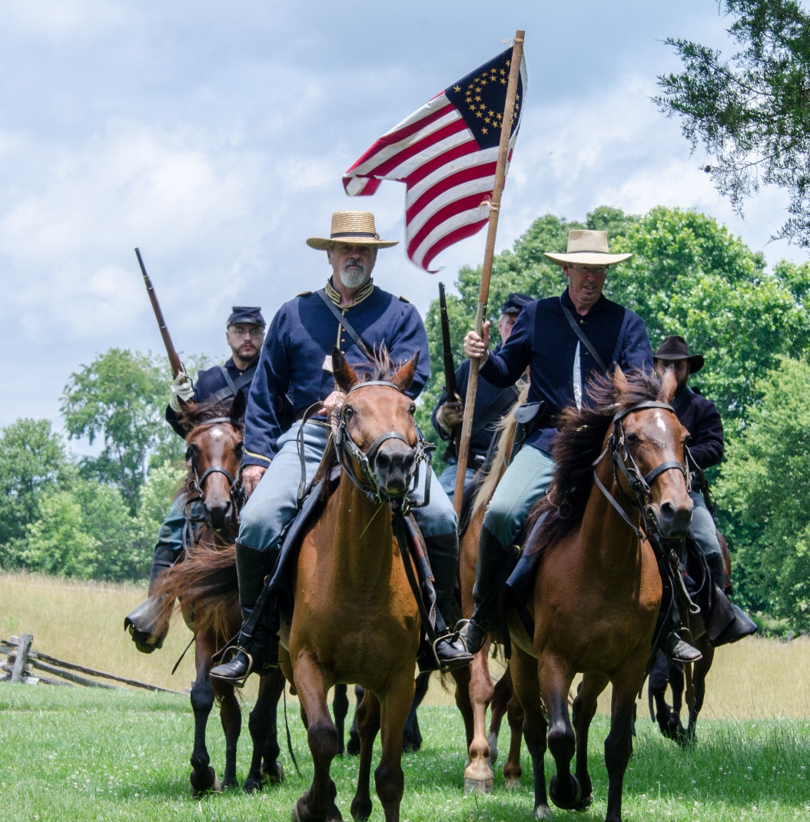
Photo Credits: Bill Tucker

BOOKER T. WASHINGTON NATIONAL MONUMENT
HARDY, VIRGINIA

MISSION STATEMENT FOR EDUCATIONAL PROGRAM

It is the mission of Booker T. Washington National Monument's education program to satisfy the curriculum needs as specified in the Standards of Learning for Virginia Public Schools and Common Core standards utilizing the park as a classroom. The programs and activities included in Booker T. Washington National Monument's War on the Home Front educational packet are designed to meet these requirements.
The activities included in this packet enable students to investigate, research, and participate in meaningful learning experiences. They will build a strong foundation in communication skills, research techniques, computer skills, writing, and thinking in terms of multiple points of view.
At Booker T. Washington National Monument, students can learn about the cultural diversity that makes up Franklin County, Virginia. It is the hope of Booker T. Washington National Monument's educational staff that by learning about the past and the life of Booker T. Washington that we can broaden our understanding of the context of race in American society.

WAR ON THE HOMEFRONT

CURRICULUM-BASED EDUCATION PROGRAM FOR GRADES 4-6

THEME: The Civil War and its outcomes were life-changing events for all the people, both free and enslaved, who were associated with the Burroughs Plantation from 1850 – 1865.

GOALS: To educate students about –

- Life on a piedmont Virginia, slaveholding tobacco farm
- National debate on slavery/Differences between North and South
- Why the war was fought
- How the enslaved and their owners reacted to the war
- How each group was affected after the war

OBJECTIVES: To develop the students understanding of the following –

- Definition of slavery
- What life was like on a piedmont Virginia, slaveholding tobacco farm
- The primary reason why the Civil War was fought
- How the war affected the enslaved and the slaveowners
- Booker T. Washington’s memory of the moment of emancipation
- What happened following emancipation for Freedmen and former slave owners

TABLE OF CONTENTS
"WAR ON THE HOME FRONT”
Learning Activities for Students Grades 4-5
"War on the Home Font" is a unit of activities designed to introduce students to the impact of the Civil War, especially as it affected those living on the Burroughs plantation.
Pre-Visit Activities
- Vocabulary
Students will become familiar with the terms used in activities and on their trip.
- Key Terms, People and Events
Students will become familiar with key terms, people, and events that they will hear on their trip to the Booker T. Washington National Monument.
- Map Activity – Civil War
Students will label a map identifying Union states, Confederate states, border states, and territories. Map – U.S. by 1861 – Duplicate for Map Activity
Map – U.S. by 1861 – Key for Map Activity

- Civil War Passage and Graphic Organizer
Students will become familiar with the main ideas and concepts of the Civil War.
5. Measure of a Man
Students will become familiar with Booker T. Washington and his life

Post-Visit Activities
1. Born Here, Freed Here (Comparing and Contrasting Activity)
Through discussion students will compare and contrast the relationships between slaveholder and slave before and after the Civil War.
2. Journal Entry
Students will write a journal entry describing their life at home during the civil war

3. Civil War Events Project and Presentation
Students will research and present a project dealing with events or people important to the Civil War era.

4. Timeline
Students will create a classroom timeline from 1850-1865.

5. Compare and Contrast
Students will compare and contrast the resources of the North and South.

6. Point of View
Students will compare and contrast the men's point of view of the Civil War to the women's point of view of the war on the Burroughs plantation.

Pre-Visit Activity

1. VOCABULARY
Objective: Students will become familiar with terms that they will hear on their trip to the Booker T. Washington National Monument.

SOL Objectives:
English: 4.1, 4.2, 4.4, 5.4, 5.7
History: VS.1, VS.7
Materials: Vocabulary list

Procedure: Use the following list to familiarize students with terms that will be used on their trip.
- plantation: a large farm where a cash crop is planted and grown to sell
- "big house": the house where the owners of the plantation lived
- emancipation: freedom, especially of the slaves in the United States
- slavery: the owning or keeping of slaves as a practice or institution; slaveholding
- cash crop: plants that are grown to sell for a profit
- grapevine telegraph: an oral form of communication in slave culture in which news spread rapidly among slaves from plantation to plantation
- agrarian: relating to the land; relating to the cultivation or ownership of land
- property: something that is owned by someone
- casualty: a soldier who is lost during active service, especially through being killed, wounded, or captured
- indentured servitude: a contract to work for a person for a certain number of years, usually to pay for passage to the New World; at the end of the contract these servants are free
- industrial: having to do with industries; relating to factories or the work, products, or people within
- insurrection: a rising up against established authority; rebellion; revolt
- territory: a part of the United States having its own legislature but without the status of a State and under the administration of an appointed governor
- secession: the withdrawal of 11 states from the United States of America in 1860 and 1861; being about the Confederate States of America and the American Civil War

Suggested Activities and Strategies
- Flash cards
- Jeopardy
- Who Wants to be A Millionaire
- Paragraph Writing
- Web Quest

Pre-Visit Activity

2. KEY TERMS, PEOPLE, AND EVENTS

Objective: Students will become familiar with key terms, people, and events that they will hear on their trip to the Booker T. Washington National Monument.
SOL Objectives:
English: 4.1, 4.2, 4.4, 5.4, 5.7
History: VS.1, VS.7
Materials: Key terms, people, dates and events list

- Slaveholder: an owner of another human being who is used as personal property
- Abolitionist: a person who works toward ending slavery in the United States
- John Rolfe: English colonist who introduced tobacco to the settlers of Jamestown
- Nat Turner: American leader of a slave rebellion in Southampton, Virginia
- Abraham Lincoln: the sixteenth President of the United States; also President during the American Civil War who issued the Emancipation Proclamation
- John Brown: American abolitionist leader who seized Harpers Ferry, Virginia in 1859
- Alexander Stevens: Vice President of the Confederate States of America
- American Civil War (1861 – 1865): the war fought between the Union and the Confederacy
- Emancipation Proclamation: the document issued by President Lincoln, which became official on January 1, 1863, that was supposed to free the slaves in the Confederate states
- Underground Railroad: an organized system of “conductors” and safe houses that helped runaway slaves escape to the North
- 13th Amendment: the amendment to the Constitution in which slavery is ended
- Union: the side of the United States during the Civil War; the North
- Confederate: the side of the South during the Civil War; Rebels

Suggested Activities and Strategies
- Flash cards
- Jeopardy
- Who Wants to be A Millionaire
- Paragraph Writing
- Web Quest

Pre-Visit Activity
3. CIVIL WAR Reading Passage with GRAPHIC ORGANIZER

Objective: Students will become familiar with main ideas and concepts of the Civil War.

SOL Objectives:
English: 4.1, 4.2, 5.1, 5.6, 5.6
History: VS.7
Materials: Pencil, Graphic Organizer, Civil War Essay

Procedures:
- The students will read the Civil War essay or the teacher will read it aloud to students.
- The students will discuss the main ideas and concepts of the Civil War.
- The students will complete the graphic organizer.

Civil War Essay

In 1861, several issues ignited the Civil War: state’s rights, the role of the federal government, the preservation of the Union, the economy; but all were connected to the institution of slavery. The main questions confronting Congress and American people were whether slavery should exist in the United States and/or be extended in new states and U.S. territories. People in different parts of the country had opposing views about the issue of slavery which resulted in conflict and the division of the country between the northern and southern states.

Slavery was not the only source of dispute. The North and South were very different in nature and wanted different things from their government. The North was becoming industrialized and had abundant inexpensive labor through increased immigration and women who had left farms for work in the cities. Industrialization increased textile production and raised the demand for more cotton picked by enslaved people in the South.

The South remained agricultural with many large plantations that relied heavily on slave labor and cheap European imports. Southerners began to fear that if the North ever gained control in Congress, it would create taxes on imports, known as tariffs, that would ruin the South’s economy. Southerners began to rely on the idea of states’ sovereignty or “rights” as a means of self-protection, which affected their position on slavery.

After a series of events, such as Nat Turner’s Rebellion, the Compromise of 1850, John Brown’s Raid, and the election of 1860, southern states decided to secede from the Union and form their own government known as the Confederacy, or the South. They elected Jefferson Davis as their President. Abraham Lincoln had won the election of 1860 and was the President of the United States, known as the North during the Civil War.

Unable to resolve the issue of slavery by peaceful means, the North and South went to war. The Civil War lasted from 1861-1865. At first, Lincoln insisted the conflict was about the effort to preserve the Union. As the war continued, the destruction of slavery became the moral objective of the North as President Lincoln issued the Emancipation Proclamation on January 1, 1863.

When the war ended in 1865, over 620,000 people had died. It brought relief and reunited the states as one country, but many divisions and problems remained. Nearly 4 million enslaved people were freed, but their freedom was yet to be realized as they now had to fight to obtain equality and civil rights.

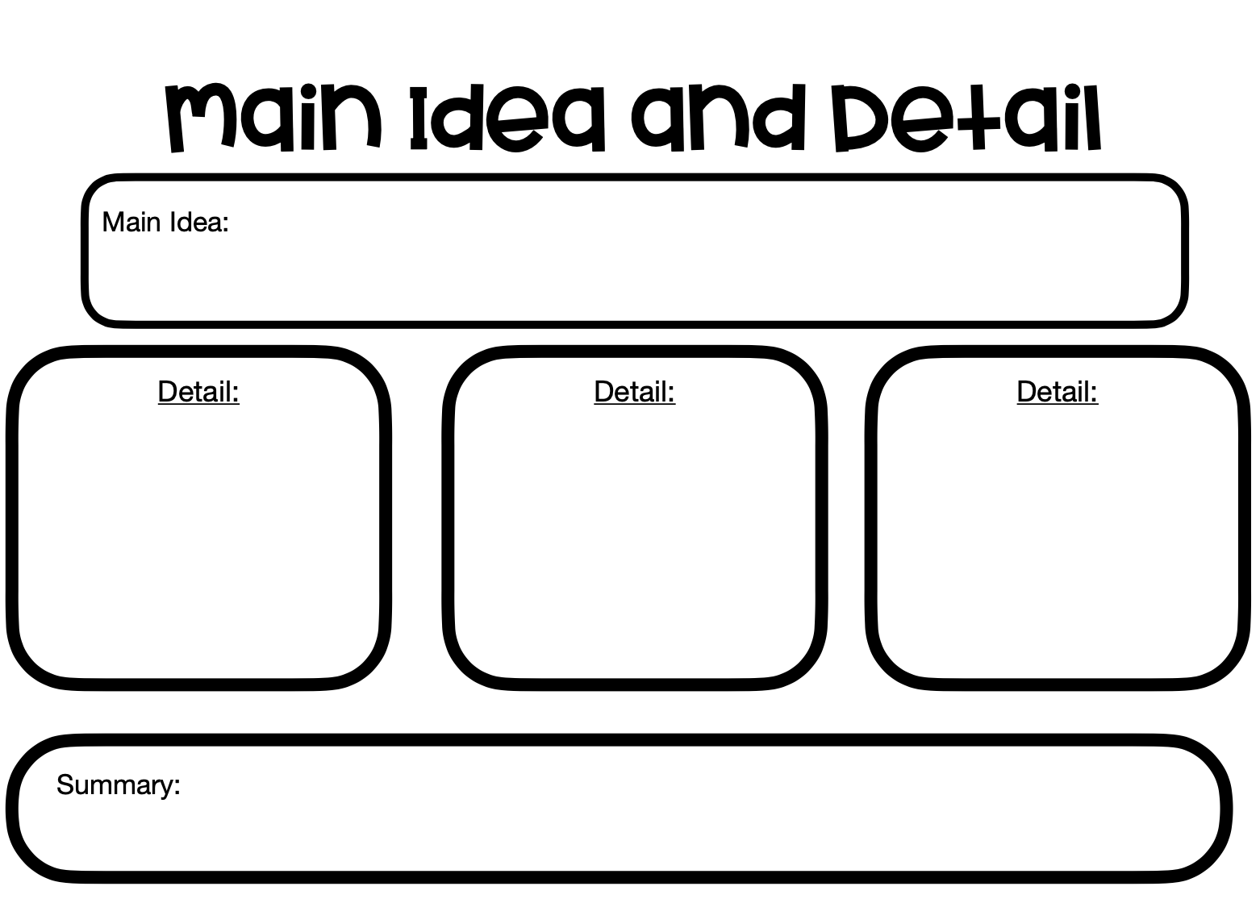

Pre Visit Activity

- Measure of a Man

Objective: Students will understand who Booker T. Washington is and his lifetime achievements

SOL Objectives:
English: 4.1, 4.2, 5.1
History: VS.7
Materials: Pencil, Graphic Organizer, Measure of a Man Video

Procedure:
- Show the video “Measure of a Man”
- Option: As students watch the video they will complete a 3,2,1
- Discuss video and responses from 3,2,1

Measure of a Man Video 3,2,1

Write 3 things you learned from the video
- ____________________________________________________________________
- ____________________________________________________________________
- ____________________________________________________________________
Write 2 Details from the video
- ____________________________________________________________________
- ____________________________________________________________________
Write one question from the video
- ____________________________________________________________________

Measure of a Man Video 3,2,1

Write 3 things you learned from the video
1.____________________________________________________________________
2.____________________________________________________________________
3.____________________________________________________________________
Write 2 Details from the video
1.____________________________________________________________________
2.____________________________________________________________________
Write one question from the video
1.____________________________________________________________________
Post- Visit Activities

1.BORN HERE, FREED HERE
Objective: Through discussion students will compare and contrast Booker T’s life before and after he was freed.
SOL Objectives: English: 4.1, 4.2, 5.1, 5.2
History: VS.1, VS.7, USI.1, USI.5, USI.8, USI.9
Materials: Notebook paper, pencil, (optional) video camera
_________________________________________________________________________________________
Procedure:
- The students will create a venn diagram and label each part "Before the Civil War." and "After the Civil War."
- The students will think about what Booker T. Washington’s life was like before and after he was freed. Think about how political events of the time could have affected both and how his life was the same even after he was freed.
- The students will think about what it meant to be a former slaveholder or former slave after the Civil War. The students will list the responsibilities and problems of each. Think about how political events of the time could have affected both.
- The students will discuss about these relationships.

Post-Visit Activity
2.Journal Entry
Objective: Students will be able to explain the life of an enslaved child during the Civil War
SOL Objectives:
English: 4.1, 4.2, 4.4, 4.7,4.9, 5.3, 5.4, 5.7, 5.9
History: VS.1, VS.7
Materials: Paper, pencil, computer, graphic organizer

Procedure:
1. Class discussion/brainstorm about what life would have been like for a child during the Civil War.
2. Students will research using a graphic organizer about what life was like for kids during the Civil War
Websites:
- https://www.battlefields.org/learn/articles/children-civil-war-home-front
- https://www.ncpedia.org/childhood-civil-war
- https://www.pbs.org/wgbh/americanexperience/features/grant-kids/
3. Students will write a journal entry using details from their research “A day in the life of an enslaved during the Civil War”

Post-Visit Activity
3. Civil War Events PROJECT AND PRESENTATION
Objective: Students will be able to complete research and present a project dealing with events or people important to the Civil War era.
SOL Objectives:
English: 4.1, 4.2, 4.3, 4.5, 4.6, 4.7, 4.8, 4.9, 5.1, 5.2, 5.3, 5.6, 5.7
History: VS.1, VS.7, VUSI.1
Materials: Books, encyclopedias, internet, paper, pencils, pens, crayons, various materials to make illustration

Procedure:
1. The students will research particular people or events important to the Civil War era using the graphic organizer below
Suggestions:
** Specific to 4th Grade Virginia Studies
Daniel Webster | **Thomas "Stonewall" Jackson
John C. Calhoun | ** Ulysses S. Grant
J.E.B. Stuart | **Robert E. Lee
Vicksburg | **Nat Turner's Rebellion
Frederick Douglass | Jefferson Davis
William Lloyd Garrison | **Abraham Lincoln
Harriet Beecher Stowe | **Booker T. Washington
Jubal Early | **Bull Run
General David Hunter | **Fredericksburg
 | **Appomattox

2. The students will make an illustration of their person or event. Examples: poster, model, drawing, mobile, collage, or puppet. (Suggestion: Use a computer to locate pictures)
3. The students will present their projects to the class. This should be done as an individual activity.

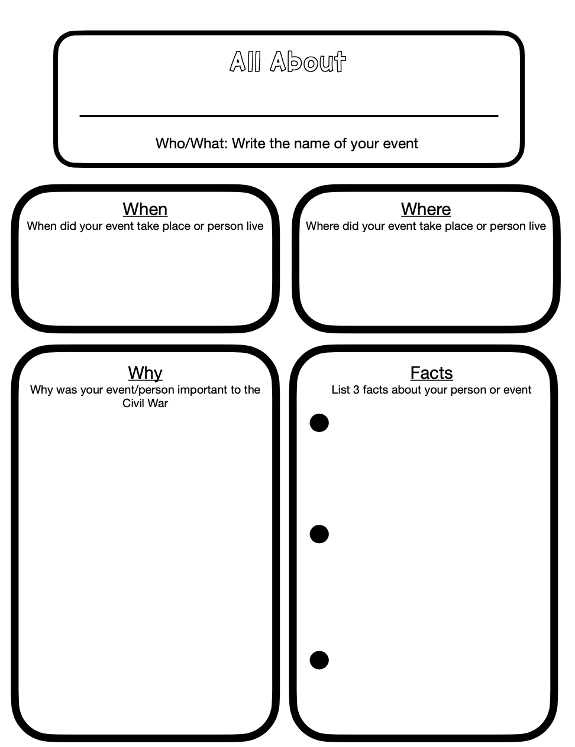
Post-Visit Activity

4. TIMELINE
Objective: Students will be able to create a classroom timeline from 1850-1865 of important events during the Civil War.
SOL Objectives: History: VS.1, VS.7
Materials: Construction paper, markers, wire or yarn to hang timeline.

Procedure:

- The students will work in groups to create a timeline putting in important events and people from 1850-1865.
- The students will cut construction paper into rectangles with each year that they wish to show events. The students will place these above the timeline.
- Place important people and events on your timeline.
Suggestion: Choose the number of events appropriate for your class.
General Dates throughout the Civil War | Virginia 4th and 5th Grade SOL Specific
- 1850 - Compromise of 1850; Fugitive Slave Law  - 1852 - Uncle Tom's Cabin by Harriet Beecher Stowe published.  - 1854 - Kansas-Nebraska Act  - April, 1856 - Booker T. Washington born.  - 1857 - Dred Scott Decision  - 1859 - John Brown attacks Harpers Ferry and is executed.  - November, 1860 - Lincoln elected 16th president.  - December, 1860 – South Carolina secedes from the Union.  - January-February, 1860 - Mississippi, Florida, Alabama, Georgia, Louisiana, and Texas secede.  - April, 1861 - Lincoln declares insurrection; blockade of Southern ports begins.  - April - May, 1861- Virginia, Arkansas, Tennessee, and North Carolina secede.  - July, 1861- Union defeated at Bull Run. James Burroughs dies.  - March, 1862 - battle of Monitor and Merrimac  - September, 1862 - Antietam, highest casualties of the war  - January, 1863 - Emancipation Proclamation issued  - May, 1863 – Vicksburg  - July, 1863 - Gettysburg  - March, 1864 - Grant named commander-in-chief of the Union forces.  - November and December, 1864 - Sherman's March to the Sea  - November, 1864 - Lincoln reelected.  - April, 1865 - Appomattox, end of Civil War  - April, 1865 - Lincoln assassinated.  - April-June 1865 - Slaves freed. | - 1850 - Compromise of 1850; Fugitive Slave Law  - April, 1856 - Booker T. Washington born.  - 1859 - John Brown attacks Harpers Ferry and is executed.  - November, 1860 - Lincoln elected 16th president.  - 1860: Some southern states seceded from the Union and formed the Confederate States of America  - 1860-Underground Railroad  - 1861 - Lincoln declared insurrection; blockade of Southern ports begins.  - July, 1861- Union defeated at Bull Run.  - June, 1863- Creation of West Virginia  - March, 1862 - battle of Monitor and Merrimac  - April, 1865 - Appomattox, end of Civil War

4. The students will create illustrations for events on timeline.

Post-Visit Activity for Advanced Students
4. Compare and Contrast
Objective: Students will construct two pie or circle graphs. Using the graphs students will compare and contrast the resources of the North and South.
SOL Objectives: English: 4.9, 5.6, 5.9 History: VS.1, VS.7, VUS.7
Math: 4.14
Materials: Paper, pencil, compass, crayons, pens ______________________________________________________________________________________

Procedure:
- The students will construct two pie graphs. One will represent the resources of the North in 1860. The other will represent the resources of the South in 1860.
- The students will include in the graph items such as the amount of money, the number of people, and the number of factories, food supplies, and railroads that each region has.
- The students will analyze the differences between the two regions. How did this affect the Civil War? How did resources affect each side's ability to fight, especially in the long term? What conclusions can you draw from the differences in resources?

Post-Visit Activity for Advanced Students
- POINT OF VIEW
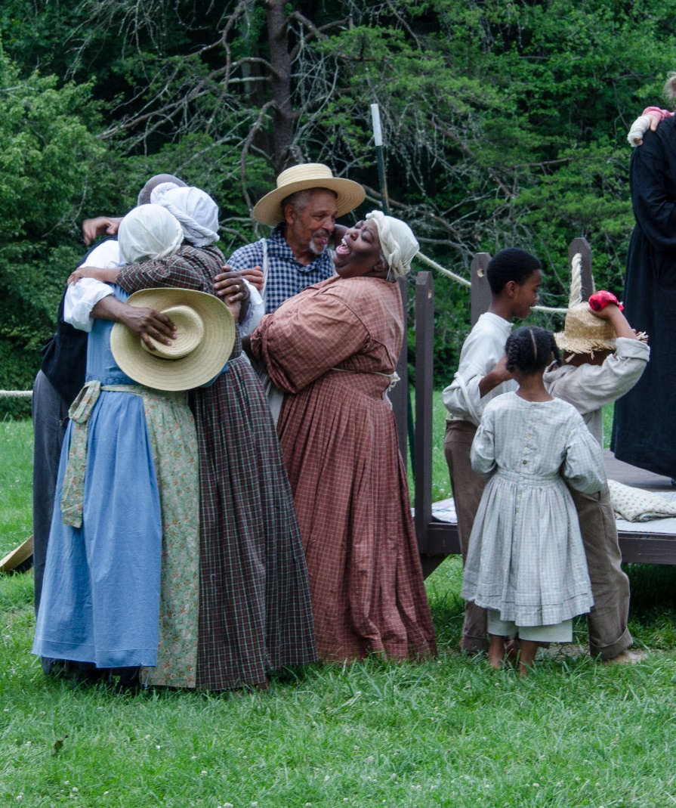
Photo Credits: Bill Tucker
Objective: Students will compare and contrast the multiple points of views of individuals on the Burroughs’s Plantation
SOL Objectives:
English: 4.1, 4.2, 4.3, 4.4, 4.5, 4.6, 4.7, 4.8, 4.9, 5.1, 5.2, 5.3, 5.4, 5.6, 5.7, 5.8
History: VS.1, VS.7, VUS.1

Materials: Books, encyclopedias, internet, paper, pencil, (optional) video camera ______________________________________________________________________________________

Procedure:

- After a trip to Booker T. Washington National Monument, students will research what the Civil War was like for those who fought as well as for those on the home front.
- The students will think of men in different situations and their points of view. How did men view the war? For example: an enlisted man, a wealthy slaveholder, a small farmer that doesn't own enslaved persons, a man who didn't fight, and an enslaved man or boy. Try to find as much as you can about what the men in the South had to deal with. What were their responsibilities? What were their long-range goals? How did they meet these goals?
- The students will think of women in different situations and their points of view, how did the women view the war? For example: a married woman with small children, or an enslaved woman on the home front, a nurse, a woman whose sons had gone to war. Try to find out as much as you can about what the women on the home front in the South had to confront. What were their responsibilities? Who did they have to depend upon? What were their long-range goals? How did they meet these goals?
- The students will hold a panel discussion comparing and contrasting these differing points of view.

