**National Park Service  
U.S. Department of the Interior**

**National Parks of Boston**

**Boston, Massachusetts**



Request for Proposals

**To Lease**

**15 State Street**

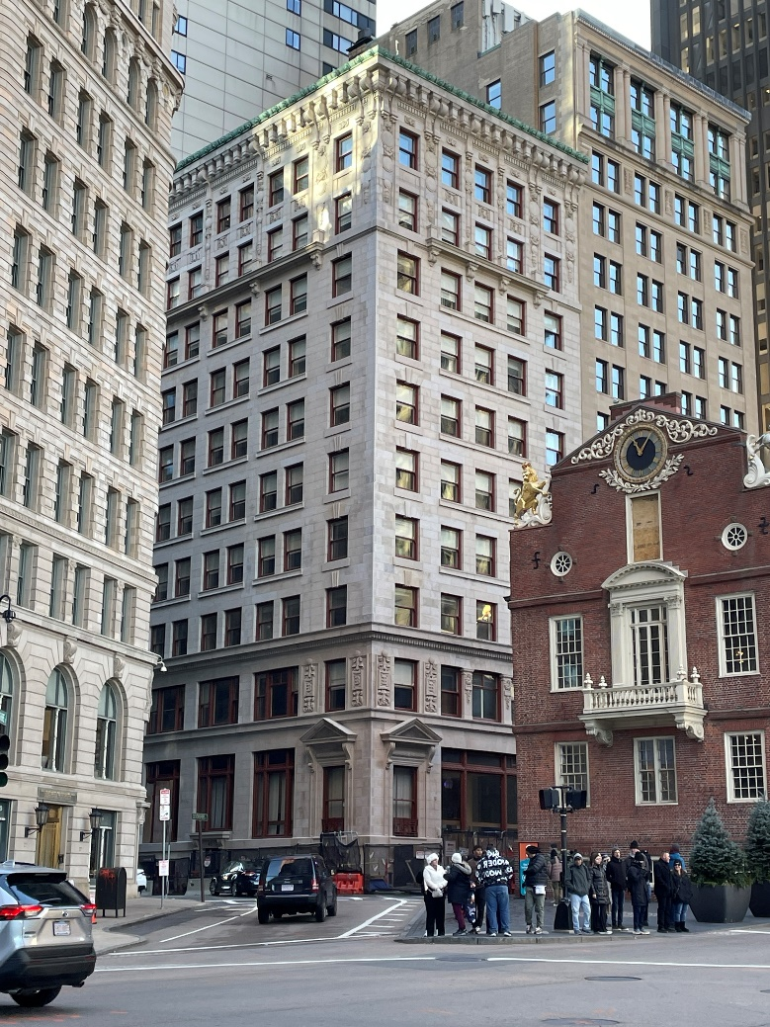

**Key Dates for this Request for Proposals**

|  |
| --- |
| **RFP Release Date: May 27, 2025 by 5:00 PM EDT (or EST if applicable)** |
| **Site Tours: Scheduled Upon Request** |
| **Initial Question Submittal Deadline: August 20, 2025 by 5:00 PM EDT (or EST if applicable)** |
| **Rolling Question Submittal Deadline: Every Wednesday by 5:00 PM EDT (or EST if applicable) until a selection is made** |
| **Initial Proposal Submittal Deadline: August 29, 2025 by 5:00 PM EDT (or EST if applicable)** |
| **Rolling Submittal Deadlines: Every Friday by 5:00 PM EDT (or EST if applicable) until a selection is made** |
| **Anticipated Date for Selection of Qualified Proposals: Four to Six Weeks after Submittal Deadline** |
| **Anticipated Lease Effective Date: Subject to Negotiation** |

Table of Contents

SUMMARY OF LEASING OPPORTUNITY 3

Overview of Property Offered for Lease 3

Exhibit 1 - Location Map 3

Exhibit 2 - Lease Premises – Representative Floor Plan 4

Allowed Uses of the Lease Premises 4

Key Information About This Leasing Opportunity 5

Jurisdiction 6

Term of the Lease 6

Rent 6

Insurance 6

Utilities 6

Maintenance Responsibilities 6

Lessee’s Responsibilities 6

Potential Improvement Projects 7

Key Personnel 7

Premises Condition 7

Contractors 7

Sustainability 7

Other Terms and Conditions 7

Competitive Process 8

Appointments-Only Site Tour and Additional Information 8

Proposal Submission Protocol 9

Authority 9

PARK PURPOSE 9

REQUIREMENTS 10

PROPOSAL EVALUATION AND SELECTION GUIDELINES 10

PROPOSAL CONTENT AND CRITERIA 11

Checklist of the Components of a Responsive Proposal 11

Required Information 12

Offeror Identification 12

Criterion 1: Proposed Use and Operations Consistent with National Park Service Values 12

Criterion 2: Improvements, Maintenance, and Preservation of the Historic Quality of the Property 12

Criterion 3: Financial Capability of the Offeror 13

Criterion 4: Demonstrated Experience Operating a Similar Property 13

Criterion 5: Environmental Enhancement 14

Criterion 6: Financial and Other Terms Offered 14

EVALUATION AND SELECTION PROCESS 15

ADDITIONAL INFORMATION AND MODIFICATION OF PROPOSALS 15

LEASE TERMS AND CONDITIONS 15

Term of Lease 15

Conditions 15

Lease Provisions 15

PROPOSALS CONSIDERED PUBLIC DOCUMENTS 16

ELIGIBILITY 17

Attachment A: Sample Lease 18

Attachment B: Identification and Credit Information Forms 18

Attachment C: Financial Information for Revenue Producing Uses Forms 18

Attachment D: Sample Offeror Transmittal Letter 18

Attachment E: Floor Plans 18

# SUMMARY OF LEASING OPPORTUNITY

This Request for Proposals (RFP) provides the opportunity for any interested individual or organization, hereinafter referred to as “Offeror” to submit proposals to the National Park Service (NPS, ‘Lessor’) to lease NPS property at National Parks of Boston (Park) for a Commercial Use under the following general terms and conditions.

The selected offeror (Offeror, ‘you’, ‘your’) will have exclusive negotiation rights to enter into a lease based on the attached Sample Lease (See Attachment A). Elements of your proposal may be incorporated into the Lease at Lessor’s discretion.

## Overview of Property Offered for Lease

The subject property is located at 15 State Street, Boston, Massachusetts 02109. The assessor’s parcel number is: 303900000. The site is an irregular corner parcel containing a gross site area of 4,053 SF (or 0.09-Acre) and is zoned BP-10 – “Boston Proper” by the City of Boston. The site is located at the intersection of State Street and Devonshire Street, in front of the Old State House, a historical tourist attraction and MBTA station. The subject site is improved with an eleven-story steel and masonry-constructed office building over English basement, that was constructed in 1902. It was designed by Shepley, Rutan and Coolidge, architects. It contains a Gross Building Area (GBA) of 37,070 SF of which 32,654 SF represents the Net Rentable Area (NRA).[1] It is listed as a Historic Building in the Inventory of Historic Assets of the Commonwealth of Massachusetts and is eligible to be on the National Register of Historic Places. Note, once on the National Register of Historic Places, both [Federal](https://www.nps.gov/subjects/taxincentives/about.htm) and [State](https://www.sec.state.ma.us/divisions/mhc/programs/state-rehabilitation-credit.htm) Tax Credits may be available for rehabilitation projects.

### Exhibit 1 - Location Map

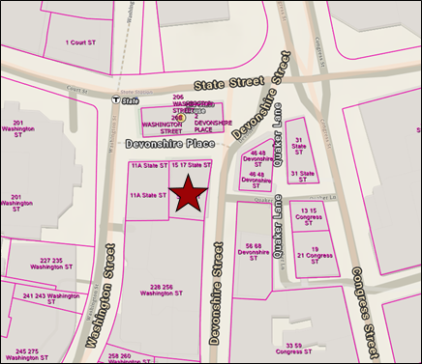

### **Exhibit 2** - Lease Premises – Representative Floor Plan

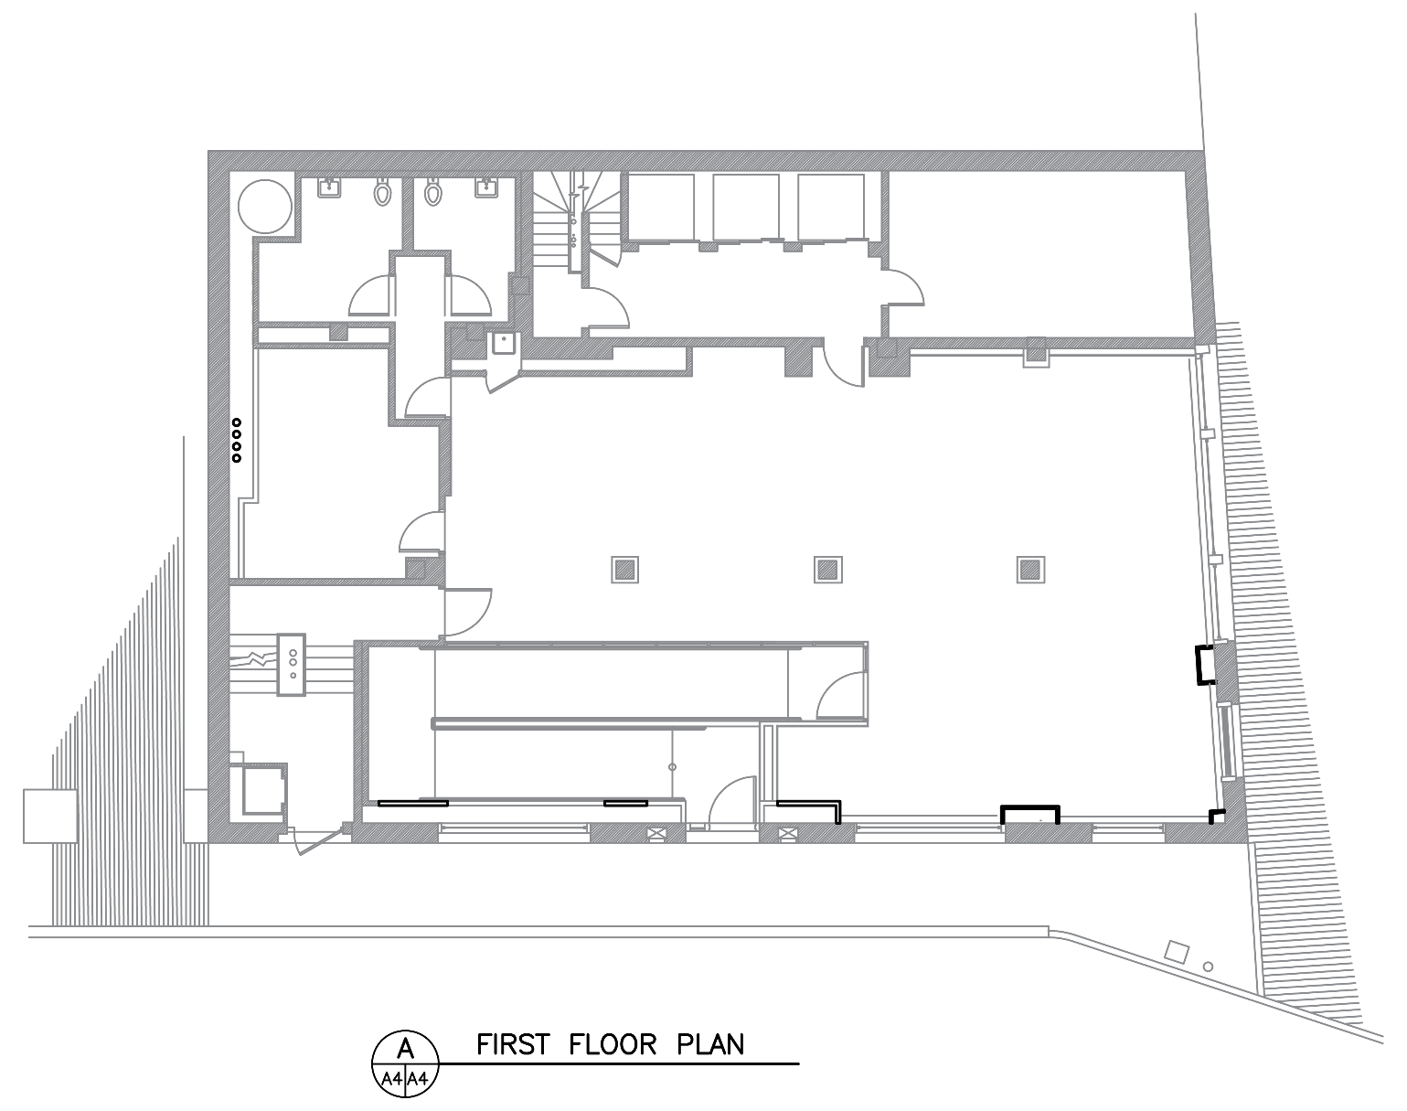

Full floor plans for 15 State Street may be downloaded as a PDF document, see Attachment E: Floor Plans.

## Allowed Uses of the Lease Premises

The intent of this RFP solicitation is to offer the property under a master lease to a developer or property management company who can then sublet the property for office space, hotel, or residential housing units. Additional uses will be considered. If office space is proposed, there are non-profit partners affiliated with the Park who might be interested in leasing spaces, including some who are current tenants of 15 State Street. If residential is proposed, it might qualify for the [City of Boston’s Downtown Residential Conversion Incentive Program](https://www.bostonplans.org/projects/office-to-residential-conversion-program).

## Key Information About This Leasing Opportunity

* **Deferred Maintenance**: Despite recent investments in the property, the following should be addressed: replacing the roof, updating plumbing throughout, and replacing elevators that are near the end of their useful life. There is known asbestos containing materials (ACM) and lead paint throughout parts of the building.
* **Planned Improvements**: The Lessor is planning to make the following improvements to the property prior to the lease commencement date:
  + Completing major renovation to repoint exterior masonry, update the HVAC system, and address structural issues in the below grade sidewalk vault.
* **Building Codes and Zoning:** The Lease Premises are owned by the Federal Government and are not subject to the zoning regulations or building codes of Boston, Massachusetts. However, the NPS will expect any work done on the property, where relevant, to meet the standards set forth by the 2024 ICC family of Codes and all codes referenced in those codes. For fire codes, follow all codes referenced in [NPS Director’s Order #58](https://www.nps.gov/subjects/policy/upload/DO_58_1-5-2022.pdf) and [NPS Reference Manual #58](https://www.nps.gov/subjects/fire/rm-58.htm). For accessibility, work must meet the ICC Codes and the Architectural Barriers Act Accessibility Standard (ABAAS). Additionally, Certificates of Occupancy are issued by the NPS Building Code Official.
* **Historic Preservation:** Construction design, authorization, regulatory compliance, and permitting will be required to comply with one or several of the following: the [Secretary of the Interior's Standards and Guidelines](https://www.nps.gov/orgs/1739/secretary-standards-treatment-historic-properties.htm); National Historic Preservation Act (NHPA) and Section 106 compliance; National Environmental Policy Act (NEPA); NFPA 914 Code for Protection of Historical Structures. Please note that your proposal may trigger compliance processes in accordance with one or more of the laws, regulations or policies listed above. The cost of any such compliance process as well as the costs of plan check, code review and construction inspections will be borne by the Lessee.
* **Tax Incentives:** Assuming the nomination package for the National Register of Historic Places is approved, rehabilitation projects may be eligible for [Federal](https://www.nps.gov/subjects/taxincentives/about.htm) and [State](https://www.sec.state.ma.us/divisions/mhc/programs/state-rehabilitation-credit.htm) Tax Credits. Additionally, if the proposed use is residential, it may be eligible for the [City of Boston’s Downtown Residential Conversion Incentive Program](https://www.bostonplans.org/projects/office-to-residential-conversion-program).
* **Additional Floors:** You may propose to add additional floors to the building subject to all applicable laws, the Historic Preservation requirements listed above, and NPS approval.
* **Rooftop Systems and Access:** Revolutionary Spaces, the non-profit organization who operates the historic Old State House (OSH), has ongoing access to the chiller and its plumbing for the OSH’s Heating, Ventilation, and Air Conditioning (HVAC) system located on the roof of 15 State Street per existing General Agreement. An appropriate agreement will be enacted between the Lessee, the Lessor, and Revolutionary Spaces to guarantee Revolutionary Spaces has access through 15 State to service the chiller system for the OSH. Additionally, the agreement will ensure that Revolutionary Spaces pays all the electrical service charges and all costs of HVAC service and maintenance charges for the OSH including maintenance of the system and the steam line within and from the building at 15 State Street.
  + The chiller system may be relocated to a mutually agreed upon location but must remain.

## Jurisdiction

For all purposes except building codes and zoning, the Lease Premises are subject to concurrent jurisdiction. Under concurrent jurisdiction, Federal and State governments share the governmental authority, and unless otherwise stated, the laws of both governments are applicable.

The Lessee must comply, at its sole cost and expense, with all Applicable Laws and Requirements (including Federal, State, and local laws, rules, regulations, requirements, and policies) in fulfilling its obligations under the Lease.

It is the responsibility of the Lessee to determine whether it is subject to specific taxes and assessments and abide by those applicable statutes. Any comments made by the NPS in this RFP do not alter those responsibilities, if any, nor should they be construed to take a position nor express a view on behalf of the Lessee.

## Term of the Lease

The term of the lease will be negotiated with the selected Offeror. The term shall be as short as possible, while considering the financial obligations of the lessee and other factors related to determining an appropriate lease term. No lease shall have a term of more than 60 years and the NPS anticipates a term between 40 and 60 years. The lease term will commence as soon as possible following selection of the best offer pending completion of any required compliance work and property valuation by the NPS.

## Rent

NPS is required under 36 CFR Part 18 to receive, at a minimum, Fair Market Value Rent (FMVR). The FMVR will be determined by the NPS after selection of the best proposal. The FMVR determination will consider any restrictions on the use of the property or terms of the lease that limit the value and/or the highest and best use of the property and any requirements under the lease for the lessee to restore, rehabilitate or otherwise improve the leased property. The amount of rent will be negotiated subsequently with the selected offeror, provided that, the final rent must at least equal the FMVR as determined by the NPS.

## Insurance

During the term of this Lease, the Lessee shall maintain General Liability, Property & Casualty, Worker’s Compensation & Employer’s Liability, and Business Interruption & Extra Expense insurance in amounts set by the Lessor. Further information regarding insurance requirements can be found in Attachment A: Sample Lease. Lessee’s insurance coverage amounts will be periodically reviewed by the Lessor. These reviews will ensure the Lessee has appropriate coverage in light of any changing circumstances.

## Utilities

The Lessee is solely responsible for all utilities including, but not limited to, telephone, cable, and internet access. Subject to advance written approval by the Lessor of any utility service, the Lessee at its sole expense shall make all arrangements with appropriate utility providers (including the Lessor where applicable), for all utilities not provided by the Lessor and furnished to the Premises. Any utility service provided by Lessor will be subject to the Lessor’s established policies and procedures for provision of utility services to third parties.

## Maintenance Responsibilities

### Lessee’s Responsibilities

Lessee will be fully responsible for all maintenance, improvements and repairs for the building, including, but not limited to:

* Scheduled repair and maintenance of the building on the Lease Premises.
* Unscheduled, emergency work (e.g. after-hours drain clearing, plumbing or electrical work) necessary to ensure the successful operation of the Lease Premises.
* Routine housekeeping of the Lease Premises and its exterior facilities.
* Pest management of the Lease Premises and its exterior facilities.
* Grounds maintenance within the Lease Premises. This includes snow removal and trash/recycling removal.

### Potential Improvement Projects

* Lessor may undertake projects intended to improve the Lease Premises or utilities serving the Lease Premises during the Lease Term. Lessor will coordinate with Lessee to minimize the impact on Lessee’s operations.

## Key Personnel

Lessee shall be required to maintain and provide to NPS an updated list of its qualified and experienced personnel, including a list of all subcontractors it uses.

## Premises Condition

Facility will be delivered to Lessee, “As-is with all faults.” The current contents of the building will be the Lessee's responsibility to dispose.

## Contractors

Lessee may utilize contractors to perform repairs, replacements, and improvements, and to provide event services.

* Contractors must abide by all Lease provisions as well as all local and national laws and regulations.
* Lessee will require Contractors to maintain appropriate insurance coverage that names the Lessee and the United States of America as an additional insured party.
* Lessee will develop and implement, subject to NPS prior approval, a contractor informational document, which will inform the contractor(s) of all pertinent information about the site.

## Sustainability

The Park manages its sustainability program under an Environmental Management System, which sets forth goals ranging from solid waste and energy conservation to renewable energy and climate change education.

* Lessee shall require that hazardous and universal waste generated from the site is disposed of in accordance with state and local laws.
* Lessee shall ensure that all trash, recycling, and composting meet applicable federal, state, and local requirements and goals.
* Lessee shall make every effort to reduce, reuse, and recycle solid waste.
* Lessee shall make every effort to utilize efficient energy and develop and implement a comprehensive plan for energy and water conservation.

## Other Terms and Conditions

The proposed terms and conditions of the offered Lease are as described in Attachment A, “Sample Lease” included in this RFP and are consistent with 36 CFR Part 18.

## Competitive Process

This Lease opportunity is open to all interested persons and businesses on a competitive basis. Whoever submits the proposal judged best under the proposal selection criteria will be given an opportunity to negotiate a final Lease agreeable to both the selected offeror and NPS.

To be selected by the NPS you must demonstrate that you have the capacity to plan, carry out, and finance your proposal. Evaluation criteria and the process for selecting a Lessee are described in detail in the PROPOSAL CONTENT AND CRITERIA and EVALUATION AND SELECTION PROCESS sections of this RFP. The NPS reserves the right to reject one or all proposals or terminate lease negotiations at any time prior to executing a final lease without penalty or liability.

## Appointments-Only Site Tour and Additional Information

A public site tour will be available to all potential offerors. The time and date will be posted on the Park's website and advanced registration will be required. It is anticipated that the date will occur in mid-June. Questions about the RFP or the Lease Premises should be sent via email to: [bost_permits@nps.gov](mailto:bost_permits@nps.gov)

Questions from interested parties will be answered via a Question & Answers (Q&A) or Frequently Asked Questions (FAQs) section on the park’s website. Questions must be submitted by the dates provided on the first page of this RFP. The Q&As or FAQs, as well as the RFP and attachments, can be found at: <https://www.nps.gov/bost/getinvolved/leasing.htm>

NPS reserves the right at any time, and from time to time, for its own convenience, and in NPS’ sole discretion, to cause or do any or all of the following:

* Waive or correct any defect or technical error as to form or content of this RFP or in any response, proposal, or proposal procedure, as part of the RFP or any subsequent selection and negotiation process.
* Reissue an RFP.
* Modify, amend, cancel, or suspend any and all aspects of the RFP and selection process.
* Modify the scope of the Lease or the required responses or modify the components of the Lease.
* Request that Respondents clarify, supplement, or modify the information submitted.
* Extend deadlines for accepting RFP responses, or request amendments to responses after expiration of deadlines.
* Consider comparable projects owned, developed, or operated by a Respondent.

**Key Dates for this Request for Proposals:**

|  |
| --- |
| **RFP Release Date: May 27, 2025 by 5:00 PM EDT (or EST if applicable)** |
| **Site Tours: Scheduled Upon Request** |
| **Initial Question Submittal Deadline: August 20, 2025 by 5:00 PM EDT (or EST if applicable)** |
| **Rolling Question Submittal Deadline: Every Wednesday by 5:00 PM EDT (or EST if applicable) until a selection is made** |
| **Initial Proposal Submittal Deadline: August 29, 2025 by 5:00 PM EDT (or EST if applicable)** |
| **Rolling Submittal Deadlines: Every Friday by 5:00 PM EDT (or EST if applicable) until a selection is made** |
| **Anticipated Date for Selection of Qualified Proposals: Four to Six Weeks after Submittal Deadline** |
| **Anticipated Lease Effective Date: Subject to Negotiation** |

The initial RFP solicitation will be open for 90 days, if the NPS has not received enough proposals by the initial submittal deadline the RFP solicitation will remain open on a rolling 1-week basis until a proposal has been selected. During a rolling RFP period, questions must be submitted by Wednesdays at 5:00 PM EDT (or EST if applicable).

## Proposal Submission Protocol

Proposals may only be submitted electronically. Proposals that are not received at the designated electronic address by the specified deadline will not be considered. NPS will not consider hardcopy proposals.

Telephonic proposals, faxes, e-mails to other addresses, and other means of transmittal will not be considered. Please refer to the **Proposals** **Considered Public Documents** section, in this RFP if you believe that a proposal contains trade secrets or confidential commercial and financial information that you do not want to be made public.

## Authority

This RFP is issued under the authority of Title 36 of the Code of Federal Regulations Part 18 Leasing of Properties in Park Areas ([36 CFR Part 18](https://www.ecfr.gov/current/title-36/part-18)). This RFP and the offered lease are subject to and incorporate all terms and conditions of Part 18 as applicable. In the event of any conflict between the terms of this RFP and Part 18, Part 18 controls.

The NPS has the authority to lease historic property through the Historic Leasing Authority ([54 USC 306121](https://uscode.house.gov/view.xhtml?req=granuleid:USC-prelim-title54-section306121&num=0&edition=prelim)), as well as the authority to lease NPS-administered buildings and associated property pursuant to the National Park Service General Leasing Authority ([54 USC Ch. 1021](https://uscode.house.gov/view.xhtml?path=/prelim@title54/subtitle1/divisionA/chapter1021&edition=prelim)), and other applicable authorities.

NPS regulations require all leases with the NPS to receive Fair Market Value Rent.

**The National Park Service and National Parks of Boston**

The United States National Park Service was created by Congress to “conserve the scenery and the natural and historic objects and the wildlife therein, and to provide for the enjoyment of the same in such a manner and by such means as will leave them unimpaired for the enjoyment of future generations.” Additionally, Congress has declared that the National Park System should be “preserved and managed for the benefit and inspiration of all the people of the United States.” To learn more about the National Park Service, visit our website at [www.nps.gov](http://cs.inside.nps.gov/projects/sites/pwr/goga/GOGA%20Residential%20Leasing/www.nps.gov). This site includes information about who we are, our mission, NPS policies and individual parks.

[The National Parks of Boston](https://www.nps.gov/bost/index.htm) is a collection of three National Park System sites – Boston National Historical Park, Boston African American National Historic Site, and Boston Harbor Islands National and State Park. Established by individual legislation and for designated purposes, the three units have come together under a unified organizational umbrella to collaborate in ways that celebrate our cultural heritage, reconnect people to history and nature, and provide outdoor recreation opportunities on land and on the water.

# PARK PURPOSE

The National Parks of Boston are three unique parks all connected by stories of revolution. Boston is the birthplace of the American Revolution, and a driver of social and environmental revolutions of the 1800s and 1900s. The National Parks of Boston, including [Boston African American National Historic Site](https://www.nps.gov/boaf), [Boston National Historical Park](https://www.nps.gov/bost), and [Boston Harbor Islands National and State Park](https://www.nps.gov/boha), invites visitors to explore the seeds of revolution, and the on-going and many-sided struggle for civil rights, liberties, and environmental justice.

Out on Boston’s Trails to Freedom, visitors can explore the meaning of freedom through sites and stories that explore the motivations that pressed for independence from Britain, and launched revolutionary movements to abolish slavery, extend the vote, and safeguard civil rights and liberties to all people.

Heading out by ferry, visitors experience the fruits of an environmental revolution that resulted in the clean-up of Boston Harbor and creation of Boston Harbor Islands National and State Park. They can visit a Civil War-era fort, explore tide pools, camp under the stars, or simply enjoy an expansive 360-degree view—all within reach of downtown Boston.

# REQUIREMENTS

Proposals must be submitted electronically to: [bost_permits@nps.gov](mailto:bost_permits@nps.gov)

Proposals must be submitted on or before the time and date provided on the first page of this Request for Proposals. ***The subject line should include the following*:** **BOST_15 State Street_Lease Proposal_[Your name or the name of your business entity or organization]** (please do not include the brackets).

**Proposals are limited to 50 pages or less, not including attachments.** Any proposals over these limits will be deemed non-responsive and not evaluated further.

**Offerors should submit their proposal in electronic format *as one cohesive document*** **in the Adobe PDF format**. The required Identification and Credit Information forms (either 10-352, 10-353, or 10-354), the required Financial Information for Revenue-Producing Uses Forms (either 10-355A or 10-355B), financial statements, and credit reports should be incorporated into your PDF submission as attachments. If you do not have PDF management software, such as Adobe Acrobat, installed on your computer there are free websites, such as [PDFCandy](https://pdfcandy.com) or [PDFgear](https://www.pdfgear.com/), that will allow you to convert other document formats to PDF and combine PDF documents. Proposals must be formatted to 8-1/2" x 11”-page size. Proposals submitted by mail, in-person delivery, telephone, fax, or other methods will not be considered.

While there is no limit on the file size of your proposal, the total file size of the email submission, including all attachments, cannot exceed 40MB. If your proposal exceeds this limit, you must separate your document into smaller files and send them in separate emails. If you do this, please separate your proposal into as few files as possible and clearly name the files so they can be reassembled in your intended order.

Effective proposals should be organized in the order of the **Required Information** detailed below and should contain clear, concise responses that address all the questions and requirements for each of the **Selection Criterion** listed in the RFP. **Proposals that do not specifically answer all questions will be deemed non-responsive and not evaluated further.**

NPS reserves the right to deviate from any provision of this RFP, consistent with applicable statutes, regulations, and policies. NPS may extend the submission deadlines for any reason.

# PROPOSAL EVALUATION AND SELECTION GUIDELINES

NPS Leasing Regulations, as provided in [36 CFR 18.8(e)](https://www.ecfr.gov/current/title-36/part-18#p-18.8(e)), require that proposals be evaluated by the criteria below:

* The compatibility of the proposal's intended use of the offered property with respect to preservation, protection, and visitor enjoyment of the park area.
* The compatibility of the proposal with the historic qualities of the property.
* The financial capability of the Offeror to carry out the terms of the lease.
* The experience of the Offeror demonstrating the managerial capability to carry out the terms of the lease.
* The ability and commitment of the Offeror to conduct its activities in the park area in an environmentally enhancing manner through, among other programs and actions, energy conservation, waste reduction, and recycling.
* The benefit to the NPS of the financial and other terms and conditions of the proposal, including the amount of rent proposed and other proposed lease terms and conditions.

Please keep these requirements in mind when developing your proposal, many of these criteria will be relevant to more than one of the selection criteria listed below.

# PROPOSAL CONTENT AND CRITERIA

Proposals submitted in response to this RFP must follow the format described below. You are asked to answer questions or supply specific information in response to the specified items. Please label your responses correspondingly and respond fully and accurately to all questions and/or requests.

## Checklist of the Components of a Responsive Proposal

* **A Transmittal Letter** **signed by all managing members, owners, partners, or principals within your organization**
* **The Proposal itself**, with clearly labeled sections for **Offeror Identification** and each of the **Selection Criteria** that covers all of the required questions and elements
* *One of the following*:
  + **Form 10-352** **Identification and Credit Information for** **Individuals,** and all of the required attachments
    - A Personal Financial Statement that identifies your total assets, your liquid assets and your financial liabilities
    - Earnings, bank, or investment account statements that substantiate the information provided in your Personal Financial Statement
    - A credit report, **with credit score**, from within the last 30 days
  + **Form 10-353** **Identification and Credit Information for** **Sole Proprietor Businesses,** and all of the required attachments
    - A Personal Financial Statement that identifies your total assets, your liquid assets and your financial liabilities
    - Earnings, bank, or investment account statements that substantiate the information provided your Personal, and or, Business Financial Statements.
    - Business Financial Statements for the most recent 2 years
    - A credit report for the Individual (and Business if available), **with credit score**, from within the last 30 days
  + **Form 10-354** **Identification and Credit Information for** **Business Entities (Corporations, LLCs, Partnerships, etc.),** and all of the required attachments
    - *One of the following:* 
      * *If this is for an existing business entity:*
        + Business Financial Statements for the most recent 2 years
        + Earnings, bank, or investment account statements that substantiate the information provided in your Business Financial Statement
        + A credit report for the Business Entity, **with credit score**, from within the last 30 days
      * *If this will be for a new business entity created for this project:*
        + Personal Financial Statements for all the principals of the organization, that identifies total assets, liquid assets, and financial liabilities
        + Credit reports for all the principals of the organization, **with credit score,** from within the last 30 days
* *One of the following:*
  + Form 10-355A Offeror Financial Statements and Projections (Small Lease) (Word)
  + Form 10-355B Offeror Financial Projections (Excel)

**Please Note: Review the credit report you provide carefully, many of the free annual credit reports that are available do not include a credit score.**

## Required Information

### **Offeror Identification**

Please fully identify the person(s) associated with your proposal, by providing: Name(s), address(es), telephone number(s), e-mail address(es), and fax number(s), if applicable. **Your proposal must include a signed Transmittal Letter**, a sample is provided in Attachment D**. If your party consists of more than one individual,** **you should identify the primary contact for your group or organization**. The NPS will send all communications to that contact person.

Please complete and submit the applicable Identification and Credit Information Form contained in the Proposal Forms attached to this RFP for the entity and/or individuals that are to be the lessee and its principals. There are separate forms for individuals, sole proprietor businesses, and other business entities.

### Criterion 1: Proposed Use and Operations Consistent with National Park Service Values

This section should explain your proposed use or uses of the property and should establish your overall vision for your proposed concept. Furthermore, it should explain why such use or uses would be compatible with the preservation, protection, and visitor enjoyment of the park area.

* 1. Please describe your proposed use or uses of the property and the type of tenants you will target, this should include:
     1. A detailed operating plan describing normal operations. Include addressing local zoning and other community concerns such as parking and traffic.
     2. A detailed marketing/advertising plan for how you will find potential tenants and fill vacancies.

### Criterion 2: Improvements, Maintenance, and Preservation of the Historic Quality of the Property

This section should describe your concept for improvements to the Lease Premises and how they will enhance your proposed use. Your response must show how you plan to take full responsibility for all repairs and maintenance of the property. Additionally, any work performed on the structure must conform to all applicable standards, including the [Secretary of Interior’s Standards for the Treatment of Historic Property](https://www.nps.gov/orgs/1739/secretary-standards-treatment-historic-properties.htm).

1. Please describe all repairs, rehabilitation, and improvements you propose for the Lease Premises.
   1. Submit documentation of the cost estimates for all building repairs, rehabilitation, and improvements.
   2. Submit a timeline for design, commencement, and completion of proposed repairs rehabilitation, and improvements.
   3. Describe the steps you will take to comply with the Architectural Barriers Act and otherwise facilitate access by mobility impaired individuals within the Lease Premises.
   4. Submit conceptual designs for the repairs, rehabilitation, and improvements you propose to the buildings or grounds. Furthermore, provide conceptual plans and specifications for major systems repairs or replacements.
2. Please describe the manner in which you will maintain the Lease Premises after the initial repairs, rehabilitation, and improvements have been completed, this should include:
   1. An estimated annual maintenance budget considering material, labor, and service contract costs.
   2. A calendar of maintenance tasks broken down into daily, weekly, monthly, quarterly, annual, or other time periods as appropriate.
3. Please describe the manner in which you will preserve the historic quality of the Lease Premises and how you will meet the standards set forth by the Secretary of Interior’s Standards for the Treatment of Historic Property.

### Criterion 3: Financial Capability of the Offeror

This section should demonstrate that you are capable of making the financial investment required to fund what you propose. Offerors must identify the manner by which they will fund the improvements, and other start-up costs they propose for the premises.

1. Submit the source, and proof of the availability, of the funds necessary to carry out the obligations described in your proposal and under the terms of the proposed lease. You must submit the Financial Capability Information and comprehensive supporting documentation outlined in Attachment B (**Forms 10-352, 10-353, or 10-354, including all required attachments**) for each manager or principal in your organization. You must provide **bank statements, financing commitment letters, investment account statements, or similar documents that substantiate your financial resources**.
2. Demonstrate that you have a credible, proven track record of meeting your financial obligations, that your proposal is financially viable and that you understand the financial obligations of the lease. At a minimum, this includes **a credit report, *with credit score*, from within the last 30 days** from one of the major credit reporting agencies (Equifax, Experian, or TransUnion).
3. Provide start-up expenses, revenue projections, and operational expense estimates and submit a proforma projecting revenue and expenses over the Lease Term using either Form 10-355A or 10-355B. These forms can be found in Attachment C, please include:
   1. An estimate of the start-up expenses and investments, revenues and operating expenses for all years covered by your proposed Lease term. You should identity all revenue sources and any fees to be charged as part of the Lease terms. Describe the basis of all assumptions in the pro forma to the fullest extent possible, including those regarding each source of income, any inflation factors, other occupancy and management costs.

### Criterion 4: Demonstrated Experience Operating a Similar Property

This section should demonstrate your qualifications to provide top quality management of the Lease Premises. To be considered qualified, responsive, and responsible, an Offeror must submit the items listed below.

1. Provide resumes of the Offeror’s owners and key managers. To the extent possible, please ensure these resumes document the Offeror’s demonstrated experience and success in facility/property management and historic preservation/rehabilitation projects.
2. Describe Offeror’s relevant and specialized experience and its role in current and past projects of similar scope and complexity. Provide at least three brief descriptions of experience on similar projects that highlight Offeror’s ability to provide superior performance.
3. Describe, in detail, your experience managing a similar property including the total years of operation of that property and any major repair projects you undertook for the property.

### Criterion 5: Environmental Enhancement

This section should explain how you plan to use and manage the Lease Premises in an environmentally enhancing manner. At a minimum describe the ways in which you will address:

1. Ecological protection.
2. Energy conservation.
3. Water conservation.
4. Waste reduction.
5. Recycling.

### Criterion 6: Financial and Other Terms Offered

This section should explain the financial and material benefit your proposed use will provide to the NPS. Due to NPS leasing regulations, no annual rent offer of an amount less than the Fair Market Value Rent (FMVR) shall be accepted. Because this RFP is soliciting proposals for a broad selection of uses for the Lease Premises it is impossible to determine the FMVR until a use has been determined. The FMVR will be determined by the NPS after selection of the best proposal. The FMVR determination will consider any restrictions on the use of the property or terms of the lease that limit the value and/or the highest and best use of the property and any requirements under the lease for the lessee to restore, rehabilitate or otherwise improve the leased property.

1. Please state the amount of Annual Rent offered in Lease Year 1 and explain how you have determined that rent value.
2. If you propose Percentage Rent, in addition to Annual Rent, the Percentage Rent should be expressed as a percentage of Gross Revenue. Using the proforma you created using Form 10-355A or 10-355B, please project the total Percentage Rent in each Lease Year and include those figures in your response. Provided NPS fully accepts the revenue assumptions in your proforma, higher Percentage Rent compared to that proposed by other Offerors will increase the competitiveness of your proposal.
3. Please state the length of the lease term you propose.
4. Please detail any terms and conditions in the Sample Lease that you intend to negotiate with NPS, but do not include a marked-up version of the Sample Lease.
5. If you plan to use any of the tax incentives (i.e., Federal/State Historic Rehabilitation Tax Credits and/or City of Boston Residential Conversion), please provide details on your plan to do so.

# EVALUATION AND SELECTION PROCESS

The National Park Service will review all responses to this RFP through an evaluation panel assisted by technical consultants as appropriate.

All proposals will first be screened for adherence to the requirements of this RFP. The NPS will not consider non-responsive proposals. A non-responsive proposal is a proposal that was not timely submitted or fails to meet the material terms and conditions of this RFP as determined by the NPS. The NPS will only use information provided in the appropriate section of a proposal during the evaluation process, please organize your proposal carefully.

It is the intention of the NPS to select the best responsive proposal as determined under the selection criteria without further submittals or presentations. If this cannot be done, the NPS will select those lease proposals that appear most suitable under the selection criteria and will request additional information or presentations from that group so that the best responsive proposal can be selected.

NPS will negotiate the terms of the final Lease with the selected Offeror. Award of a Lease to that Offeror is dependent on successful negotiation of the final terms of the lease. If negotiations fail, NPS may negotiate with other Offerors for award of the Lease or terminate this solicitation without liability to any person.

The NPS reserves the right to reject one or all proposals, terminate lease negotiations, or cancel this RFP Solicitation at any time prior to executing a final lease without penalty or liability.

# ADDITIONAL INFORMATION AND MODIFICATION OF PROPOSALS

The NPS may request from any Offeror additional information or written clarification of a proposal after the submission date. However, proposals may not be amended after the submission date unless permitted by the NPS. The NPS may not permit amendment of a proposal unless all Offerors that submitted responsive proposals are given an opportunity to amend their respective proposals.

# LEASE TERMS AND CONDITIONS

## Term of Lease

The Lease to be awarded under this RFP will have a minimum term of ten (10) years. The Lease may be extended once for a period not to exceed one (1) additional year if the NPS determines that an extension is necessary because of circumstances beyond the control of the NPS. In accordance with applicable policy guidance, all leases with a term of five or more years must contain a CPI adjustment provision; and, and all leases with a term of fifteen or more years must contain a rent reconsideration provision.

## Conditions

**Selection of a proposal does not guarantee a lease for the Offeror.** The responsive proposal judged best under the proposal selection criteria will be given an opportunity to negotiate a final lease agreeable to both the Offeror and NPS.

## Lease Provisions

The Lease to be awarded under this RFP will contain the provisions required by 36 CFR Part 18 as well as other provisions determined by the NPS to be necessary to assure use of the leased property in a manner consistent with the purposes of the park area, and where applicable, to assure the preservation of historic property. Required provisions include, without limitation:

* A termination for cause or default provision and a termination for convenience provision;
* Appropriate provisions requiring the Lessee to maintain the leased property in good condition throughout the term of the Lease;
* Appropriate provisions stating that subletting of a portion of the leased property and assignment of a lease, if permissible under the terms of the lease, must be subject to the written approval of NPS;
* Appropriate provisions requiring the Lessee to pay for use of all services and utilities not provided by the Lessor and to pay all taxes and assessments imposed by federal, state, or local agencies applicable to the leased property or to Lessee activities;
* Appropriate provisions stating that the Lessee has no rights of renewal of the Lease or to the award of a new Lease upon Lease termination or expiration;
* Appropriate provisions stating that the Lessee may not construct new buildings or structures on leased property except in limited circumstances;
* Appropriate provisions requiring that any improvements to or demolition of leased property to be made by the Lessee may be undertaken only with written approval from the NPS; and
* Appropriate provisions that describe and limit the type of activities that may be conducted by the Lessee on the leased property.

**A Sample Lease is attached to this RFP and incorporates these terms.**

# PROPOSALS CONSIDERED PUBLIC DOCUMENTS

All proposals submitted in response to this Prospectus may be disclosed by the Service to any person, upon request, to the extent required or authorized by the Freedom of Information Act (5 U.S.C.§ 552). If you believe that your proposal contains trade secrets or confidential commercial or financial information exempt from disclosure under the Freedom of Information Act, mark the cover page of each copy of the proposal with the following legend:

“The information specifically identified on pages of this proposal constitutes trade secrets or confidential commercial or financial information that the Offeror believes to be exempt from disclosure under the Freedom of Information Act. The Offeror requests that this information not be disclosed to the public, except as may be required by law.”

You must specifically identify what you consider to be trade secret information or confidential commercial or financial information on the page of the proposal on which it appears, and you must mark each such page with the following legend:

“This page contains trade secrets or confidential commercial and financial information that the Offeror believes to be exempt from disclosure under the Freedom of Information Act, and which is subject to the legend contained on the cover page of this proposal.”

Information so identified will not be made public by the NPS except in accordance with law. The NPS does not warrant and assumes no liability for the accuracy of the information provided in this RFP.

# ELIGIBILITY

Applicants subject to existing legal authorizations must be compliant with current lease obligations in order to be eligible for this opportunity. *Current lessees of NPS property who have not satisfied reporting obligations or other lease obligations or have outstanding rent payments will not be considered eligible for this opportunity.*

*Applicants who are presently debarred, suspended, proposed for debarment, declared ineligible, or voluntarily excluded from a public transaction by a federal department or agency, or whose legal authorizations to undertake operations on park lands or to use and occupy park lands and facilities have been revoked, suspended, or terminated, or whose obligations for payments have been deemed delinquent and have been deferred to the United States Treasury, are not eligible for consideration.*



EXPERIENCE YOUR AMERICATM

# Attachment A: Sample Lease

[Attachment A: Sample Lease](https://www.nps.gov/bost/upload/Attachment-A_Sample-Lease_BOST_15-State_RFP_Final2.docx)

# Attachment B: Identification and Credit Information Forms

Complete and include only one of the following as applicable:

[NPS FORM 10-352 Identification and Credit Information (Individual)](https://www.nps.gov/bost/getinvolved/upload/Form-10-352-Business-History-Information_508_Compliant.pdf)

[NPS FORM 10-353 Identification and Credit Information (Business: Individual or Sole Proprietor)](https://www.nps.gov/bost/getinvolved/upload/Form-10-353-Business-Organization-Information-Individual-or-Sole-Proprietors_508_Compliant.pdf)

[NPS FORM 10-354 Identification and Credit Information (Business: Corp., LLC, Partnership, or Joint Venture)](https://www.nps.gov/bost/getinvolved/upload/Form-10-354-Business-Organization-Information-Corporation-Limited-Liability_508_Compliant.pdf)

# Attachment C: Financial Information for Revenue Producing Uses Forms

Complete and include only one of the following as applicable:

[Form 10-355A Offeror Financial Statements and Projections (Small Lease)](https://www.nps.gov/bost/getinvolved/upload/Form_10-355A_Offeror_Financial_Statements_and_Projections-Small_Lease_508_Compliant.pdf)

[Form 10-355B Offeror Financial Projections](https://www.nps.gov/bost/getinvolved/upload/Revised-Lease-Form-10-355B-Offeror-Financial-Projections.xlsx)

# Attachment D: Sample Offeror Transmittal Letter

[Attachment D: Sample Offeror Transmittal Letter](https://www.nps.gov/bost/getinvolved/upload/Attachment-D_Sample-Offeror-s-Transmittal-Letter_BOST_15-State_RFP.docx)

# Attachment E: Floor Plans

[Floorplans (Levels 1-2)](https://www.nps.gov/bost/getinvolved/images/Attachment-E_Floor-Plans_BOST_15-State_RFP_Page_1-Floors1-2.jpg)

[Floorplans (Levels 3-5)](https://www.nps.gov/bost/getinvolved/images/Attachment-E_Floor-Plans_BOST_15-State_RFP_Page_Floors3-5.jpg)

[Floorplans (Levels 6-8)](https://www.nps.gov/bost/getinvolved/images/Attachment-E_Floor-Plans_BOST_15-State_RFP_Page_Floors6-8.jpg)

[Floorplans (Levels 9-11)](https://www.nps.gov/bost/getinvolved/images/Attachment-E_Floor-Plans_BOST_15-State_RFP_Page_Floors9-11.jpg)

1. Colliers International Valuation & Advisory Services. (2019). Easton Building: Appraisal Report (Report No. BOS180341). Pg. 11. 