Read all application instructions (at the end of this application) as well as all conditions of the authorization before completing and submitting the application. Some parks have additional requirements for businesses that offer services to visitors relating to the safety and welfare of the visitors and protection of the resources. These requirements may include applicable operating licenses, certificates showing proof of training, operating plans, emergency response plans, group size limitations, etc.

1. Service for which you are applying: [attach diagram, attach additional pages, if necessary, include locations within the park, frequency, estimated number of participants (per trip and annually), number of vehicles, support equipment (trailers, generators, etc.)]
Mobile Food and Beverage Service at Mabry Mill

2. Will you be providing this service in more than one park? Yes No If “Yes”, list all parks and services provided.

3. Applicant’s Legal Business Name: [Include any additional names (DBA) under which you will operate.]

4. Owner and Authorized Agents: (Give the name(s) of the owners and name(s) of the persons designated as Authorized Agents for your business. Authorized Agents have the power to sign on your behalf.)

5. Mailing Addresses
PRIMARY CONTACT INFORMATION (Dates to contact you at this address, if seasonal. )
Address:
City, State, Zip:
Email: Website:
Day Phone: Evening Phone: Fax:

ALTERNATE CONTACT INFORMATION (Dates to contact you at this address, if seasonal. )
If same as “Primary Contact Information, check here and go to question 6.
Address:
City, State, Zip:
Email:
Website:
Day Phone: Evening Phone: Fax:

6. What is your Business Type? (Please check one below)

Sole Proprietor
Partnership (Print the names of each partner. If there are more than two partners, please attach a complete list of their names.)
Name:
Name:
Limited Liability Company
Corporation
Non-Profit (Please attach a copy of your IRS Ruling or Determination Letter)
Other
7. Business License – State and Number: Expiration Date:

8. Employer Identification Number (EIN):

9. Liability Insurance:
Provide proof of liability insurance. We recommend obtaining an Acord form from your insurance provider. The CUA operator must maintain General Liability insurance naming the United States of America as additional insured. Minimum coverage amount is $500,000 per occurrence. Some activities will require increased coverage or other types of liability insurance; see Park-Specific CUA Insurance Requirements (“Attachment A”).

- Will your business operate vehicles/vessels/aircraft within NPS boundaries?
Yes No

Information for vehicles/vessels/aircraft chartered from and operated by another company is NOT required. If “Yes,” please give a description of each vehicle. Use additional paper, if necessary.

Make/Model of Vehicle | Year | Max # Passenger Capacity | Own/Rent/Lease

Make of Aircraft | Tail Number | Max # Passenger Capacity | Own/Rent/Lease

Make/Model of Vessel | Registration # or  USCG Documentation | Length | Max # Passenger Capacity | Own/Rent/Lease

11. Additionally Required Documentation:
Parks may require proof of licenses, registrations and certificates, etc. Provide copies of additionally required documentation identified in “Attachment B”.

12. DOI Employment:
Are you, your spouse, or minor children employed within the U.S. Department of the Interior?
Yes No If “Yes”, please provide information below:
Employee Name: Title:
Bureau or Office where employed:
If you selected yes, to 12., please contact your servicing ethics office for further guidance prior to submitting this form. A list of servicing ethics offices can be found at, https://www.doi.gov/ethics.

13. Violations: To your knowledge, have you, your company, or any current or proposed employees been convicted or fined for violations of State, Federal, or local law within the last 5 years? Are you, your company, or any current or proposed employees now under investigation for any violations of State, Federal, or local law or regulation? See instructions.
Yes No If “Yes”, please provide the following information. Attach additional pages, if necessary.
Date of violation or incident under investigation:
Name of business or person(s) charged:
Please identify the law or regulation violated or under investigation:

Please identify the State, municipality, or Federal agency that initiated the charges:
Additional Detail (optional):

(Results) Action Taken by Court:

14. Fee: Please include the Application Fee as outlined in Attachment B.

- Signature:
False, fictitious or fraudulent statements of representations made in this application may be grounds for denial or revocation of the Commercial Use Authorization and may be punishable by fine or imprisonment (U.S. Code, Title 18, Section 1001). All information provided will be considered in reviewing this application. Authorized Agents must attach proof of authorization to sign below.

By my signature, I hereby attest that all my statements and answers on this form and any attachments are true, complete, and accurate.

Signature Date

Printed Name Title

NOTICES
Privacy Act Statement
Authority: The authority to collect information on the attached form is derived from 16 U.S.C. 5966, Commercial Use Authorizations.
Purpose: The purposes of the system are (1) to assist NPS employees in managing the National Park Service Commercial Services program allowing commercial uses within a unit of the National Park System to ensure that business activities are conducted in a manner that complies with Federal laws and regulations; (2) to monitor resources that are or may be affected by the authorized commercial uses within a unit of the National Park System; (3) to track applicants and holders of commercial use authorizations who are planning to conduct or are conducting business within units of the National Park System; and (4) to provide to the public the description and contact information for businesses that provide services in national parks.
Routine Uses: In addition to those disclosures generally permitted under 5 U.S.C.552a(b) of the Privacy Act, records or information contained in this system may be disclosed outside the National Park Service as a routine use pursuant to 5 U.S.C. 552a(b)(3) to other Federal, State, territorial, local, tribal, or foreign agencies and other authorized organizations and individuals based on an authorized routine use when the disclosure is compatible with the purpose for which the records were compiled as described under the system of records notice for this system.
Disclosure: Providing your information is voluntary, however, failure to provide the requested information may impede the processing of your commercial use authorization application.
Paperwork Reduction Act Statement
In accordance with the Paperwork Reduction Act (44 U.S.C. 3501), please note the following. This information collection is authorized by The Concession Management Improvement Act of 1998 (54 USC 101911). Your response is required to obtain or retain a benefit in the form of a Commercial Use Authorization. We will use the information you submit to evaluate your ability to offer the services requested and to notify the public what services you will offer. We may not conduct or sponsor and you are not required to respond to a collection of information unless it displays a currently valid Office of Management and Budget control number. OMB has assigned control number 1024-0268 to this collection.
Estimated Burden Statement
We estimate that it will take approximately 2.5 hours to prepare an application, including time to review instructions, gather and maintain data, and complete and review the proposal. Send comments regarding this burden estimate or any other aspect of this collection of information, including suggestions for reducing this burden, to the Information Collection Officer, National Park Service, 12201 Sunrise Valley Drive, MS-242, Reston, VA 20192. Please do not send your completed form to this address; but rather to the address at the top of the form.

The following explanations correspond directly with the numbered items on the Application Form. Please read this entire document prior to completing the application. Include the nonrefundable application fee when submitting this application.

COMMERCIAL USE AUTHORIZATION APPLICATION INSTRUCTIONS

- Enter the service you are proposing to provide. These are the services which are currently approved in the park:
This application is being used exclusively for a Temporary Food Operation (Food Truck) at Mabry Mill.
- Respond “No” or list other parks where you will be providing this service.
- Enter the legal name of your business. If you have a secondary name under which you are doing business (d.b.a.), please enter that name also.
- Give the name(s) of owners and name(s) of persons designated as Authorized Agents for your business. Authorized Agents have the power to sign on your behalf.
- Provide contact information for both the main season and the off-season. Your contact information may also be published in the NPS Commercial Services Directory.
- Check the box that identifies your type of business.
- If the state in which you operate or the state where your business is domiciled requires a state business license, provide the state, license number and year of expiration.
- Provide your Employer Identification Number (EIN). The Debt Collection Improvement Act of 1996 requires us to collect an EIN or Social Security Number (SSN). The NPS will not collect SSNs, only EINs. The EIN is issued by the Internal Revenue Service. You may receive a free EIN at http://www.irs.gov/Businesses/Small-Businesses-&-Self-Employed/How-to-Apply-for-an-EIN. We will use the EIN that you provide as needed to collect debts.
- Provide proof of General Liability Insurance naming the United States of America, as additional insured in the amounts designated in the application. Provide proof of vehicle/vessel/aircraft liability insurance if you own, rent, or lease vehicles/vessels/aircraft and transport visitors by those means or if those owned, rented, or leased vehicle/vessel/aircraft are engaged in providing the service (i.e., hauling horses used in the activity). Insurance companies must be rated at least A- by the most recent edition of A.M. Best’s Key Insurance Reports (Property-Casualty edition) or similar insurance rating companies (Moody’s, Standard and Poor’s, or Fitch). You may be subject to additional insurance requirements. Refer to “Attachment A”.
- Provide a description of each owned, rented, or leased vehicle/vessel/aircraft you will utilize during the course of the proposed commercial service. Information for vehicles/vessels/aircraft chartered from and operated by another company is not required.
- Provide copies of additional documentation as required by “Attachment B”.
- Indicate if you, your spouse, or parent (if you are a minor child) is employed by the U.S. Department of the Interior (Department). Departmental ethics regulations at 5 C.F.R. § 3501.103(c) prohibit Department employees, their spouses, and minor children, from acquiring or retaining permits, leases, and other rights in Federal lands granted by the Department. This prohibition includes any commercial use authorization to conduct commercial activities or services on Department property.
- Provide details if your business or business owners or current employees or proposed employees have been convicted or are currently under charges for violation of State, Federal, or local law or regulation in the last 5 years. Do not include minor traffic tickets.
- Include payment of the Application Fee - $ 300. See “Attachment ” B.
- Please sign and date your application. If the person SIGNING this application is an Authorized Agent for the business, proof of signing authority must accompany this application.

Attachment A: Insurance Requirements
Attachment B: List of Approved Services, Additionally Required Documentation, and Fee Information

Additional Information: The National Park Service has terms and conditions on all commercial service agreements. The following terms and conditions will apply to all Commercial Use Authorizations. There may be additional terms and conditions based on the services provided. These may include but are not limited to limits on locations, times, group size, and employee licenses and certifications and providing such information to the park superintendent for approval.

CONDITIONS OF THIS AUTHORIZATION
- False Information: The holder is prohibited from knowingly giving false information. To do so will be considered a breach of conditions and be grounds for revocation: [RE: 36 CFR 2.32(a) (3)].
- Legal Compliance: The holder shall exercise this privilege subject to the supervision of the area Superintendent. The holder shall comply with all applicable laws and regulations of the area and terms and conditions of the authorization. The holder must acquire all permits or licenses of State or local government, as applicable, necessary to provide the services described above, and, must operate in compliance with all applicable Federal, State, and local laws and regulations, including, without limitation, all applicable park area policies, procedures and regulations. All vehicles/vessels/aircraft are required to be registered and the operators are required to have the proper licenses to operate them commercially, as required by law or regulation.

- Employee Conduct: The holder must ensure that its employees are hospitable and exercise courtesy and consideration in their relations with the public. The holder must establish appropriate screening, hiring, training, safety, employment, termination and other policies and procedures. The holder must review the conduct of any of its employees whose action or activities are considered by the holder or the Director to be inconsistent with the proper administration of the Area and enjoyment and protection of visitors and must take such actions as are necessary to correct the situation. The holder must maintain, to the greatest extent possible, a drug free work environment.
- Rates: The holder shall provide commercial services under this authorization to visitors at reasonable rates satisfactory to the area Superintendent.

- Operating Conditions: The holder shall provide the authorized commercial services to visitors under operating conditions satisfactory to the area Superintendent.
- Liabilities and Claims: This authorization is issued upon the express condition that the United States, its agents and employees shall be free from all liabilities and claims for damages and/or suits for or by reason of any injury, injuries, or death to any person or persons or property of any kind whatsoever, whether to the person or property of the holder, its agents or employees, or third parties, from any cause or causes whatsoever while in or upon said premises or any part thereof during the term of this authorization or occasioned by any occupancy or use of said premises or any activity carried on by the holder in connection herewith, and the holder hereby covenants and agrees to indemnify, defend, save and hold harmless the United States, its agents, and employees from all liabilities, charges, expenses and costs on account of or by reason of any such injuries, deaths, liabilities, claims, suits or losses however occurring or damages growing out of the same.
- Insurance: Holder agrees to carry general liability insurance against claims occasioned by the action or omissions of the holder, its agents and employees in carrying out activities and operations under this authorization. The policy shall name the United States of America as additional insured. Holder agrees to have on file with the park copies of the above insurance with the proper endorsements.
- CUA Fees: At a minimum, the holder shall reimburse the park for all costs incurred by the park as a result of accepting and processing the application and managing and monitoring the authorized activity. Administrative costs for the application process must be paid when the application is submitted. Monitoring fees and any additional costs incurred by the park to support the commercial activity will be paid annually or on a more frequent basis as determined by mutual agreement between the Holder and the area Superintendent.

- Benefit: No member of, or delegate to, Congress, or Resident Commissioner shall be admitted to any share or part of this authorization or to any benefit that may arise from this authorization. This restriction shall not be construed to extend to this Contract if made with a corporation or company for its general benefit.

- Transfer: This authorization may not be transferred or assigned without the written consent of the area Superintendent.
- Termination: This authorization may be terminated upon breach of any of the conditions herein or at the discretion of the area Superintendent.
- Preference or Exclusivity: The holder is not entitled to any preference to renewal of this authorization except to the extent otherwise expressly provided by law. This authorization is not exclusive and is not a concession contract.
- Construction: The holder shall not construct any structures, fixtures or improvements in the park area. The holder shall not engage in any groundbreaking activities without the express, written approval of the area Superintendent.
- Reporting: The holder must submit annually the CUA Annual Report (NPS Form 10-660) by January 31 for the prior CUA season and also must submit upon request the CUA Monthly Report (NPS Form 10-660A). The holder is to provide the area Superintendent upon request any other specific information related to the holder’s operations that the area Superintendent may request, including but not limited to, visitor use statistics, and resource impact assessments.
- Accounting: The holder is to maintain an accounting system under which its accounts can be readily identified within its system of accounts classification. This accounting system must be capable of providing the information required by this authorization. The holder grants the United States of America access to its books and records at any time for the purpose of determining compliance with the terms and conditions of this authorization.

- Minimum Wage: The holder must comply with all provisions of Executive Order 14026 of April 27, 2021, (Increasing the Minimum Wage for Federal Contractors) and its implementing regulations, including the applicable contract clause, codified at 29 C.F.R. part 23, all of which are incorporated by reference into this authorization as if fully set forth in this authorization.

- Visitor Acknowledgment of Risks (VAR): The holder is not permitted to require clients sign a waiver of liability statement or form, insurance disclaimer, and/or indemnification agreement waiving the client’s right to hold the CUA holder responsible for accidents or injury occurring on NPS property. The holder is permitted to request or require a client to sign a form or statement acknowledging risk and/or indicating that certain prerequisite skills may be needed to participate in the commercial activity. The holder must provide the park with the current copy of all forms and/or statements used for this purpose and obtain written approval by the park to use the form and/or statement. A sample Acknowledgment of Risk form may be obtained by contacting the CUA office at blri_concessions@nps.gov or by going to the park CUA webpage at https://home.nps.gov/blri/planyourvisit/commercial-use-authorization-permits.htm.

- Intellectual Property of the National Park Service: Except with the written authorization of the Director of the National Park Service, the Holder shall not assert any legal claim that the Holder or any related entity holds a trademark, tradename, servicemark or other ownership interest in the words "National Park Service", the initials "NPS", or official name of any unit or part thereof, including but not limited to any facility, logo, distinctive natural, archaeological, cultural, or historic site, within the National Park System, or any colorable likeness thereof, or the likeness of a National Park Service official uniform, badge, logo, or insignia.

- Nondiscrimination: The holder must comply with Applicable Laws relating to nondiscrimination in providing visitor services to the public and with all equal employment opportunity provisions of Title VII of the Civil Rights Act, as amended.

- Notification of Employee Rights: The holder must comply with all provisions of Executive Order 13496 of January 30, 2009, (Notification of Employee Rights Under Federal Labor Laws) and its implementing regulations, including the applicable contract clause, codified at 29 CFR part 471, appendix A to subpart A, all of which are incorporated by reference into this authorization as if fully set forth in this authorization.

BLUE RIDGE PARKWAY COMMERCIAL USE AUTHORIZATION

STANDARD TERMS AND CONDITIONS
Mobile Food and Beverage Service (“Food Trucks”) at Mabry Mill

This Commercial Use Authorization is for Mobile Food and Beverage Service at Mabry Mill. Mobile Food and Beverage Service consists of providing grab-and-go items and/or quick service menu offerings. Mobile food and beverage vendors may provide a variety of hot and cold dishes, snacks, and beverages from inside a self-contained, hard-sided, enclosed, moveable, and lockable vehicle. No open structures (like tents, carts, or kiosks) may be used. All food preparation and sales must occur inside the vehicle, not outside.

Authorization Compliance: The holder and all participants authorized herein must comply with all of the conditions of this authorization, including all exhibits, amendments, application requirements, and written or verbal directives from the Superintendent. Failure to obtain an authorization to provide commercial services and have a copy of the document available for inspection at any time while in the park are violations of the authorization terms for which a citation may be issued and may subject the commercial operator to penalties as prescribed by law or regulation, including exclusion from doing business in the park.

Termination: The National Park Service (NPS) may, at any time, terminate this authorization at its discretion or upon breach of any of the conditions based on the seriousness of the violation and the company’s cumulative history. As a new, trial service to the Parkway, food truck operations will be monitored to assure the health, safety, and protection of Parkway visitors and resources.

Public Health: The holder will comply with applicable public health and sanitation standards and codes. The holder will promptly report information about any human illness, whether employees or guests, to the park Commercial Services Office for reporting to the NPS Southeast Region’s Public Health Consultant. This information, along with any other relevant factors, will be evaluated by the Public Health Consultant to help identify outbreaks of illness associated with contaminated water or food sources or caused by other adverse environmental conditions.

Area Use: This authorization is applicable only for the use of the area, term, and conditions designated. The area authorized for use under this authorization must be left in substantially the same condition as it was prior to the activities authorized herein. Permitted groups are sharing visitor facilities with the general public. CUA holders must not interfere with the general visiting public.

Nonexclusive Authorization: The holder will have none of the rights or privileges of P.L. 105-391, Title IV (National Park Service Concessions Management Improvement Act of 1998) specified for concession contracts. The National Park Service does not grant the holder a preferential or exclusive right to conduct business in any Parkway administered area.

Closed Areas: Parkway roads and other park areas may be closed due to weather or other conditions at any time during the year. If such conditions occur in the park while using this permit, no access or use is permitted beyond closed sections of the park. The holder may check the Parkway road closure listing at https://www.nps.gov/blri/planyourvisit/roadclosures.htm to verify any road closures.

Permits/Licenses: The holder must operate in compliance with all applicable federal, state, and local laws and regulations. The holder must obtain all permits or licenses of the State of North Carolina and/or the Commonwealth of Virginia local governments, as applicable, and as necessary to conduct the business activities specified above. Vehicle, operator, license, and authorization compliance inspections may occur at any time by National Park Service or Law Enforcement personnel. It is the responsibility of each operator to ensure they are meeting all conditions of VA-DOT’s and NC-DOT’s overweight and oversize vehicle permitting requirements, if applicable.

Insurance: The Superintendent shall not be responsible for any omissions or inadequacies of insurance coverage and amounts if such prove to be inadequate or otherwise insufficient for any reason whatsoever. The holder shall provide the Superintendent thirty (30) days written notice of any material change in the holder’s insurance program hereunder. Upon notification that the holder’s automotive or general liability insurance has lapsed or cancelled for any reason, the authorization to operate in the park shall be suspended until new insurance is in place.

Advertisements/Promotional Materials: The holder may not distribute or post any advertisements in the park. The holder will provide Concessions staff a copy of any existing company brochure, internet advertising, or other promotional material as it pertains to the Blue Ridge Parkway upon request. The holder will, at the request of the park, make corrections to any promotional material deemed inappropriate, such as: containing inaccurate or misleading statements regarding the services provided under the terms of this authorization, material that is non-complimentary to the park's mission and visitor service objectives, or that depicts illegal or unauthorized activities. Promotional material consisting of landscape and/or portrait subject(s) only may be used, with client approval, without the need to obtain further the park approval.

Professionalism: The holder is responsible for engaging in a standard level of professionalism on park land and behaving in a manner appropriate to represent the United States government and the National Park Service as an authorized commercial vendor. Professional practices include requiring all employees to treat park visitors, volunteers, customers, other commercial service employees, and park employees in a respectful manner and wear identifying clothing or name tags. Language and demeanor shall be appropriate at all times.

Monitoring: The Superintendent, or their designee, shall have the right to monitor/observe permittee activity for compliance with all aspects of this permit.

Complaints: Copies of any written complaints regarding activities conducted under this authorization must be provided to the Commercial Services Office within a reasonable period. Likewise, the NPS will provide copies of any written complaints received by it to the holder.

Rules and Regulations: The permit holder or his/her designated representative is responsible for understanding the obligations of this permit, including the rules and regulations pertaining to the use of the resources (CFR 36, Chapter 2). Specific regulations for the Parkway are found in the Superintendent’s Compendium located on the Parkway website at http://www.nps.gov/blri.

Park Resources: The holder and all group leaders shall ensure that park natural and cultural resources are not harmed or disturbed in any way as a result of their activities during the course of this authorization. The holder will not allow customers to disturb or remove any natural and/or cultural items from the park, including rocks, flowers, and plants. No vegetation will be removed or trimmed by Permittee.

Wildlife: Willfully approaching within 50 yards of wildlife, or within any distance that results in their disturbance or displacement, is prohibited. Harassing (e.g., intentional touching, teasing, frightening, or disturbing) or feeding wildlife is prohibited pursuant to 36 CFR 2.2(a)(2).

Trash: The permit holder is responsible for the removal of all trash associated with their operation in the park. Leaving food scraps or waste of any kind on the ground is prohibited and must be carried out or deposited in an appropriate receptacle.

Unmanned Aerial Vehicles (UAV)/Drones: Launching, landing, or operating an unmanned aircraft from or on lands and waters administered by the National Park Service within the boundaries of the Blue Ridge Parkway is prohibited.

Emergency Response: The permit holder shall provide necessary equipment for basic emergencies and first aid care. All emergency situations such as accidents, fires, and search and rescues will be reported to a Park Ranger or Blue Ridge Parkway Dispatch at 828-298-2491 or 911 at the earliest possible opportunity.

Reporting Accidents: All accidents resulting in personal injury, death, property damage, or injury to park wildlife or resources must be reported to park dispatch at 828-298-2491 or by dialing 911. Commercial operators must remain on scene until law enforcement officials arrive, if it is safe to do so.

Annual Reports: By January 31 of each partial or full calendar year of operation under this authorization, the holder will be responsible for submitting an annual report which summarizes total in-park visitor use, including gross revenues, for the reporting period.

Hours of Operation: Authorized operating hours are from 8:00 AM to 6:00 PM. Hours may vary according to season and public demand. The CUA holder’s anticipated operating hours should be submitted to the Commercial Services Office. Extension of operating hours beyond 6:00 PM requires permission from the Superintendent.

Signs: All advertising signs and materials must be restricted to the local site of operation only and must be removed immediately upon conclusion of services daily. Signs are prohibited along the Parkway motor road. All sign content and placement must receive approval from the Commercial Services Office prior to placement within the park. No signs may be placed in the ground or on buildings, fences, existing signs, or trees. Sandwich board style is allowed.

Authorized Locations: Food Trucks are authorized to operate in the Mabry Mill Overflow Parking Area on VA Route 603 behind the Mabry Mill Historic District (Figure 1). Up to three (3) food truck vendors may operate in the northeast section of the lot, adjacent to the comfort station fence line. Vendors must park so that the customer line forms safely between the food truck and the comfort station fence. In Figure 2, the red area designates the authorized parking location.

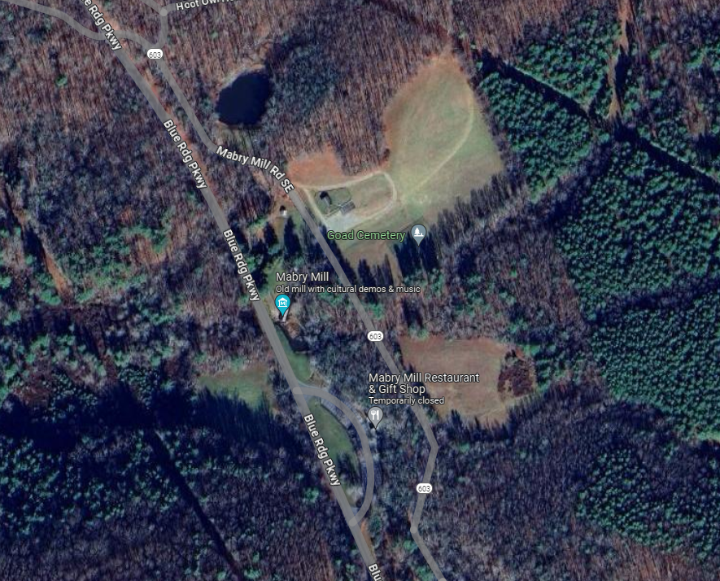
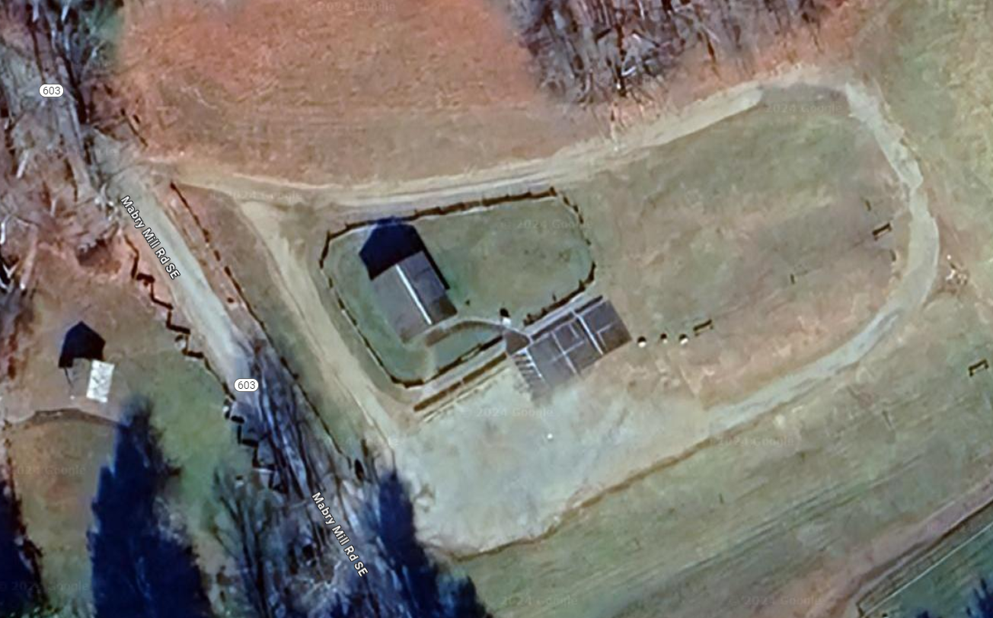
Figure 1

Figure 2

Provider, Staff, and Equipment Food Handling Requirements:
- All food must be prepared in accordance with Federal, State, and Local rules, laws, and regulations. Food service is required to comply with NPS Public Health Guidelines (DO-83) and the U.S. Public Health Service / FDA Food Code.
- The business must have a current and valid Mobile Food permit from the Commonwealth of Virginia at all times while in operation in the park.
- A USPHS Food Establishment Plan Review must be submitted to an NPS Public Health consultant prior to operating.
- The menu is limited to approved items identified in application.
- Water must be obtained from an approved source and stored in an approved container.
- Cold food items must be held at ≤ 41°F during transport and while onsite.
- Hot food items must be held at ≥ 135°F during transport and while onsite.
- Source – All food items must be from an approved source.
- Food items prepared off-site must be prepared in a pre-approved, licensed establishment. No food prepared or stored in a private home may be used, stored, served, and offered for sale, sold, or given away to the public.
- If required, HACCP temperature logs are to be maintained on TCS Foods prepared offsite.
- Food must be stored in food-safe containers (not in garbage bags or unapproved buckets).
- Raw meats must be stored so that they will not contaminate other foods.
- The minimum cooking temperatures are:
- Poultry and Stuffed Meats—165 °F
- Pork, Seafood, Ground Beef, & Game—°155F.
- Condiments must be dispensed from squeeze bottles or individual packets.
- Toxic materials must be stored separately from foods.
- For more information, follow the link below for the most current FDA Food code and guidelines:
https://www.fda.gov/food/retail-food-protection/fda-food-code

- All equipment and supplies must meet minimum Federal, State, and Local rules, laws and regulations.
- Food containers must be cleaned and sanitized after each use. Potentially hazardous food containers must be cleaned and sanitized every 4 hours.
- Portable storage tanks and containers must be filled utilizing a food-grade hose.
- Must have sufficient refrigeration or drained ice to maintain cold temperatures <41°F.
- Must have sufficient hot holding devices to maintain hot temperatures >135°F.
- Must have sufficient cooking equipment to heat food to 165°F.
- Must have sufficient power to operate all heating and refrigeration units.
- Must utilize approved clean food thermometers and use them frequently to measure food temperatures during cooking and holding.
- Must have an approved refrigeration thermometer for each cold holding unit.
- Must have a three-compartment sink or equivalent for dishwashing.
- Must have counter protection (sneeze guards) if food is to be held on counter for serving.
- Tables, stands, pallets or other devices are required to keep all food, utensils, single service, equipment, food prep and other operations off the ground or pavement.
- Must use clean and sanitized water containers to transport water to food booth.
- Must have wiping cloth sanitizer containers.
- Must have sufficient utensils, disposable gloves for food prep and dispensing.
- Must have sufficient garbage storage containers for food prep.
- Propane (and all compressed gas) cylinders must be secured at all times (chaining or crating).
- Must have adequate fire extinguishers.
- Must have adequate ventilation equipment.
- Handwashing facilities MUST be provided. Minimal hand washing facilities consist of: Potable Water (5 gallons) in a container with a continuous (hands-free spigot), pump-dispensed hand soap, paper towels, a wastewater catch basin, and a nearby trash can.
- Must have clean and sanitized water containers to transport water to food booth and for wiping cloth sanitizing solution containers. Hoses used to supply water must be constructed of food grade materials.
- All liquid waste must be stored in a retention tank that is 15% larger than the drinking water supply tank.
- Must have a sufficient supply of the following:
- sanitary disposable towels
- hand soap and dishwashing soap
- chemical sanitizer (chlorine, quat or iodophor)
- sanitizer test strips for selected sanitizer
- fuel for cooking and hot holding
- ice if needed for cold holding
- extra plastic wrap and/or foil to cover food containers during holding.
- Wiping cloths are stored in a 50-100 PPM chlorine solution (1 capful of household bleach per gallon of water) or in another approved sanitizer (quat or iodophor), changed when dirty. Wiping cloths must be either discarded or washed when soiled.
- Wash, rinse, and sanitizer solutions are changed frequently.
- Solid waste must be stored in insect/rodent proof waste receptacles.
- Liquid waste must be disposed of in an approved gray water receptacle and not on the ground or in storm drains.

- All staff preparing food must have, at least, a food handler’s certification, such as ServSafe.

- There must be one certified Food Manager on site at all times. The CUA holder must provide a list of staff and certification level to the permit coordinator prior to the season and updated as necessary.

- All staff must be healthy; no illnesses or infection symptoms such as: diarrhea, fever, vomiting, jaundice, sore throat with fever, open cuts or sores on the hands or wrists.

- All staff must wear clean outer garments and restrained hair.

- All staff must vigorously wash their hands and forearms with soap and warm water prior to the start of food preparation activities, after using the toilet, after smoking, eating, and whenever necessary to prevent contamination of food.

- Employees that are serving or handling non-prepackaged food items must wear gloves. Hands must be washed and fresh gloves must be worn after handling money.
Mobile Food Service Operations
1) Food service vehicle must not be stored in the park overnight and must be removed when not in service. Overnight parking requires permission of the Superintendent. Permittees wishing to park overnight must request permission in writing through the Concessions office at least seven days in advance.
2) Food service vehicle must only park in areas designated by the park and authorized by this CUA.
3) Food service vehicle CUA holders must provide their own power. Generators must not exceed 60 decibels, create unreasonable noise, or disturb normal park visitors at 50 feet from the truck.
4) Gray water must be disposed of at a location outside of the park.
5) Trash from permit holder’s internal/kitchen operations must be disposed of at a location outside of the park. NPS will provide and maintain bear-proof trash cans for customer trash. CUA holders, however, are encouraged to assist with overall maintenance of the area to ensure that park resources are protected.
Prohibited Activities: The CUA holder and their employees are prohibited from the following:
1) Constructing any structure, fixture, or improvement upon the area.
2) Using Polystyrene foam in the distribution of food or beverages. Permittees are encouraged to use environmentally friendly products.
3) Smoking anywhere inside or within 25 feet of any Blue Ridge Parkway buildings.

4) Engaging in any act that may result in the contamination or adulteration of food, food contact surfaces, or utensils.

5) Selling or possessing alcoholic beverages.

6) Eating inside the food truck.

7) Having non-employees, including children, inside the food truck.

8) Using pesticides, fungicides, herbicides, or toxic materials is prohibited unless the Superintendent specifically approves them.

9) Having live animals of any kind in the authorized area is prohibited.

10) Using fireworks, sparklers, glitter, confetti, or bird seed under any circumstances is prohibited.

11) Driving a vehicle anywhere other than on designated open areas is prohibited.

12) Music of any kind is not permitted outside the assigned area. If music is being played inside the assigned area, it must be at no more than 60 decibels at 50 feet.

AS THIS ACTIVITY IS FURTHER REVIEWED AND MONITORED BY THE BLUE RIDGE PARKWAY, ADDITIONAL CONDITIONS MAY BE ADDED THROUGH AMENDMENT TO THIS PERMIT. A FINAL DETERMINATION OF COMPLIANCE AND REQUIREMENTS IS THE AUTHORITY OF THE NATIONAL PARK SERVICE/BLUE RIDGE PARKWAY AND MUTUAL AGREEMENT TO SUCH CHANGES IS NOT REQUIRED.

ATTACHMENT A

CUA Insurance Requirements

Commercial General Liability (CGL) Insurance

Liability insurance is required for all CUA holders under the terms of the authorization. Such insurance should be of sufficient scope to cover all potential risks and in an amount to cover claims that can reasonably be expected in the event of serious injury or death. The minimum commercial general liability insurance is $1,000,000. Liability insurance policies must name the United States of America, Blue Ridge Parkway, 199 Hemphill Knob Road, Asheville, NC 28803 as additional insured. The business or person that is providing the service must be the named insured (policy holder). Companies that provide transportation only are not required to have Commercial General Liability as long as the passengers do not disembark.

Other Required Insurance

Commercial Auto Liability Insurance is required if a CUA holder transports passengers or uses in the performance of the service in the park owned/leased/rented vehicles. If a CUA holder charters the vehicle and those chartered vehicles are owned and operated by another company, the CUA holder is not required to have Commercial Automobile Liability insurance. The minimum Commercial Auto Liability Insurance for interstate passenger transport is:

Commercial Vehicle Insurance – Passenger Transport  (bodily injury and property damage) | Minimum per Occurrence Liability Limits*
15 or fewer passengers | $1,500,000
16 or more passengers | $5,000,000

The NPS has not established standard commercial automobile liability minimums for intrastate auto use by CUA holders because each state has unique rules and regulations. Intrastate CUA holders must meet individual state requirements for Commercial Automobile Liability Insurance or the interstate requirements above, whichever are greatest.

Insurance Company Minimum Standards

The NPS has established the following minimum insurance company requirements. All insurance companies must meet the following minimum standards. These standards apply to foreign insurance companies as well as domestic companies.

- All insurers for all coverages must be rated no lower than A- by the most recent edition of Best’s Key Rating Guide (Property-Casualty edition), or similar insurance rating companies (Moody’s, Standard and Poor’s, or Fitch), unless otherwise authorized by the Service.
- All insurers for all coverages must have Best’s Financial Size Category of at least VII according to the most recent edition of Best’s Key Rating Guide (Property-Casualty edition), or similar insurance rating companies (Moody’s, Standard and Poor’s, or Fitch), unless otherwise authorized by the Service.
- The insurance ratings must be submitted with the CUA Application. The rating companies do not issue certificates. We require the insurance broker to note this rating in the Certificate. If the rating does not appear on the certificate, the insurance broker must provide it in another document.

Proof of Insurance Submission

Applicants must submit proof of insurance with the CUA Application. The proof of insurance must:

- Be written in English with monetary amounts reflected in USD.
- Reflect that insurance coverage is effective at time of CUA Application submission.
- Name as insured the business or person that is providing the service.
- Name the United States as additional insured.
- Reflect a General Commercial Liability Policy with the minimum coverage amount required in the CUA Application.
- Reflect required additional insurances (commercial vehicle, vessel, aircraft, etc.) with the minimum coverage amount required in the CUA Application.
- Include insurance provider rating or provide in separate document.

ATTACHMENT B
List of Approved Service, Additionally Required Documentation, and Fee Information

AUTHORIZED COMMERCIAL SERVICE | REQUIRED DOCUMENTATION | REQUIRED CUA FEES

Temporary Food Operation (Food Truck) at Mabry Mill. | -Photo and description of vehicle, including dimensions  -Insurance Certification  -Business License  -Recent inspection from local authority  -Recent Commissary inspection from local authority  -List of food and beverage menu with prices  -Food Protection Manager Certification | Application Fee: $300  Management Fee: $300

