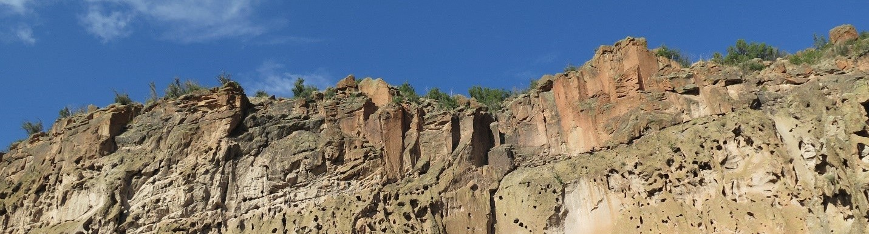
2022 Artist In Residence Program

Artists in National Parks
Since Thomas Moran and William Henry Jackson, whose paintings and photographs influenced Congress to establish Yellowstone National Park, artists have continued to impact the formation, expansion, and direction of our National Park system.
Today’s visual artists document the landscape and cultural features of our parklands, following both traditional techniques and contemporary approaches that stir the imaginations and wanderlust of visitors from around the world. Writers, musicians, composers, sculptors, story tellers, dancers and other performing artists draw inspiration from and focus the attention of new generations on our national treasures.
Artists translate the purposes of the National Parks—places of pleasure, places for preservation and for the enlightenment even of those who may never have the opportunity to visit many of their parks in person. Bandelier is proud to continue this tradition.

What an Artist-in-Residence Does
The Artist-in-Residence program at Bandelier National Monument offers professional writers, composers and visual and performing artists the opportunity to pursue their artistic discipline in the park’s inspiring and stimulating environment. Artists are selected by a jury of professionals from diverse artistic disciplines based solely on the quality of that year’s applicants’ presentations from all disciplines.
However, in any given year, the park may choose to stipulate (or limit) the disciplines from which it accepts applications, based on compatibility with current programming objectives and needs.
Selected artists stay in an historic, Pueblo-style furnished residential facility for four weeks during the period from September 1 through mid-December 2022. No application fee is required, and no stipend is provided.

The Artist-in-Residence Program Benefits the Artist and the Park.
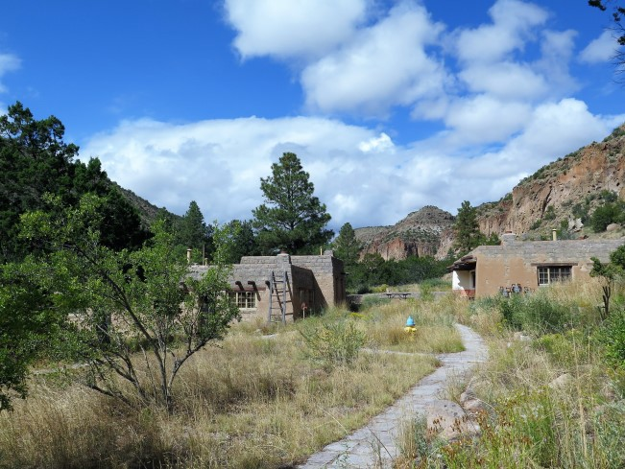
The primary purpose of the program is to give qualified artists an opportunity to live and practice their chosen discipline, following their own inspirations, in a National Park. In return for the opportunity, the artist agrees to
contribute to Bandelier’s mission through public programs while pursuing their own artistic growth.
Experience has shown that an artist’s presence in the park, with the opportunity to interact with the public, can create a memorable experience for visitors while nurturing a deeper appreciation for the natural, historical, cultural, and archeological resources that have made
these parks an important part of our national Historic housing is provided for the Artist-in-Residence

heritage. By offering public programs—workshops, demonstrations, guided walks, or performances— artists can leave lasting impressions that benefit Bandelier, its visitors, and the artist in many and sometimes unanticipated ways.
Upon selection to participate in the Artist-in-Residence program, the artist will meet with the program coordinator and plan a schedule that will permit public interaction in the way that best utilizes the artist’s talents and skills, while assuring adequate time to fulfill his or her personal goals. Artists will provide their own supplies and equipment for their presentations, excepting sound and projection devices already present in park facilities. Park policy prohibits sales of artwork in the park.

Program Management
Bandelier’s Artist-in-Residence Program is managed by the park’s Division of Interpretation & Visitor Services. Artists selected will be evaluated based on their explanations of how they propose to use their work to characterize Bandelier National Monument for present and future generations, and how they believe they can offer the park visitor and the general public an opportunity to appreciate our heritage.

How to Apply
Artists must submit application materials and samples exactly as indicated on the application form. Insufficient or excessive application materials including samples will be cause for rejection of the application, as is an artist’s proposed use of a work already in progress as a residency project.

Applications Calendar
For 2022, Bandelier National Monument will accept three applicants for Artist-in-Residence positions lasting four weeks each. These will be scheduled between September 1 and mid-December 2022.
Applications must be postmarked no earlier than January 15 and no later than March 31, 2022.
Applications postmarked outside these dates will not be considered.
On the application, please indicate the months that you are available. This is to help with scheduling; there is no guarantee of availability on specific dates.
Notifications of acceptance will be made by May 31, 2022.
Application forms, CDs and DVDs will be returned only if accompanied by a large stamped, self- addressed envelope.

About Bandelier National Monument
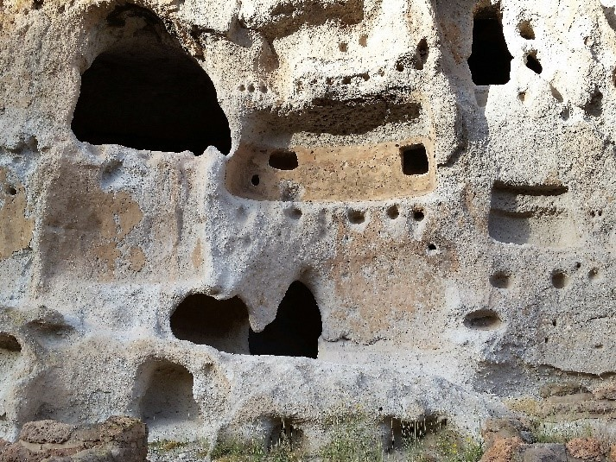
In north-central New Mexico, ten miles from Los Alamos and an hour’s drive from Santa Fe, Bandelier National Monument occupies more than 32,817 acres on the southern section of the Pajarito Plateau, a gently sloping highland on the eastern flank of the Jemez Mountains. It contains a wealth of archeological sites dating from 1150 to 1550 CE, including large pueblos, medium sized house- blocks, single room shelters and cave dwellings— evidence of 400 years of occupation by Ancestral Pueblo people. In 1916, President Woodrow Wilson established Bandelier National Monument to protect, preserve, study, and interpret this heritage.
The park’s namesake is Adolph Bandelier, a Swiss-born banker from Illinois who first came to the area in 1880 to pursue his passion for archaeology. His careful observations of Pueblo culture, recorded in his journals, offer a rich resource for understanding the diverse natural and cultural history of the monument.
The entrance to Frijoles Canyon and the visitor center can be reached by car over a paved road, but access
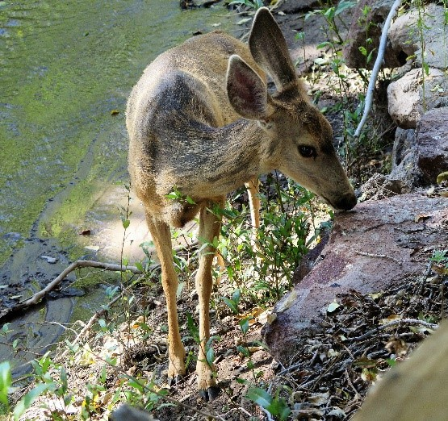
to most of the park is by an extensive trail system. A hiker will enjoy many relatively short hikes or challenging ones that climb into and out of three steep-walled canyons with elevations ranging from 5,300 feet at the Rio Grande River to 10,199 at the summit of Cerro Grande.
The views are spectacular, the geology— primarily volcanic— is fascinating, and the vegetation extremely varied ranging from cottonwood, Ponderosa pine, Gambel oak, and boxelder in Frijoles Canyon to juniper, piñon and several species of desert cacti growing on the mesa tops. The variety of wildlife includes deer, elk, the more elusive cougar, and black bear, and the always-delightful Abert’s squirrel. Birds range in size from the tiny broad-tailed hummingbird and white-breasted nuthatch to the turkey vulture and red-tailed hawk.
For more information, please see the park website at www.nps.gov/band

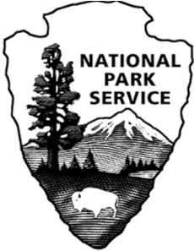

2022 Bandelier Artist-in-Residence Application Form

Artistic Medium

Name

Address

City State Zip

Daytime Phone ( ) Evening phone ( )

Email

Circle the months that you are available: September October November December

Application Enclosure Checklist
All applicants will submit a CD or DVD containing
- A detailed resume of professional experience
- A brief biography, up to 100 words, that can be used for social media and press releases
- Statement of Purpose for their Residency in no more than two pages, addressing relevancy of proposed project to Bandelier National Monument (See Project Management) and potential for personal growth during residency
- Samples of artistic work as described below
Items (1) through (3) should be in Microsoft Word .doc files. Formats for artistic work are described below. Do not send paper copies of Resume or Statement of Purpose.

Samples of Artistic Work (submit as appropriate)
  - Visual Artists (photographers, sculptors, painters, etc.) No more than eight images in jpeg or tiff format.
  - Writers – No more than eight pages of written examples in MS doc format.
  - Musicians/Composers – No more than eight examples in mp3 format
  - Performing Artists or other video submissions – No more than eight examples in mp4 format
  - Multi-Discipline Artists – Send appropriate sample combinations based on the above.
Mail your application to: Coordinator, Artist in Residence Program
Bandelier National Monument 15 Entrance Road
Los Alamos, NM 87544-9508

Applications must be postmarked between January 15, 2022 and March 31, 2022

