Group A – Five Group Rotation with Pueblo Games

Do activities in this order:
1st – Walk the trail through the Aztec West great house. Teacher guides are available. Spend 30 minutes on the walk.

2nd – Play Pueblo Games in the picnic area. Spend 30 minutes here.

3rd – Walk the Old Spanish Trail to the Animas River (1/4 mile each way) OR do the Build a Pueblo activity on the front porch of the Visitor Center. This is a good time for bathroom breaks. Spend 30 minutes here.

4th – Look around in the museum, check out the ArcKart, and watch the 15 minute film. This is a good time for bathroom breaks. Spend 30 minutes here.

5th – Interact with the Object Reproduction Trunk on the back porch of the Visitor Center and grind corn with a mano and metate. Spend 30 minutes here.

Group B – Five Group Rotation with Pueblo Games

Do activities in this order:
1st – Play Pueblo Games in the picnic area. Spend 30 minutes here.

2nd – Walk the Old Spanish Trail to the Animas River (1/4 mile each way) OR do the Build a Pueblo activity on the front porch of the Visitor Center. This is a good time for bathroom breaks. Spend 30 minutes here.

3rd – Look around in the museum, check out the ArcKart, and watch the 15 minute film. This is a good time for bathroom breaks. Spend 30 minutes here.

4th – Interact with the Object Reproduction Trunk on the back porch of the Visitor Center and grind corn with a mano and metate. Spend 30 minutes here.

5th – Walk the trail through the Aztec West great house. Teacher guides are available. Spend 30 minutes here.
Visitor Center
Visitor Center
Group C – Five Group Rotation with Pueblo Games

Do activities in this order:
1st – Walk the Old Spanish Trail to the Animas River (1/4 mile each way) OR do the Build a Pueblo activity on the front porch of the Visitor Center. This is a good time for bathroom breaks. Spend 30 minutes here.

2nd – Look around in the museum, check out the ArcKart, and watch the 15 minute film. This is a good time for bathroom breaks. Spend 30 minutes here.

3rd – Interact with the Object Reproduction Trunk on the back porch of the Visitor Center and grind corn with a mano and metate. Spend 30 minutes here.

4th – Walk the trail through the Aztec West great house. Teacher guides are available. Spend 30 minutes on the walk.

5th – Play Pueblo Games in the picnic area. Spend 30 minutes here.

Group D – Five Group Rotation with Pueblo Games

Do activities in this order:
1st – Look around in the museum, check out the ArcKart, and watch the 15 minute film. This is a good time for bathroom breaks. Spend 30 minutes here.

2nd – Interact with the Object Reproduction Trunk on the back porch of the Visitor Center and grind corn with a mano and metate. Spend 30 minutes here.

3rd – Walk the trail through the Aztec West great house. Teacher guides are available. Spend 30 minutes on the walk.

4th – Play Pueblo Games in the picnic area. Spend 30 minutes here.

5th – Walk the Old Spanish Trail to the Animas River (1/4 mile each way) OR do the Build a Pueblo activity on the front porch of the Visitor Center. This is a good time for bathroom breaks. Spend 30 minutes here.

Visitor Center
Visitor Center
Group E – Five Group Rotation with Pueblo Games

Do activities in this order:
1st – Interact with the Object Reproduction Trunk on the back porch of the Visitor Center and grind corn with a mano and metate. Spend 30 minutes here.

2nd – Walk the trail through the Aztec West great house. Teacher guides are available. Spend 30 minutes on the walk.

3rd – Play Pueblo Games in the picnic area. Spend 30 minutes here.

4th – Walk the Old Spanish Trail to the Animas River (1/4 mile each way) OR do the Build a Pueblo activity on the front porch of the Visitor Center. This is a good time for bathroom breaks. Spend 30 minutes here.

5th – Look around in the museum, check out the ArcKart, and watch the 15 minute film. This is a good time for bathroom breaks. Spend 30 minutes here.

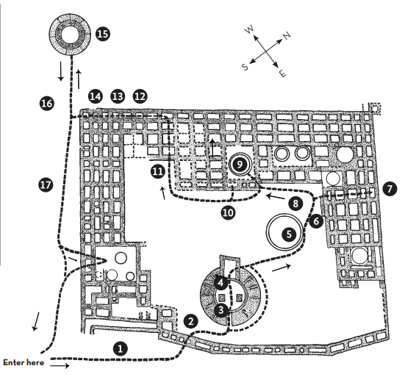

Visitor Center

