NATIONAL PARK SERVICE

[*(…Park Name…)*]

MUSEUM COLLECTIONS EMERGENCY OPERATIONS PLAN

|  |  |  |  |  |  |  |
| --- | --- | --- | --- | --- | --- | --- |
| Recommended by |  |  |  |  |  |  |
| Curator | Name (Print) |  | Signature |  | Date |  |
|  |  |  |  |  |  |  |
| Concurred by |  |  |  |  |  |  |
| Chief Ranger | Name (Print) |  | Signature |  | Date |  |
|  |  |  |  |  |  |  |
| Concurred by |  |  |  |  |  |  |
| Park Emergency Operations Coordinator | Name (Print) |  | Signature |  | Date |  |
|  |  |  |  |  |  |  |
| Concurred by |  |  |  |  |  |  |
| Park Facility Manager | Name (Print) |  | Signature |  | Date |  |
|  |  |  |  |  |  |  |
| Concurred by |  |  |  |  |  |  |
| Regional Curator | Name (Print) |  | Signature |  | Date |  |
|  |  |  |  |  |  |  |
| Approved by |  |  |  |  |  |  |
| Superintendent | Name (Print) |  | Signature |  | Date |  |

|  |
| --- |
| **Instructions**  Fill in [*…blue…*] text with park information.  See *Museum Handbook*, Part I Chapter 10, Figure 10.4: Museum Collections Emergency Operations Plan (Sample) for completed sample. |

National Park Service  
[*……*] Museum Collections Emergency Operations Plan

Title Page

Record of Changes to the Museum Collections Emergency Operations Plan

TABLE OF CONTENTS

A. Museum Emergency Planning Standards and Policies 1

DOI and NPS Museum Emergency Planning Policies 1

NPS Museum Emergency Planning and Preparedness Standards 1

B. Incident Command System (ICS) 2

C. Collections and Structures Housing Collections Overview X

D. Risk Assessment X

Risk Assessment Documents on File X

Risks to Collections and Structures Housing Collections X

E. MCEOP Team Responsibilities X

F. First Priorities for Relocation and Salvage X

First Priority Objects for Relocation and Salvage X

Restricting First Priority Information X

G. Emergency Response X

Evacuation Plan X

Emergency Response Steps X

Designated Assembly Point X

H. Security X

Designated Secure and Stable Location for Relocated Objects X

Access and Key Control Policies and Procedures X

I. Emergency Contact Information X

Emergency Contact List X

Vendor and Sources of Assistance List X

J. Emergency Equipment, Services, and Supplies X

Utility and Mechanical Equipment Shut-Offs X

Emergency Supplies and Equipment X

K. Salvage Procedures X

L. Post-Emergency Critique X

M. MCEOP Update and Review X

N. List of Figures X

[*……*] Site Map X

First Priority Object List for Relocation and Salvage (*Restricted distribution*) X

Floor Plan: Curatorial Facility First Priorities for Relocation and Salvage (*Restricted distribution*) X

Floor Plan: Curatorial Facility Emergency Supplies and Utilities X

Floor Plan: Curatorial Facility Evacuation Route X

Floor Plan: [*……*] First Priorities for Relocation and Salvage (*Restricted distribution*) X

Floor Plan: [*……*] Emergency Supplies and Utilities X

Floor Plan: [*……*] Evacuation Route X

Emergency Response StepsX

Active ShooterX

Disruptive IndividualX

EarthquakeX

ExplosionX

FireX

Hazardous Materials Spill, Odor, and Gas LeakX

Medical EmergencyX

Mold OutbreakX

Power OutageX

Severe WeatherX

Suspicious Package or ItemX

Suspicious Person and VandalismX

Threat (Threatening Call or Bomb Threat) X

Volcanic EruptionX

Water Leak and FloodX

Utility Shut-OffsX

Mechanical Equipment Shut-OffsX

Emergency Contact ListX

Emergency Vendor and Sources of Assistance ListX

Emergency Supplies and EquipmentX

Salvage ProceduresX

Collection Damage and Salvage OverviewX

Post-Emergency CritiqueX

Record of Changes to the Museum Collections Emergency Operations Plan

The following information in the MCEOP has been updated:

|  |  |  |  |  |
| --- | --- | --- | --- | --- |
| Page | Section | Change | Made by, Title | Date |
|  |  |  |  |  |
|  |  |  |  |  |
|  |  |  |  |  |
|  |  |  |  |  |
|  |  |  |  |  |
|  |  |  |  |  |

[*……*] MUSEUM COLLECTIONS EMERGENCY OPERATIONS PLAN

This Museum Collections Emergency Operations Plan (MCEOP) provides guidance for responding to emergency incidents that impact life safety and museum collections at [*……*]. It includes Emergency Response Steps, First Priorities for Relocation and Salvage, emergency contact, vendor and sources of assistance, and supply and equipment lists, floor plans, access and key control policies and procedures, designated secure and stable location, and salvage procedures.

This MCEOP has been appended to the [*……*] park Emergency Operations Plan (EOP). It is reviewed annually and updated every five years. It is activated when the Incident Command System (ICS) becomes operational.

A. MUSEUM EMERGENCY PLANNING STANDARDS AND POLICIES

1. DOI and NPS Museum Emergency Planning Policies

This MCEOP is developed in accordance with:

*411 DM 1: Identifying and Managing Museum Property 1.11.B.3: Emergency Management Plan (EMP):* “… identifies risks and vulnerabilities to museum property from events such as fires, earthquakes, floods, tornadoes, or civil disturbances. The EMP pertains to each bureau/office facility and non-bureau facility housing museum property. The EMP must be reviewed every 5 years and updated, if necessary.”

*900 DM 1: Emergency Management Program 1.3.A: Policy* “All Bureaus/Offices must provide necessary resources to prevent, protect against, mitigate the effects of, respond to, and recover from an incident; declared Emergency and/or Major Disaster…”

*NPS Management Policies 5.3.1.1: Emergency Management*: “Measures to protect or rescue cultural resources in the event of an emergency, disaster, or fire will be developed as part of a park’s emergency operations and fire management planning processes.”

*NPS-28: Cultural Resource Management Guideline 9.D: Standards*: “Each park and center has identified threats to the security and protection of its museum collection and has taken appropriate measures to deal with them, including emergency planning.”

*NPS Director’s Order 24.4.3.10 Emergency Operation:* “Park superintendents, center managers, and others who manage collections (with the assistance of museum management staff) have the following responsibilities:…Approve, keep current, and implement a Museum Collections Emergency Operations Plan, as part of the park’s Emergency Operations Plan and consistent with the National Incident Management System identifying museum collection vulnerabilities to events (such as fire, earthquakes, and floods) and responses that will protect resources without endangering human health and safety. Ensure that staff trains, practices, and prepares for emergency response.”

2. NPS Museum Emergency Planning and Preparedness Standards

1. Develop, approve, keep current, and implement a Museum Collections Emergency Operations Plan (MCEOP) as part of the park Emergency Operations Plan in accordance with Director’s Order (DO) 24.4.3.10: Emergency Operation, that addresses museum collection requirements for emergency protection, response, relocation, and salvage. Review the MCEOP annually and update every five years.
2. Develop Emergency Response Steps for different emergency incidents in the MCEOP.
3. Complete the NPS Checklist for Preservation and Protection of Museum Collections to identify and document hazards to and vulnerabilities of museum collections and structures and spaces housing collections in accordance with DO 24.4.3.21: Checklist. Review and submit to the National Catalog annually in accordance with DO 24.5.2: Checklist.
4. Develop a Museum Mitigation Action Plan that includes corrective actions to be implemented to remove or reduce hazards and vulnerabilities identified in risk assessments. Review annually and update every five years.
5. Mitigate hazards and vulnerabilities identified in the Museum Mitigation Action Plan *or* relocate objects at risk to a designated secure and stable location.

B. INCIDENT COMMAND SYSTEM (ICS)

The superintendent activates the Incident Command System (ICS). In accordance with Director’s Order 55.3.12: Chain of Command, “During emergencies or special events, the chain of command still exists. However, any level of the chain may delegate authority to an Incident Commander or Area Commander.”

The MCEOP team leader, as a resource advisor, will familiarize the Incident Commander (IC) or designee with the MCEOP and the needs of the collection.

C. COLLECTIONS AND STRUCTURES HOUSING COLLECTIONS OVERVIEW

Structures housing collections at [*……*] include [*……*] (see Site Map). The [*……*] collection numbers [*……objects,*] including [*……*]

The [*……*] collections and museum records are housed in [*……*], with [*……objects*] on exhibit in [*……*] [*Emergency access key boxes are located in ……*]

A museum-quality photocopy of the accession book and digital scans of the accession book, accession documents, backup copies of ICMS records, and digital collection images are housed in [*……*], off-site at [*……*], and with the regional curator as of [*……*]

[*……*](FMSS Location # [*……*], [*National Register of Historic Places (#……*]), built in [*……*]It is a furnished [*……*] story structure with a [*……*] foundation and a [*……*] roof. There are [*……*] exterior doors on the [*……*] Each floor has [*……*] windows. Floors are [*……*] Doorways to furnished rooms have [*……*] The building is equipped with [*……*] systems.

The [*……*] (FMSS Location# [*……*]), located [*……*], is a [*……*]-story, [*……*] with [*……*] exterior doors built in [*……*] It includes [*……*] and [*……*]

[*……*], including the Superintendent’s office, is located [*……*]

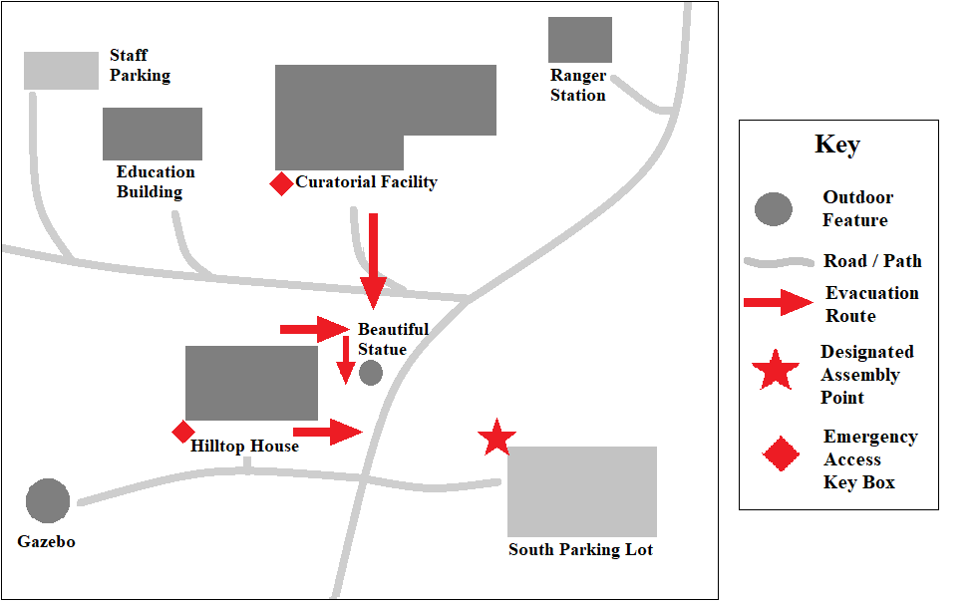

[*……*] Site Map *(Replace with park site map)*

D. RISK ASSESSMENT

1. Risk Assessment Documents on File

The following risk assessment documents are on file in [*……*]:

* NPS Checklist for Preservation and Protection of Museum Collections
* Risk Assessment Worksheet
* First Priorities for Relocation and Salvage
* Object Assessment
* Museum Mitigation Action Plan
* Physical Security Assessment for structures housing collections

A paper copy of the current Museum Mitigation Action Plan is on file in [*……*]

2. Risks to Collections and Structures Housing Collections

The park is at high risk from the following emergency incidents:

* [*……*]

E. MCEOP TEAM RESPONSIBILITIES

*MCEOP team leader* is on call 24/7 to respond to emergency incidents affecting collections and structures housing collections and will, in collaboration with the MCEOP team:

* Develop and implement the MCEOP, review annually, and update every five years.
* Append the MCEOP to the park EOP, in collaboration with the emergency operations coordinator.
* Develop Emergency Response Steps.
* Develop emergency contact, vendor and sources of assistance, and supply and equipment lists.
* Select MCEOP team members, assign responsibilities, and schedule MCEOP meetings.
* Determine object First Priorities for Relocation and Salvage.
* Arrange for and coordinate:
* designated secure and stable location(s) for relocated objects
* emergency supplies, equipment, vendor and contractor agreements, purchases, and services
* relocation and salvage activities
* documentation of museum emergency planning, response, and salvage activities
* training with the emergency operations coordinator and safety officer
* assistance from nearby parks, local museums, and conservators
* Brief superintendent and emergency operations coordinator on museum program needs.

*MCEOP team members* perform relocation and salvage activities, and include:

*Emergency registrar* manages response and salvage documentation, including labeling, salvage activities, and supplies/equipment orders and availability.

*Salvage coordinator* prioritizes objects for salvage and facilitates packing and relocation.

*Security coordinator* ensures collections security and works with the facility manager and emergency operations coordinator on utility and service recovery.

3

F. FIRST PRIORITIES FOR RELOCATION AND SALVAGE

1. First Priority Objects for Relocation and Salvage

First Priority objects on exhibit in [*……*] and in storage in the [*……*] are identified in the list and floor plans on [*pages ……*]. Storage cabinets containing First Priority objects are identified with red tags*.*

2. Restricting First Priority Information

The MCEOP team leader will:

* Maintain the MCEOP (paper copy) with the First Priority list and floor plan(s) in a secure, locked cabinet in the curatorial office, and limit access to electronic copies.
* Distribute MCEOP copies with the First Priority list and floor plan(s) to the superintendent and regional curator that must be secured in a locked cabinet.
* Provide copies of the MCEOP with the First Priority list and floor plan(s) *redacted* to the emergency operations coordinator and safety officer.
* Provide MCEOP team members with copies of the MCEOP with the First Priority list and floor plan(s) *redacted*, and distribute First Priority list and floor plan(s) as needed.
* Maintain the MCEOP in a loose-leaf binder. Mark pages with First Priority information with “Sensitive Information: Do Not Distribute.”

G. EMERGENCY RESPONSE

1. Evacuation Plan

Evacuation Plan for [*……*] and [*……*] from the park Occupant Emergency Plan (OEP) are attached to this MCEOP.

2. Emergency Response Steps

The following Emergency Response Steps are attached to this MCEOP:

|  |  |
| --- | --- |
| **Type of Emergency Response Step** | **Page** |
| Active Shooter |  |
| Disruptive Individual |  |
| Earthquake |  |
| Explosion |  |
| Fire |  |
| Hazardous Materials Spill, Odor, and Gas Leak |  |
| Medical Emergency |  |
| Mold Outbreak |  |
| Power Outage |  |
| Severe Weather |  |
| Suspicious Package or Item |  |
| Suspicious Person and Vandalism |  |
| Threat (Threatening Call or Bomb Threat) |  |
| Volcanic Eruption |  |
| Water Leak and Flood |  |

3. Designated Assembly Point

The designated assembly point is the [*……*] See Site Map.

H. SECURITY

1. Designated Secure and Stable Location for Relocated Objects

The designated secure and stable location for relocated objects is [*……*]

2. Access and Key Control Policies and Procedures

The curator develops and implements access and key control policies and procedures and maintains keys and keycards for [*……*] and [*……*], including cabinets and exhibit cases, and the salvage area. The curator maintains the NPS Visitor Log and Conditions for Access to Museum Collections. The curator maintains a sign-in log for the salvage area.

Attach list of all individuals with keys, key cards, or security system access codes for [*……*], [*……*], and the salvage area, including structures, spaces, and room(s) to which they have access.

I. EMERGENCY CONTACT INFORMATION

1. Emergency Contact List: See page [*……*]

2. Vendor and Sources of Assistance List: See page [*……*]

J. EMERGENCY EQUIPMENT, SERVICES, AND SUPPLIES

1. Utility and Mechanical Equipment Shut-Offs

List of utilities and mechanical equipment, including electrical, cooling, HVAC, fire protection, and security systems, with shut-off locations and responsible individual(s) is attached on page .

2. Emergency Supplies and Equipment: See page [*……*]

K. SALVAGE PROCEDURES

Quickly and safely relocate affected objects in accordance with the First Priority list to a designated secure and stable location outside the impacted area. *Relocate objects only when a greater danger is posed by leaving them in storage or on exhibit.*

Salvage Procedures are attached to this MCEOP on page [*……*]. They include: Before Salvage, Preparing the Salvage Area, General Salvage Procedures, Mold, Water Damage to Objects, and Water Damage to Spaces Housing Collections.

L. POST-EMERGENCY CRITIQUE: See page [*……*]

M. MCEOP UPDATE AND REVIEW

The MCEOP is reviewed annually and updated every five years by the MCEOP team leader in collaboration with the MCEOP team. This MCEOP is also reviewed and updated after each major emergency incident, change in the MCEOP team leader, addition of a new or renovated structure or space to house collections, large acquisition, new exhibit, when new risks are identified, or when entering into new cooperative relationships with emergency responders.

FIRST PRIORITY OBJECT LIST FOR RELOCATION* AND SALVAGE

|  |
| --- |
| RESTRICTED INFORMATION  Distribute ONLY to the superintendent, MCEOP team leader, and regional curator.  Remove this page from other copies of the MCEOP. |

|  |  |  |  |
| --- | --- | --- | --- |
| First Priority Objects for Relocation and Salvage | | | |
| Catalog  Number | Object Name | Room | Location |
|  |  |  |  |
|  |  |  |  |
|  |  |  |  |
|  |  |  |  |
|  |  |  |  |
|  |  |  |  |
|  |  |  |  |
|  |  |  |  |
|  |  |  |  |

*First Priority objects are to be relocated to [*……*] in the event of an emergency.

†A museum-quality photocopy of the accession book and a digital scan of the accession book and documents were deposited in the [*……*] and with the regional curator on [*……*] A digital scan of the accession book is housed off-site at [*……*]

7

|  |
| --- |
| RESTRICTED INFORMATION  Distribute ONLY to the superintendent, MCEOP team leader, and regional curator.  Remove this page from other copies of the MCEOP. |

Floor Plan: CURATORIAL FACILITY FIRST PRIORITIES FOR RELOCATION AND SALVAGE *(Replace with park site map)*

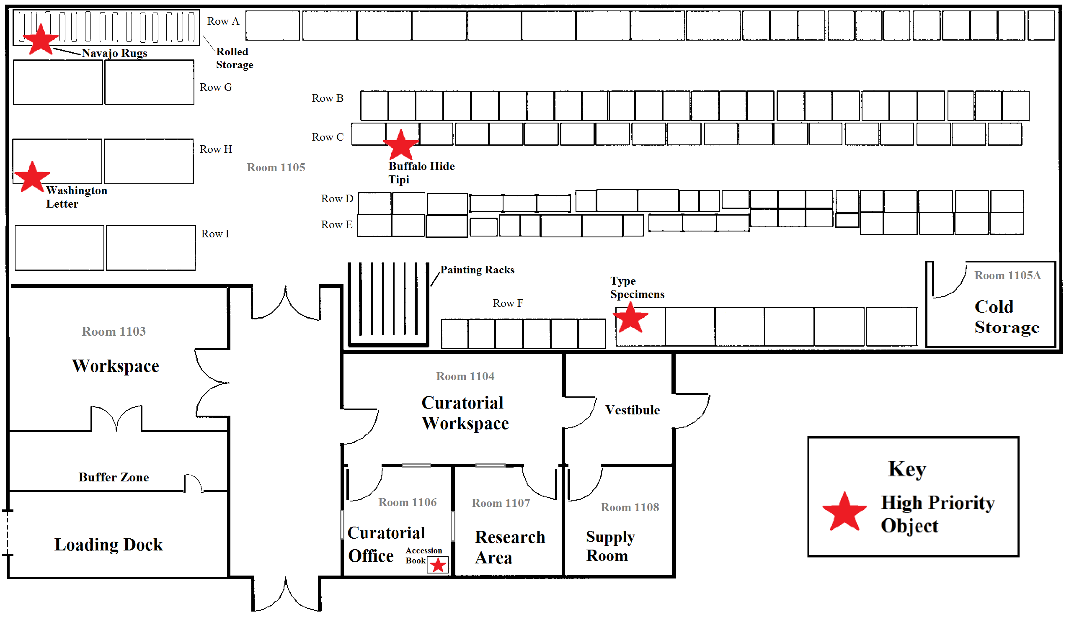

Floor Plan: HILLTOP HOUSE FIRST PRIORITIES FOR RELOCATION AND SALVAGE

*(Replace with park site map)*

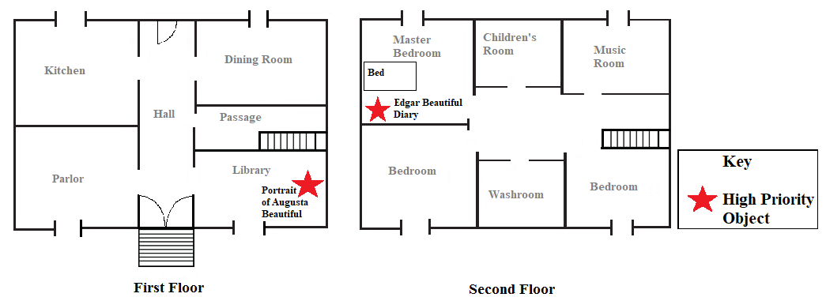

Floor Plan: CURATORIAL FACILITY EMERGENCY SUPPLIES AND UTILITIES

*(Replace with park site map)*

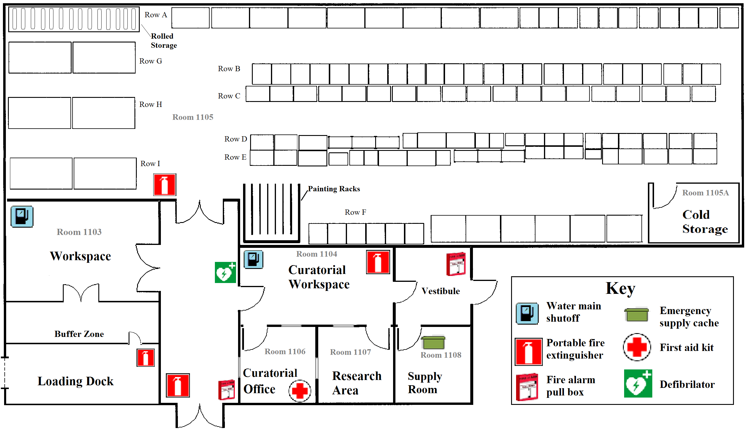

Floor Plan: HILLTOP HOUSE EMERGENCY SUPPLIES AND EQUIPMENT

*(Replace with park site map)*

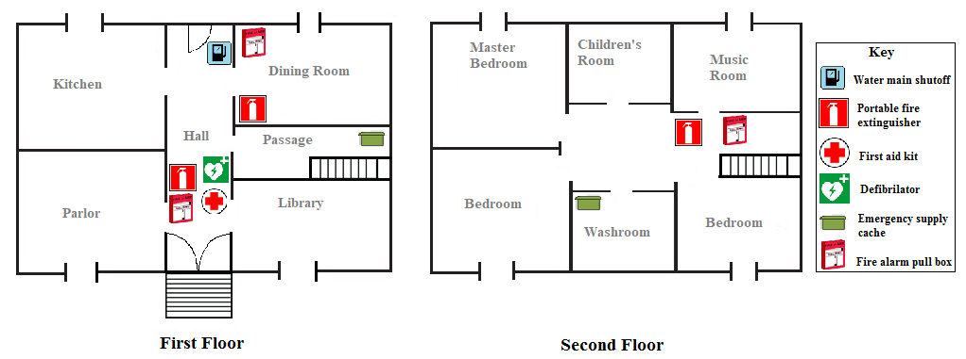

Floor Plan: CURATORIAL FACILITY EVACUATION ROUTE

*(Replace with park site map)*

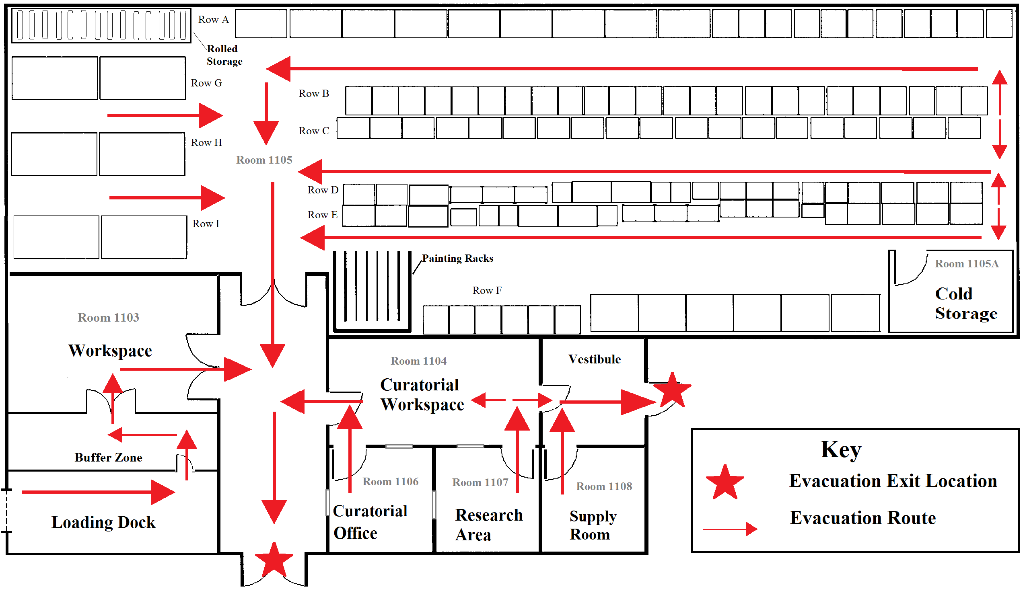

Floor Plan: HILLTOP HOUSE EVACUATION ROUTE

*(Replace with park site map)*

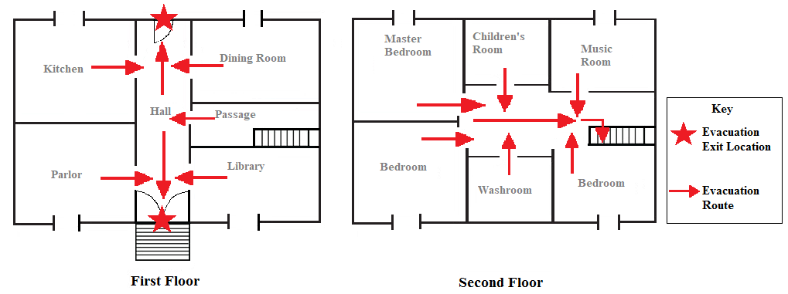

Meet at the designated assembly point at the [*……*]

|  |
| --- |
| ACTIVE SHOOTER  EMERGENCY RESPONSE STEPS |

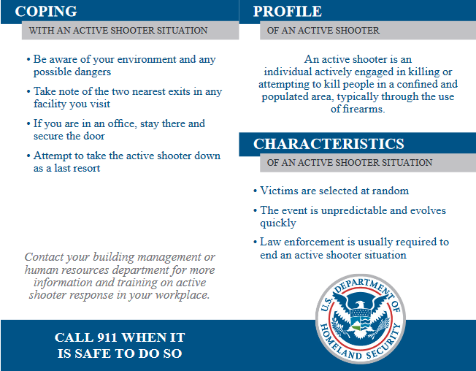

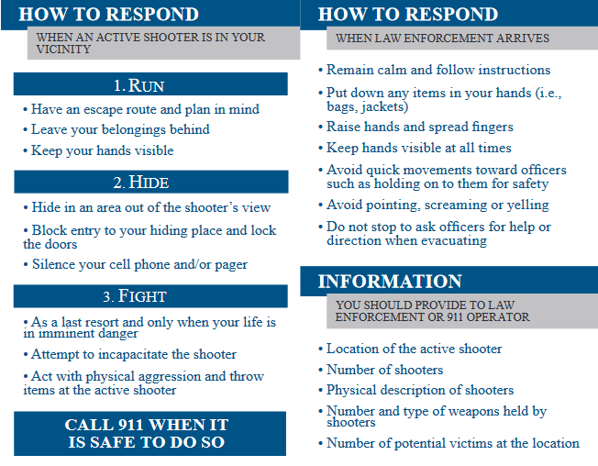

Reproduced from: Department of Homeland Security, “Active Shooter Pocket Card.” 2017. <https://www.dhs.gov/sites/default/files/publications/active-shooter-pocket-card-508.pdf>.

|  |
| --- |
| DISRUPTIVE INDIVIDUAL  EMERGENCY RESPONSE STEPS |

* Call park dispatch and 911.
* Stay calm.
* Be courteous and attentive.
* Direct staff and visitors to move away from the area.
* Stay within sight of the disruptive individual until law enforcement/ranger arrives.
* Do not jeopardize your personal safety.
* Be prepared to describe the individual (age, appearance, gender, etc.).

|  |
| --- |
| EARTHQUAKE  EMERGENCY RESPONSE STEPS |

During the Earthquake

* Stay inside.
* Shelter under the nearest sturdy desk or table.
* DROP, COVER, then HOLD ON
  + drop to hands and knees
  + cover head and neck
  + hold on to sturdy desk or table until shaking stops
* Move away from bookshelves, cases, cabinets, exterior walls, overhead light fixtures, and windows.
* *Do not:*
  + shelter under doorways
  + rush outside
  + use elevators
* If there is no cover, drop to the floor against an interior wall and cover head and neck.
* Shelter in Place until cleared for evacuation.

After Cleared for Evacuation

* Be prepared for aftershocks and tremors.
* Call 911 and park dispatch.
* Evacuate the building.
* *Do not* use elevators.
* Once outside, move away from the building.
* Avoid falling debris, electrical lines, standing water, broken water pipes, and fuel leaks.
* Meet at the designated assembly point.
* Do not re-enter the building until cleared for re-entry.

|  |
| --- |
| EXPLOSION  EMERGENCY RESPONSE STEPS |

Bomb or Explosion Inside the Building

* Take cover under a sturdy desk or table away from windows until debris stops falling.
* Call 911 and park dispatch.
* Evacuate the building.
* *Do not* use:
  + elevators
  + matches, lighters, and other open flames
* Check for fire and other hazards.
* Cover nose and mouth with a wet cloth as needed.
* Stay low if there is smoke.
* Meet at the designated assembly point.
* Do not re-enter the building until cleared.

If Trapped Inside the Building

* Use a flashlight or tap on pipes to signal location.
* Shout only as a last resort to avoid inhaling dangerous dust.

Bomb or Explosion Outside the Building

* Avoid windows, doors, and exterior walls.
* Shelter in Place in the building until cleared.

|  |
| --- |
| FIRE  EMERGENCY RESPONSE STEPS |

* Activate the fire alarm.
* Call 911 and park dispatch.
* Use a portable fire extinguisher to put out a small fire *only* if properly trained.
* *Do not* attempt to put out a nitrate or plastics fire.
* Do not jeopardize your personal safety.
* Evacuate the area immediately.
* If smoke is present, keep close to the ground.
* Cover nose and mouth with a wet cloth as needed.
* *Do not:*
  + use elevators
  + open windows
* Close doors when evacuating to confine the fire.
* If clothing catches fire, STOP, DROP, and ROLL.
* Meet at the designated assembly point.

|  |
| --- |
| HAZARDOUS MATERIALS SPILL, ODOR, AND GAS LEAK  EMERGENCY RESPONSE STEPS |

Hazardous Materials Spill (Liquid or Powder)

* Call 911 and park dispatch.
* *Do not* try to clean the spill.
* Cover the spilled material.
* Remove affected clothing using gloves if splashed.
* Wash hands with soap and water.
* Restrict access to the contaminated area.
* Leave the room and close the door.
* Evacuate the building.
* Meet at the designated assembly point.

Exposure to Blood, Bodily Fluids, or Infectious Material

* Assume all blood or bodily fluids carry blood-borne pathogens.
* Avoid coming into contact with blood and bodily fluids.
* If exposed, wash affected area(s) with soap and water immediately.
* Call 911 and park dispatch.
* Restrict access to the contaminated area.
* Await first responders.

Odor or Gas Leak

* Open a window if there is hissing or a gas odor.
* Call 911 and park dispatch.
* *Do not* turn electrical appliances on or off to prevent sparking.
* Evacuate the building immediately.
* Meet at the designated assembly point.
* Notify the facility manager to turn off the gas main valve.

Figure 10.10. Hazardous Materials Spill, Odor, and Gas Leak Emergency Response Steps

|  |
| --- |
| MEDICAL EMERGENCY  EMERGENCY RESPONSE STEPS |

* Call 911 and park dispatch.
* Be prepared to describe the nature and location of the medical emergency.
* Keep the injured person calm and indicate help is on the way.
* Provide care *only* if trained to do so.
* Remain with the injured person.
* Keep the area clear.
* *Do not:*
  + move the injured person
  + give the injured person anything to eat or drink
  + attempt to administer first aid without consent
* Arrange to meet first responders.

|  |
| --- |
| MOLD OUTBREAK  EMERGENCY RESPONSE STEPS |

Mold on Objects

* Wear gloves and protective clothing.
* Be aware of potential allergic reactions to all molds.
* Isolate affected objects:
  + in a room with low relative humidity and temperature
  + with separate air handling from other collections
* Remove all sources of moisture or excess humidity within 48 hours.
* Identify mold in consultation with a specialist.
* Follow salvage procedures for mold.

Large-scale Mold Outbreak in Spaces Housing Collections

* Evacuate the contaminated area.
* Restrict access to the contaminated area.
* Contact:
  + park safety officer and facility manager
  + specialist to identify the mold
  + professional abatement team
* *Do not:*
  + touch contaminated materials
  + re-enter the area until cleared

|  |
| --- |
| POWER OUTAGE  EMERGENCY RESPONSE STEPS |

* Report the outage to the facility manager and park dispatch.
* Ensure continued security coverage and fire protection.
* Keep HVAC operational using back-up power systems.
* Use a flashlight.
* Tape refrigerators, freezers, and cold storage units shut and:
  + turn units to the coldest settings
  + seal with polyethylene sheeting and duct tape
  + mark with “Do not open” and name and date
* *Do not* use matches, lighters, and other open flames.
* Evacuate the building and:
  + move single file with caution along the evacuation route
  + close doors and windows en route
  + meet at the designated assembly point
* Secure the building.
* Restrict access until regular services and security are restored.

|  |
| --- |
| SEVERE WEATHER  EMERGENCY RESPONSE STEPS |

Hurricane

* Monitor National Weather Service and other advisories.
* Check battery-powered equipment, back-up power sources, and emergency exit lights.
* Ensure collections are safely stored and secured.
* Cover and secure objects with polyethylene sheeting or tarp.
* Relocate First Priority objects to the designated secure and stable location.
* Tape refrigerators, freezers, and cold storage units shut and:
  + turn units to the coldest settings
  + seal with polyethylene sheeting and duct tape
  + mark with “Do not open” and name and date
* Back up and secure electronic museum records in a secure and stable location.
* Close and secure doors, windows, and shutters, and cover with boards.
* Brace exterior doors and place sandbags in front of doors.
* Shut down and unplug electrical appliances.
* Evacuate the building.
* Meet at the designated hurricane assembly point.
* Shelter in Place in a windowless interior room above ground level if evacuation is not possible.

Thunderstorm

* With advance notice, move objects away from windows and doors.
* Close and secure windows and doors.
* Disconnect electrical appliances.
* *Do not* use landline telephones or electrical equipment.
* Avoid metal structural elements, outlets, faucets and sinks.
* Use battery operated equipment.
* Remain indoors.
* Shelter in Place in a windowless interior room until the storm passes.

Tornado or Wind Storm

* With advance notice, move objects away from windows and doors.
* Avoid doors, outside walls, and windows.
* Shelter in Place in the basement or windowless interior room on the lowest level.
* Take cover under a sturdy desk or table until cleared.
* If stranded on an upper floor, go to a closet or windowless hallway.

|  |
| --- |
| SUSPICIOUS PACKAGE OR ITEM  EMERGENCY RESPONSE STEPS |

* Be suspicious of a package or item displaying:
  + - excessive postage weight
    - excessive tape or string
    - foreign mail, airmail, or special delivery
    - hand written/poorly typed address or no return address
    - incorrect title or title with no name
    - markings such as “Confidential” without a return address
    - misspellings of common words
    - oily stains or discoloration
    - protruding wires or tinfoil
    - rigid, lop-sided, or uneven envelope
    - ticking or buzzing
    - vapors or odors
* *Do not:*
  + - handle, open, or move the package/item
    - activate fire alarm pull bars to avoid activating explosive devices
    - use a cell phone or radio to avoid activating explosive devices
* Restrict access to the area and package/item.
* Evacuate the building.
* Move to a safe area (100 feet away) before calling 911 and park dispatch.
* Meet at the designated assembly point.
* Be alert for a possible second explosive device.

|  |
| --- |
| SUSPICIOUS PERSON AND VANDALISM  EMERGENCY RESPONSE STEPS |

Suspicious Person

* Call 911 and park dispatch.
* *Do not* engage the suspicious person.
* Keep a safe distance.
* Evacuate occupants using the nearest exit.
* Meet at the designated assembly point.
* Be prepared to describe the individual, vehicle, license plate, and direction of escape.

Vandalism

* *Do not* interfere with or physically restrain the vandal.
* Call 911 and park dispatch.
* Be prepared to describe the individual, vehicle, license plate, and direction of escape.
* Do not touch or move anything until cleared by law enforcement.
* Gather vandalized museum object(s), label broken pieces, and keep together in storage.

|  |
| --- |
| THREAT (THREATENING CALL OR BOMB THREAT)  EMERGENCY RESPONSE STEPS |

* Listen carefully.
* Do not interrupt the caller.
* Write down what the caller says in their own words.
* Make notes on:
* age, sex, accent, tone of voice
* background noises
* location and timing of threat or bomb
* reason for threat or bomb
* Stay on the phone as long as possible.
* Discretely signal a coworker to call 911 and park dispatch.
* Only notify employees directly involved to prevent panic.
* For bomb threats, *do not:*
* activate fire alarm pull bars to avoid activating explosive devices
* use a cell phone or radio to avoid activating explosive devices
* Evacuate if instructed to do so.*
* Meet at the designated assembly point.

*Note: Evacuations may move people to locations that could become targets for active shooter situations.

|  |
| --- |
| VOLCANIC ERUPTION  EMERGENCY RESPONSE STEPS |

* Monitor National Weather Service and other advisories.
* Seal cabinet doors with tape.
* Cover storage cabinets, exhibit cases, and furnishings with polyethylene sheeting or tarps.
* Move objects away from doors and windows.
* Cover freestanding objects with polyethylene sheeting.
* Work with the facility manager to:
* shut down the HVAC system to prevent clogging
* tape HVAC ducts and vents shut
* place coverings over chimneys
* *Do not* shut off the intrusion detection and alarm and automatic fire protection systems.
* Cover windows with boards and/or plastic sheeting.
* Seal exterior doors with tape.
* Evacuate the building immediately.
* Meet at the designated assembly point.
* When evacuating, stay on high ground where possible.
* Avoid areas where lava or mudslides can accumulate.

|  |
| --- |
| WATER LEAK AND FLOOD  EMERGENCY RESPONSE STEPS |

* Call park dispatch, 911, and the facility manager.
* Stop the flow of water immediately if safe to do so.
* Determine which objects are in jeopardy.
* Move First Priority and small objects out of the affected area to a designated secure and stable location.
* Cover the following with polyethylene sheeting or tarps:
* freestanding non-moveable objects
* storage cabinets and exhibit cases
* *Avoid:*
* flooded spaces and standing water
* appliances or outlets near the leak or water
* Restrict access until the leak or flood has been safely controlled.
* Evacuate if danger is imminent.
* Meet at the designated assembly point.

# EMERGENCY CONTACT LIST (SAMPLE)

Park Dispatch [*…*]

Emergency 911

Museum:

MCEOP Team:

Supervisory museum curator (MCEOP team leader) [*……*]

Museum collections manager (Emergency registrar) [*……*]

Museum technician (Salvage coordinator) [*……*]

Museum specialist (Security coordinator) [*……*]

Other museum staff:

Museum technician [*……*]

Intern [*……*]

Park:

Facility manager [*……*]

Emergency operations coordinator [*……*]

Structural Fire Coordinator [*……*]

Fire Management Officer [*……*]

Safety officer [*……*]

Chief Ranger [*……*]

Law enforcement [*……*]

Superintendent [*……*]

Administrative Officer [*……*]

Information technology [*……*]

Region / Center:

Regional curator [*……*]

Conservator [*……*]

Historical architect advisor [*……*]

Cultural landscape specialist [*……*]

Local sources of assistance:

Fire Chief [*……*]

Police Chief [*……*]

Medical services [*……*]

Hospital [*……*]

Local utility provider [*……*]

Structural/mechanical engineer [*……*]

Local park/museum [*……*]

# EMERGENCY VENDOR AND SOURCES OF ASSISTANCE LIST

|  |  |  |  |  |
| --- | --- | --- | --- | --- |
| Name | Contact Type | Phone # | Email | Cooperative Agreement/ Order # |
|  | Abatement services (pest and hazardous materials) |  |  |  |
|  | Architect |  |  |  |
|  | Chemical testing laboratory |  |  |  |
|  | Cleaning services |  |  |  |
|  | Cold storage vault or freezer rental |  |  |  |
|  | Computer data recovery |  |  |  |
|  | Conservation laboratory |  |  |  |
|  | Dehumidification services |  |  |  |
|  | Electrician |  |  |  |
|  | Engineer (structural) |  |  |  |
|  | Fire detection and suppression system services |  |  |  |
|  | Freezer truck rental |  |  |  |
|  | Generator supplier |  |  |  |
|  | Glazier |  |  |  |
|  | HVAC services |  |  |  |
|  | Local library |  |  |  |
|  | Local museum |  |  |  |
|  | Portable equipment supplier |  |  |  |
|  | Public health consultant |  |  |  |
|  | Scientific monitoring equipment rental |  |  |  |
|  | Security system services |  |  |  |
|  | Transportation rental |  |  |  |

EMERGENCY SUPPLIES AND EQUIPMENT *(Sample)*

|  |  |
| --- | --- |
| Supply Category | Emergency and Salvage Supplies |
| Collections Salvage Supplies | aluminum trays, archival tape, blank newsprint, blotting paper, brushes with soft natural bristles, buckets, cheesecloth, clothesline, cotton cloth, Emergency Response & Salvage Wheel, freezer bags, garbage bags, garbage cans (clean), Japanese tissue paper, mesh screens (plastic), Mylar, packing boxes, packing tape, porch screen, polyethylene bags, polyethylene sheeting (inert), polyester boxes, precision knife with spare blades, rope, sandbags (small), sponges (cleaning, soot, etc.), towels (cloth and paper), tulle mesh, twill tape, twine, Tyvek® rolls and tags, wax paper, weights |
| Construction Materials | glue, lumber, nails, plywood, screws, twine, wire |
| Documentation Supplies | cameras, clipboards, color and gray scale cards, erasers, file folders, hole punch, laptop computers with Interior Collections Management System (ICMS) installed, notebooks, paper, pencils, pencil sharpeners, photo ID stand with numbers (magnetic), portable computer printer, rulers, staplers, tripods |
| Emergency Supplies and Equipment* | air compressors, baker’s racks, batteries, bleach, brooms, calculators, cellular phone, containers, disinfectants, dumpsters, duct tape, dust pans, extension cords, fans, flashlights, freezer (commercial grade), generators, hair dryer with a cool setting, hand trucks, headlamps, hoses, knives, ladders, masking tape, mops, movable flood barriers, polyurethane ice chests, portable lights, portable tables, pumps, radios (battery-powered, wind-up, etc.), rope, sandbags (large), scissors, scrub brushes, shovels, spill-absorbent materials, squeegees, storage cart, surge protector, tarps (fire-retardant), trays, weights, wet/dry vacuum cleaners with HEPA filters and mesh screening material  *Equipment and manuals stored together. |
| First Aid Equipment | antibiotic cream, blankets, burn packs, cortisone cream, first aid kits, stretcher, 3 – 4 days of clean water for museum staff |
| Hand Tools | block and tackle pulleys, hammers, pliers, ropes, saws, scissors, screwdrivers, staple gun, staples, tape measures, tin snips, utility knives with spare blades, wire cutters, wood saws, wrenches |
| Museum Environmental Equipment | dataloggers, dehumidifiers, fans, hygrometers, hygrothermographs with extra paper, silica gel, space heaters (closed coil) |
| Protective Clothing | masks (N-95, HEPA respirator), nitrile gloves, protective coveralls, rain ponchos, rubber aprons and boots, safety glasses, safety goggles, safety vests, shoes |

# SALVAGE PROCEDURES

|  |
| --- |
| *Follow these salvage procedures during the* ***first 48 – 72 hours*** *following an emergency incident*  *to stabilize affected objects and prevent further damage or loss.* |

Certain materials such as animal skins, basketry, glass plate negatives, metals, paintings, photographic materials, and works on paper may require professional treatment after the first 48 – 72 hours have passed. Consult the regional curator and a conservator to determine treatment needed.

See NPS [*Conserve O Gram*](https://www.nps.gov/museum/publications/conserveogram/cons_toc.html)*s* Section 21: Disaster Response and Recovery; [*Primer on Disaster Preparedness, Management & Response*](https://www.nps.gov/museum/publications/primer/primintro.html), issued by the Smithsonian Institution, National Archives and Records Administration, Library of Congress, and National Park Service; and the Emergency Response & Salvage Wheel, published by AIC.

|  |
| --- |
| **BEFORE SALVAGE** |

* Work with the Incident Commander, emergency operations coordinator and facility manager to ensure the salvage space has functioning HVAC, stable relative humidity (RH) and temperature, and excludes ultraviolet radiation.
* Work with the safety officer to arrange for professional abatement services as needed.
* Set up and secure back-up generators, dehumidifiers, and ventilation and/or fans.
* Contact contractors and service providers, including conservators.
* Establish secure access and key control policies and procedures, including a daily sign-in log.
* Set up environmental control and monitoring systems.
* Set up documentation procedures, including inventory control.
* Arrange for photography of damage and salvage activities.
* Ensure Personal Protective Equipment (PPE) is available for designated MCEOP team members.
* Set up mobile communications.

|  |
| --- |
| **PREPARING THE SALVAGE AREA** |

* Set up a secure salvage area, including locking doors and key control.
* Assemble and allocate necessary equipment and supplies.
* Set up access to computers, including ICMS.
* Separate work areas from break areas.
* Clean and cover work surfaces, including tables.
* Place and secure mats at entrances to avoid tracking dirt into the salvage area.
* Prepare work stations for various activities, including documentation, photography, rinsing, air-drying, interleaving, and packing.
* Establish work teams with assigned responsibilities.
* Ensure staff and volunteers wear appropriate protective clothing, masks, nitrile gloves, and shoes.

|  |
| --- |
| **GENERAL SALVAGE PROCEDURES** |

|  |
| --- |
| *Use these general salvage procedures together with specific salvage procedures below.* |

* Relocate First Priority objects first, including the accession (and deaccession) book, to the salvage area.
* Determine which other objects should be relocated as time permits.
* Record temporary object storage locations.
* Salvage and stabilize First Priorities and other objects in consultation with the regional curator and conservator.
* List damage sustained and salvage activities using the Collection Damage and Salvage Overview (Figure 10.25).
* Do the minimum necessary to stabilize affected objects. Remember: “less is more.”
* Keep handling to a minimum. Handle objects carefully.
* Keep components of broken objects together.
* Use supports when handling weak or damaged objects.
* Ensure objects are labeled and packed into boxes that are labeled and include an inventory list.
* Number and maintain an inventory of all boxes and containers.
* Document work in writing, including salvage activities.
* Photograph object damage and salvage activities. Include catalog numbers with all object images.
* Update ICMS records.

|  |
| --- |
| **MOLD** |

* Isolate affected objects.
* If many objects are affected, or if there is a large-scale mold outbreak, contact an organization specialized and experienced in mold identification and abatement.
* Place affected objects in polyethylene bags to prevent cross-contamination.
* *Only* keep objects in bags for a short time to prevent further mold growth.
* House in a secure area with functioning HVAC and stable low RH and temperature.
* If wet and moldy materials cannot be dried immediately, place in cold storage or freezer.
* Wear appropriate protective clothing, including gloves and masks, when handling moldy objects.
* Avoid touching or blotting moldy objects, as this spreads mold spores.
* *Do not* attempt to remove mold until it is completely dry and powdery.
* Clean mold *only* in a well-ventilated area, such as under a fume hood.
* Determine whether to vacuum dried mold *only* after consulting with a specialist and conservator.
* If vacuuming is recommended, use a HEPA filtered vacuum on low suction to avoid damaging the object:
  + cover the nozzle with screening material to catch any dislodged material
  + dispose of the used vacuum bag, filter, and screening material
* Clean and wash protective clothing separately with soap and bleach.
* Dispose of contaminated protective clothing and cleaning equipment appropriately.

For detailed information, see *Conserve O Grams* 3/4: Mold: Prevention of Growth in Museum Collections and 16/1: Causes, Detection, and Prevention of Mold and Mildew on Textiles.

|  |
| --- |
| **WATER DAMAGE TO OBJECTS** |

* *Do not* clean, rinse, remove mud, or treat objects without consulting with a conservator and the regional curator, as this may cause permanent damage or loss.
* Support wet and damaged objects using trays or boxes during relocation and salvage.
* Ensure that RH and temperature return to acceptable levels gradually to prevent shrinkage, cracking, loss in finishes, and/or loss of attached parts.
* Separate wet objects by degree of wetness.

Air Drying

* Air dry organic materials such as paper, skins, and leather, and inorganic materials such as glass, metals, and fired ceramics. Consult with a conservator and the regional curator for iron and unfired ceramics.
* Place damp or slightly wet objects in a clean environment that has stable low RH and temperature, functioning HVAC or ventilation, and excludes ultraviolet radiation.
* Place objects on flat surfaces covered with sheets of absorbent paper or blank newsprint.
* Space objects and items so air can circulate freely.
* If needed, use space heaters to hasten the drying process. *Never* use open-coil heaters; they are fire hazards.
* When books and paper are dry, close, lay flat on a table or other horizontal surface, gently form into their normal shape, and hold in place with a light weight.
* Check frequently for mold growth.
* *Do not:*
  + blow air directly onto fragile objects
  + use adhesives, metal clips, or detergents on wet materials
  + stack drying books on top of each other
  + open wet books, close books that have swollen open, or separate stuck together books and paper
* If many objects are affected, contact an organization experienced in handling water-damaged museum objects.

Freezing and Cold Storage

* Determine which objects to place in cold storage or freezer after 48 – 72 hours, in consultation with a conservator and the regional curator.
* Arrange for a commercial-grade freezer or freezer truck for large volumes of water-damaged museum objects.
* *Do not freeze* sensitive objects such as:
  + bone, horn, ivory, shell, and teeth
  + canvas and wood-panel paintings
  + ceramics
  + composite objects containing inorganic materials (ceramics, glass, metals)
  + glass and glass plate negatives
  + inlaid, lacquered, painted, or varnished wood and furniture
  + objects under tension, such as drums
  + painted or treated leather
* Interleave paper items and blot to remove excess water using unprinted blotting paper, lint-free towels, or blank newsprint.
* Retain the original order of archival items.
* Wrap and pack objects safely for cold storage or freezing as appropriate.
* Label and inventory each container and include an inventory list.

For detailed information, see *Conserve O Grams* 21/3: Salvage of Water-Damaged Collections: Salvage At A Glance and 21/6: Salvage At A Glance Part III: Object Collections.

|  |
| --- |
| **WATER DAMAGE TO SPACES HOUSING COLLECTIONS** |

* Limit access to the affected area(s).
* Work with the facility manager and safety officer to ensure there are no live electrical appliances or power lines in contact with water before entering.
* Arrange for the removal of water and:
  + keep the HVAC system running
  + set up dehumidifiers, pumps, fans, and other needed equipment
  + dehumidify the space or structure
* Lower the RH and temperature to avoid mold outbreaks.
* Arrange for set points for HVAC systems to return gradually to acceptable levels, based on monitoring data from impacted spaces.
* If using tarps, avoid direct contact with objects by draping from shelving supports and uprights.
* Be aware that:
  + moisture absorbed by organic material will continue to release over time
  + pressure from swollen objects may strain shelving and cause buckling or collapse
  + paper products such as boxes and archival storage will absorb water and may collapse
  + wooden doors may swell and stick
  + RH and temperature may take time to return to collection set points
* After the incident and when immediate risk is mitigated, remove protective coverings to allow air circulation and prevent mold outbreaks.

# COLLECTION DAMAGE AND SALVAGE OVERVIEW

Completed by: _______________________________ Date: _______________________________

Name, Title (Print)

|  |  |  |  |  |  |  |
| --- | --- | --- | --- | --- | --- | --- |
| Catalog Number | Object Name | Damage Sustained | Salvage Activities Taken | Conservation Treatment Needed (Y/N) | Photo (Y/N) | Temporary Location |
|  |  |  |  |  |  |  |
|  |  |  |  |  |  |  |
|  |  |  |  |  |  |  |
|  |  |  |  |  |  |  |
|  |  |  |  |  |  |  |
|  |  |  |  |  |  |  |
|  |  |  |  |  |  |  |
|  |  |  |  |  |  |  |
|  |  |  |  |  |  |  |
|  |  |  |  |  |  |  |

Total number of objects affected: ________________________________________________________________

Total number of objects requiring conservation treatment: __________________________________________

# POST-EMERGENCY CRITIQUE

Park Name: ___________________________________________________________________________

Completed by: __________________________________ Date: __________________________________

Name, Title (Print)

Collections Care

|  |
| --- |
| Were emergency response and salvage activities well-coordinated and adequate? If not, what changes are needed? |
| *Response / Comments:* |
|  |
| Were object relocation and temporary storage arrangements and activities well planned, implemented, and documented? If not, what changes are needed? |
| *Response / Comments:* |
|  |
| Were object First Priorities for Relocation and Salvage adequately implemented? If not, what changes are needed? |
| *Response / Comments:* |

Team Efficiency and Communication

|  |
| --- |
| Were MCEOP team members including team leader, staff, and volunteers working with collections given timely notice of the emergency and their assigned responsibilities? If not, what changes are needed? |
| *Response / Comments:* |
|  |
| Did MCEOP team members function according to their assigned responsibilities? If not, what changes are needed? |
| *Response / Comments:* |
|  |
| Were sufficient personnel available and effectively deployed? If not, what changes are needed? |
| *Response / Comments:* |
|  |
| What MCEOP team communication methods were used, and were they effective? If not, how could they be improved? |
| *Response / Comments:* |
|  |
| Was communication and coordination between the MCEOP team, Incident Commander, and park emergency responders effective? What changes are needed? |
| *Response / Comments:* |

Implementation

|  |
| --- |
| Were museum emergency preparedness, response, relocation, and salvage procedures followed? If not, what changes are needed? |
| *Response / Comments:* |
|  |
| Were MCEOP team members provided with accurate and sufficient information? If not, what changes are needed? |
| *Response / Comments:* |
|  |
| Did serious unexpected problems or circumstances occur? If so, were they handled appropriately? If not, what changes are needed? |
| *Response / Comments:* |
|  |
| Were emergency supplies and equipment sufficient? If not, what supplies were needed? Were they obtained? If not, what changes are needed? |
| *Response / Comments:* |
|  |
| Was there a delay in response, and did it play a significant role in the outcome? If so, what changes are needed? |
| *Response / Comments:* |
|  |
| Did staff from other parks assist? Were they effective? If not, what changes are needed? |
| *Response / Comments:* |

|  |
| --- |
|  |
| What other sources of assistance were used? Were they effective? If not, what changes are needed? |
| *Response / Comments:* |
|  |
| Were major decisions promptly documented? Were activities photographed? If not, what changes are needed? |
| *Response / Comments:* |

General Post-Emergency

|  |
| --- |
| Were Emergency Response Steps adequate and followed? |
| *Response / Comments:* |
|  |
| How could the emergency and damage have been avoided/reduced? Were corrective actions identified in the Museum Mitigation Action Plan implemented? |
| *Response / Comments:* |
|  |
| Did other unidentified impacts/weaknesses occur? If yes, what were they? |
| *Response / Comments:* |
|  |
| What documents, procedures, and lists require revision? |
| *Response / Comments:* |
|  |
| What lessons were learned during and after the emergency incident? |
| *Response / Comments:* |
|  |
| Additional recommendations: |
| *Response / Comments:* |