
National Park Service
U.S. Department of the Interior
Blue Ridge Parkway
Laurel Springs, NC
September 2013
Key dates for this Request for Proposals are as follows:
RFP Release Date:  June 1, 2026 | Proposal Submittal Deadline:  September 30, 2026
Site Tour (Exterior only): July 15, 2026  Access inside facility will be by appointment only after July 15, 2026 | Anticipated Date for Selection of Qualified Proposals:  TBD

Request for Proposals
Lease No. BLRI005-27
Bluffs Lodge

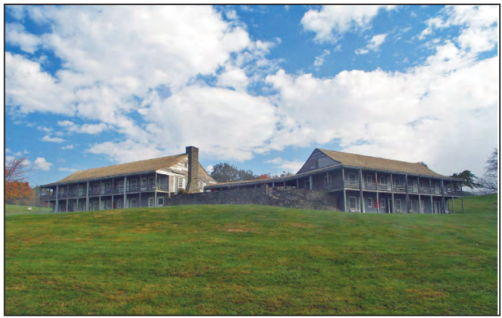

TABLE OF CONTENTS
A. SUMMARY OF LEASING OPPORTUNITY 3
1) Property Offered for Lease 3
2) Exterior Conditions 12
3) Interior Conditions 12
4) Site Conditions & Utilities 12
5) Use of the Leased Property 13
6) Term of the Lease 13
7) Fair Market Value Rent 13
8) Other Terms and Conditions 13
9) Competitive Process 13
10) Site Tour and Additional Information 13
11) Key dates 15
12) Authority 15
B. NATIONAL PARK SERVICE AND BLUE RIDGE PARKWAY 15
C. HISTORY OF BLUFFS LODGE AND GROUNDS 16
D. PROPOSAL SUBMISSION REQUIREMENTS 16
E. PROPOSAL SELECTION CRITERIA OVERVIEW 17
F. PROPOSAL CONTENT 17
1) In General 17
2) Information Requested 18
G. EVALUATION AND SELECTION PROCESS 19
H. ADDITIONAL INFORMATION AND MODIFICATION OF PROPOSALS 19
I. LEASE TERMS AND CONDITIONS 20
1) Term of Lease 20
2) Lease Provisions 20
J. PROPOSALS CONSIDERED PUBLIC DOCUMENTS 20

ATTACHMENTS
A – Draft Lease
B – Business History Information Form
C – Business Organization Information – Corporate and LLC
D – Business Organization Information – Individual and Partnership
E – Offeror Financial Projects (Investments and Start-Up Costs, Proforma Income Statement, Assumptions, Operating Assumptions, Cash Flow, and Recapture) in Excel
F – Sample Offeror Transmittal Letter
G - Historic Structures Report

SUMMARY OF LEASING OPPORTUNITY
This Request for Proposals (RFP) provides the opportunity for any interested individual or organization, hereinafter referred to as “Offeror” to submit proposals to the National Park Service (NPS, ‘Lessor’) to lease NPS property at the Blue Ridge Parkway under the following general terms and conditions.

The selected offeror (Offeror, ‘you’, ‘your’) will have exclusive negotiation rights to enter into a lease based on the attached Draft Lease (See Attachment A). Elements of your proposal may be incorporated into the Draft Lease at Lessor’s discretion.

Property Offered for Lease

Bluffs Lodge, located at Milepost 241.1, opened to visitors September 1950. It is the first motor lodge constructed on the Blue Ridge Parkway.

Bluffs Lodge consists of two buildings, Unit A which is approximately 3,553 square feet and Unit B which is approximately 4,400 square feet. These two buildings are set at an angle with a patio between them. The layout consists of 24 individual rooms. Each room can be accessed from the outside, consistent with a historic “motor court” or motel layout. The patio or paved courtyard features a stone fireplace that encourages engagement and activities amongst visitors. Steps from the courtyard lead to the lower levels of the lodge and a stone retaining wall with a parapet on the west side of the court to take advantage of views of the sunset. Rooms on the rear side of the lodge have views of the adjacent meadow, while those on the front face the single bay loop parking lot.

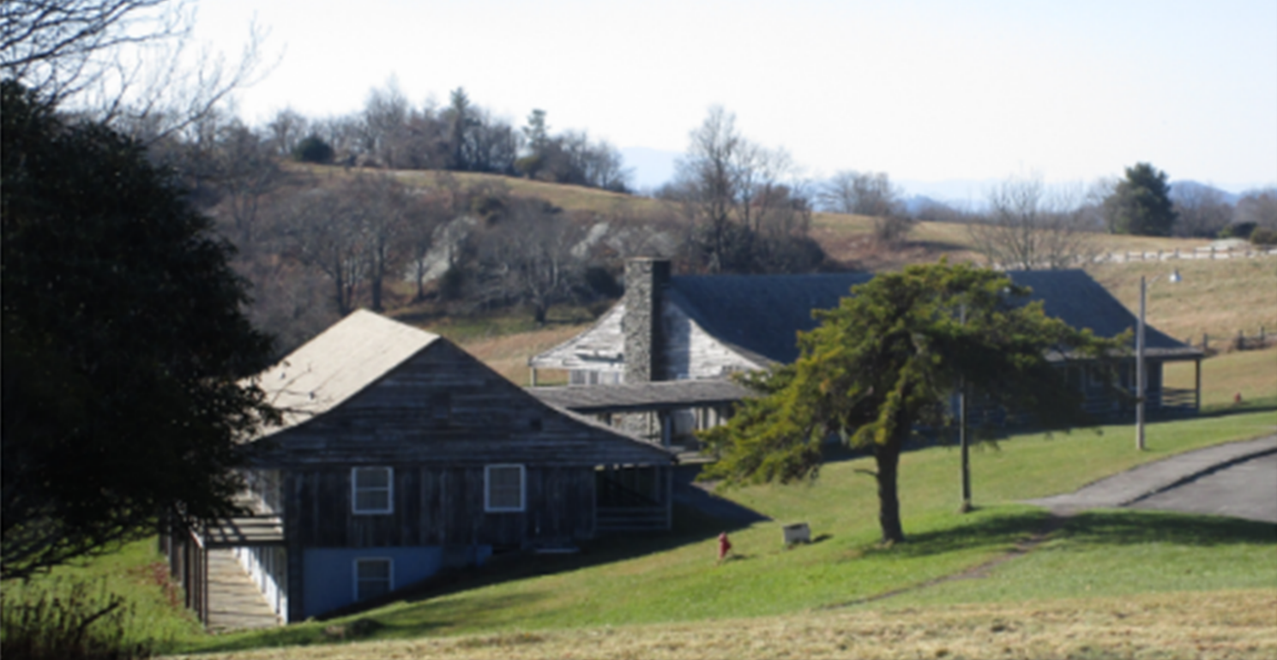

The location of Bluffs Lodge is depicted below as “Project Location.”

Exhibit 1. Project Location.
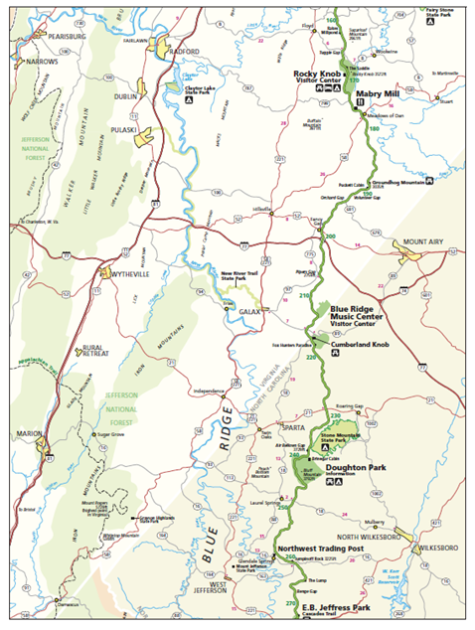
Project Location

The Lease Premises under this Request for Proposals include the Lodge, the terrace, the Lodge parking area, and the lawn located on the northwest corner of the property. If your proposal requires additional facilities, please include plans and purpose for expanded facilities as part of your package.

Exhibit 2. Exterior Lease Premises.

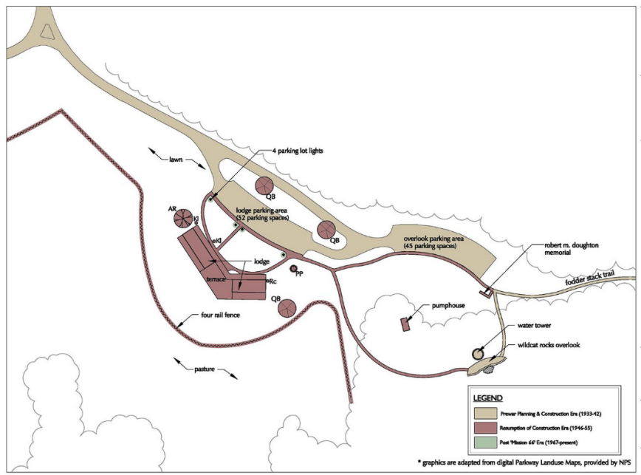

Exhibit 3. Bluffs Lodge Unit A Floorplans

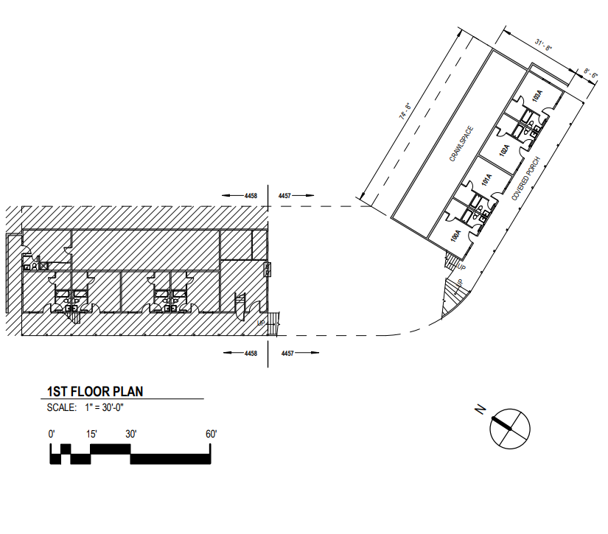

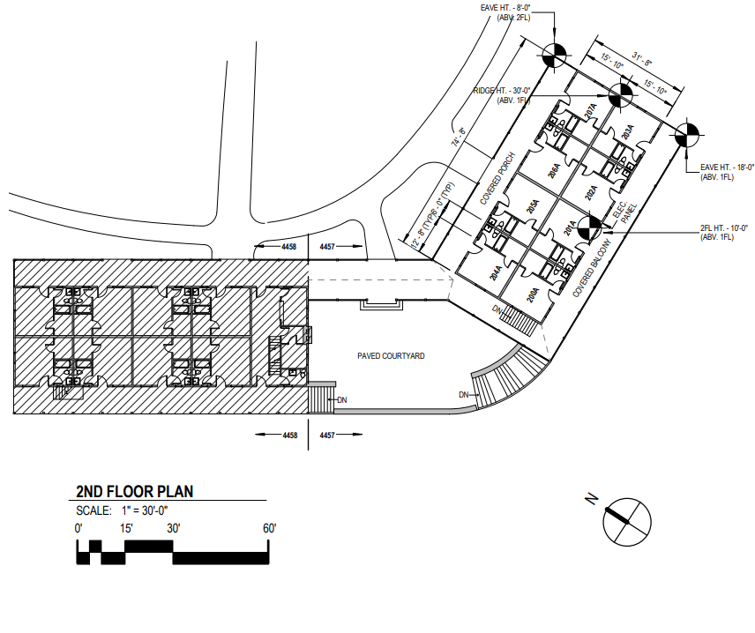

Exhibit 4. Bluffs Lodge Unit B Floorplans

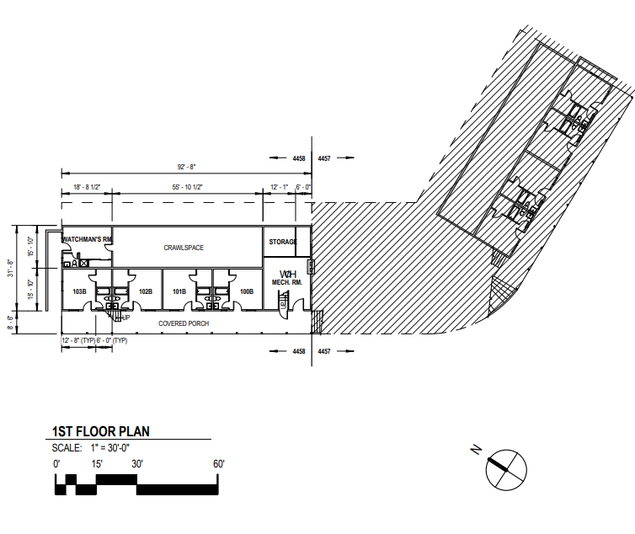

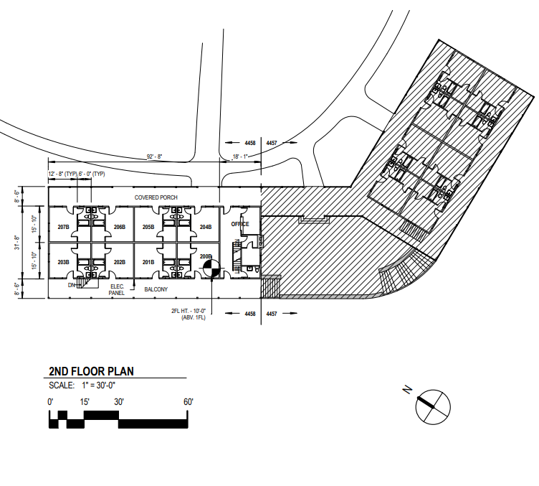
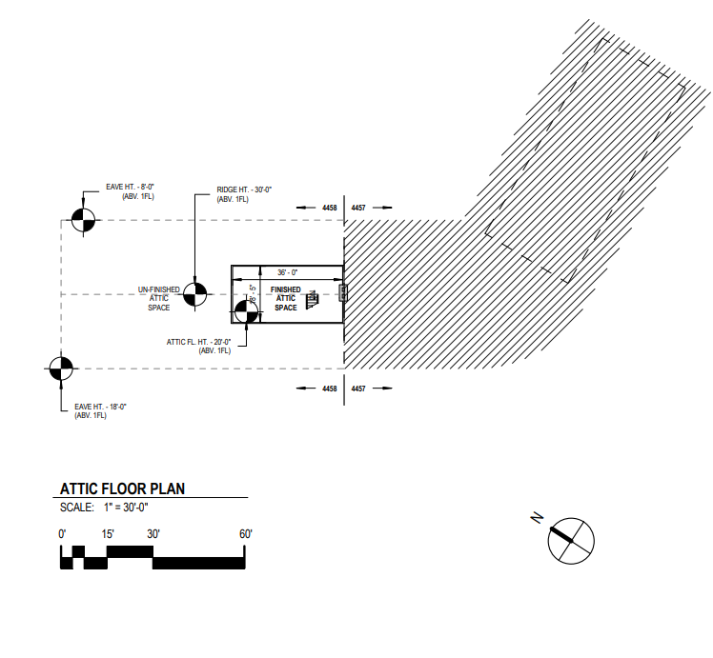

Exterior Conditions

The Bluffs Lodge consists of two lodge structures linked by a covered walkway and is considered in poor condition. Typical exterior features include vertical wood siding, concrete shingle roof with wood gutters, wood windows and doors, stone paving, and wood decking. Needed exterior repairs will include, but are not limited to, repairs or replacement of the wood siding, windows, doors, exterior lighting, gutters, stone paving and masonry repairs on foundation, staircases, and patios. There has been no work performed on the exterior of the building since closing in 2010. Any change or alteration to the exterior of the structure must meet Secretary of the Interior’s standards and meet obligations for review and approval under the National Environmental Policy Act (NEPA), as well as Section 106 review requirements. Additions to footprints of existing structures or the addition of new structures may be possible within these federal guidelines.

Interior Conditions

The interior of the buildings is in fair to poor condition with no maintenance or improvements made to them since the facilities’ closing in 2010. Typical construction of the interior includes carpet flooring, plaster wall and ceilings with wood wainscot in the bedrooms. At the time of its closure in 2010, it was reported that there were areas where excessive moisture had generated unacceptable mold growth in sections of the building, requiring cleanup and remediation. All utility systems including HVAC, water, electrical and plumbing have not been in service since 2010. Needed interior repairs will include plaster wall and ceiling repairs, painting, flooring replacement, water and mold remediation and assessments/replacement of all support systems as necessary (electrical, plumbing, HVAC, etc.). Any major reconstruction of the building or change in use of the building would trigger requirements to bring building systems up to current building code for electrical, plumbing, accessibility, fire suppression, etc. All work must meet obligations for review and approval under the National Environmental Policy Act (NEPA), as well as Section 106 review requirements. Additions to footprints of existing structures or the addition of new structures may be possible within these federal guidelines.

Site Conditions & Utilities

The site consists of maintained lawns, driveways and parking lots, sidewalks, staircases, and incidental features such as site lighting. Much of the constructed sidewalks and patios is of stone surfacing and in need of repair, repointing, and/or resetting. Needed repair work will include, but is not limited to, addressing overgrown vegetation, reestablishment of edges along roads, driveways, and pathways, repointing or repairing stoned walking surfaces, staircases and walls including other masonry features, restoration of site lighting, and repointing various flagstone patios and approaches adjacent to the buildings on the site.

The complex was previously provided potable water from a well located on site. The potable water system, including the well, storage tank, water mains, service lines, and fire hydrants have not been fully operated since 2010 and may require full or partial replacement if it is the intention to provide potable water in any proposed use of the site. Wastewater was treated by localized septic tanks adjacent or nearby to the buildings. All work must meet obligations for review and approval under the National Environmental Policy Act (NEPA), as well as Section 106 review requirements. Additions to footprints of existing exterior grounds and/or utility structures or the addition of new structures may be possible within these federal guidelines.

Use of the Leased Property
The property may be used for the following purposes, or other purposes as may be approved by the NPS: Motel; Restaurant; Educational Facility; Special Event Space; Conference Center; General Commercial or Retail Use; Inn; Professional Offices.

Term of the Lease
The term of the lease will be negotiated with the selected Offeror. The term must be as short as possible, taking into account the financial obligations of the lessee and other factors related to determining an appropriate lease term. The maximum lease term is sixty (60) years. However, the NPS anticipates a term between ten (10) and fifty (50) years depending on the actual costs to rehabilitate the property. The lease term will commence as soon as possible following selection of the best offer pending completion of any required compliance work and property valuation by the NPS.

Fair Market Value Rent
The Lessee will be required to pay annual rent of Fifty-nine Thousand, Four Hundred Nineteen dollars ($59,419). The NPS may offset rent for the cost of improvements incurred by the Lessee in accordance with the requirements of the Lease. The method and timing of such rent offsets will be agreed to by the Lessor and Lessee from time to time, provided that, no rent offsets may be made in the absence of such an agreement.

Other Terms and Conditions
The proposed terms and conditions of the offered Lease are as described in Attachment A “Draft Lease” included in this RFP and are consistent with 36 CFR Part 18. Final terms will be negotiated between NPS and the selected Offeror.

Competitive Process
This lease opportunity is open to all interested persons and businesses on a competitive basis. Whichever Offeror submits the proposal judged best under the proposal selection criteria will be given an opportunity to negotiate a final lease agreeable to both the Offeror and NPS. To be selected by the NPS you must demonstrate that you have the capability to plan and finance your proposal. Evaluation criteria and the process for selecting the Lessee are described in detail in the sections called “Proposal Selection Criteria” and “Evaluation and Selection Process” in this RFP. The NPS reserves the right to reject one or all proposals or terminate lease negotiations at any time prior to executing a final lease without penalty or liability.

Site Tour and Additional Information
The NPS will hold a site tour on July 15, 2026. The tour will not include interior access to the building. Interior visits can be arranged by appointment after July 15, 2026, and all participants must agree to follow safety guidelines and provide their own Personal Protective Equipment (PPE) for safe entry to the facilities.

To obtain further information regarding this Request for Proposals, please email blri_leasing@nps.gov. Questions not addressed in this RFP will be collected in writing and responded to through issuance of Question & Answers (Q&A). Interested parties are required to check the website to ensure they are aware of any modifications to the RFP, additional documentation, or new Q&A’s.

Key dates
RFP Release Date | June 1, 2026
Site Tour | July 15, 2026
Proposal Submittal Date | September 30, 2026
Anticipated Date for Selection of Lessee | TBD
Lease Effective Date | TBD

Authority
This RFP is issued under the authority of 36 CFR Part 18. This RFP and the offered lease are subject to and incorporate all terms and conditions of Part 18 as applicable. In the event of any conflict between the terms of this RFP and Part 18, Part 18 controls.

The NPS has the statutory authority to lease historic property through the National Historic Preservation Act (54 U.S.C. 306121), and to lease buildings and associated land under the control of the agency through the National Park Service General Leasing Authority (54 U.S.C. 102102).

NATIONAL PARK SERVICE AND BLUE RIDGE PARKWAY
America’s National Park Service was created by Congress to “conserve the scenery and the natural and historic objects and the wildlife therein, and to provide for the enjoyment of the same in such a manner and by such means as will leave them unimpaired for the enjoyment of future generations.” Additionally, Congress has declared that the National Park System should be “preserved and managed for the benefit and inspiration of all the people of the United States.” To learn more about the National Park Service, visit our website at www.nps.gov. This site includes information about who we are, our mission, NPS policies, and individual parks.

Blue Ridge Parkway was established June 30, 1936 and was built to link Shenandoah and Great Smoky Mountains National Parks. The parkway traverses the states of Virginia and North Carolina through the central and southern Appalachian Mountains, some of the world’s oldest. Created as a national rural roadway with limited access, the continuous 469-mile parkway was designed for pleasant motoring, a form of recreational driving free from commercial traffic or stop signs. The Blue Ridge Parkway travels the crests, ridges, and valleys of five major mountain ranges, encompassing several geographic and vegetative zones ranging in elevation from approximately 600 to more than 6,000 feet above sea level. Visitors experience diverse vistas of scenic Appalachian landscapes ranging from forested ridge tops and mountain slopes to rural rolling farmlands to urban areas. The parkway offers a “ride-a-while, stop-a-while” experience that includes scenic pullouts, recreation areas and opportunities, historic sites, and visitor contact stations. It is known nationally and internationally for its designed landscape as a scenic parkway.

The parkway is many things to many people. It is the longest road planned as a single park unit in the United States. It contiguously protects significant mountain landscapes far beyond the shoulders of the road itself. Its range of geography and topography provides visitors access to high mountain passes, splendid natural “gardens” of flowering mountain plants, waterfalls and water gaps, deep forests, and upland meadows. It provides a continuous series of panoramic views, the boundaries of the parkway’s limited right-of-way rarely apparent, and miles of the adjacent countryside seemingly a part of the protected scene. Historic scenes along the parkway illustrate the diverse social, economic, and cultural groups of the region, as well as the role of the National Park Service in presenting their stories to the motoring public. It is the product of a series of major public works projects that provided a boost to the travel and tourism industry and helped the Appalachian region climb out of the depths of the Great Depression. It is an important neighbor that links 29 counties through two states and shares boundaries with other national park system units, national forests, tribal lands, and state parks.

The Blue Ridge Parkway and the corridor it travels through are a complex fusion of overlapping jurisdictions, interests, and responsibilities. Strong and coordinated external relations are vital to the parkway’s management and mission. Formal and informal partner organizations provide essential services, staffing, funding, and innovative solutions to management of this linear park and the corridor through which it passes. It is frequently the most heavily visited unit of the national park system.

HISTORY OF BLUFFS LODGE AND GROUNDS
Bluffs Lodge is part of one of the first developed areas to be designed and built along the Blue Ridge Parkway. The lodge was completed in 1950, and the pump house was completed circa 1948-1952. The entry road was completed by 1939, along with Wildcat Rocks Overlook and its parking lot and walkway. The final major addition to the site is the Robert L. Doughton Memorial Plaque, which was installed in 1953 at the start of the walkway leading from the parking lot to the overlook.

The rolling mountain laurel and rhododendron meadows, interspersed with patches of forest, figured prominently in this location for the lodge. A 1942 planting plan called for the enhancement of this existing flora, with a few trees suggested for the entry.

As one of the first lodges to be designed and built on the Blue Ridge Parkway, the property contributes to its historical significance. All major development took place during the first period of Blue Ridge Parkway history (1936 – 1955) and contributes to the national significance of the park unit as a National Historic Landmark (NHL). These features include the entrance road, Wildcat Rocks Overlook and its parking area and walkway, the water tank, the lodge and its associated parking and walkways, and trail connecting it to Wildcat Rocks Overlook, the pump house, as well as the existing vegetation, and the views into Basin Cove and the surrounding meadows. As a historic structure, any work to the Bluffs Lodge must meet the Secretary of Interior’s Standards for Historic Preservation.

PROPOSAL SUBMISSION REQUIREMENTS
Please submit your proposal, accompanied by a transmittal letter from the principal of the proposed lessee, by email to bill_g_stevens@nps.gov. Proposals will not be returned.

Proposals may also be submitted by First Class Mail, accompanied by a transmittal letter signed by a principal of the proposed lessee. The copies must be on 8-1/2" x 11" paper punched with 3 holes on the left side and unstapled (suitable for NPS to put in binders) with double-sided copying. The proposal must be enclosed in a sealed envelope and received at the NPS office stated below by the date and time stated above. The face of the sealed envelope must state the Offeror's name and address along with the following information:

William Stevens
Chief of Commercial Services, Southeast Region
National Park Service
100 Alabama Street SW
Atlanta, GA 30303
Phone: 404-507-5636

Proposals that are not actually received at the designated physical or email address by the specified deadline will not be considered. In the event proposals are sent via first class mail, they must be postmarked prior to the deadline.

Please refer to Section J. Proposals Considered Public Documents, in this RFP if you believe that a proposal contains trade secrets or confidential commercial and financial information that you do not want to be made public.

PROPOSAL SELECTION CRITERIA OVERVIEW
The NPS will select the best responsive proposal received under this RFP under the following selection criteria:

- The compatibility of the proposal's intended use of the offered property with respect to preservation, protection, and visitor enjoyment of the park area;

- The compatibility of the proposal with the historic qualities of the property;

- The financial capability of the Offeror to carry out the terms of the lease;

- The experience of the Offeror demonstrating the managerial capability to carry out the terms of the lease;

- The ability and commitment of the Offeror to conduct its activities in the park area in an environmentally enhancing manner through, among other programs and actions, energy conservation, waste reduction, and recycling;

- The benefit to the NPS of the financial and other terms and conditions of the proposal, including the amount of rent proposed and other proposed lease terms and conditions.

PROPOSAL CONTENT

In General
Proposals submitted in response to this RFP must follow the format described below. You are asked to answer questions or supply specific information in response to the specified items. Please label your responses correspondingly and respond fully and accurately to all questions and/or requests.

Information Requested

- Offeror Identification

Please provide full identification of the person(s) responsible for each proposal submitted: Name(s), address(es), telephone number(s), and e-mail address(es). In addition, please supply the names, addresses, phone numbers, and e-mail addresses of two personal and two professional references.

Please complete and submit the forms contained in the Proposal Forms attached to this RFP for the entity and/or individuals that are to be the lessee and its principals. There are separate forms for sole proprietorships/partnerships and for corporations.

- Proposed Uses

Please describe your proposed use or uses of the property and explain why such use or uses would be compatible with the preservation, protection, and visitor enjoyment of the park area.

- Improvement Plan

Please submit an improvement plan specifying how the applicant intends to rehabilitate and improve this historic property. The plan should comprehensively describe the proposed rehabilitation and improvements which the applicant will accomplish and outline a detailed schedule for program development, construction, completion, and opening for operation. Appropriate preliminary plans and drawings should be included in the plan. Detailed cost estimates should also be included.

- Financial Capability

Please complete and submit the Offeror Financial Projections located in Attachment E, explaining in detail the basis of all estimates included on the form.

Please submit documentation of the source and availability of funding for the estimated investment costs (including rehabilitation costs) through bank statements, bank financing commitment letters, or similar documents that convincingly substantiate your financial capability. All financial statements submitted must be audited.

- Experience

Please explain in detail and document how your experience and background qualify you as being operationally and managerially capable of satisfactorily performing the terms and conditions of the offered lease including the proposed rehabilitation of the historic buildings and the successful marketing of your proposed use.
Please complete and submit the Business Organization Information contained in the attached Proposal Forms for each key individual/entity.

- Environmental Enhancement

Please explain your proposal for managing and using the property in an environmentally enhancing manner through, among other programs and actions you may propose, energy conservation, waste reduction, and recycling.

- Rent Offered

Please state how much annual rent you offer to pay. The amount of rent will be negotiated with the selected Offeror, provided that, the annual rent must be at least Fifty-nine Thousand, Four Hundred Nineteen dollars ($59,419).
- Term Requested

Please state the term of the lease that would be acceptable to you and address, in particular, how the proposed term relates to your estimated rehabilitation costs. When considering the term, please keep in mind that the lease term cannot exceed sixty (60) years, and the NPS is required to award leases with as short a term as possible, taking into account the financial obligations of the lease and other related factors. Shorter terms are considered to be more desirable to the NPS during evaluation of lease proposals.

EVALUATION AND SELECTION PROCESS
The National Park Service will review all responses to this RFP through an evaluation panel assisted by technical consultants as appropriate.

All proposals will first be screened for adherence to the requirements of this RFP. The NPS will not consider non-responsive proposals. A non-responsive proposal is a proposal that was not timely submitted or fails to meet the material terms and conditions of this RFP as determined by the NPS.

It is the intention of the NPS to select the best responsive proposal as determined under the selection criteria without further submittals or presentations. If this cannot be done, the NPS will select those lease proposals that appear most suitable under the selection criteria and will request additional information or presentations from that group so that the best responsive proposal can be selected.

NPS will negotiate the terms of the final Lease with the Offeror determined to have submitted the best responsive proposal under the selection criteria. Award of a Lease to that Offeror is dependent on successful negotiation of the final terms of the lease. If negotiations fail, NPS may negotiate with other Offerors for award of the offered Lease or terminate this solicitation without liability to any person.

Please note that all criteria will be evaluated commensurate with your plans. In other words, your experience and financial capability must match the scale and scope of your plans.

ADDITIONAL INFORMATION AND MODIFICATION OF PROPOSALS
The NPS may request from any Offeror additional information or written clarification of a proposal after the submission date. However, proposals may not be amended after the submission date unless permitted by the NPS. The NPS may not permit amendment of a proposal unless all Offerors that submitted responsive proposals are given an opportunity to amend their respective proposals.

LEASE TERMS AND CONDITIONS

Term of Lease
The lease to be awarded under this RFP is to have a term that is as short as possible, taking into account the financial obligations of the lessee and other factors related to determining an appropriate lease term. The Lease to be awarded under this RFP may have a maximum term of up to 60 years. The Lease may be extended once for a period not to exceed one (1) additional year if the deciding official determines that an extension is necessary because of circumstances beyond the control of the NPS.

Lease Provisions
The Lease to be awarded under this RFP will contain the provisions required by Part 18 as well as other provisions determined by the NPS to be necessary to assure use of the leased property in a manner consistent with the purposes of the park area, and where applicable, to assure the preservation of historic property. Required provisions include, without limitation:
- A termination for cause or default provision and a termination for convenience provision;
- Appropriate provisions requiring the Lessee to maintain the leased property in good condition throughout the term of the Lease;
- Appropriate provisions stating that subletting of a portion of the leased property and assignment of a lease, if permissible under the terms of the lease, must be subject to the written approval of NPS;
- Appropriate provisions requiring the Lessee to pay for use of all services and utilities not provided by the Lessor and to pay all taxes and assessments imposed by federal, state, or local agencies applicable to the leased property or to Lessee activities;
- Appropriate provisions stating that the Lessee has no rights of renewal of the Lease or to the award of a new Lease upon Lease termination or expiration;
- Appropriate provisions stating that the Lessee may not construct new buildings or structures on leased property except where indicated;
- Appropriate provisions requiring that any improvements to or demolition of leased property to be made by the Lessee may be undertaken only with written approval from the NPS; and
- Appropriate provisions that describe and limit the type of activities that may be conducted by the Lessee on the leased property.

A Draft Lease is attached to this RFP and incorporates these terms.

PROPOSALS CONSIDERED PUBLIC DOCUMENTS
All proposals submitted in response to this RFP may be disclosed by the Service to any person, upon request, to the extent required or authorized by the Freedom of Information Act (5 U.S.C.§ 552). If you believe that your proposal contains trade secrets or confidential commercial or financial information exempt from disclosure under the Freedom of Information Act, mark the cover page of each copy of the proposal with the following legend:

“The information specifically identified on pages of this proposal constitutes trade secrets or confidential commercial or financial information that the Offeror believes to be exempt from disclosure under the Freedom of Information Act. The Offeror requests that this information not be disclosed to the public, except as may be required by law.”

You must specifically identify what you consider to be trade secret information or confidential commercial or financial information on the page of the proposal on which it appears, and you must mark each page with the following legend:

“This page contains trade secrets or confidential commercial and financial information that the Offeror believes to be exempt from disclosure under the Freedom of Information Act, and which is subject to the legend contained on the cover page of this proposal.”

Information so identified will not be made public by the NPS except in accordance with law. The NPS does not warrant and assumes no liability for the accuracy of the information provided in this RFP.

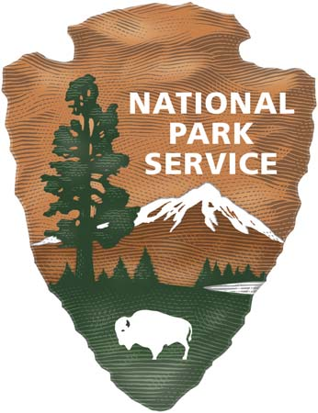

EXPERIENCE YOUR AMERICATM

