APPENDIX A: Descriptions and Photos for Buildings Included in the Lease

Map of Dune Shacks Included in the Lease (Highlighted in Yellow)
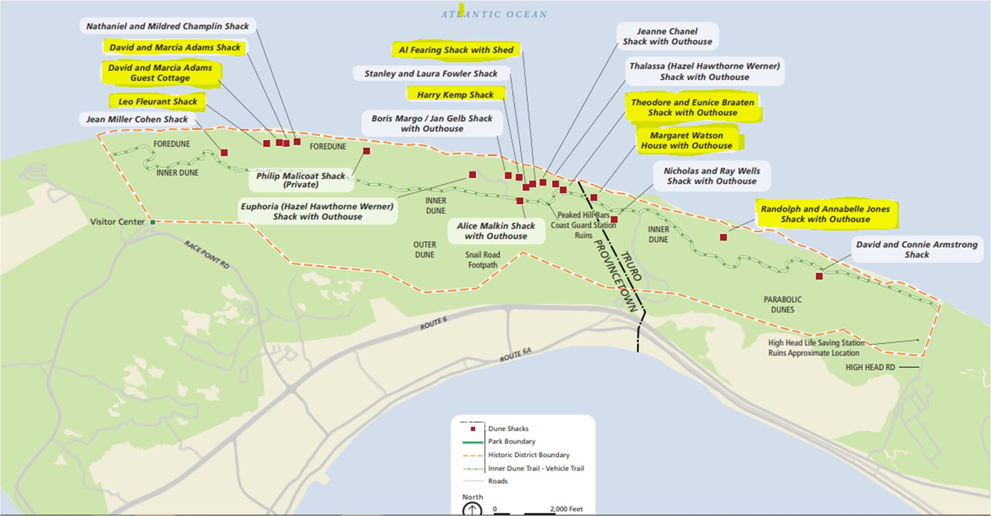

Fleurant Dune Shack:
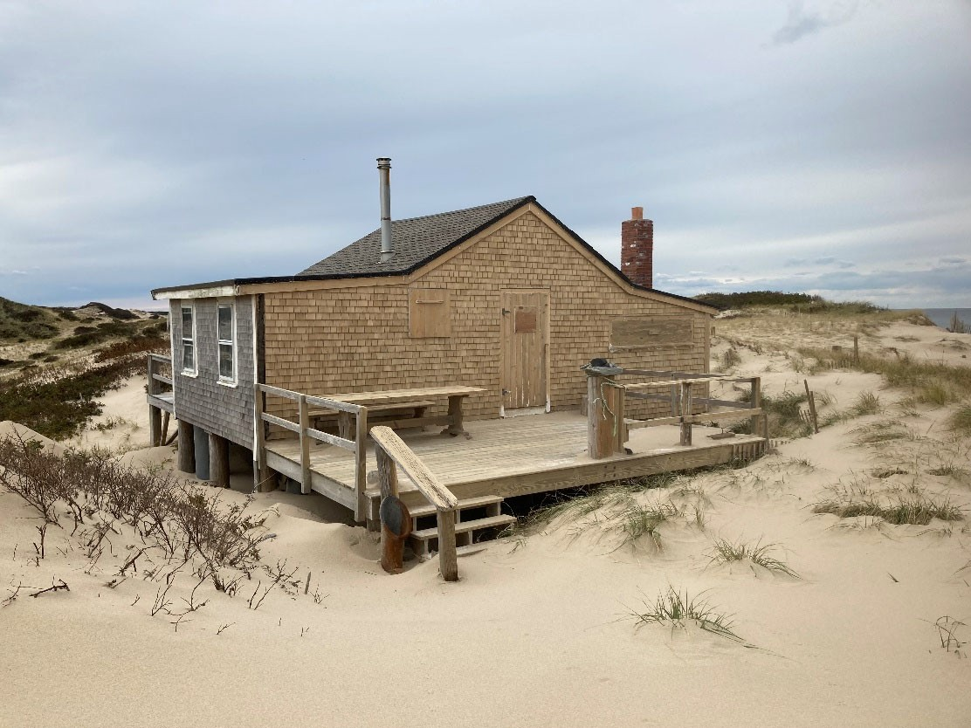

Property Location: The Fleurant Dune Shack is currently located within the Peaked Hill Bars Historic District that is listed on the National Register. The Fleurant Shack is located 1.6 miles east of the Race Point Coast Guard Station approximately 150 feet in from the ocean.

Property Description: The Fleurant Shack consists of a central gable roofed, one‐story section. rectangular one‐story structure with an enclosed screened shed roofed porch. Decks are located along 2/3 of the front/east elevation and along the entire rear/west elevation. The shack rests on a foundation of wooden posts. The footprint of the building is rectangular with low pitch roofs.

The shack is approximately 650 square feet.

The total acreage for the Fleurant Shack is 0.90 acres

Fleurant Dune Shack Annual Rent Cost: $10,357.00.

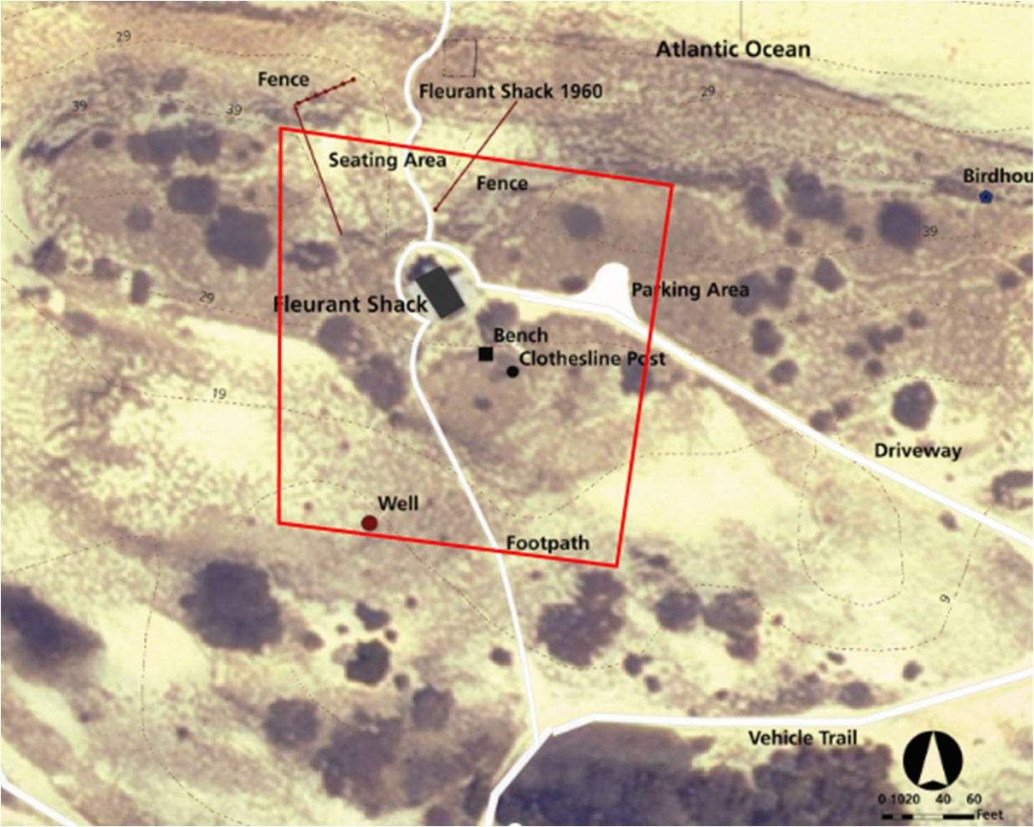

(Image: Fleurant Dune Shack Aerial Map)
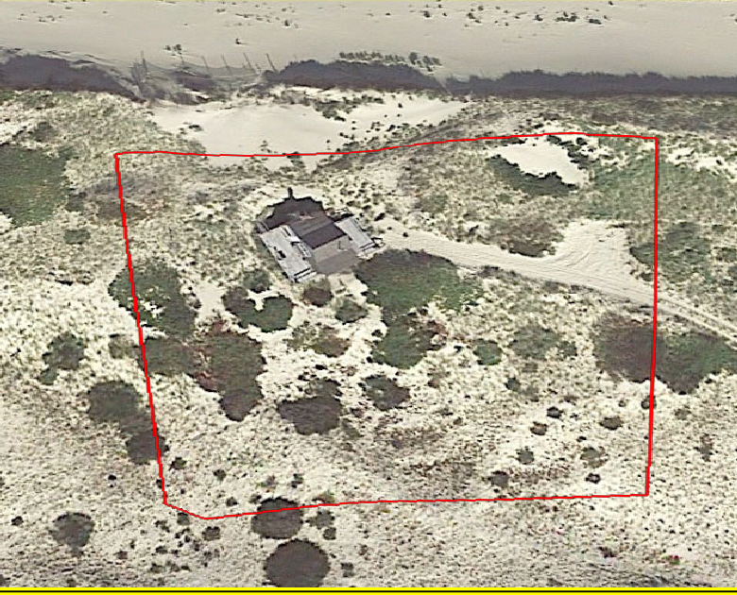

(Image: Fleurant Dune Shack Google Earth Image)

Adams Dune Shack and Guest Cottage:

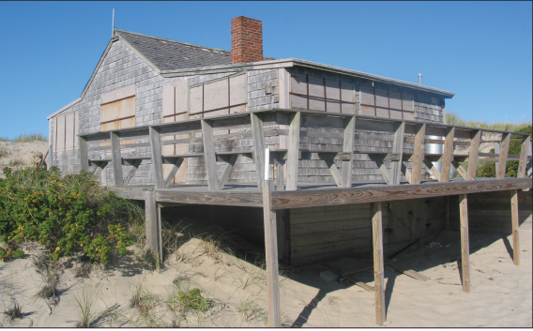

Property Location: The Adams Dune shack is currently located within the Peaked Hill Bars Historic District that is listed on the National Register. The Adams Dune Shack is located below the crest of the fore dune on the southern slope 1.7 miles east of the Race Point Coast Guard Station.

Property Description: The Adams Dune Shack is a one‐story, gable roof structure with two shed roof wings. The shack rests on wood piers and is oriented on a north/south axis with a central gable roof running east to west. The exterior is wood shingle siding with plain corner boards. A simple wood deck surrounds the building on the north, west and south elevations. The footprint of the building is a simple rectangle. A brick chimney for the interior fireplace projects above the south slope of the gable roof.

The Adams Dune Shack is 590 square feet.

The total acreage for the Adams Shack and Guest Shack is 2.30 acres.

Please note: Adams Dune Shack and Guest Cottage are being offered together under one lease.

The Annual Rent Cost: $16,000.00.

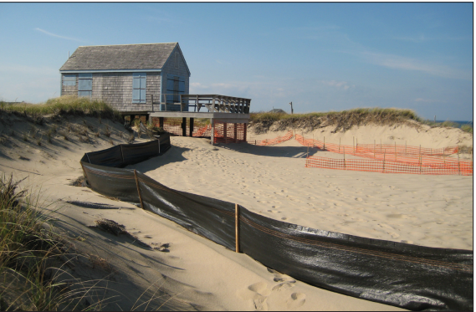

Property Location: The Adams Guest Cottage is located just below the crest of the fore dune on the southern slope 1.7 miles east of the Race Point Coast Guard Station. The shack is oriented with its north gable and facing the ocean. It is one of a cluster of structures that includes the Adams Shack approximately 200 feet to the east, the Fleurant Shack approximately 400 feet to the west and the Champlin Shack approximately 525 feet to the east. It rests on wood post footings. A wood deck is located across the north end of the structure and wraps around the west elevation.

Property Description: The Adams Guest Cottage is a one and a half‐story, one room gable roof structure with an open sleeping loft. The footprint of the building is a simple rectangle.

The Adams Guest Cottage is 520 square feet.

The total acreage for the Adams Shack and Guest Shack is 2.30 acres. The Annual Rent Cost: $16,000.00.

Please note: Adams Dune Shack and Guest Cottage are being offered together under one lease.

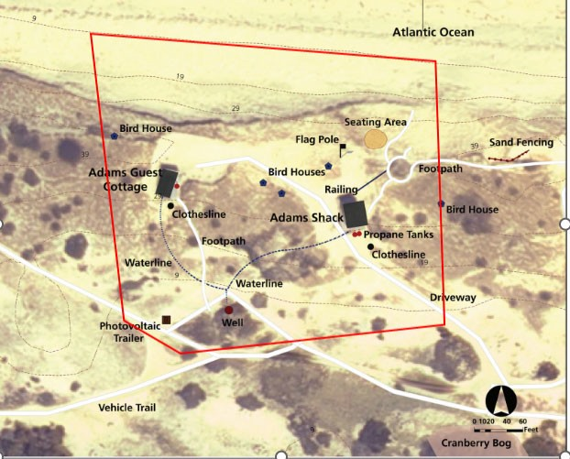

(Image: Adams Shack and Cottage Aerial Map)
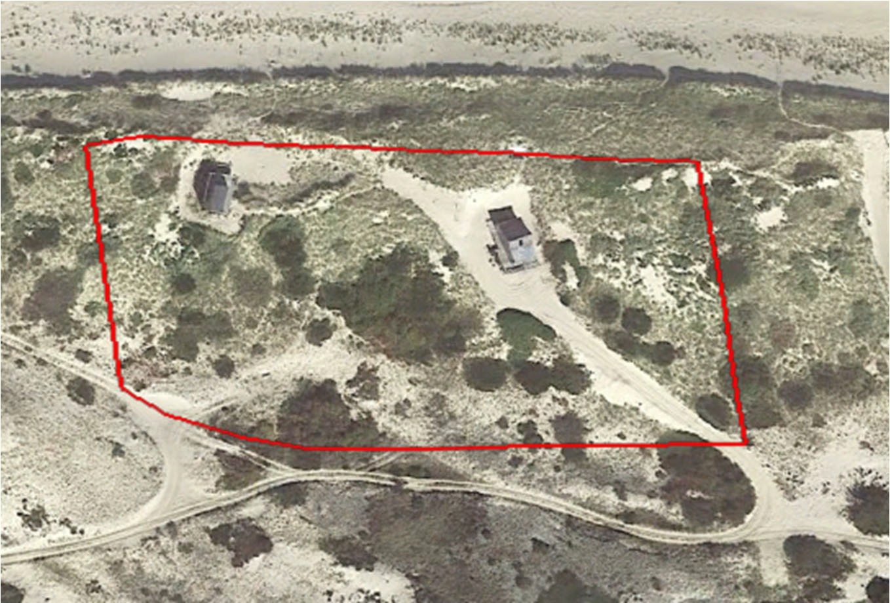

(Image: Adams Shack and Cottage Google Earth Image)

The Jones Dune Shack:
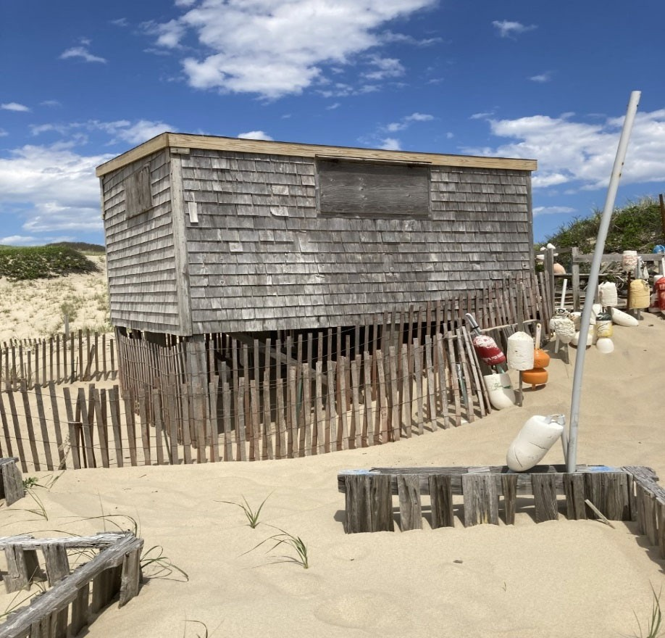

The Jones Dune Shack is currently located within the Peaked Hill Bars Historic District that is listed on the National Register.

The Jones Dune Shack is located approximately 200 feet from the ocean just beyond the southern leeward side of the fore dune on the north side of the inner dune. The Jones Shack is a small rectangular one‐story, one room balloon‐frame structure. A well with an old pump is located about 35 feet north of the shack. A small photovoltaic panel is fastened to the south‐facing roof.

The Jones Shack is 120 square feet.

The total acreage for the Jones Shack is 0.25 acres.

Jones Dune Shack Annual Rent Cost: $2,107.00

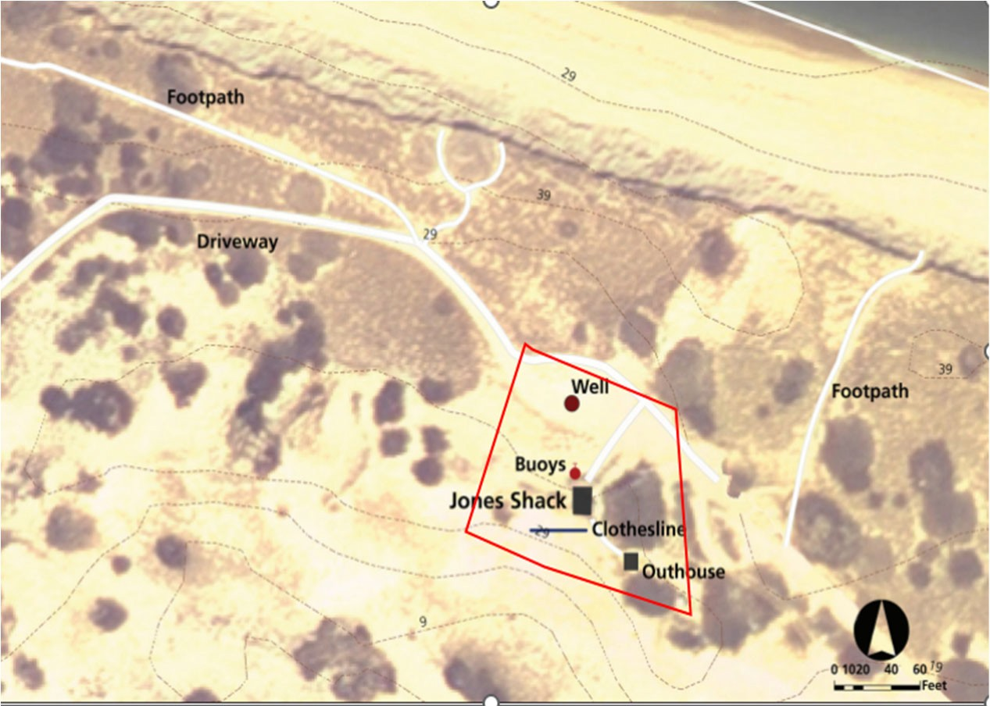

(Image: Jones Shack Aerial Map)
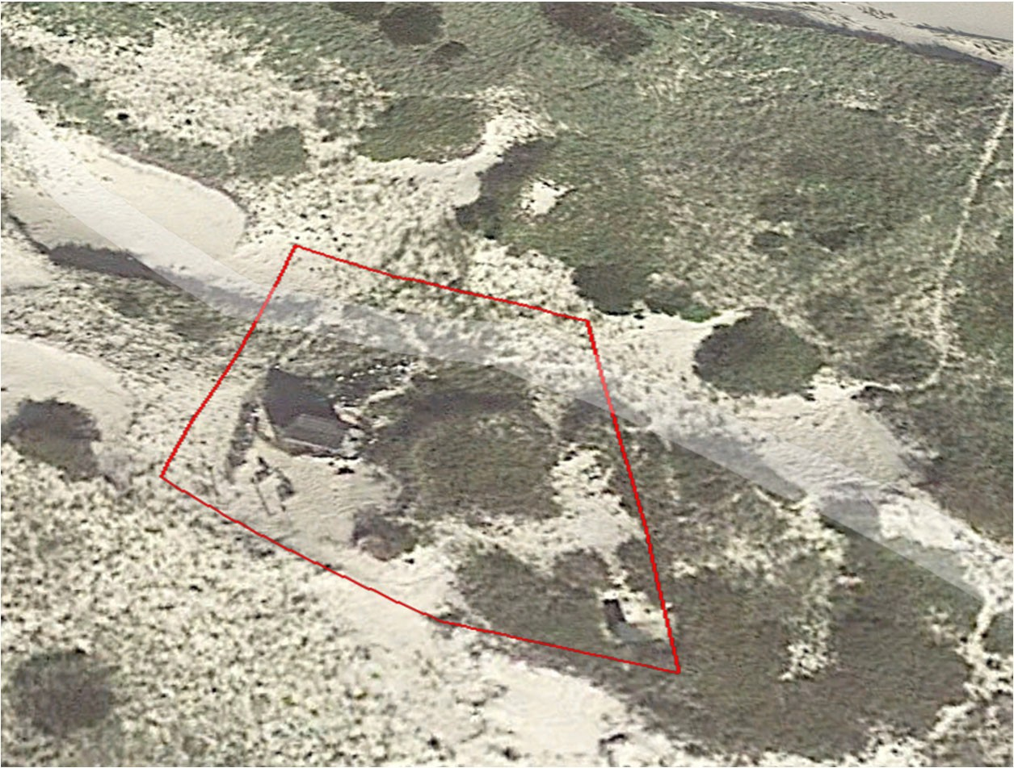

(Image: Jones Shack Google Earth Image)

Braaten Dune Shack:
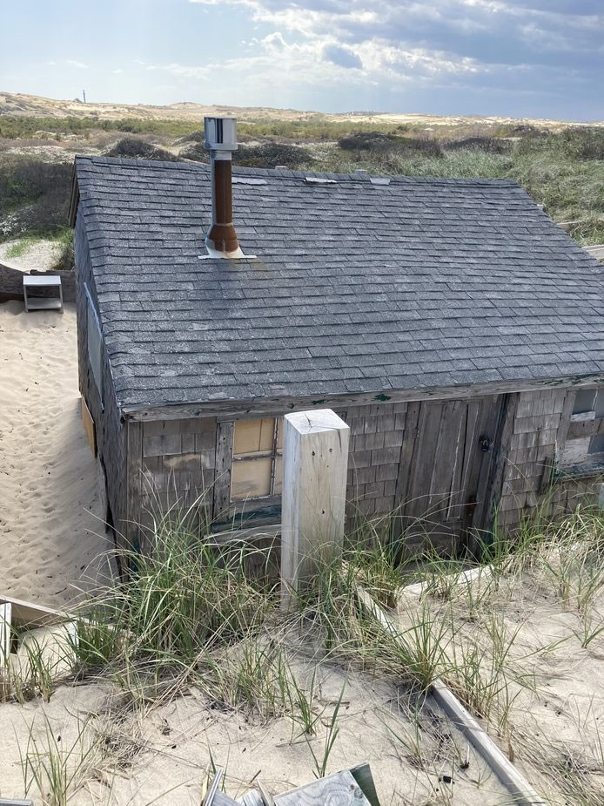

Property Location: The Braaten Shack is currently located within the Peaked Hill Bars Historic District that is listed on the National Register.

The Braaten Shack is in a depression on the top of the fore dune approximately 200 feet from the ocean and is 2.8 miles north of High Head Road, Provincetown, Massachusetts.

Property Description: The Braaten Shack is a one‐story balloon frame building set on a foundation of posts sunk deep below grade. The shack consists of a main gable roofed section with a shed roof kitchen addition extending half the width of the structure to the rear. An enclosed porch runs along the front elevation.

The Braaten Dune Shack is 224 square feet.

The total acreage for the Braaten Shack is 0.94 acres.

Braaten Dune Shack Annual Rent Cost: $4,020.00.

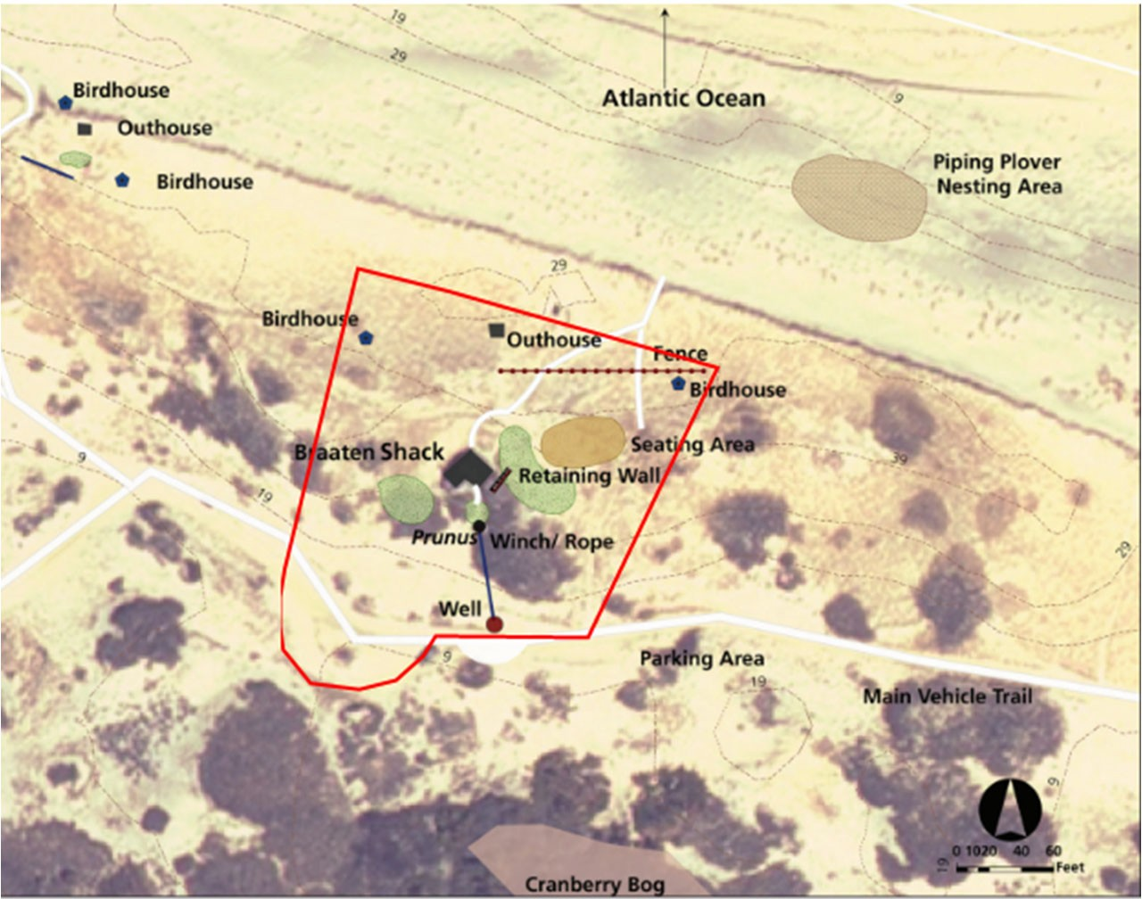

(Image: Braaten Shack Aerial Map)
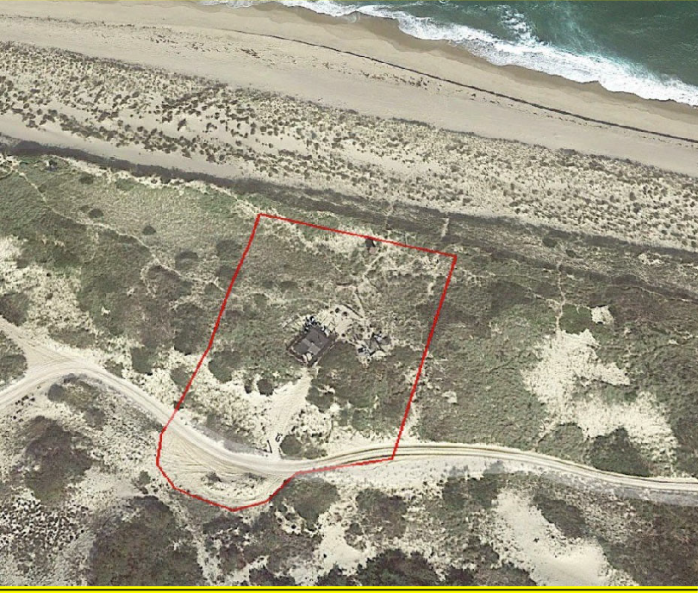

(Image: Braaten Shack Google Earth Image)

Watson‐Schmidt Dune Shack:
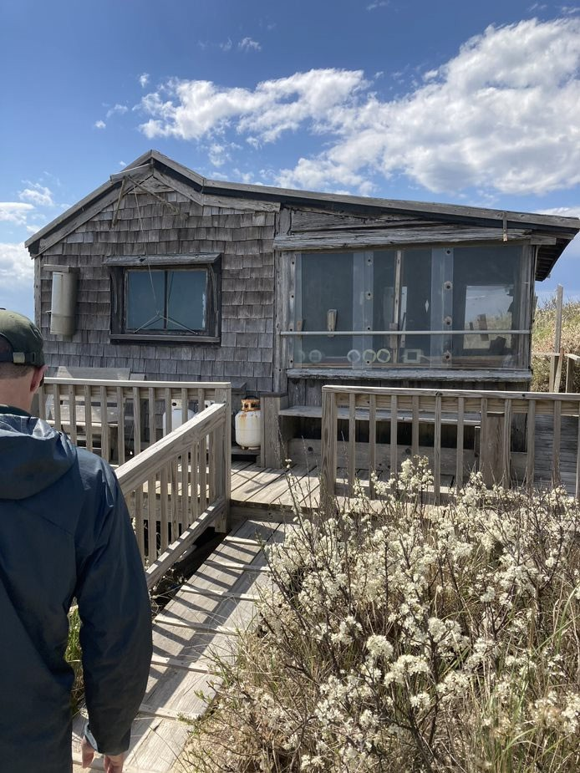

Property Location: The Watson‐Schmidt Shack is currently located within the Peaked Hill Bars Historic District that is listed on the National Register

Property Description: The Watson‐Schmidt Shack is located high on the southern slope of the fore dune in a heavily vegetated area approximately 300 feet from the ocean. It is 2.5 miles northwest of High Head Road in Truro, Massachusetts. The Watson‐Schmidt Shack is a rectangular one‐story balloon framed gable roofed structure with an enclosed screened shed roofed porch.

The Watson‐Schmidt Shack is 300 square feet.

The total acreage for the Watson – Schmidt Shack is 0.60 acres

Watson‐Schmidt Dune Shack Annual Rent Cost: $4,732.50.

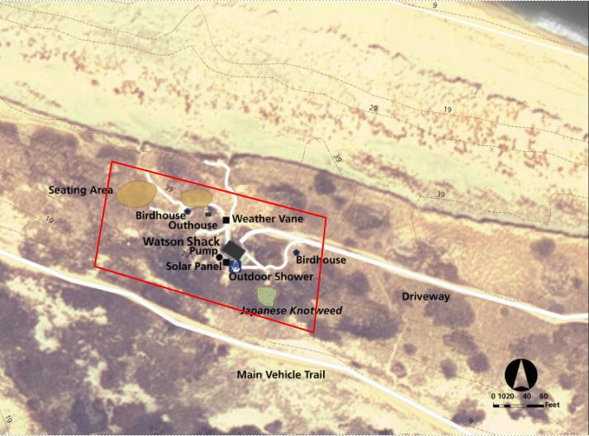

(Image: Watson‐Schmidt Shack Aerial Map)
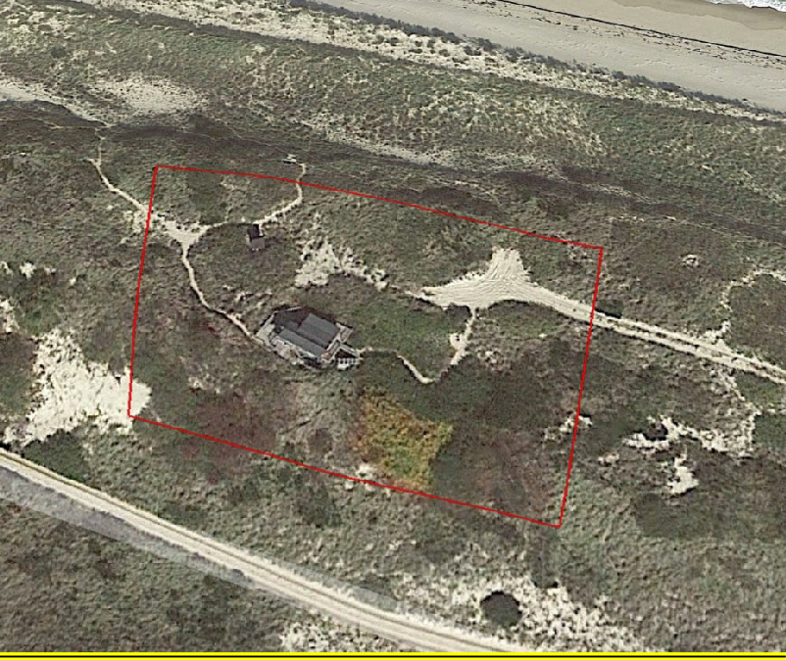

(Image: Watson‐Schmidt Shack Google Earth Image)

The Kemp Dune Shack:
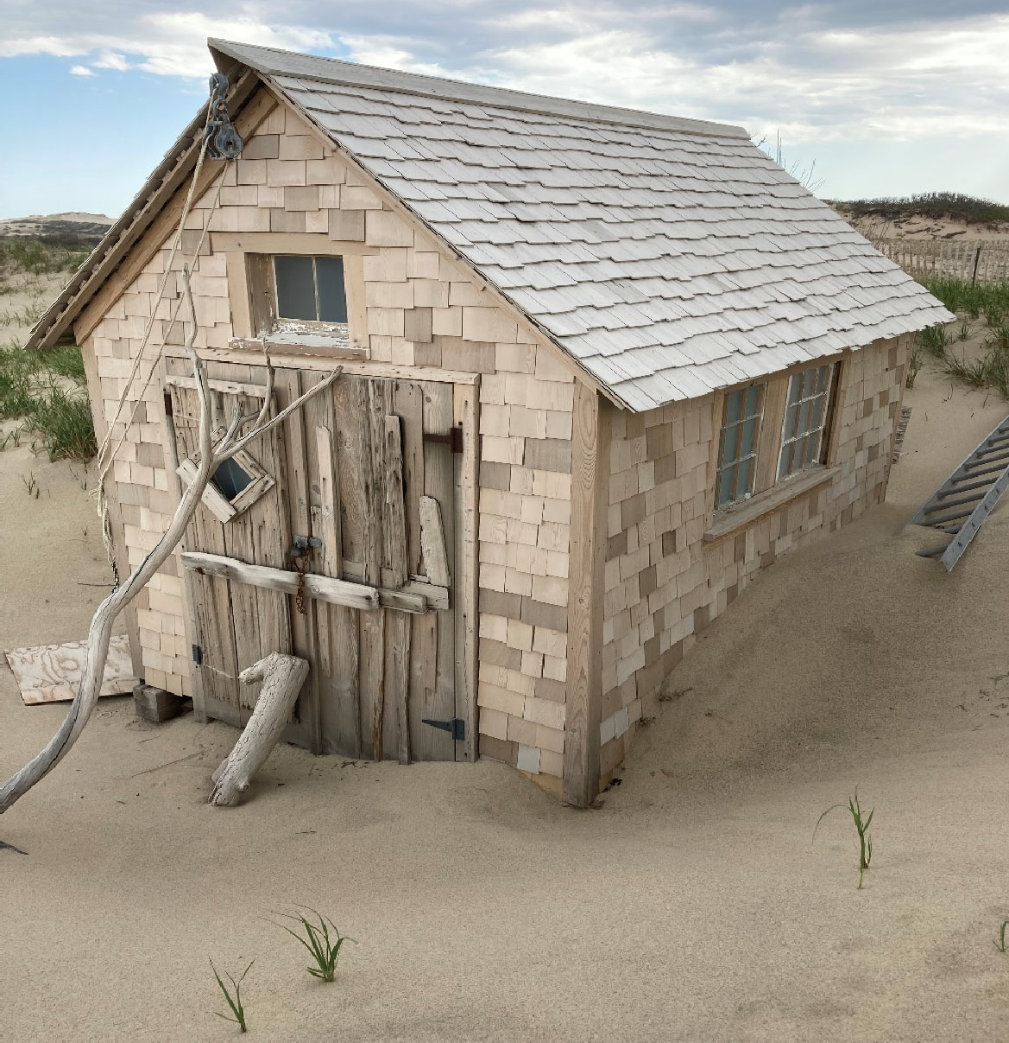

Property Location: The Kemp Dune Shack is currently located within the Peaked Hill Bars Historic District that is listed on the National Register. The Kemp “Tasha” Shack is located close to the northern lip of the fore dune in the middle of a cluster of shacks that includes the Margo, Fowler, Fearing and Chanel Dune Shacks. It is 3.4 miles east of the Race Point Coast Guard Station in Provincetown, Massachusetts.

Property Description: The Kemp Shack is one of the oldest and most rustic of the dune shacks. The shack is 102 square feet. The Kemp Shack is a small one‐story wood frame gable roof structure that rests on railroad ties on the sand.

The Kemp Dune Shack is 96 square feet.

The total acreage for the Tasha Shack is 0.40 acres.

Kemp Dune Shack Annual Rent Cost: $3,157.50.

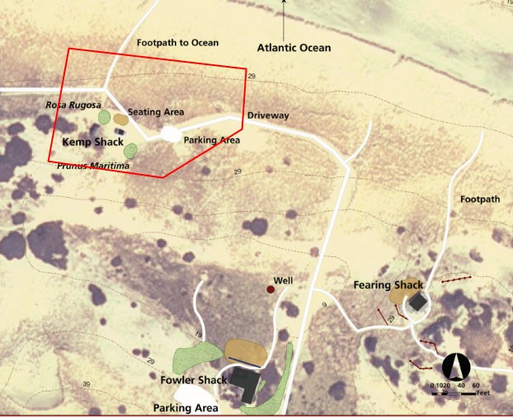

(Image: Kemp Dune Shack Aerial Map)
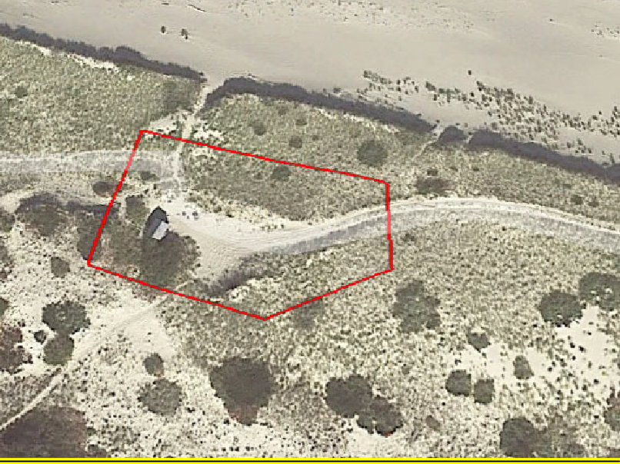

(Image: Kemp Dune Shack Google Earth Image)

The Fearing Dune Shack:
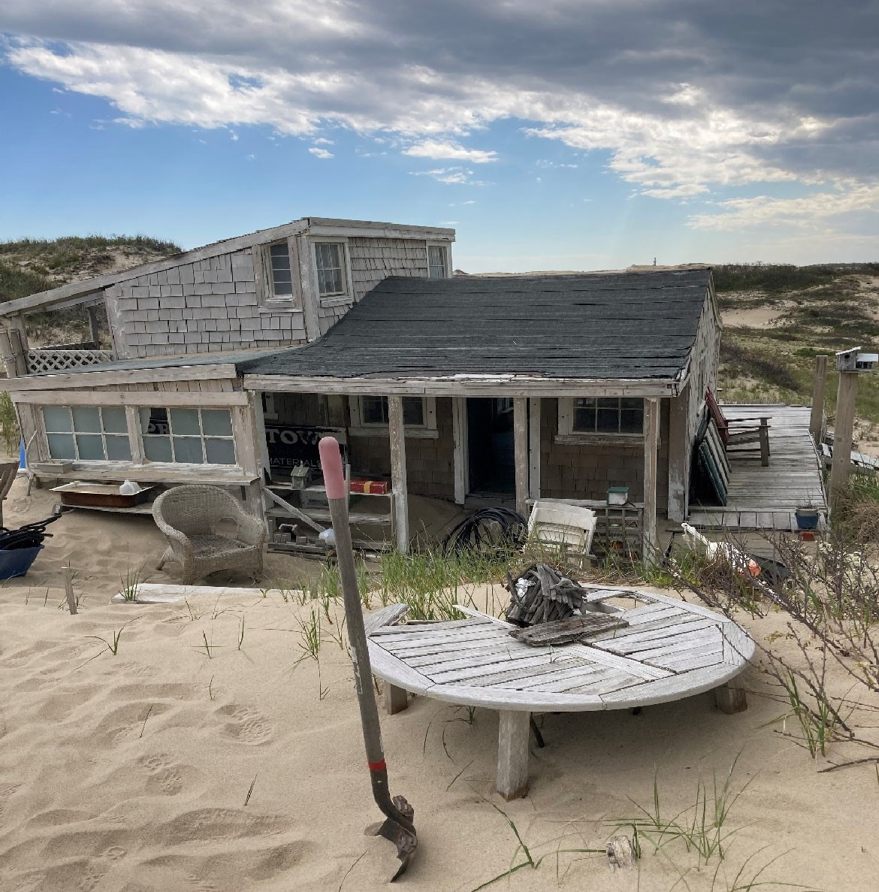

Property Location: The Fearing Dune Shack is currently located within the Peaked Hill Bars Historic District that is listed on the National Register. The Fearing Dune Shack is located on a high peak behind the fore dune approximately 300 feet from the ocean. A small parking area is located on the south side of the fore dune near the shack. The Fearing Shack is 3.5 miles east of the Race Point Coast Guard Station in Provincetown, Massachusetts.

Property Description: The Fearing Shack consists of an original single story one‐room gable roof section with a shed roof addition. An open deck wraps around the southwest corner of the building.

The Fearing Dune Shack is approximately 440 square feet. The total acreage for the Fearing Dune Shack is 1.4 acres.

Fearing Dune Shack Annual Rent Cost: $6,607.50.

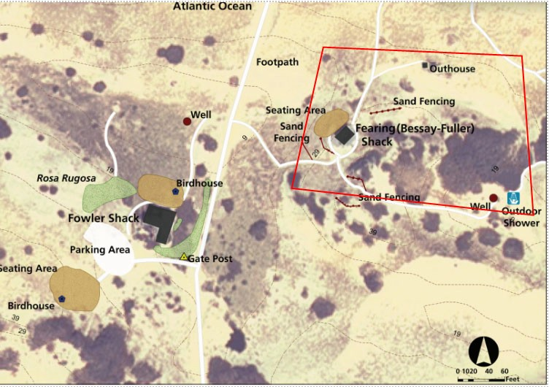

(Image: Fearing Dune Shack Aerial Map)
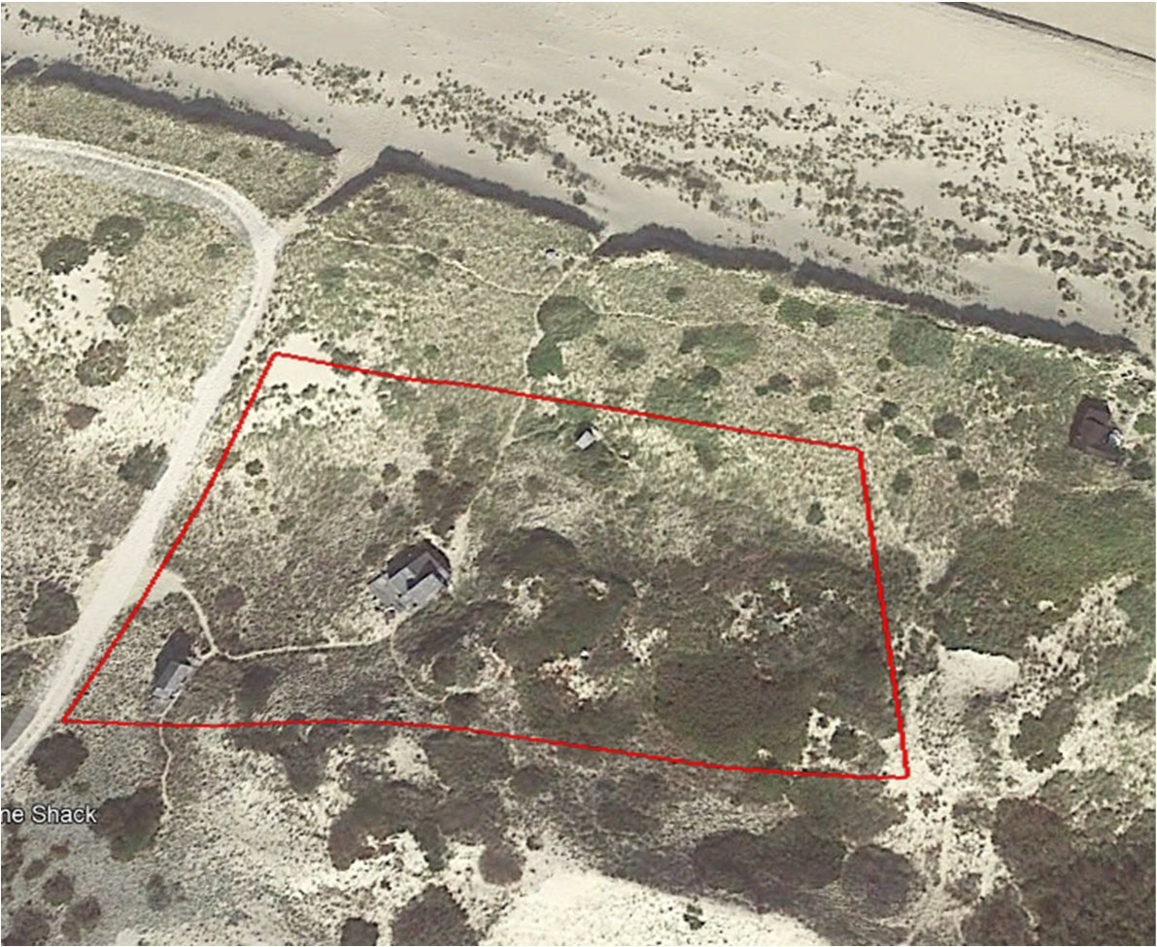

(Image: Fearing Dune Shack Google Earth Image)

