FIRE MANAGEMENT PLAN

for

APPALACHIAN NATIONAL SCENIC TRAIL

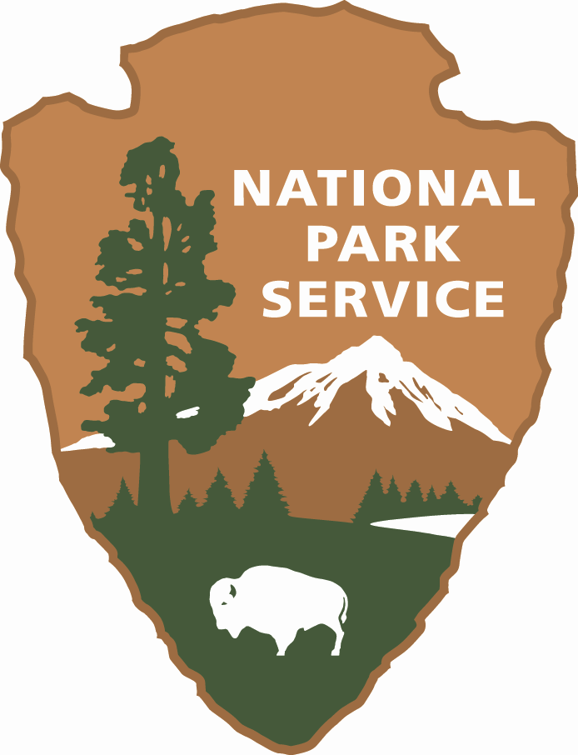

United States Department of the Interior
National Park Service
Appalachian National Scenic Trail
Harpers Ferry, West Virginia

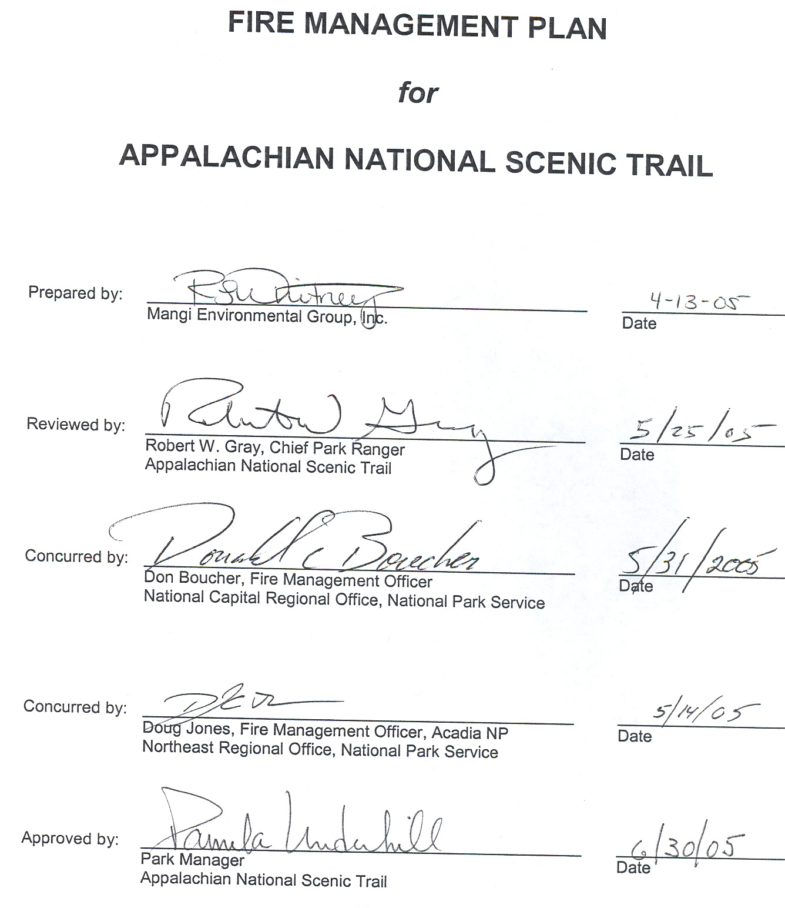

TABLE of CONTENTS
I. INTRODUCTION 1
A. Requirements 1
B. Collaborative Processes 1
C. Policy Implementation 1
1. 10 Year Comprehensive Strategy 1
2. Cohesive Strategy Elements 2
3. Contribution of Wildland Fire Goals to Regional/National Plans 2
D. NEPA and Other Compliance 2
E. Authority for Implementation 3
1. Section 102 3
2. Public Law 101-121 3
3. 31 USC 665 (E) (1) (B) 3
II. Relationship to Land management planning and fire policy 4
A. NPS Policy 4
B. Relation to Establishing and Other Legislation 4
1. Establishment 4
2. Significant Resources 4
C. Goals of Strategic Plan Related to Fire Management 5
D. Objectives of Strategic Plan Related to Fire Management 5
E. Achieving Strategic Plan Objectives through the FMP 5
III. wildland fire management strategies 6
A. General Management Considerations 6
1. Area-wide Considerations 6
2. 10 Year Comprehensive Strategy Core Principles 6
3. Contribution of Wildland Fire Goals to Regional/National Plans 6
B. Wildland Fire Management Goals and Objectives 8
1. Fire Management Goals 8
2. Fire Management Objectives 8
C. Wildland Fire Management Options 8
1. Wildland Fire 8
2. Fuels Management 9
D. Description of Fire Management Unit (FMU) 9
1. Characteristics 9
2. Fire Management Objectives 12
3. Management Considerations 12
4. Historic Role of Fire 12
5. Wildland Fire Management Situation 12
IV. Wildland Fire Management program components 17
A. General Implementation Procedures 17
B. Wildland Fire Suppression 17
1. Fire Behavior 17
2. Preparedness 18
3. Pre-attack Plan 18
4. Initial Attack 18
5. Extended Attack and Large Fire Suppression 19
6. Exceeding Existing WFIP 20
7. Minimum Impact Suppression Tactics (MIST) 20
8. Fire Rehabilitation 20
9. Records and Reports 21
C. Wildland Fire Use 21
D. Prescribed Fire 21
E. Non-Fire Fuel Treatment Applications 22
F. Emergency Rehabilitation and Restoration 22
V. Organizational and Budgetary Parameters 23
A. Fire Organization Structure 23
1. Park Manager or Designee 23
2. Park Fire Coordinator 23
3. Administrative Technician 23
B. FIREPRO/FPA Funding 23
C. Fire Organization Structure Related to Park Organization 23
1. Park Manager or Designee 23
2. Park Fire Coordinator 23
D Park Manager Responsibilities 23
E. Interagency Coordination and Agreements 23
F. Key Interagency Contacts 23
G. Fire-related Agreements 26
VI. Monitoring and Evaluation 27
VII. FIRE RESEARCH 28
A. Previous and Ongoing Fire Related Research 28
B. Fire Research Needs 28
VIII. Public safety 29
A. Issues and Concerns 29
B. Mitigation 29
IX. PUBLIC INFORMATION AND EDUCATION 30
A. Capability and Needs 30
B. Response to Increasing Fire Activities 30
X. PROTECTION OF SENSITIVE RESOURCES 31
A. Archeological/Cultural/Historic Resources 31
1. Resources 31
2. Mitigation 31
B. Natural Resources 31
1. Resources 31
2. Mitigation 31
C. Infrastructure 31
1. Improvements 31
2. Mitigation 31
XI. FIRE CRITIQUES AND ANNUAL PLAN REVIEW 32
A. Introduction 32
1. Scope 32
2. Reviews 32
3. Authority 32
4. Incident Types 32
5. Associate Director 32
6. Purpose 32
B. Fire Reviews 33
1. "Hotline" Review 33
2. Incident Management Team (IMT) Closeout and Review 33
3. Unit Level Review 33
4. National Level Review 33
6. Entrapment and Fire Shelter Deployment Review 34
C. Program Reviews 34
1. Operations Evaluations 34
2. Annual Fire Program Review 34
3. FIREPRO Review 34
4. Fire Program Analysis Review 34
XII. CONSULTATION AND COORDINATION 36
XIII. APPENDICES 37
A. References Cited 38
B. Definitions 40
C. Species List 46
D. NEPA and Other Compliance 51
1. EA FONSI 51
2. SHPO – NHPA consultation 51
3. FWS Section 7 Consultation 51
E. Annual Revision Documents 52
1. Fire Call-up List 52
2. Preparedness Inventory 52
3. Key Contacts 52
F. Wildland and Prescribed Fire Monitoring Plan 53
G. Pre-Attack Plan 54
H Long-Term Prescribed Fire and Hazard Reduction Plan 55
I. Fire Prevention Plan 56
J. Rental Equipment Agreements 57
K. Contracts for Suppression and Prescribed Fire Resources 58
L. Burned Area Emergency Stabilization and Rehabilitation Plan 59

List of Figures

Figure 1 - Appalachian Trail 7
Figure 2 - Current Cover Types of the Eastern United States 10
Figure 3 - Fire Regime Map - Appalachian National Scenic Trail 14
Figure 4 - Condition Classes of the Eastern United States 15

List of Tables

Table 1 - Fire Regimes 16
Table 2 - Condition Class Descriptions 16
Table 3 - Checklist - Wildland Fire 21
Table 4 - Key Contacts 24
Table 5 - Connecticut - Animals 46
Table 6 - Connecticut - Plants 46
Table 7 - Maine - Animals 46
Table 8 - Maine - Plants 46
Table 9 - Maryland - Animals 46
Table 10 - Maryland - Plants 47
Table 11 - Massachusetts - Animals 47
Table 12 - Massachusetts - Plants 47
Table 13 - New Hampshire - Animals 47
Table 14 - New Hampshire - Plants 47
Table 15 - New Jersey - Animals 47
Table 16 - New Jersey - Plants 48
Table 17 - New York - Animals 48
Table 18 - New York - Plants 48
Table 19 - Pennsylvania - Animals 48
Table 20 - Pennsylvania - Plants 48
Table 21 - Vermont - Animals 49
Table 22 - Vermont - Plants 49
Table 23 - Virginia - Animals 49
Table 24 - Virginia - Plants 49
Table 25 - West Virginia - Animals 49
Table 26 - West Virginia - Plants 50

I. INTRODUCTION

A. Requirements
The plan is guided by Director’s Order-18 (DO-18) which requires that all park units with vegetation capable of sustaining fire develop a Fire Management Plan (FMP). Appalachian National Scenic Trail Office (Trail) management will work with partner agencies to aggressively suppress all wildland fires, taking into account the safety of firefighting personnel, the visiting public and protection of all resources at risk on the unit.

It is important to note that this Fire Management Plan covers only those portions of the Trail corridor that are managed by the National Park Service’s Appalachian Trail Park Office. These lands, which were acquired by the National Park Service specifically to protect the Appalachian Trail, are NOT part of other NPS units or other federal or state units. These lands total approximately 80,000 acres, and are frequently interspersed with lands administered by other agencies. Lands are located in Maine, Massachusetts, Connecticut, New York, New Jersey, Pennsylvania, Maryland, West Virginia, and Virginia.

B. Collaborative Processes
Trail management and protection has been a collaborative process since the Appalachian Trail was begun in 1925. Most recently, the Strategic Plan (NPS, 2000) has benefited from collaboration by other Federal agencies, the Appalachian Trail Conference and other state and local supporters. Because the trail is over 2,000 miles long and traverses portions of fourteen states, cooperative efforts are the only means on maintaining the Trail’s integrity.

The FMP will implement activities in accordance with the regulations and directions governing the protection of historic and cultural properties as outlined in the Department of Interior Manual, Part 519 (519 DM), and Code of Federal Regulations (36 CFR 800). The National Historic Preservation Act of 1966 (NHPA), as amended, particularly Section 106, sets the requirements for the protection of the historic properties found on the unit. Management and protection will require continued interaction of numerous agencies and private parties.

C. Policy Implementation
Implementation of the FMP will meet the requirements of the most recent Federal Wildland Fire Management Policy and Program Review. The 2001 Federal Fire Management Policy update addresses 17 distinct items, the foremost being safety; all Fire Management Plans and activities must reflect this commitment. The full text of the policy, Secretarial Transmittals, and Appendices may be found at (http://www.nifc.gov/fire_policy/index.htm).

1. 10 Year Comprehensive Strategy
a. Priorities to Protect Communities and High Risk Watersheds
There are numerous communities near portions of the Trail. Due to the linear nature of the Trail, it is not likely that fire ignited within the Trail corridor would have significant effects on adjoining communities.

Numerous water resources are found within and adjacent to the Trail corridor. It is not likely that a fire on the Trail corridor would have more than a fleeting effect on water quality of these resources.

b. Collaboration among Governments and Representative Stakeholders
Collaboration will continue to occur among the parties to the Appalachian Trail Cooperative Management System and other interested stakeholders.

c. Performance Measures and Results Monitoring
The primary performance measure applicable to the Trail involves effective protection of life, property and existing habitat conditions.

2. Cohesive Strategy Elements
a. Institutional Objectives and Priorities
While some of the Trail’s habitats are fire-adapted, the linear nature of the trail does not support the use of fire to modify or restore historic habitat conditions on a landscape basis at the present time. A number of adjoining properties may be managed to achieve habitat restoration and some Trail habitats may be included. National Forest lands and other National Park Service units hosting the Trail would be involved.

b. Program Management Budgets and Authorities
With a very limited fire history, the Trail does not currently support dedicated fire management staffing. Near term support will be continue to be provided by other NPS offices or cooperators, primarily local fire departments.

c. Social Awareness and Support
A formula to determine visitation is under development. While no solid numbers are available, there is tremendous use and visitor interest in the Trail, its surrounding habitats, vistas etc.

3. Contribution of Wildland Fire Goals to Regional/National Plans
a. National Fire Plan
Although the gross acreage covered in this plan is relatively large (80,000 acres), the limited fire history indicates that wildland fire operations will not contribute significantly to any of the National Fire Plan goals.

b. Restore Fire-Adapted Communities
Prescribed fire application is not considered in this plan and will have no effect on National Fire Plan Goals.

D. NEPA and Other Compliance
An Environmental Assessment (EA) guides the FMP and complies with National Environmental Policy Act (NEPA) requirements and National Park Service (NPS) policy. The completed EA analyzes environmental impacts of the operations detailed in this plan. Completed NEPA documentation will be included as Appendix D with the full document available at the Trail office.

Requirements of the National Historic Preservation Act (NHPA) are met as well by means of consultation with the State Historic Preservation Officer(s). Copies of the record of consultation will be included in Appendix D.

A Section 7 consultation with the U.S. Fish and Wildlife Service with regards to endangered species issues is also required and will be included in Appendix D.

E. Authority for Implementation
The legal authority for the operation of fire management program is found in 16 U.S.C. Chapters 1 and 3 with specific authorities found in 620 DM 1.1. The Organic Act of the National Park Service (August 25, 1916, Section 102) provides the authority for implementation of this plan.

The authority for FIREPRO funding (Normal Fire Year Programming) and all emergency fire accounts is found in the following authorities:

1. Section 102
General Provisions of the Department of the Interior's annual Appropriations Bill provides the authority under which appropriated monies can be expended or transferred to fund expenditures arising from the emergency prevention and suppression of wildland fire.

2. Public Law 101-121
Department of the Interior and Related Agencies Appropriation Act of 1990 established the funding mechanism for normal year expenditures of funds for fire management purposes.

3. 31 USC 665 (E) (1) (B)
This section contains the authority to exceed appropriations due to wildland fire management activities involving the safety of human life and protection of property.

II. Relationship to Land management planning and fire policy

A. NPS Policy
This FMP is prepared to meet the policy requirements of Director’s Order 18, Wildland Fire Management, dated November 17, 1998. In addition, preparation of this plan meets the requirements set forth in Department of Interior Manual 620 (620 DM) and the requirements of the Federal Fire Policy update of 2001. While the presence or absence of fire is a factor in the condition of habitats adjacent to the Trail, it is recognized that fire applied in a narrow band is neither cost effective nor effective in managing habitat on a landscape basis.

B. Relation to Establishing and Other Legislation

1. Establishment
The Appalachian National Scenic Trail was established as part of the National Trails System Act (Public Law 90-543, October 2, 1968, 16 USC 27 §1244.) Coordination of management and maintenance of the Trail is the responsibility of the Appalachian Trail Park Office. Language specific to the Trail’s establishment follows:

“The Appalachian National Scenic Trail, a trail of approximately two thousand miles extending generally along the Appalachian Mountains from Mount Katahdin, Maine, to Springer Mountain, Georgia. Insofar as practicable, the right-of-way for such trail shall comprise the trail depicted on the maps identified as ''Nationwide System of Trails, Proposed Appalachian Trail, NST-AT-101-May 1967'', which shall be on file and available for public inspection in the office of the Director of the National Park Service. Where practicable, such rights-of-way shall include lands protected for it under agreements in effect as of October 2, 1968, to which Federal agencies and States were parties. The Appalachian Trail shall be administered primarily as a footpath by the Secretary of the Interior, in consultation with the Secretary of Agriculture.” (emphasis added).

2. Significant Resources
Natural heritage surveys have been completed in all fourteen states. At the time of preparation of this plan, approximately 320 occurrences of globally rare species are known to occur on Appalachian Trail lands; however, few are located on NPS-acquired Appalachian Trail lands.

The Federal Endangered Species Act prohibits harm to any species of fauna or flora listed by the U. S. Fish and Wildlife Service (USFWS) as being either threatened or endangered. Such harm includes not only direct injury or mortality, but also disrupting the habitat on which these species depend. As there are no management actions other than suppression planned, and the trail covers over 2,000 miles in a narrow band, it is not likely that federally listed species on lands administered by the National Park Service would be adversely affected.

Cultural resources on NPS-acquired Appalachian Trail lands are currently being inventoried. Inventories completed in Pennsylvania and Connecticut have identified, respectively, 75 and 382 cultural resource sites along the Trail. Additional inventories are being conducted on a state by state basis as funding permits.
For Trail users, solitude and scenic vistas are important resources.

C. Goals of Strategic Plan Related to Fire Management
Four basic goals are established in the Trail Strategic Plan (April, 2000).
- Preserve Park Resources;
- Provide for the Public Use and Enjoyment and Visitor Experience of Parks;
- Strengthen and Preserve Natural and Cultural Resources and Enhance Recreational Opportunities Managed by Partners;
- Ensure Organizational Effectiveness.

Each of these goals can be related to fire protection. Because only a small part of the land on which the Trail exists is actually owned by the National Park Service, fire suppression will be provided by numerous partners with varying legal responsibilities.

The current condition of habitats is considered a baseline. Future management is directed to maintain or improve habitat conditions by reducing invasive plant species.

D. Objectives of Strategic Plan Related to Fire Management
The following objectives are derived from the goal action statements found in the Strategic Plan.
- Increase the number of monitored sites containing globally rare plant and animal species of special concern;
- Complete natural resource inventories to provide information that could be used to implement appropriate management response (AMR) to wildland fires;
- Complete cultural resource inventories to provide information that could be used to implement appropriate management response to wildland fire;
- Assist organizations or agencies in implementation of management actions to protect federally threatened and endangered species within the Trail corridor;
- Protect employees, public and park resources.
- Encourage the proliferation of native plants and historic densities of those plants.

E. Achieving Strategic Plan Objectives through the FMP
Use of naturally ignited wildland fire to achieve management objectives is not being considered in this plan. The use of prescribed fire is not considered in this plan due to the nature of the landscape and small staff assigned to the Park. All wildland fires will be suppressed to protect susceptible resources identified in the objective in section D above.

III. wildland fire management strategies

A. General Management Considerations

1. Area-wide Considerations
a. Interagency Relationships
There is an Appalachian Trail Cooperative Management System including other federal and state partners and the Appalachian Trail Conference. A complex web of working relationships exists under this agreement. A generalized map of the Trail is found in Figure 1.

b. Regional Strategies
No regional strategies related to fire management exist along the Trail. Each organization with land management or statutory fire protection responsibilities follows its own policy and strategies. Generally these organizations are oriented to immediate and complete suppression of wildland fires

c. Other Collaborative Processes
Most collaborative opportunities will result from review by management system partners. Other interested parties will be given an opportunity to provide input. Because of the length of the Trail and its proximity to highly urbanized areas, management system partners will be a critical link to FMP input.

2. 10 Year Comprehensive Strategy Core Principles
a. Collaboration
As stated above, collaboration with management system partners is of primary concern. Other opportunities will be presented to interested publics when feasible.

b. Priority Setting
There are no projects proposed for hazardous fuel reduction in this plan. Should mechanical fuel reduction treatments become necessary in the future, priority setting for project funding will occur on a local, regional and national basis within the NPS organization. Local project priorities may be developed collaboratively with cooperators, adjacent landowners and other stakeholders as appropriate.

c. Accountability
Accountability for achieving objectives, other than suppression, developed in this plan will be accomplished by reporting results of projects or activities to the National Fire Plan Operations and Reporting System (NFPORS) as it is implemented. For objectives related to suppression reports of fire activity, available from the National Fire Office of NPS, will document results of suppression actions taken on Trail lands.

3. Contribution of Wildland Fire Goals to Regional/National Plans
a. National Fire Plan
Due to the narrow, linear, nature the Trail and limited fire history since acquisition, wildland fire operations are not expected to contribute significantly to any of the National Fire Plan goals.

Figure 1 - Appalachian Trail
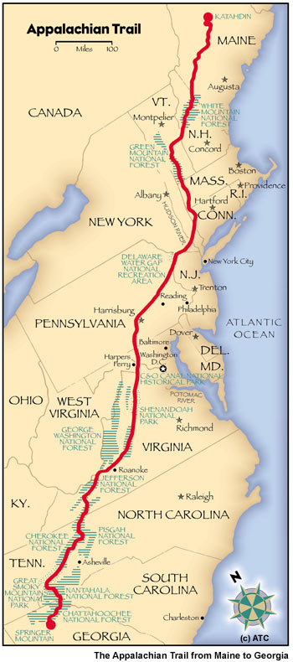
b. Restore Fire-Adapted Communities
Prescribed fire application is not included in this plan. Due to the narrow, linear nature of the Trail, prescribed fire is difficult to apply. There will be no effect on National Fire Plan Goals.

c. Performance Measures and Results Monitoring
The primary performance measure applicable to the Trail involves effective protection of life, property and existing habitat conditions.

B. Wildland Fire Management Goals and Objectives
The following goals and objectives will contribute to the goals established under the umbrella of the Federal fire policy as it currently exists.

1. Fire Management Goals
Fire program goals include:
- Firefighter safety is the highest priority of every fire management activity;
- Protect life, private and public property, and park resources from the effects of unwanted fire;
- Prevent adverse impacts from fire suppression activities;

2. Fire Management Objectives
- Educate employees and the public about the scope and effect of wildland fire management, resource protection, wildland fire prevention, hazard/risk assessment, mitigation and rehabilitation;
- Maintain the highest standards of professional and technical expertise in planning and safely implementing an effective wildland fire management program;
- Manage wildland fire incidents in accordance with accepted interagency standards, using appropriate management response strategies and tactics and maximize efficiencies realized through interagency coordination and cooperation;
- Identify wildland-urban interface areas that adjoin NPS managed Trail lands.

C. Wildland Fire Management Options

1. Wildland Fire
a. Suppression
All wildland fire regardless of cause will be suppressed using an appropriate management response. As the lands under consideration cover a large portion of the Trail, suppression actions will generally be conducted by state or local fire organizations. Trail management staff is not equipped for suppression operations. In those areas where the Trail passes through other Federal ownerships; i.e. National Forests, other National Park Service units, U.S. Fish and Wildlife Service lands, the existing agency FMP for the area should provide adequate direction for a suppression response consistent with current Federal Fire Management Policy.

Suppression operations are complicated by the number of individual fire organizations involved, their capability and the remote location of much of the Trail. With the increase in residential construction in previously rural areas, there is a corresponding increase in potential of wildland fires in the Trail corridor to impact urban areas.

b. Wildland Fire Use – Due to the linear nature of the Trail there will be no Wildland Fire Use (WFU) planned on the Trail corridor.

2. Fuels Management
a. Prescribed Fire
At this time prescribed fire use is not being considered in the FMP. As knowledge of trail habitats increases there may be some potential for prescribed fire application. If limited use of prescribed fire is necessary prior to revision of this plan, projects will be undertaken on a case by case basis. Each project would follow NPS requirements and would include site specific NEPA documentation, Endangered Species Act Section 7 consultation with USFWS and coordination with the affected State Historic Preservation Officer.

b. Non-fire Hazard Fuel Reduction
At this time no formal projects are proposed. As fire history is developed, future revisions may identify a need. Wildland Urban Interface (WUI) projects may eventually be needed to protect neighboring properties. These projects would be handled in the same manner as prescribed fire projects in section a, Prescribed Fire above.

D. Description of Fire Management Unit (FMU)
Because the Trail covers over 2,000 miles in fourteen states, the following FMUs are designated:
Federal Lands (other than Appalachian Trail Park Office-Administered Lands) FMU
State Lands FMU
Appalachian Trail Park Office-administered Lands FMU

It is expected that federally owned lands (other than Trail acquired) address the fire suppression needs along the Trail corridor in the appropriate unit FMP and they will not be considered further. Where the Trail passes through other governmental ownerships (State Lands FMU), the hosting agency’s planning policies and procedures will be considered adequate to address suppression needs.

Only the FMU consisting of lands acquired and managed by ATPO is addressed in the plan.

The trail extends from Northern Georgia to northern Maine. A large part of the trail at the southern end is located on federal lands, primarily U.S. Forest Service and National Park Service units. From central Virginia northward, the trail crosses different ownerships: private lands, state park and forest lands, additional federal lands and lands administered by the Appalachian Trail Park Office. This last category of lands will be considered from this point on.

1. Characteristics
- Vegetation
Vegetation ranges from boreal forest to mixed hardwoods to bottomland hardwoods to pine forests. Many areas of the Trail are located on ridge crests with rock outcrops while other areas cross grassland areas. Fire effects on vegetation are expected to vary from negligible to moderate depending on long term weather and fuel moisture conditions (Brown, 2000). A current cover type map of the Eastern United States is found in Figure 2.

Figure 2 - Current Cover Types of the Eastern United States
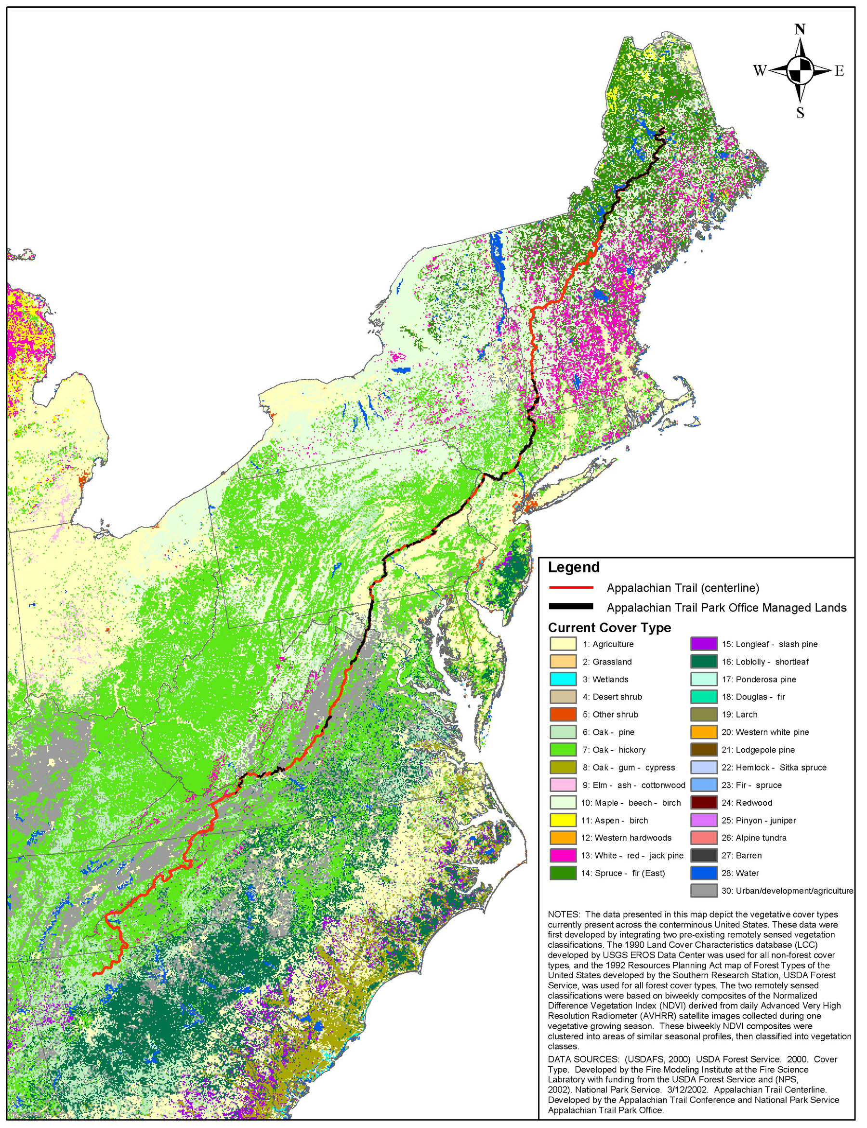

b. Wildlife
Because much of the Trail corridor is located in areas currently under Federal or State ownership and management, wildlife is considered abundant. There is little likelihood that wildland fire occurrence on the corridor would have any effects, either beneficial or adverse, on wildlife populations (Smith, 2000).

c. Threatened and Endangered Species
According to information in the Strategic Plan, there are 20 known occurrences of federally listed threatened and endangered species within the corridor. However, none have been documented on NPS administered lands. Most inventories related to threatened and endangered species are completed. If these species are found on NPS ownership, appropriate action will be taken to protect them in accordance with approved recovery plans.

A formal Section 7 consultation (biological opinion) will be requested where federally listed species may be present on NPS lands. Listed species are found in a table, by state, in Appendix C.

d. Geology
The Trail generally follows the Appalachian Mountain chain. Numerous crossings of major watercourses bring the Trail to much lower elevations. Many areas of rock outcrops are found along the mountain crests. Elevations range from 124 ft. above Mean Sea Level (MSL) at Bear Mountain on the Hudson River in New York to 6,625 ft. MSL at Clingman’s Dome in Tennessee.

e. Soils
Soils vary widely over the Trail depending on elevation, underlying material and other factors. Most soils on the higher elevations are thin and subject to erosion from use and could be similarly affected by suppression operations. Lowland soils on the other hand are expected to be deeper and more productive but still subject to damage by suppression operations.

- Hydrology
The Trail is cut by many large, well known rivers including the Hudson, Delaware, Susquehanna, and Potomac Rivers. Small streams are frequently found within the corridor. These small streams in particular are subject to damage from suppression operations. Water quality varies widely with some streams considered unsafe due to pollution while others are deemed safe for drinking.

g. Air Quality
Air quality also varies considerably depending on atmospheric conditions and location. The Trail passes through several Congressionally designated Wilderness areas, most are Class II air quality areas. Air quality can be adversely affected by wildland fire although most fires are of relatively short duration.

h. Cultural Resources
Within the areas managed by the Trail office, several efforts to inventory and classify cultural features are underway as part of the Strategic Plan. As these resources are catalogued site-specific protection plans may be developed. Damage to cultural resources would most likely occur as a result of suppression operations.

i. Unit Infrastructure
There are many NPS-owned facilities along the Trail. There are hundreds of trail shelters and incidentally-acquired structures (barns, houses, etc.) supporting trail operations.

j. Visual Landscape
Wildland fire impacts (blackened land, fire killed trees, etc.) on the visual landscape along the corridor are generally expected to be minimal. It is always possible, however, to have large burned areas off the corridor visible from the Trail.

2. Fire Management Objectives
- Contain 95% of unwanted wildland fires at less than 5 acres. Contain the remaining 5% within the Trail corridor at less than 100 acres.
- Monitor fire behavior and fire effects of all wildland fires to provide information for future evaluation and program direction.
- Identify and assess wildland fire risks to wildland-urban interface areas adjacent to ATPO managed lands along 100 miles of trail annually.

3. Management Considerations
- Firefighter caution in areas of overhead transmission line, and underground pipelines (firefighter safety issue).
- Protect structures.
- Suppression actions will use the least damaging tools and procedures to the maximum extent possible.
- Provide for safety of visiting public, particularly those on the trail and away from normal access routes, through signing and ridgerunner contacts.

4. Historic Role of Fire
Fire is a natural component of forest and grasslands. Additionally, fire has been used by humans since prehistoric times for vegetation and game management. In the recent past, fires have usually been contained before affecting extensive areas. Insect, disease and drought conditions are contributors to fuel conditions that could have widespread impacts on fire occurrence and extent.

5. Wildland Fire Management Situation
a. Historical Weather Analysis
Due to the wide variation of geography there is a wide variety of climatological conditions. A weather analysis has not been conducted and would not be useable on a broad basis along the Trail.

- Fire Season
Again, because of the north-south orientation of the Trail, the fire season is expected to be longer in the south than in the north. The basic fire season consists of two parts, a spring and a fall season. The fall fire season normally lasts from around the first killing frost until snow cover. The spring season begins when snow cover is gone and lasts until the new season vegetation has achieved significant growth. The wide variation in elevations also affects the fire season.

There is insufficient wildland fire history to establish a FIREPRO wildland fire season within the areas under the Trail management office. Other NPS units where the trail is an overlay may have a FIREPRO established season. Historic information from areas along the trail indicates a split season with the spring season being the more active. To develop an historic fire record will require considerable effort on the small staff to maintain dialogue with an estimated 300+ local fire departments that probably take suppression actions on ATPO lands.

- Fuel Characteristics
Vegetation, as previously discussed, varies considerably depending on location along the Trail. Most fuels should fall into the following Northern Forest Fire Laboratory (NFFL) fuel models (Anderson, 1982):
  - Fuel Model 3 Tallgrass (2.5 ft.);
  - Fuel Model 5 Brush (2 ft.);
  - Fuel Model 9 Hardwood Litter;
  - Fuel Model 10 Timber (litter and understory)

Critical fire behavior variables, such as flame length, rate of spread, and fireline intensity are estimated using the BEHAVE computer software and NFFL fuel models 3, 9 and 10 as these are the predominant fuels and offer the greatest resistance to control (Rothermel, 1983).

d. Fire Regime Alteration
The fire regime along the corridor has been altered several times and in various ways since European settlement. Clearing for agriculture removed forest cover and provided row crops or grass in its place. As agriculture became more marginal, some areas came back to forest. Recent infestations of gypsy moth have created areas of dead fuels on and adjacent to the corridor. Diseases including Dutch elm disease and Chestnut blight have also had effects on areas along the Trail.

A fire regime map of the eastern United States (Figure 3) shows historic fire regimes. It is likely that current habitat falls into three major fire regimes. Hardwood forest, both upland and bottomland, types are expected to be in Fire Regime III and mostly in Condition Class 1. Boreal forest is expected to be in Fire Regime V and Condition Class 1. Grassland complexes are expected to be in Fire Regime II and Condition Class 2. Table 1 defines the fire regimes as used in the Cohesive Strategy document (USDA, USDI, 2002).

Figure 4 maps the current condition class of lands in the eastern United States. Table 2 defines the Condition Classes as used in the Cohesive Strategy document.

- Control Problems
In some areas there are roads at frequent intervals that could used to quickly access wildland fires. Other areas, where access is not readily available, may see fires of greater size. In rocky areas, fire occurrence is not as likely, fire size is expected to be small, and again access is generally difficult.

Figure 3 - Fire Regime Map - Appalachian National Scenic Trail
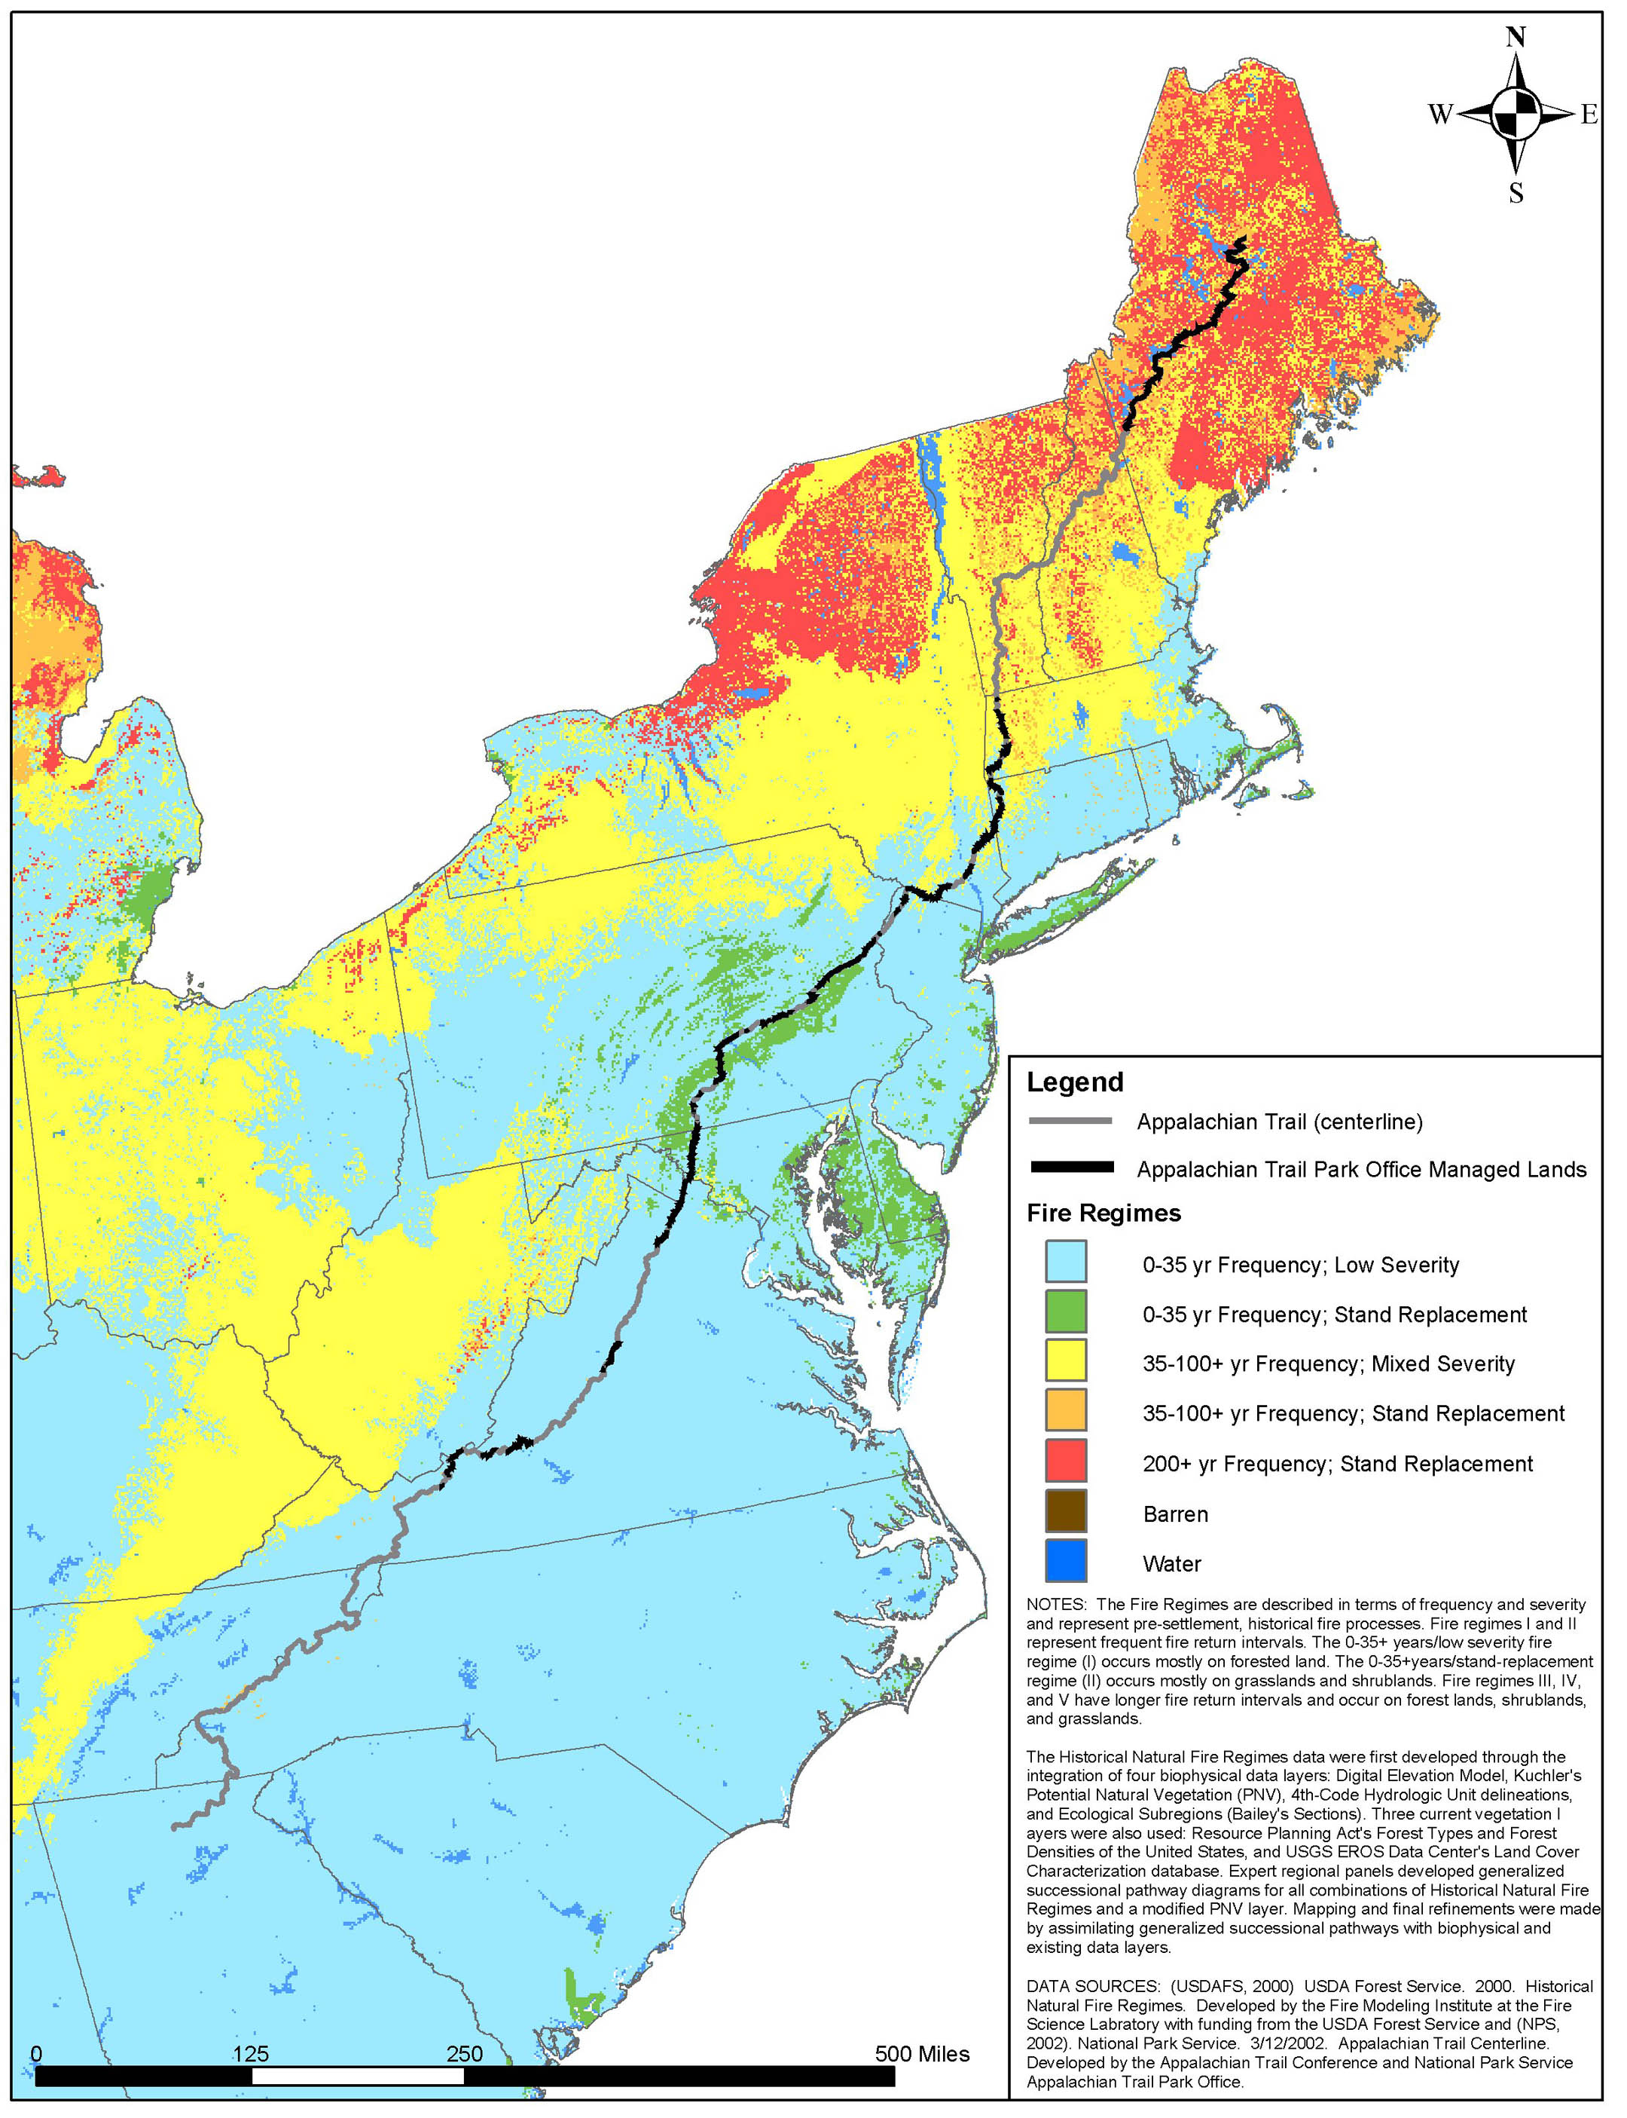
Figure 4 - Condition Classes of the Eastern United States
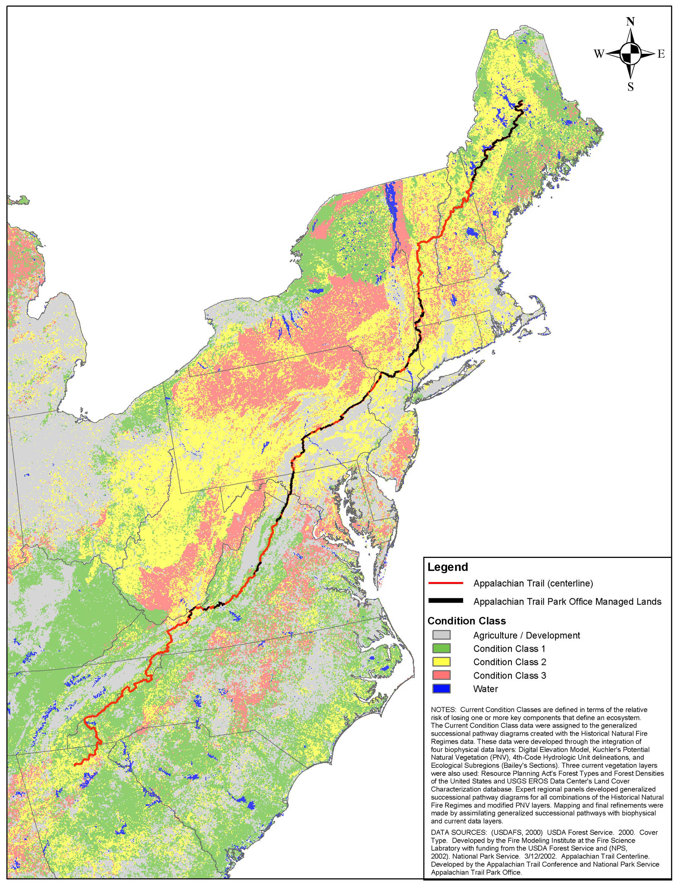

Table 1 - Fire Regimes
Fire Regime Group | Frequency (Fire Return Interval) | Severity
I | 0-35 years | low severity
II | 0-35 years | stand replacement severity
III | 35-100+ year | mixed severity
IV | 35-100+ year | stand replacement severity
V | >200 years | stand replacement severity
Table 2 - Condition Class Descriptions
Condition Class¹ Descriptions
Condition Class | Fire Regime
Condition Class 1 | Fire regimes are within an historical range and the risk of losing key ecosystem components is low. Vegetation attributes (species composition and structure) are intact and functioning within an historical range.
Condition Class 2 | Fire regimes have been moderately altered from their historical range. The risk of losing key ecosystem components is moderate. Fire frequencies have departed from historical frequencies by one or more return intervals (either increased or decreased). This results in moderate changes to one or more of the following: fire size, intensity and severity, and landscape patterns. Vegetation attributes have been moderately altered from their historical range.
Condition Class 3 | Fire regimes have been significantly altered from their historical range. The risk of losing key ecosystem components is high. Fire frequencies have departed from historical frequencies by multiple return intervals This results in dramatic changes to one or more of the following: fire size, intensity, severity, and landscape patterns. Vegetation attributes have been significantly altered from their historical range.
¹Current conditions are a function of the degree of departure from historical fire regimes resulting in alterations of key ecosystem components such as species composition, structural stage, stand age, and canopy closure. One or more of the following activities may have caused this departure: fire suppression, timber harvesting, grazing, introduction and establishment of exotic plant species, insects or disease (introduced or native), or other past management activities

- Values to Protect
There are overnight Trail shelters and other facilities to be protected. However the landscape view is probably more important to visitor satisfaction and is a high priority for protection. NPS infrastructure is limited; although a number of cooperator buildings are within the corridor and require protection.

IV. Wildland Fire Management program components

A. General Implementation Procedures
Current management is guided by the Trail’s 2000 Strategic Plan. The basic direction is the preservation of natural and cultural resources, provide for public use and enjoyment, strengthen management opportunities by partners and ensure organizational effectiveness.

The direction provided by the Strategic Plan indicates that prompt, aggressive suppression actions will be the normal response to wildland fires on the Trail. Historically, fire records are inadequate to determine the fire load. Anecdotal information does indicate that numerous areas along the length of the Trail are affected by fire either directly (causing Trail closures) or indirectly (reducing visibility) each year.

As Wildland Fire Use is not an option under this FMP, full suppression action is expected with due consideration to firefighter and visitor safety. A Wildland Fire Implementation Plan (WFIP) will not be completed by NPS staff as suppression operations will be by cooperators.

B. Wildland Fire Suppression

1. Fire Behavior
Because the Trail extends across a diverse landscape, numerous vegetative associations occur. Each of these vegetative complexes can be represented by a fire fuel model. Depending on latitude, elevation, slope, aspect and other factors the Fire Behavior Prediction System models listed below are found along the Trail. A general statement of expected fire behavior is included for each fuel model.

Fuel Model 1- describes areas dominated by short grass. A spread rate of 78 chains/hour with flame lengths of 4 feet under moderate conditions is possible. This fuel model is expected on low river terraces.

Fuel Model 3- describes areas dominated by grass or grasslike vegetation averaging 3 feet in height. This would include cured stands of cattail and stands of native warm season grasses. A spread rate of 104 chains/hour with flame lengths of 12 feet is possible under moderate conditions. This fuel model represents wetland, lowland shrub, and some seeded grass habitat types.

Fuel Model 8 Closed Canopy Forests - describes areas of heavy fuel concentration. Only under severe weather conditions are these fuels expected to pose fire problems. Closed canopy stands of short needle conifers or hardwoods that have leafed out support fire in the compact litter layer. The layer consists of mostly needles, leaves, and some twigs since little undergrowth is present in the stand. Representative conifer types are white pine, spruce, true firs, and larches.

Fuel Model 9- describes areas dominated by hardwood litter from deciduous trees in the bottomland forest and upland forest habitat types. A spread rate of 7-8 chains per hour with flame lengths of 2-3 feet is possible under moderate conditions.

Fuel Model 10- describes areas of heavy down material. The fires burn in the surface and ground fuels with greater fire intensity than in the other timber litter models. Dead-down fuels include greater quantities of 3 inch or larger limbwood resulting from overmaturity or natural events that create a large load of dead material on the forest floor. Crowning, spotting, and torching of individual trees are more frequent in this fuel situation. Examples include insect or disease-ridden stands, windthrown stands, overmature situations with deadfall, and aged light thinning or partial-cut slash.

2. Preparedness
a. Prevention
The objectives of the Trail’s fire prevention program are: to prevent human caused wildland fires and, to incorporate prevention messages into interpretive programs. There is no Fire Prevention Plan for the Trail. Should one be developed it will be added as Appendix J. Prevention messages and programs are expected to continue via the appropriate state agencies or Federal land management agencies as has been done in the past.

b. Annual Training
Annual refresher training emphasizing safety will be made available to park staff as appropriate. Minimum training will include LCES, Standards for Survival, fire shelter training and other updates as appropriate. In addition, each year the Chief Park Ranger/Fire Management Officer will assess the current qualifications of the ATPO’s fire qualified personnel. From this assessment, current and future training needs for individuals will be determined. Training will be obtained in the most cost-effective manner either in house or through interagency training courses. Qualified instructors will be utilized for all courses.

c. Readiness
The Trail office has no fire cache. Equipment needed for individuals will be purchased or provided through the Regional FMO. Personal protective equipment maintenance will be the responsibility of the individual user.

d. Fire Weather and Fire Danger

(1). Weather Stations – Weather stations are available through the cooperating agencies and the Trail office will make necessary arrangements when weather data is needed.

(2). NFDRS – The Trail has no single National Fire Danger Rating System Model (Deeming et al, 1977) because of the geographic diversity. State and other Federal agencies will provide access to their trend monitoring index and fire danger prediction scale. Step-up Plans are available from cooperators and will be used by them to determine appropriate levels of staffing. ATPO will have no Step-up Plan.

3. Pre-attack Plan
Pre-attack planning will be completed by the cooperating agencies following their policies and procedures. ATPO will have no Pre-attack Plan.

4. Initial Attack
a. Initial Attack Priorities
Setting initial attack priorities involves determining the risk of fire to visiting public and firefighters, resources at risk, existing fires and threat to adjoining property. These priorities will be established by the cooperating agencies. All fires will be aggressively suppressed with due consideration of firefighter and public safety.

- Initial Attack Response
Initial attack crews will be of the normal cooperating agency complement. Additional backup may be provided through compacts or other agreements.

c. Initial Attack Strategies
While confinement is the preferred NPS initial attack strategy; each responding agency is expected to use its own discretion and judgment on the fireground.

d. Response Times
Response times are expected to vary from very short near urban areas to several hours to remote reaches of the Trail.

e. Management Constraints
The preferred suppression tactics to be used along the Trail include use of water firelines in conjunction with natural barriers to reduce damage potential from suppression actions. There are several management constraints:
- When fire lines must be constructed techniques requiring the least disturbance (i.e. hand tools, leaf blown lines, mowed lines) are preferred. In rare circumstances when less disturbing techniques can't be used, the use of bulldozers or heavy equipment in suppression may be authorized by the Park Manager or designee. Engines and other vehicles will be restricted from areas identified as potentially affected by vehicle traffic where rutting, soil compaction or other habitat damage could occur if at all possible;
- Handlines should be constructed only in areas where damage to known archeological and/or historic resources is not likely to occur.
- Avoiding ground disturbance in sensitive areas identified in Natural Resource Inventories to the greatest extent possible.

It must be understood, with an estimated 300+ potential fire response organizations along the Trail that local equipment limitations, training, experience and other factors may not favor NPS preferred suppression tactics. As a fire history for NPS lands develops, local responders may be provided training or other information regarding desired suppression tactics.

f. Local Issues
Close communication with partners and adjacent landowners should reduce wildland fire controversy to a minimum. There are no known tribal issues.

5. Extended Attack and Large Fire Suppression
a. Extended attack needs
Due to the narrow linear nature of the Trail, few fires are expected to remain uncontrolled and within the Trail corridor past the first burning period.

b. Implementation Plan Requirements
Cooperating agency policy will be followed. NPS staff is not likely to be available to assist in this process. Should Wildland Fire Situation Analysis (WFSA) development be required, cooperating agency policy will provide guidance. On NPS-owned lands, when the second burning period will not see control of fire spread, qualified NPS staff should be on site to prepare the WFSA for documentation purposes. At this point a WFSA will be completed each day until the fire is surrounded by firelines or natural or other barriers that will stop fire spread.

c. Complexity Decision
When a WFSA has been completed for operations during a second burning period, the fire will be considered to be an extended attack fire.

d. Delegation of Authority
Due to the length of the Trail, a delegation of authority to an incident commander will not be completed. If a cooperating agency hosting the Trail issues a delegation of authority, protection of Trail resources should be an item of concern.

6. Exceeding Existing WFIP
A WFIP will not be prepared as all fires on ATPO lands are designated for full and immediate suppression. The cooperating agency’s policy and procedures will be used.

7. Minimum Impact Suppression Tactics (MIST)
Director’s Order #18 states that: “Methods used to suppress wildland fires should minimize impacts of the suppression action and the fire, commensurate with effective control and resource values to be protected.” Cooperators will be asked to use MIST but will make suppression decisions on scene based on firefighter and public safety as well as the risk to nearby property. Some Minimum Impact Suppression Tactics include:
    - Keep engines or slip-on units on existing roads;
    - Restrict the use of heavy equipment such as bulldozers or plows for constructing firelines. A tractor with box blade or disc would be used for fire line construction only in extreme situations when high value resources are at risk, and then only with the authorization of the Park Manager or designee;
    - Prohibit heavy equipment line construction on the Appalachian Trail footpath, unless necessary for emergency protection of public property and safety;
    - Prohibit the use of fire line explosives;
    - Use existing natural fuel breaks and human-made barriers, wet line, or cold trailing the fire edge in lieu of handline construction whenever possible;
    - Keep fire line widths as narrow as possible when they must be constructed;
    - Avoid ground disturbance within known natural and archeological/cultural/historic resource locations. When fire line construction is not discretionary and deemed necessary to protect human life or property in proximity to these resource locations, it would involve as little ground disturbance as possible and be located as far outside of resource boundaries as possible;
    - Use water instead of fire retardant. If retardant must be used, use a non-fugitive type, and avoid surface water resources;
    - Use soaker hose, sprinklers or foggers in mop-up; avoid boring and hydraulic action;
    - Minimize the cutting of trees;
    - Scatter or remove debris as prescribed by the incident commander;
    - Protect water quality by complying with the the Clean Water Act, and all other applicable federal, state, and local laws and requirements.

8. Fire Rehabilitation
The only rehabilitation needs anticipated are those associated with fireline construction and mop-up activities. Proper placement of hand constructed firelines should reduce the need for major work. Areas with handlines will be restored to their pre-fire condition as soon as possible. Anecdotal information about the nature of fires on the unit indicates that long term rehabilitation should not be necessary. Should a Burned Area Emergency Rehabilitation Team (BAER) be required on the unit an archeologist or cultural resource specialist will be part of the team. Following are park specific guidelines:
- Trash will be removed from lines, camp locations and other staging areas.
- Should waterbars be necessary they will be installed every 70-200 feet for slopes 0 to 15%, 50-70 feet for 15-30%, and 30-50 feet for 30+% slope.
- Stumps will be cut within 3 inches of the ground.
- All snags or trees felled will be lopped and the branches scattered.
- Rehabilitation will occur before resources are released from the fire to the greatest extent possible.

9. Records and Reports
The Park Manager is ultimately responsible for fire reporting and fiscal accounting. Individual report assignments may be made by the Park Manager. The table below is a checklist of possible wildland fire documents and the individual usually responsible for completing them.

Because most suppression is going to be accomplished by cooperators, it is important that reports of suppression actions be obtained by ATPO for input to the Fire Management Information System in Boise, ID. Even though the action taken is external to NPS, the reported information is needed to accurately report fire loads, establish fire seasons and provide information as to National Fire Plan accomplishments for Congress and other interested organizations.
Table 3 - Checklist - Wildland Fire
Checklist of Wildland Fire Documents and Reports
Document Revision Or Preparation Responsible Party
Frequency
DI-1202 | Each Incident | Incident Commander
WFSA | As Needed | Unit Management/IC
Fire Complexity Analysis | Per Incident As Needed | Incident Commander
Wildland Fire Critique | Each Incident | On Site Suppression Staff

Time and filing deadlines are associated with each of these reports and will control scheduling and response times. It must be noted that many fires may be suppressed without the knowledge of ATPO staff. As contacts are developed more knowledge of wildland fire occurrence will become available and a fire history can be developed.

C. Wildland Fire Use
Because of the narrow nature of the Trail corridor, Wildland Fire Use is not considered in this plan and will not be discussed further.

D. Prescribed Fire
Because of the narrow nature of the Trail corridor, prescribed fire is not considered in this plan and will not be discussed further.

E. Non-Fire Fuel Treatment Applications
There are no plans to conduct non-fire fuel treatments during the span of this plan. Should treatments become necessary prior to the scheduled revision of this plan, the plan may be modified.

F. Emergency Rehabilitation and Restoration
Because most wildland fires are suppressed by cooperating agencies, NPS staff seldom knows a wildland fire has occurred soon enough to consider rehabilitation actions. In addition, the wide variety of terrain and habitats traversed by the Trail along with a lack of knowledge of when and where fire occurs make preplanning rehabilitation/restoration actions a non-productive exercise.

V. Organizational and Budgetary Parameters

A. Fire Organization Structure

1. Park Manager or Designee
Has responsibility for the overall program direction with final decision making authority for management operations. Approves and signs Interagency Agreements pertaining to the park.

2. Park Fire Coordinator
During any fire operations, will act as liaison between NPS personnel, other agencies and general public. The Coordinator also serves a park contact with Regional FMO, communicates burning conditions and fire information, maintains fire agreements.

3. Administrative Technician
Provide administrative support in procuring any needed supplies and equipment, responsible for proper documentation of personal services.

B. FIREPRO/FPA Funding
FIREPRO funding is available for approved equipment needs. No staffing is funded by FIREPRO. The Trail is expected to be a participant in several Fire Planning Units under the interagency Fire Program Analysis System. This system models preparedness needs taking into account cooperator resources available to protect NPS lands.

C. Fire Organization Structure Related to Park Organization

1. Park Manager or Designee
Responsible for the overall program direction; has final decision making authority for management operations and approves and signs Interagency Agreements pertaining to the unit.

2. Park Fire Coordinator
The Park Fire Coordinator has oversight for all fire management operations at the park level.

D Park Manager Responsibilities
Park Manager has the final decision making authority for fire management operations. Approves WFSAs for escaped wildland fires or may delegate that authority to another individual on the staff.

E. Interagency Coordination and Agreements
The Trail staff maintains a good working relationship with partners. Due to the length of the Trail and number of local units of government involved, suppression agreements when developed will be with states that will use their legislated authority to work with smaller political subdivisions.

F. Key Interagency Contacts
Key contacts for fire suppression on the Trail include the fire staff officers for each of the National Forests traversed, the park FMO for each NPS unit traversed, the district or zone FMO for U.S. Fish and Wildlife Service units traversed and the state individual responsible for wildland fire suppression in each of the fourteen states. Organization names and contact numbers are found in Table 4. The listing includes only the major contacts. There are an estimated 50 additional regional, district or other subdivisions within the state organizations and potentially 300+ local fire departments that could be listed.
Table 4 - Key Contacts
Unit | Position to Contact | Contact Number
Chattahochee NF  1755 Cleveland Highway  Gainesboro, GA 30501  (770) 297-3000 | Fire Management Officer | (770) 297-3039
National Forests in North Carolina  P.O. Box 2750  Asheville, NC 28802-2750  (828) 257-4200 | Fire Management Officer | (828) 257-4811
Cherokee National Forest  2800 N. Ocoee Street  Cleveland, TN 37320  (423) 476-9700 | Fire Management Officer | (423) 476-9772
George Washington-Jefferson NF  5162 Valleypointe Parkway  Roanoke, VA 24019-3050  (540) 265-5100 | Fire Management Officer | (540) 265-5114
Green Mountain NF  231 North Main Street  Rutland, VT 05701  (802) 747-6700 | Fire Management Officer | (802) 747-6737
White Mountain NF  719 North Main Street  Laconia, NH 03246  (603) 528-8721 | Fire Management Officer | (603) 528-8746
Great Smoky Mountains NP  107 Park Headquarters Road  Gatlinburg, TN 37738  (865) 436-1200 | Fire Management Officer | (865) 436-1253
Blue Ridge Parkway  199 Hemphill Knob Road  Asheville, NC 28803  (828) 271-4779 | Chief Ranger | (828) 271-4779
Shenandoah NP  3655 U.S. Highway 211 East  Luray, VA 22835-9036  (540) 999-2243 | Fire Management Officer | (540) 999-3441
C&O Canal NHP  1850 Dual Highway, Suite 100  Hagerstown, MD 21740-6620  (301) 739-4200 | Chief Ranger | (301) 714-2222
Harpers Ferry NHP  P.O. Box 65  Harpers Ferry, WV 25425  (304) 535-6223 | Chief Ranger | (304) 535-6232
Delaware Water Gap NRA  River Road  Bushkill, PA 18324  (570) 588-2435 | Fire Management Officer | (570) 588-1845
Wallkill NWR  1547 Route 565  Sussex, NJ 07461  (973) 702-7266 | Fire Management Officer | (973) 702-7266
Georgia Forestry Commission  Macon Office  5645 Riggins Mill Road  Dry Branch, Georgia 31020  (478) 751-3494 |  | (478) 751-3494
North Carolina State Forest Service  1616 Mail Service Center  Raleigh, NC 27699-1616  (919) 723-2162 |  | (919) 723-2162
Tennessee Division of Forestry  PO Box 40627, Melrose Station, Nashville, TN 37204 | Protection Chief | (615) 837-5425
Virginia Department of Forestry  Fontaine Research Park, 900 Natural Resources Drive, Suite 800  Charlottesville Virginia, 22903  (434) 977-6555 | Chief, Fire Management | (434) 977-6555
West Virginia Division of Forestry  1900 Kanawha Boulevard, East Charleston, WV 25305-0180  (304) 558-2788 | State Forester | (304) 558-2788
Maryland Forest Service  Tawes State Office Building., E-1  580 Taylor Avenue Annapolis, Maryland 21401  410-260-8531 | State Forester | 410-260-8531
Pennsylvania Bureau of Forestry  6th Floor, Rachel Carson State Office Building  P.O. Box 8552  Harrisburg, PA 17105-8552  717-787-2925 | Chief | 717-787-2925
New Jersey Forest Fire Service  501 E. State Street, 4th Floor  P.O. Box 404  Trenton, NJ 08625-0404 | State Fire Warden | (609) 292-2977
New York Division of Forest Protection and Fire Management  625 Broadway  Albany, NY 12233–2560 | Director | (518)402–8839
Connecticut Division of Forestry  79 Elm Street  Hartford, CT 06106 | State Forester | (860) 424-3630
Massachusetts Bureau of Forestry  740 South Street  P.O. Box 1433  Pittsfield, MA 01202-1433 | Chief | (413) 442-8928
Vermont Forestry Division  103 South Main Street  Waterbury, Vermont 05671-0601 | Chief | (802) 241-3670
New Hampshire Division of Forests and Lands  PO Box 1856  Concord, NH 03301 | Chief | (603) 271-2217 x306
Maine Forest Service  Department of Conservation  22 State House Station  Augusta, Maine 04333-0022 | Chief | (207) 287-2791

G. Fire-related Agreements
As agreements are formalized they will be listed in Appendix K, with copies available in Trail Office files.

VI. Monitoring and Evaluation
A program to monitor fire effects is not currently in place. Only wildland fire effects could be monitored and the scattered nature of both fire occurrence and landownership does not allow for cost effective monitoring implementation. Should the location of a wildland fire become known to ATPO staff an attempt to mark the location and establish a photopoint will be made, time and staff limitations considered. Should monitoring become necessary procedures described in the National Park Service Fire Monitoring Handbook (NPS, 2001) will be followed.

VII. FIRE RESEARCH

A. Previous and Ongoing Fire Related Research
No fire research has been conducted along the Trail corridor.

B. Fire Research Needs
There are no currently identified fire research needs along the Trail corridor.

VIII. Public safety

A. Issues and Concerns
The primary safety concern is for firefighter safety followed by user safety. There are areas adjacent to the Trail corridor containing private property that can be considered Wildland-Urban Interface areas.

B. Mitigation
In order to make NPS employees and the general public aware of such hazards, the following mitigation measures will be considered:
- Trail users will be made aware of wildland fires through the capability of the Appalachian Trail Conference Website, postings at access entry points and local media outlets;
- Trail segments may be closed to use;
- Safety briefings will be conducted for NPS personnel prior to any participation in wildland suppression;
- All fire personnel will be reminded of the "18 Situations That Shout Watch Out" and will be expected to comply with the "10 Standard Fire Orders".

IX. PUBLIC INFORMATION AND EDUCATION

A. Capability and Needs
Cooperating agencies currently conduct fire prevention programs with appropriate emphasis prior to the fire season and during high-risk periods. Ways of providing this information to the greatest number of users are limited. As users come from all over the country, and fourteen states are involved in determining prevention needs and programs, there appears to be two potential outlets for information dissemination. One is the Conference website; the second is the Trail Office website. Posting at access points and shelters is also possible but relies on volunteers to accomplish the task and if not properly maintained may provide inaccurate information.

To further public information and education, the following guidelines will be followed to the extent possible:
- Timely and accurate information will be provided to local media and Trail users regarding the status of fire suppression efforts.
- Adjacent landowners will be notified when wildland fire is a threat to off-unit residential areas.
The information dissemination in the preceding statements will, of necessity, be the responsibility of the local responding agencies.

B. Response to Increasing Fire Activities
Because there is such a variation in conditions along the Trail, efforts will be made to provide up to date information at access points, trailhead information kiosks, shelters and other locations when possible including Trail websites.

X. PROTECTION OF SENSITIVE RESOURCES

A. Archeological/Cultural/Historic Resources

1. Resources
Surveys are underway to identify archeological and cultural resources to be protected along the Trail. Every effort will be made to protect archeological sites both known and those discovered as a result of fire on the landscape.

2. Mitigation
In all locations every effort will be made to avoid damage to known resources during suppression operations. Because Trail staff is limited in number and distribution archeologists or cultural resource specialists will not be available to oversee suppression operations. Information and training to responding agencies that explains preferred suppression techniques least damaging to surface resources may be provided. It must be understood that due to the sheer numbers of organizations that may be involved training would necessarily be on a long rotation. Personnel turn-over within organizations also affects the viability of training as a mitigation strategy.

An additional issue is how much information to disseminate to the local level to protect cultural resources from unauthorized disturbance.

B. Natural Resources

1. Resources
The natural resources most at risk from wildland fire along the Trail are vegetative. Animal species are generally mobile enough to escape most low to moderate intensity fires. No transient threatened or endangered animal species are expected to be at risk.

2. Mitigation
Wildland fire in all habitats will be managed with the least disturbance possible.

C. Infrastructure

1. Improvements
There are hundreds of NPS-owned facilities in the Trail Corridor. Shelters, footbridges and other trail related improvements exist all along the Trail.

2. Mitigation
In the case of NPS infrastructure, normal grounds maintenance should be adequate to mitigate the hazard from wildland fire. There is little mitigation possible to protect shelters and other trail related improvements except on a case by case basis during a wildland fire incident.

XI. FIRE CRITIQUES AND ANNUAL PLAN REVIEW

A. Introduction

1. Scope
All wildland fires and fire-related incidents will be reviewed.

2. Reviews
Reviews are conducted for one or more of the following purposes:

a. To examine the progress of an on-going fire incident and to confirm effective decisions or correct deficiencies.

b. To identify new or improved procedures, techniques or tactics.

c. To compile consistent and complete information to improve or refine park, regional or national fire management programs.

d. To examine anomalous fire-related incidents in order to determine cause(s), contributing factors, and where applicable, recommends corrective actions. If negligence is indicated, the circumstances will be reported and investigated in accordance with applicable regulations, policies or guidelines.

e. To determine the cost effectiveness of a fire operation.

3. Authority
The authority to convene a fire review rests with the Park Manager, regional director, or the Associate Director, Park Operations and Education. It is the clear responsibility of the Park Manager to call for a review, to insure timely completion, and to implement recommended actions. The appropriate line officer has responsibility to follow-up with the Park Manager: that reviews are established and completed in a timely manner, and that recommended actions are completed. The Park Manager may request technical support from Fire Management Program Center, regional, park or interagency personnel with the appropriate expertise.

4. Incident Types
All wildland fire incidents which result in human entrapment, fatalities, or serious injuries, or result in incidents with potential, will be investigated and reviewed.

5. Associate Director
The Associate Director, Park Operations and Education, will convene an ad-hoc team to review Service-wide fire management programs subsequent to the occurrence of any significant, controversial or unusual wildland fire management activities.

6. Purpose
All reviews will be conducted as constructive critiques aimed at determining the facts related to the specific fire or fire management program. They will identify commendable actions, techniques and decisions as well as areas which need improvement. Reviews are intended to resolve operational issues, not impose punitive actions.

B. Fire Reviews

1. "Hotline" Review
The purpose of the hotline review is to examine the progress of an on-going fire incident, regardless of size. The review will provide a confirmation of the decisions being made daily in the Wildland Fire Situation Analysis or determine where the decision process has been faulty and corrective actions are needed.

The "hotline" review is normally conducted by the park's fire management officer (or an official who has designated fire program management responsibilities) in conjunction with the incident commander on the fire.

These reviews require no special reporting. Documentation of "hotline" reviews should be included in the normal fire report narrative.

2. Incident Management Team (IMT) Closeout and Review
The Park Manager will conduct a closeout review with the IMT prior to their release from the fire incident. The purpose of this review is to ensure complete transition of the incident management back to the unit and to evaluate the status of any incomplete fire business. RM 18, Chapter 13, Exhibit 1 contains a sample Close-Out Review with Incident Management Team.

3. Unit Level Review
The Park Manager or his/her designated representative should conduct the unit level review. The Park Manager will appoint other qualified persons, including the unit fire management officer (or an official who has designated fire program management responsibilities) to be a part of the review. The purpose of this review is to provide the Park Manager with information to recognize commendable actions and to take needed corrective action(s). Costs associated with the review will be charged to the account assigned to the fire with the approval of the regional fire management officer. A copy of the complete report will be sent to the regional fire management officer, who will review it and, if appropriate, forward a copy to the Fire Management Program Center.

4. National Level Review
A national level review may be conducted for any fire that involves Service wide or national issues, including:

a. Significant adverse media or political interest.

b. Multi-regional resource response.

c. A substantial loss of equipment or property.

d. A fatality, or multiple, serious fire-related injuries (three or more personnel).

e. Any other fires that the Associate Director, Park Operations and Education, wants reviewed.

The national level review normally will be conducted at the unit where the fire occurred. The National Fire Management Officer or his/her designated representative will convene it. It will be attended by the Park Manager of the unit, the unit's fire management officer (or an official who has designated fire program management responsibilities), the regional fire management officer, the incident commander(s) for the fire, and other individuals agreed upon by the National Fire Management Officer, the regional director and the Park Manager. If possible, the review team should visit the actual site of the fire as part of the review. All costs associated with the review will be charged to the account assigned to the fire.

An outline for final reports of fire reviews may be found in RM 18, Chapter 12, Exhibit 2. Exhibit 3 provides a checklist of sample questions, which might be asked during a fire review. These two documents should be used for unit, regional and national level reviews.

6. Entrapment and Fire Shelter Deployment Review
Fire shelter deployment is defined as the use of a fire shelter for its intended purpose in any situation other than training. Use of the terms "precautionary deployment", "practice deployment" and "entrapment deployment" are not acceptable or recognized. Entrapments and fire shelter deployments will be reviewed in order to gather complete and accurate information to determine the reasons for the deployment. Corrective recommendations will be developed to minimize future situations which might lead to other shelter deployments. All entrapments and fire shelter deployments will be reported to the regional fire management officer, who will be responsible for developing the review team in cooperation with the Fire Management Program Center. The team leader will contact the Park Manager for reporting information. See RM 18, Chapter 3 for investigation and reporting requirements.

All entrapments and fire shelter deployments will be investigated as soon as possible after the deployment incident. RM 18, Chapter 13, Exhibit 4 provides specific directions for conducting an entrapment or shelter deployment review. RM 18, Chapter 13, Exhibit 5 provides an outline format for final reports on entrapment and fire shelter deployment reviews.

C. Program Reviews

1. Operations Evaluations
Operations evaluations of NPS units and regions may include review of fire management programs to assure compliance with established Service standards.

2. Annual Fire Program Review
The Park Manager will convene an ad-hoc team to review park fire activity during any year in which significant, unusual or controversial fire activity occurs. This review team should analyze the reports from any reviews to determine what, if any, operational changes should be initiated. The review team will develop findings and recommendations and establish priorities for action.

3. FIREPRO Review
Annually, the Regional FMO will conduct a FIREPRO audit and review of the park values at risk, research, equipment and project needs. This review will be completed on the schedule set by the Fire Management Program Center.

4. Fire Program Analysis Review
An annual analysis will be conducted and reviewed by Trail staff in conjunction with the other Fire Planning Unit participants. Assistance may be provided regional and/or unit fire management officers

XII. CONSULTATION AND COORDINATION
The following individuals and groups were consulted during the preparation of this plan.

Gale, Cal, Mangi Environmental Group
Gorder, Joel, Mangi Environmental Group
Rebecca Whitney, Mangi Environmental Group
Jones, Doug, Acadia National Park
Merchant, Karl, Delaware Water Gap National Recreation Area
Boucher, Don, NPS National Capital Region
Seabright, Jeffrey, NPS National Capital Region
Gray, Robert, Appalachian National Scenic Trail
Irvine, Pete, Appalachian National Scenic Trail
Owen, Don, Appalachian National Scenic Trail
Proudman, Robert, Appalachian Trail Conference

XIII. APPENDICES
APPENDIX A

A. References Cited
Publications:

Anderson, H.E. 1982. Aids to Determining Fuel Models for Estimating Fire Behavior. General Technical Report INT-122. Ogden, UT: Forest Service, Intermountain Forest and Range Experiment Station

Brown, James K., ed. 2000. Wildland fire in ecosystems: effects of fire on flora. Gen. Tech. Rep. RMRS-GTR-42-vol. 2. Ogden, UT: U.S. Department of Agriculture, Forest Service, Rocky Mountain Research Station.

Deeming, J.E.; Burgan, R.L.; Cohen, J.D. 1977. The National Fire Danger Rating System -1978. General Technical Report INT-39. Ogden, UT: Forest Service, Intermountain Forest and Range Experiment Station

McPherson, G.; Wade, E.; Phillips, C. B. 1990. Glossary of wildland fire management terms. Bethesda, MD: Society of American Foresters.

National Park Service. 2001. NPS Management Policies, Chapter 4 Natural Resource Management

National Park Service. 2002. RM-18: Wildland Fire Management.

National Park Service. 2001. Fire Monitoring Handbook.

National Park Service. 2000. Strategic Plan, Appalachian Trail Park Office. Harpers Ferry, West Virginia.

National Park Service. 1987. Appalachian Trail Comprehensive Plan

National Wildfire Coordinating Group (NWCG). 1995. Glossary of wildland fire terminology. Boise, ID: National Interagency Fire Center, National Fire and Aviation Support Group.

Rothermel, R.C. 1983. How to Predict the Behavior of Forest and Range Fires. General Technical Report INT-143. Ogden, UT: Forest. Service, Intermountain Forest and Range Experiment Station

Smith, Jane Kapler, ed. 2000. Wildland fire in ecosystems: effects of fire on fauna. Gen. Tech. Rep. RMRS-GTR-42-vol. 1. Ogden, UT: U.S. Department of Agriculture, Forest Service, Rocky Mountain Research Station.

USDA, USDI. 2002. A Collaborative Approach for Reducing Wildland Fire Risks to Communities and the Environment 10-Year Comprehensive Strategy Implementation Plan.
Internet Reference Sites:

2001 Federal Fire Policy Review (http://www.nifc.gov/fire_policy/index.htm)

Clean Air Act (PL 88-206, as amended), (http://www.epa.gov/oar/oaq_caa.html)

Cultural Resource Management references (http://archnet.asu.edu/archnet/topical/crm/crmusdoc.html)

Endangered Species Act of 1973 (http://endangered.fws.gov/esa.html)

National Environmental Protection Act (http://www4.law.cornell.edu/uscode/42/ch55.html#PC55)

National Historic Preservation Act (http://www4.law.cornell.edu/uscode/16/470.html)

National Park Service DO-18, Wildland Fire Management (http://www.nps.gov/fire/fire/policy/do18/do18.htm)

National Park Service RM-18, Wildland Fire Management (http://www.nps.gov/fire/fire/policy/rm18/index.htm)

U.S. Department of Interior. Departmental Manual 620 DM 1 (http://elips.doi.gov/elips/release/3203.htm)

APPENDIX B

B. Definitions
A consistent list of terms and their definitions has been developed and approved by the NWCG. This list of defined terms includes terms obsolete under the new policy. Additional terms used in this reference guide but not defined by NWCG are from the Fire Effects Information System and other sources. The sources may be found in the References Cited (Appendix A).

Appropriate Management Response – Specific actions taken in response to a wildland fire to implement protection and fire use objectives. This term is a new term that does not replace any previously used term.

Backfire – A fire set along the inner edge of a fireline to consume the fuel in the path of a fire or to change the fire’s convection column.

BI – Burning Index. A number related to the contribution that fire behavior makes to the amount or effort needed to contain a fire in a particular fuel type within a rating area. An Index for describing Fire Danger.

Climax – A biotic community that is in equilibrium with existing environmental conditions and represents the terminal stage of an ecological succession (Smith 2000).

Cover – The proportion of ground covered by the aerial parts of individuals of a species, usually expressed as a percentage (Grieg-Smith 1983). Total cover for all species on a site can exceed 100%. However, TOP-COVER, the proportion of ground for which a species provides the uppermost cover, cannot exceed 100% (Grieg-Smith 1983). Mueller-Dombois and Ellenberg (1974) consider basal area a special kind of "cover," but FEIS does not usually use COVER in this way.

Crown Fire – Fire that burns in the crowns of trees and shrubs. Usually ignited by a surface fire. Crown fires are common in coniferous forests and chaparral-type shrublands (Brown 2000).

Direct Effects of Fire – Described in FEIS plant species summaries under FIRE EFFECTS; IMMEDIATE FIRE EFFECT ON PLANT and DISCUSSION AND QUALIFICATION OF PLANT RESPONSE.

Duff – Partially decomposed organic matter lying beneath the litter layer and above the mineral soil. Includes the fermentation and humus layers of the forest floor (02 soil horizon) (Brown 2000).

Ecosystem – An interacting system of interdependent organisms.

Fire Duration – The length of time that combustion occurs at a given point. Fire duration relates closely to downward heating and fire effects below the fuel surface as well as heating of tree boles above the surface.

Fire Exclusion – The policy of suppressing all wildland fires in an area (Smith 2000).

Fire Frequency = Fire Occurrence – Number of fires per unit time in a specified area (McPherson and others 1990).

Fire Interval – Time (in years) between two successive fires in a designated area (i.e., the interval between two successive fire occurrences); the size of the area must be clearly specified (McPherson and others 1990).

Fire Management Plan (FMP) – A strategic plan that defines a program to manage wildland and prescribed fires and documents the Fire Management Program in the approved land use plan. The plan is supplemented by operational plans such as preparedness plans, preplanned dispatch plans, prescribed fire plans and prevention plans.

Fire Management Unit (FMU) – Any land management area definable by objectives, topographic features, access, values-to-be-protected, political boundaries, fuel types, or major fire regimes, etc., that sets it apart from management characteristics of an adjacent unit. FMU’s are delineated in Fire Management Plans (FMP). These units may have dominant management objectives and pre-selected strategies assigned to accomplish these objectives.

Fire Regime – Describes the patterns of fire occurrence, size, and severity - and sometimes, vegetation and fire effects as well - in a given area or ecosystem (Agee 1994, Mutch 1992, Johnson and Van Wagner 1985). A fire regime is a generalization based on fire histories at individual sites. Fire regimes can often be described as cycles because some parts of the histories usually get repeated, and the repetitions can be counted and measured.

Under current Federal policy and planning standards, a fire regime is expected to occur in one of five categories based on fire return interval and severity of burn.

Fire Severity – Degree to which a site has been altered or disrupted by fire; also used to describe the product of fire intensity and residence time (McPherson and others 1990, Agee 1994, Rowe 1983).

Fire Use – The combination of wildland fire use and prescribed fire application to meet resource objectives

Fireline Intensity – The rate of heat release per unit time per unit length of fire front. Numerically, the product of the heat of combustion, quantity of fuel consumed per unit area in the fire front, and the rate of spread of a fire, expressed in kW/m (McPherson and others 1990).

Flame Length – The length of flames in a fire front measured along the slant of the flame, from the midpoint of its base to its tip. Flame length is mathematically related to fireline intensity and tree crown scorch height (Brown 2000).

FMO – Fire Management Officer.

Fuel – Fuel is comprised of living and dead vegetation that can be ignited. It is often classified as dead or alive and as natural fuels or activity fuels (resulting from human actions, usually from logging operations). Fuel components refer to such items as downed dead woody material by various size classes, litter, duff, herbaceous vegetation, live foliage etc. (Brown 2000).

Fuel Loading – The weight per unit area of fuel, often expressed in tons per acre or tonnes per hectare. Dead woody fuel loadings are commonly described for small material in diameter classes of 0 to 1/4-, 1/4 to 1-, and 1 to 3-inches and for large material in one class greater than 3 inches (Brown 2000).

Fuel Moisture – percent or fraction of oven dry weight of fuel. It is the most important fuel property controlling flammability. In living plants it is physiologically bound. Its daily fluctuations vary considerably by species but are usually above 80 to 100%. As plants mature, moisture content decreases. When herbaceous plants cure, their moisture content responds as dead fuel moisture content, which fluctuates according to changes in temperature, humidity, and precipitation (Brown 2000).

FWS – U.S. Fish and Wildlife Service, Department of the Interior.

GIS – Geographic Information System

GMP – General Management Plan. A park document that describes broad management goals and objectives for NPS units.

Hazard Fuel – A fuel complex that, by nature, presents a hazard to socio-politico-economic interests when ignited. The hazard fuel condition can be mitigated through hazard fuel reduction.

Hazardous fuels – Those vegetative fuels which, when ignited, threaten: public safety, structures and facilities, cultural resources, natural resources, and/or natural processes. Also: fuels that permit the spread of wildland fires across administrative boundaries except as authorized by agreement, and fuel accumulations and arrangement may be within the natural range of variability and still be hazardous because of the proximity to values at risk.

Initial Attack – The first aggressive suppression action taken on a fire, consistent with firefighter and public safety, and values to be protected.

Initial Attack Incident Commander – Leader of first response fire suppression forces.

Litter – The top layer of the forest floor (01 soil horizon); includes freshly fallen leaves, needles, fine twigs, bark flakes, fruits, matted dead grass and other vegetative parts that are little altered by decomposition. Litter also accumulates beneath rangeland shrubs. Some surface feather moss and lichens are considered to be litter because their moisture response is similar to that of dead fine fuel.

Mean Fire Interval – Arithmetic average of all FIRE INTERVALS determined, in years, for a designated area during a specified time period; the size of the area and the time period must be specified.

Mitigation Actions – Mitigation actions are considered to be those on-the-ground activities that serve to check, direct, or delay the spread of fire; and minimize threats to life, property, and resources. Actions may include mechanical and physical non-fire tasks, specific fire applications, and limited suppression actions. These actions will be used to construct firelines, reduce excesssive fuel concentrations, reduce vertical fuel continuity, create fuel breaks or barriers around critical or sensitive sites or resources, create "blacklines" through controlled burnouts, and to limit fire spread and behavior.

Mixed-Severity Fire Regime – Fire regime in which fires either cause selective mortality in dominant vegetation, depending on different species’ susceptibility to fire, or vary between understory and stand replacement (Smith 2000).

MOA – Memorandum of Agreement

MOU – Memorandum of Understanding.

National Fire Danger Rating System (NFDRS) – A widely used system to predict several measures of fire probability and resistance to control.

Natural Fire – Fires ignited by natural means (usually lighting).

NFFL Model – One of the thirteen fuel models used to predict fire behavior using the fire spread formulas developed by Rothermel (1972).

NPS – National Park Service, Department of the Interior.

Organic Soils – Deep layers of organic matter that develop in poorly drained areas such as bogs, swamps, and marshes (Brown 2000).

Preparedness – Activities that lead to a safe, efficient and cost effective fire management program in support of land and resource management objectives through appropriate planning and coordination. This term replaces presuppression.

Prescribed Fire – Any fire ignited by management actions to meet specific objectives. Prior to ignition, a written, approved prescribed fire plan must exist, and National Environmental Protection Act requirements must be met. This term replaces management ignited prescribed fire.

Presettlement Fire Regime – The time from about 1500 to the mid- to late-1800s, a period when Native American populations had already been heavily impacted by European presence and before extensive settlement by European Americans in most parts of North America, before extensive conversion of wildlands for agricultural and other purposes, and before fires were effectively suppressed in many areas (Smith 2000).

Prescribed Fire Plan – A plan required for each fire application ignited by managers. It must be prepared by qualified personnel and approved by the appropriate Agency Administrator prior to implementation. Each plan will follow specific agency direction and must include critical elements described in agency manuals. Formats for plan development vary among agencies, although the content is identical.

Prescribed Fire Specialist – The staff specialist with primary duties of managing both the prescribed fire and Wildland Fire Used for Resource Benefit (where applicable) programs.

Prescription – Measurable criteria which define conditions under which a prescribed fire may be ignited, guide selection of appropriate management responses, and indicate other required actions. Prescription criteria may include safety, economic, public health, environmental, geographic, administrative, social or legal considerations.

Resource Management Plan (RMP) – Park planning document that describes resource management goals and objectives for NPS units.

Snag – A standing dead tree from which the leaves and some of the branches have fallen (Smith 2000).

Stand-Replacement Fire Regime – Fire regime in which fires kill or top-kill aboveground parts of the dominant vegetation, changing the aboveground structure substantially. Approximately 80 percent or more of the aboveground, dominant vegetation is either consumed or dies as a result of fires. Applies to forests, shrublands, and grasslands (Smith 2000).

Succession – The gradual, somewhat predictable process of community change and replacement leading toward a climax community; the process of continuous colonization and extinction of populations at a particular site (Smith 2000).

Suppression – see Wildland Fire Suppression

Surface Fire – Fire that burns in litter and other live and dead fuels at or near the surface of the ground, mostly by flaming combustion (Brown 2000).

T&E – Threatened and Endangered plants and animals. Also referred to as listed species.

Top-Kill – Kills aboveground tissues of plant without killing underground parts from which the plant can produce new stems and leaves (Smith 2000).

Total Heat Release – The heat released by combustion during burnout of all fuels, expressed in BTU per square foot or kilocalories per square meter (Brown 2000).

Understory Fire Regime – Fire regime in which fires are generally not lethal to the dominant vegetation and do not substantially change the structure of the dominant vegetation. Approximately 80 percent or more of the aboveground dominant vegetation survives fires. Applies to forest and woodland vegetation types (Smith 2000).

Urban Interface – See Wildland-Urban Interface.

Urban Intermix – Locating structures (homes, offices, and other developments) in wildland fuel complexes. Also known as wildland-urban interface.

USFS – United States Forest Service, U.S. Department of Agriculture.

Wildfire – An unwanted wildland fire. This term was only included to give continuing credence to the historic fire prevention products. This is NOT a separate type of fire.

Wildland Fire – Any non-structure fire, other than prescribed fire, that occurs in the wildland. This term encompasses fires previously called both wildfires and prescribed natural fires.

Wildland Fire Management Program – The full range of activities and functions necessary for planning, preparedness, emergency suppression operations, and emergency rehabilitation of wildland fires, and prescribed fire operations, including non-activity fuels management to reduce risks to public safety and to restore and sustain ecosystem health.

Wildland Fire Situation Analysis (WFSA) – The decision-making process that evaluates alternative management strategies against selected safety, environmental, social, economic, political, and resource management objectives.

Wildland Fire Suppression – An appropriate management response to wildland fire that results in curtailment of fire spread and eliminates all identified threats from the particular fire. All wildland fire suppression activities provide for firefighter and public safety as the highest consideration, but minimize loss of resource values, economic expenditures, and/or the use of critical firefighting resources.

Wildland Fire Use – The management of naturally-ignited wildland fires to accomplish specific, pre-stated, resource management objectives in pre-defined geographic areas outlined in Fire Management Plans. Operational management is described in the Wildland Fire Implementation Plan (WFIP). Wildland fire use is not to be confused with "fire use," a broader term encompassing more than just wildland fires.

Wildland-Urban Interface – Locating structures (homes, offices, and other developments) in wildland fuel complexes. Also known as urban interface.

APPENDIX C

C. Species List
No general species lists are currently available that cover the entire 2,000 miles of Trail. The following tables list the federal threatened and endangered species by state. Animals listed in the tables are likely to be transient rather than resident on Trail lands. Currently, none of the plants listed below are known to occur on NPS owned lands.
Table 5 - Connecticut - Animals
Status | Common Name | Scientific Name
T | Eagle, bald (lower 48 States) | Haliaeetus leucocephalus
T | Plover, piping | Charadrius melodus
E | Puma, eastern | Puma concolor couguar
E | Tern, roseate | Sterna dougallii dougallii
T | Tiger beetle, northeastern beach | Cicindela dorsalis dorsalis
T | Tiger beetle, Puritan | Cicindela puritana
T | Turtle, bog (northern) | Clemmys muhlenbergii
T | Wolf, gray | Canis lupus
Table 6 - Connecticut - Plants
Status | Common Name | Scientific Name
E | Gerardia, sandplain | Agalinis acuta
T | Pogonia, small whorled | Isotria medeoloides
Table 7 - Maine - Animals
Status | Common Name | Scientific Name
T | Eagle, bald | Haliaeetus leucocephalus
T | Lynx, Canada | Lynx canadensis
T | Plover, piping | Charadrius melodus
E | Puma, eastern | Puma concolor couguar
E | Tern, roseate | Sterna dougallii dougallii
T | Wolf, gray | Canis lupus
Table 8 - Maine - Plants
Status | Common Name | Scientific Name
T | Pogonia, small whorled | Isotria medeoloides
E | Lousewort, Furbish | Pedicularis furbishiae
T | Orchid, eastern prairie fringed | Platanthera leucophaea
Table 9 - Maryland - Animals
Status | Common Name | Scientific Name
E | Bat, Indiana | Myotis sodalist
E | Darter, Maryland | Etheostoma sellare
T | Eagle, bald | Haliaeetus leucocephalus
T | Plover, piping | Charadrius melodus
E | Puma eastern | Puma concolor couguar
T | Tiger beetle, northeastern beach | Cicindela dorsalis dorsalis
T | Tiger beetle, Puritan | Cicindela puritana
T | Turtle, bog (northern) | Clemmys muhlenbergii

Table 10 - Maryland - Plants
Status | Common Name | Scientific Name
T | Joint-vetch, sensitive | Aeschynomene virginica
E | Gerardia, sandplain | Agalinis acuta
T | Amaranth, seabeach | Amaranthus pumilus
T | Pink, swamp | Helonias bullata
E | Dropwort, Canby's | Oxypolis canbyi
E | Harperella | Ptilimnium nodosum
E | Bulrush, Northeastern | Scirpus ancistrochaetus
Table 11 - Massachusetts - Animals
Status | Common Name | Scientific Name
E | Beetle, American burying | Nicrophorus americanus
E | Cooter, northern redbelly | Pseudemys rubriventris bangsi
T | Eagle, bald | Haliaeetus leucocephalus
T | Plover, piping | Charadrius melodus
E | Puma, eastern | Puma concolor couguar
E | Tern, roseate | Sterna dougallii dougallii
T | Tiger beetle, northeastern beach | Cicindela dorsalis dorsalis
T | Tiger beetle, Puritan | Cicindela puritana
T | Turtle, bog (northern) | Clemmys muhlenbergii
T | Wolf, gray | Canis lupus
Table 12 - Massachusetts - Plants
Status | Common Name | Scientific Name
E | Gerardia, sandplain | Agalinis acuta
T | Pogonia, small whorled | Isotria medeoloides
E | Bulrush, Northeastern | Scirpus ancistrochaetus
Table 13 - New Hampshire - Animals
Status | Common Name | Scientific Name
E | Butterfly, Karner blue | Lycaeides melissa samuelis
T | Eagle, bald | Haliaeetus leucocephalus
T | Plover, piping | Charadrius melodus
E | Puma, eastern | Puma concolor couguar
T | Tiger beetle, Puritan | Cicindela puritana
T | Wolf, gray | Canis lupus
Table 14 - New Hampshire - Plants
Status | Common Name | Scientific Name
E | Milk-vetch, Jesup's | Astragalus robbinsii var. jesupi
T | Pogonia, small whorled | Isotria medeoloides
E | Bulrush, Northeastern | Scirpus ancistrochaetus
Table 15 - New Jersey - Animals
Status | Common Name | Scientific Name
E | Bat, Indiana | Myotis sodalist
T | Eagle, bald | Haliaeetus leucocephalus
T | Plover, piping | Charadrius melodus
E | Puma, eastern | Puma concolor couguar
E | Tern, roseate | Sterna dougallii dougallii
T | Tiger beetle, northeastern beach | Cicindela dorsalis dorsalis
T | Turtle, bog (northern) | Clemmys muhlenbergii
T | Wolf, gray | Canis lupus
Table 16 - New Jersey - Plants
Status | Common Name | Scientific Name
T | Joint-vetch, sensitive | Aeschynomene virginica
T | Amaranth, seabeach | Amaranthus pumilus
T | Pink, swamp | Helonias bullata
T | Pogonia, small whorled | Isotria medeoloides
T | Beaked-rush, Knieskern's | Rhynchospora knieskernii
E | Chaffseed, American | Schwalbea americana
Table 17 - New York - Animals
Status | Common Name | Scientific Name
E | Bat, Indiana | Myotis sodalist
E | Butterfly, Karner blue | Lycaeides melissa samuelis
T | Eagle, bald | Haliaeetus leucocephalus
T | Plover, piping | Charadrius melodus
E | Puma, eastern | Puma concolor couguar
T | Snail, Chittenango ovate amber | Succinea chittenangoensis
E | Tern, roseate | Sterna dougallii dougallii
T | Turtle, bog (northern) | Clemmys muhlenbergii
T | Wolf, gray | Canis lupus
Table 18 - New York - Plants
Status | Common Name | Scientific Name
T | Monkshood, northern wild | Aconitum noveboracense
E | Gerardia, sandplain | Agalinis acuta
T | Amaranth, seabeach | Amaranthus pumilus
T | Fern, American hart's-tongue | Asplenium scolopendrium var. americanum
T | Roseroot, Leedy's | Sedum integrifolium ssp. leedyi
T | Goldenrod, Houghton's | Solidago houghtonii
Table 19 - Pennsylvania - Animals
Status | Common Name | Scientific Name
E | Bat, Indiana | Myotis sodalist
T | Eagle, bald | Haliaeetus leucocephalus
E | Puma, eastern | Puma concolor couguar
T | Turtle, bog (northern) | Clemmys muhlenbergii
T | Wolf, gray | Canis lupus
Table 20 - Pennsylvania - Plants
Status | Common Name | Scientific Name
T | Pogonia, small whorled | Isotria medeoloides
E | Bulrush, Northeastern | Scirpus ancistrochaetus
T | Spiraea, Virginia | Spiraea virginiana

Table 21 - Vermont - Animals
Status | Common Name | Scientific Name
E | Bat, Indiana | Myotis sodalist
T | Eagle, bald | Haliaeetus leucocephalus
E | Puma, eastern | Puma concolor couguar
T | Tiger beetle, Puritan | Cicindela puritana
T | Wolf, gray | Canis lupus
Table 22 - Vermont - Plants
Status | Common Name | Scientific Name
E | Milk-vetch, Jesup's | Astragalus robbinsii var. jesupi
E | Bulrush, Northeastern | Scirpus ancistrochaetus
Table 23 - Virginia - Animals
Status | Common Name | Scientific Name
E | Bat, gray | Myotis grisescens
E | Bat, Indiana | Myotis sodalist
E | Bat, Virginia big-eared | Corynorhinus townsendii virginianus
T | Eagle, bald | Haliaeetus leucocephalus
T | Isopod, Madison Cave | Antrolana lira
T | Plover, piping | Charadrius melodus
E | Puma, eastern | Puma concolor couguar
E | Salamander, Shenandoah | Plethodon Shenandoah
E | Snail, Virginia fringed mountain | Polygyriscus virginianus
E | Squirrel, Delmarva Peninsula fox | Sciurus niger cinereus
E | Squirrel, Virginia northern flying | Glaucomys sabrinus fuscus
E | Tern, roseate | Sterna dougallii dougallii
T | Tiger beetle, northeastern beach | Cicindela dorsalis dorsalis
T(S/A) | Turtle, bog (southern) | Clemmys muhlenbergii
E | Woodpecker, red-cockaded | Picoides borealis
Table 24 - Virginia - Plants
Status | Common Name | Scientific Name
T | Joint-vetch, sensitive | Aeschynomene virginica
T | Amaranth, seabeach | Amaranthus pumilus
E | Rock-cress, shale barren | Arabis serotina
T | Birch, Virginia round-leaf | Betula uber
E | Bittercress, small-anthered | Cardamine micranthera
E | Coneflower, smooth | Echinacea laevigata
T | Sneezeweed, Virginia | Helenium virginicum
T | Pink, swamp | Helonias bullata
E | Mallow, Peter's Mountain | Iliamna corei
T | Pogonia, small whorled | Isotria medeoloides
T | Orchid, eastern prairie fringed | Platanthera leucophaea
E | Harperella | Ptilimnium nodosum
E | Sumac, Michaux's | Rhus michauxii
E | Bulrush, Northeastern | Scirpus ancistrochaetus
T | Spiraea, Virginia | Spiraea virginiana
Table 25 - West Virginia - Animals
Status | Common Name | Scientific Name
E | Bat, gray | Myotis grisescens
E | Bat, Indiana | Myotis sodalist
E | Bat, Virginia big-eared | Corynorhinus townsendii virginianus
T | Eagle, bald | Haliaeetus leucocephalus
E | Puma, eastern | Puma concolor couguar
T | Salamander, Cheat Mountain | Plethodon nettingi
T | Snail, flat-spired three-toothed | Triodopsis platysayoides
E | Squirrel, Virginia northern flying | Glaucomys sabrinus fuscus

Table 26 - West Virginia - Plants
Status | Common Name | Scientific Name
E | Rock-cress, shale barren | Arabis serotina
T | Pogonia, small whorled | Isotria medeoloides
E | Harperella | Ptilimnium nodosum
E | Bulrush, Northeastern | Scirpus ancistrochaetus
T | Spiraea, Virginia | Spiraea virginiana
E | Clover, running buffalo | Trifolium stoloniferum

APPENDIX D

D. NEPA and Other Compliance

1. EA FONSI
See FMP EA

2. SHPO – NHPA consultation
See Appendix A of the FMP EA.

3. FWS Section 7 Consultation
See Appendix A of the FMP EA.

APPENDIX E

E. Annual Revision Documents

1. Fire Call-up List
Because fire suppression is conducted primarily by local fire departments a call-up list has not been prepared.

2. Preparedness Inventory
Due to the small staff size and limited information about fire occurrence on the Trail, there is no suppression equipment beyond individual personal protective equipment assigned to fire qualified individuals.

3. Key Contacts
Chattahochee NF | Tommy Anderson, FMO | (770)297-3039
National Forests in North Carolina | Mike McGuire, FMO | (828) 257-4811
Cherokee National Forest | Glen Fortenberry, FMO | (423) 476-9772
George Washington-Jefferson NF | Greg Sanders, FMO | (540) 265-5114
Green Mountain NF | Sandra Williams, FMO | (802) 747-6737
White Mountain NF | Tom Brady, FMO | (603) 528-8746
Great Smoky Mountains NP | Leon Konz, FMO | (865) 436-1253
Blue Ridge Parkway | (vacant), Chief Ranger | (828) 271-4779
Shenandoah NP | Allen Biller, FMO | (540) 999-3441
C&O Canal NHP | Rob Danno, Chief Ranger | (301) 714-2222
Harpers Ferry NHP | (vacant), Chief Ranger | (304) 535-6232
Delaware Water Gap NRA | Cliff Lively, FMO | (570) 588-1845
Wallkill NWR | Michael Durfee, NY/NJ/PA District FMO | (973) 702-7266
Georgia Forestry Commission | David Nicholson | (478) 751-3494
North Carolina State Forest Service | David Jarman | (919) 723-2162
Tennessee Division of Forestry
Virginia Department of Forestry |  | (434) 977-6555
West Virginia Division of Forestry |  | (304) 558-2788
Maryland Forest Service | Steven W. Koehn, State Forester | 410-260-8531
Pennsylvania Bureau of Forestry | John P. Berst, Chief | 717-787-2925
New Jersey Forest Fire Service | Maris Gabliks, State Fire Warden | (609) 292-2977
New York Division of Forest Protection and Fire Management | Andrew Jacob  Director, | (518)402–8839
Connecticut Division of Forestry |  | (860) 424-3630
Massachusetts Bureau of Forestry | Mike Tirrell, Chief | (413) 442-8928
Vermont Forestry Division | Brent Teillon, Chief
New Hampshire Division of Forests and Lands | Robert D. Nelson, Chief | (603) 271-2217 x306
Maine Forest Service | Bill Williams, Chief | (207) 287-2791

APPENDIX F

F. Wildland and Prescribed Fire Monitoring Plan
There is no monitoring plan in place as no prescribed fire or wildland fire use is planned for the Trail.

APPENDIX G

G. Pre-Attack Plan
All pre-attack planning is done by local cooperators to meet their need/legal requirements.

APPENDIX H

H Long-Term Prescribed Fire and Hazard Reduction Plan
No prescribed fire or hazard fuel reduction operations are planned under this FMP.

APPENDIX I

I. Fire Prevention Plan
There is no Wildland Fire Prevention Plan for the Trail and none is expected to be written in the foreseeable future.

APPENDIX J

J. Rental Equipment Agreements
None in place.

APPENDIX K

K. Contracts for Suppression and Prescribed Fire Resources
If any are developed, they will be listed in the following table, including who the agreement is with, effective date, type and number of resources.

Contractor | Effective Date | Type and Number of Resources

APPENDIX L

L. Burned Area Emergency Stabilization and Rehabilitation Plan
There are no pre-planned rehabilitation actions because seldom does the staff know about fire occurrence until well after the fact.

