National Park Service | Appomattox Court House | P. O. Box 218
U.S. Department of the Interior | National Historical Park | State Route 24
 |  | Appomattox, Virginia 24522
 |  | 434-352-8987 phone
 |  | 434-352-8568 fax

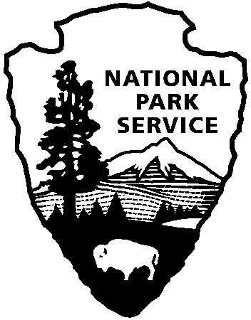
School Groups and Curriculum Based Education Programs

- It is best if you can provide us with 2-3 weeks notice. We are unable to provide Curriculum Based Education Programs if we do not have this notice. You may still visit, but we may not have staff available for education programs.

- Please try to get the documentation back to us as soon as possible. Once we have received all of the needed documentation, we will send out a confirmation email or call to confirm.

- Due to concerns about impacts on the historic resources at Appomattox Court House, we are not able to accommodate multiple large groups at one particular time. If there is a conflict, we will contact you and try to accommodate all groups requesting a reservation.

- If you are leading a group of students please remember, we require one adult for every ten students. Teachers and group leaders are responsible for their students.

For our education program descriptions, please visit: https://www.nps.gov/apco/learn/education/upload/2018-Ed-Program-Flyer.pdf
Our education programs are 20 minutes in length and due to resource limitations; we must divide larger groups into groups of about 25 to 30 people each. Please remember programs are 20 minutes each and an additional 5 minutes to move between stations.
For example: Excellent Elementary School is bringing its 4th graders (two classes of approximately 20 children each) along with two teachers and at least two other adult chaperons. They wish to arrive at 9:30am and plan to leave by 12:00pm. The schedule may look something like this:

Time | Activity | Schedule 1 | Schedule 2
9:30 | Arrival and introduction | Group 1 | Group 2
9:40 | 1st station | McLean House | Parole Passes
10:00 | rotate to the next station
10:05 | 2nd station | Parole Passes | McLean House
10:25 | rotate to the next station
10:20 | 3rd station | Stacking of Arms (both groups)
11:00 | Lunch
11:30 | Exploration time
12:00 | Depart

Please fill out the following information and email it to brandon_chamberlain@nps.gov or fax it to 434-352-8568 Attention “Group Tours Coordinator.” Please call 434-352-8987 x 231 with any questions.

Requested Date of Visit:
Time:
Day of Week:

Name of Group:

Total Number in Group:
Adults:
Children:
Seniors:

Y/N Education Program Requested? Age/or grade of children:

Group Contact Person:

Phone: Email:

Group Address:

Fax:

City: State: Zip Code:
Teacher Information is available on the park website, www.nps.gov/apco (look in “Learn About the Park” then “Education” then “Curriculum Materials” or “Bring the Park to Your School” sections for more information).

Also available on our website is Where Our Country Reunited, an integrated teaching/learning package designed for 4th and 5th grade students.

Please list any special request or accessibility needs.

