Acadia National Park Banner
Carroll Homestead Field Trip

We are looking forward to your visit to Acadia National Park and Carroll Homestead, which will provide your students with a special opportunity to learn about family life on the Maine coast in the 1800's.

Please meet your ranger at 9:00 AM at agreed upon location in your confirmation email.). The program concludes at 1:00 PM. Plan a bathroom break just before departing. If you have any questions about the program in advance, please call the education office at 288-8823, or 288-8825 on the day of the program. If you will be more than 15 minutes late, please call the Visitor Center at 288-
8832 so that they can contact the ranger by radio.
Program Schedule (timing and sequence may vary)
9:00 Welcome and introduction
9:15 “Walk back in time” activity
9:45 Snack / life on a subsistence farm
10:00 Carroll family stories (with family descendent if available)
10:30 House tour
10:45 Homestead hunt
11:30 Lunch
12:00 Leisure activities / “Hailey Over” game
12:50 Conclusion
1:00 Departure

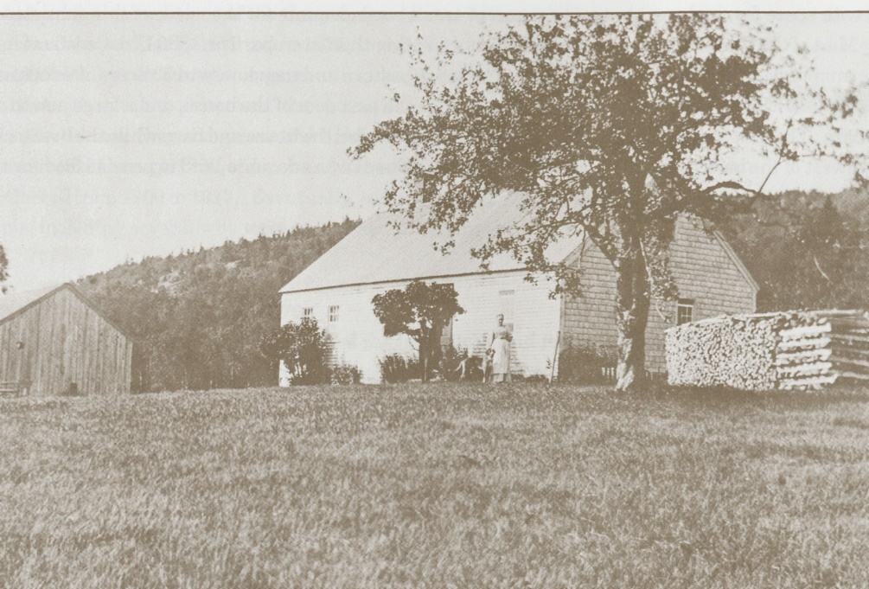

Plan to Bring
- Chaperones: Plan early! Acadia requires a chaperone for every ten students. Extra chaperones are welcome.
- Food: No food or drink is available at Carroll Homesead. Each student needs to bring a snack, a bag lunch and a re-sealable drink.
- Clothing: Wear layered outdoor clothing to accommodate changing weather conditions. Supportive shoes are essential—no sandals or flip-flops. You can encourage your students to dress in period clothing (e.g. pigtails and long skirts for girls, straw hats and suspenders for boys) to provide a more authentic experience. Brimmed hats and sunscreen provide more protection from the sun.
- Nametags: Students and adults need name tags. A piece of masking tape with name in marker is sufficient.
- Signed photo release forms: Please send photo releases home with students for parent signatures.

Teachers’ Responsibilities
- Prepare students for the program. Pre-visit activities can be found in the Carroll Homestead Educator’s Guide (see Online Resources below).
- Adherence to school procedures such as permission slips, insurance, transportation, etc.
- Recruit chaperones and inform them of their responsibilities. Please photocopy and distribute the chaperone handout.
- Prepare students to follow Leave No Trace practices:
  - Stay on trails if possible.
  - Respect, listen, and use quiet voices.
  - Leave natural objects. Take trash with you. (You may want to bring a trash bag.)
- Remind children that the 1825 house is very old and fragile and needs to be treated gently.
- Supervise students and help them stay focused while on the program.
- Notify trip participants about the recommendation to check for ticks after visiting the park. Tick numbers here have risen in recent years.
- Ensuring that safe practices are followed throughout.

Program Goals:
- To learn about coastal Maine life in the 1800’s, using the Carrolls as a representative family.
- To compare and contrast life today with life in the period from 1825-1925.
- To recognize the park’s mission in protecting and preserving cultural history.

Program Objectives:
Students will be able to:
- Describe in their own words, subsistence living in the 1800’s.
- List three subsistence practices used by the Carrolls (e.g. masonry, logging, farming, hunting, fishing, quarrying, food preservation, making clothes).
- Identify two ways the Carrolls supplemented their resources (e.g. teaching, bartering, masonry, berries, seafaring).
- Name five routine chores performed by the Carroll family members.
- State two ways the Carrolls used their leisure time.
- Describe one characteristic of 19th Century architecture represented by the Carroll’s house.
- Specify two similarities and two differences between life today and life when the Carrolls lived at the Mountain House.
- Give a reason why and how the Carroll Homestead is preserved as part of Acadia National Park.

Learning Standards:
From the Common Core:
Literature
CCSS.ELA-Literacy.RL.4.3 Describe in depth a character, setting, or event in a story or drama, drawing on specific details in the text (e.g., a character’s thoughts, words, or actions).
CCSS.ELA-Literacy.RL.4.6 Compare and contrast the point of view from which different stories are narrated, including the difference between first- and third-person narrations.
Informational Text:
CCSS.ELA-Literacy.RI.4.3 Explain events, procedures, ideas, or concepts in a historical, scientific, or technical text, including what happened and why, based on specific information in the text.
CCSS.ELA-Literacy.RI.4.4 Determine the meaning of general academic and domain-specific words or phrases in a text relevant to a grade 4 topic or subject area.
Speaking & Listening
CCSS.ELA-Literacy.SL.4.4 Report on a topic or text, tell a story, or recount an experience in an organized manner, using appropriate facts and relevant, descriptive details to support main ideas or themes; speak clearly at an understandable pace.

From the Maine Learning Results: Social Studies Context: Maine
Social Studies: Geography
D1d. Understand how Maine’s physical features affect resources.
D1d. Understand how Maine's climate affects resources.
D1d. Understand that people settle in particular areas because of natural resources.
Social Studies: History
E1b. Identify various major historical eras, major enduring themes, turning points, events, consequences, persons, and timeframes, in the history of Maine.
E2a. Describe examples in the history of diverse and shared values and traditions in Maine.
E2b. Describe various cultural traditions and contributions of Maine Native Americans and various historical and recent immigrant groups in Maine.

