Fiscal Year: 2013
State: Utah
Agency: National Park Service
Theme: Fire-Adapted Human Communities

Clear Trap Prescribed Fire
Zion National Park, Utah
Cohesive Strategy – Fire Adapted Human Communities

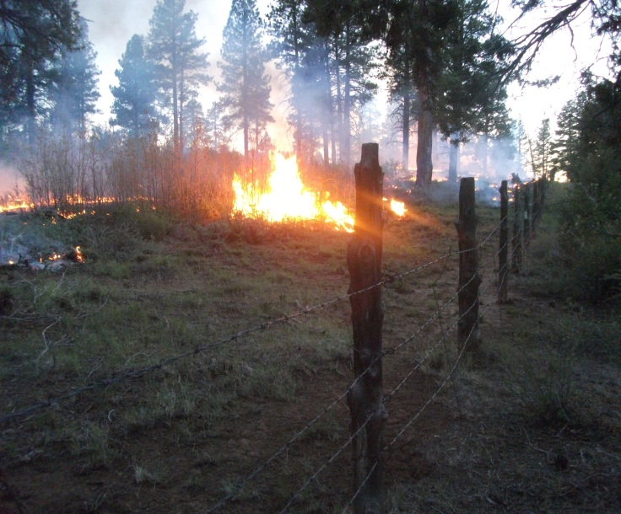
In late May, 2013, fire management personnel from Zion National Park, with cooperation from interagency partners, completed the Clear Tap prescribed fire (Rx) project. This second entry burn is located along the park’s eastern boundary and had been previously identified as one of the six original wildland-urban interface “Focus Areas” located in the Color Country Interagency Fire Management Area that required fuel reduction treatments to protect communities/properties at risk from the threat of wildland fire. The objectives of the Clear Trap Rx are to provide protection for surrounding property and structures, reduce fuel loading and restore fire to its natural role in the ecosystem. This phase of the ongoing project retreated 650 acres of the original 4,000 acres in the burn unit. The remaining acreage of the burn unit was first treated in the fall of 2004.

The project began with a hand ignited blacklining operation along the park boundary, adjacent to private lands and structures, to create a buffer zone along the boundary to reduce the risk of the prescribed fire escaping containment lines. Once the buffer zone was secure, the remaining portion of the burn unit was ignited from the air using a helicopter which was a safer and more effective use of resources.

Once ignited, portions of the interior of the burn unit continued to slowly burn over several days. Smoke dispersal was very good during the burn due to favorable wind conditions and a high clearing index. Very few impacts from smoke were encountered during the burn. Some temporary trail closures were instituted in and adjacent to the burn unit, but were reopened as soon as it was safe to do so.

The cooperation from our local, interagency partners was vital in the success of the project. Cedar City Bureau of Land Management, Dixie National Forest and the State of Utah Division of Forestry, Fire and State Lands provided much needed resources and experience. The National Park Service also provided assistance including two Wildland Fire Modules and the helicopter from Grand Canyon National Park.

The Clear Trap Rx will benefit both Zion National Park and the landowners and residents of the East Zion area. The burn will not only provide them with a lowered risk from wildland fire, but will also benefit the plants and animals of the fire-adapted ponderosa pine ecosystem. The policy of using fire as a management tool will help decrease risks to life, property and resources and will perpetuate the values for which the park was established.

Keywords: Fire ecology, Restore and Enhance landscapes
Contact: David Eaker, Fire Information/Education Specialist 435-772-7811, david_eaker@nps.gov

