Zion National Park News Release

Zion National Park

State Route 9

Springdale, UT 84767

435-772-3256

www.nps.gov/zion

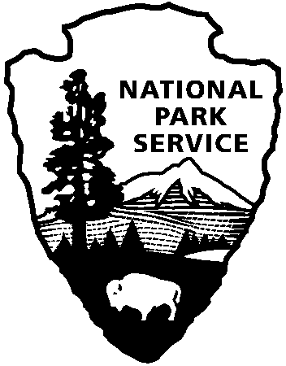

National Park Service

U.S. Department of the Interior

For Immediate Release

David Eaker 435-772-7811

Taiga Rohrer 435-772-7842

June 27, 2011

11-18

Zion National Park Implementing Fire Restrictions

As a result of high fire danger in Zion National Park, restrictions prohibiting campfires in Watchman and South Campgrounds, and smoking on trails will be instituted. These restrictions go into effect at 12:01 a.m. on Friday, June 24, 2011 and will be enforced until rescinded by the Superintendent Jock Whitworth. The degree of risk to public safety and structures within Zion National Park from a human-caused fire warrants these restrictions.

The following acts will be prohibited in Zion National Park until further notice starting Friday, June 24, 2011 at 12:01 a.m.

* Setting, building, maintaining, attending, or using a campfire in Watchman and South Campgrounds, all picnic areas, and/or permanently improved places of habitation. Stoves fueled by petroleum, liquid propane gas (LPG) are permitted.
* Smoking on all trails. Smoking is allowed within designated smoking areas, developed recreational sites, or enclosed vehicles.
* Discharging, or using any type of fireworks or other pyrotechnic devices, is prohibited at all times on all federal public lands.

Violation of the prohibited acts listed above is punishable by a fine of up to $5,000 and/or imprisonment for up to twelve months, or both.

For information concerning fire restrictions in Zion National Park, call 435 772-3256.