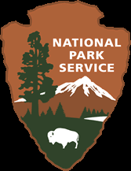
National Park Service
U.S. Department of the Interior
Yosemite National Park

DRAFT Goals of the Merced Wild and Scenic River Comprehensive Management Plan – Version 5.11.2011

The overall goal of the Merced River Plan is to protect and enhance the values for which the river was designated wild and scenic, leaving the river unimpaired for future generations. More specifically, the goals of this plan are to:
- Promote the river’s ability to shape the landscape, reducing impediments to free flow, improving geologic/hydrologic processes, restoring flood-plains and meadows, and protecting water quality.
- Support opportunities for people to experience and develop direct connections to the Merced and its unique values as a place of cultural association, education, recreation, reflection and inspiration.
- Institute a visitor use management program that balances the provision of high quality, resource-related visitor use opportunities in the river corridor with the protection and enhancement of natural and cultural river values today and into the future.
- Provide clear direction on land uses and associated developments in the river corridor, allowing for appropriate structures to support the protection and enhancement of river values.

