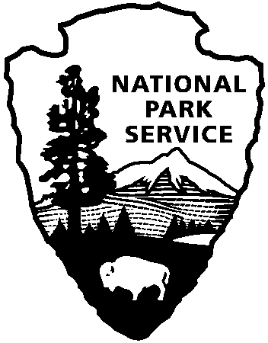
Valles Caldera National Preserve
National Park Service
U. S. Department of the Interior

Valles Caldera National Preserve
2020 Livestock Grazing Program
Application

Please type or print clearly all information; sign and date proposal affirming accuracy of answers.
SUBMIT THIS FORM TO: Valles Caldera National Preserve, National Park Service, P.O. Box 359,
090 Villa Louis Martin, Jemez Springs, NM 87025, USA or email to: Brenda_Montoya@nps.gov.
Completed and signed applications must be received by 4:30 PM, Wednesday, March 11, 2020.

Applicant Information:

Name:

Address – Street:

City/State/Zip code:

Telephone – Home: Work: Cell:

Email:

Are you representing a group of livestock owners, institution, or a livestock association? Yes No

If yes, list name of institution/association and name(s) of livestock owners. (Attach additional sheets as needed.):

Program qualifications: Please review the attached 2020 Livestock Operations Plan (Plan), and respond to the Plan’s requirements below. (Failure to answer all questions, or answering ‘No’ to any question, will eliminate the application from further consideration.)

- Type of livestock operation (e.g., cow-calf, steers, heifer, etc.):

- Able to meet average stocking rate of 163 Animal Units per Month Yes No
for four (4) months*?

- Minimum stocking rate of 67 AUM* acceptable? Yes No

- Maximum number of AUM that can be fulfilled (up to 273 AUM*):

- Entry/exit dates (June 1 – September 30) acceptable? Yes No

- Grazing fee of $20-$25 per AUM acceptable? Yes No

- Ownership and veterinary records for all livestock available? Yes No

- Able to provide full-time range rider? Yes No

- Able to maintain fences? Yes No

- Able to meet herd rotation schedule? Yes No

- Able to round up and return stray livestock? Yes No

- Able to provide livestock veterinary care? Yes No

- Able to prevent noxious weed introduction? Yes No

- Able to provide safety plan? Yes No

- Able to ensure humane treatment of livestock and stock animals Yes No
(horses, dogs) during transport to/from and while on the preserve?

- Have all past NPS invoices for previous livestock grazing been paid? Yes No
(If not applicable, mark ‘Yes’)

- Able to meet requirement to further scientific research or interpretation? Yes No

- If applicable, have all past science/interpretation reports been submitted? Yes No
(If not applicable, mark ‘Yes’)

- Description attached of proposed plan for either (1) interpretation of the Yes No
preserve’s ranching history (e.g., public educational workshops,
demonstrations, public-participation events, etc.), or (2) scientific
research (include objectives/questions, methods, and expected results
and management applications) to be conducted during June-Sept. 2020?

Signature of Applicant _____________________________________ Date: __________________

