National Park Service
1845 Wasp BLVD, #176
Honolulu, HI 96818
808-422-3311 phone
www.nps.gov /valr
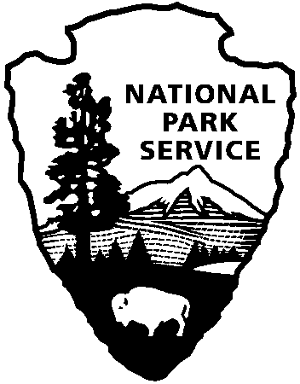
National Park Service
U.S. Department of the Interior
National Park Service Media Advisory

National Park Service POC: Abby Wines, Public Information Officer: 808-422-3311
Navy Region Hawaii POC: Public Affairs Office: 808-590-8363
USS Arizona Memorial Reopens June 5 After Repairs
The National Park Service is re-opening the USS Arizona Memorial this morning, June 5.

The “heavy lifting” of repairs was completed by June 3, when a floating crane was used to reposition the brow (bridge connecting the floating dock to the stationary memorial). The Navy continued working on June 4. The Navy divers finished their underwater work just after midnight.

Safety inspections started during the final stages of repair work and included reviews of how the structure performed during a cycle of high and low tidal movements.

The Navy will do a visual safety inspection of the dock each morning before the first tour. Public tours to the USS Arizona Memorial will begin today at the normally scheduled time, 7:30am.

Early this morning there will be a blessing of the repaired dock.

NPS Superintendent Paul DePrey said, “The National Park Service deeply appreciates the dedicated efforts of the US Navy and others to get this repair done as quickly and safely as possible.”

"This was a tremendous team effort - both with our military-civilian team and together with our partners at the National Park Service," said Capt. Stan Keeve, Commander, Joint Base Pearl Harbor-Hickam. "We certainly appreciate the understanding and forbearance of veterans, visitors and kama'aina," Keeve added.

www.nps.gov/valr

About the National Park Service. More than 20,000 National Park Service employees care for America's 405 national parks and work with communities across the nation to help preserve local history and create close-to-home recreational opportunities. Visit us at www.nps.gov, on Facebook www.facebook.com/nationalparkservice, Twitter www.twitter.com/natlparkservice, and YouTube www.youtube.com/nationalparkservice.

