National Park Service
1845 Wasp BLVD, #176
Honolulu, HI 96818
808-422-3311 phone
www.nps.gov /valr
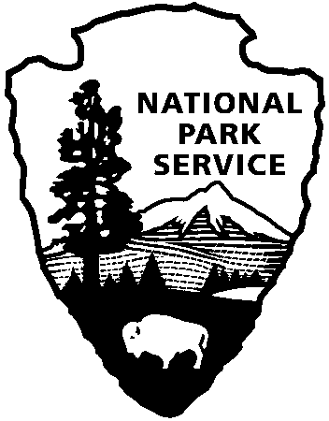
National Park Service
U.S. Department of the Interior
National Park Service Media Advisory

National Park Service POC: Abby Wines, Public Information Officer: 808-422-3311
Navy Region Hawaii POC: Public Affairs Office: 808-590-8363
USS Arizona Memorial Reopens After Repairs
As of 3:00pm on Thursday, June 4, repairs to the USS Arizona Memorial’s floating dock and brow are nearly complete. The Navy anticipates having the repairs finalized by Friday morning. Therefore, the National Park Service hopes to resume tours out to Battleship Row and onto the USS Arizona Memorial on Friday, June 3rd.

Final checks and assessments were done by the Navy working weekends and evenings as expeditiously - but as safely - as possible. NPS Superintendent Paul DePrey said, “The National Park Service deeply appreciates the dedicated efforts of the US Navy and others to get this repair done as quickly and safely as possible.”

"This was a tremendous team effort - both with our military-civilian team and together with our partners at the National Park Service," said Capt. Stan Keeve, Commander, Joint Base Pearl Harbor-Hickam. "We certainly appreciate the understanding and forbearance of veterans, visitors and kama'aina," Keeve added.

Barring any unforeseen complications, tours are scheduled every 15 minutes from 7:30am to 3:00pm. Every day, Navy staff will do a visual safety check of the USS Arizona Memorial’s dock before tours begin. Demand might be high to visit the USS Arizona Memorial on Friday, since no visitors have been able to set foot on it since May 26. There are 4,350 tickets available per day.
Reservations can be made in advance at 877-444-6777 or www.recreation.gov. Some tickets are released into the reservation system two months in advance, some are released at 7am the prior day, and some are available first-come, first-served on the day of the tour. On a typical summer day, all tickets for the entire day can be distributed by late morning.
The U.S. Coast Guard and Military Sealift Command continue to investigate what happened at the USS Arizona Memorial’s dock on May 27.

The Navy doesn’t have an estimate of the cost of repairs yet.

www.nps.gov/valr

About the National Park Service. More than 20,000 National Park Service employees care for America's 405 national parks and work with communities across the nation to help preserve local history and create close-to-home recreational opportunities. Visit us at www.nps.gov, on Facebook www.facebook.com/nationalparkservice, Twitter www.twitter.com/natlparkservice, and YouTube www.youtube.com/nationalparkservice.

