National Park Service Upper Delaware 274 River Road
U.S. Department of the Interior Scenic and Beach Lake, PA 18405
Recreational River 570-729-7134
Ext 2225 phone
570-729-8565 fax

Superintendent’s Compendium of Designations, Closures, Permit Requirements and Other Restrictions Imposed Under Discretionary Authority.

Approved:

/s/ Signature on file
__________________________________________ Date: 03/24/2023
Lindsey Kurnath, Superintendent

In accordance with regulations and the delegated authority provided in Title 36, Code of Federal Regulations (“36 CFR”), Chapter 1, Parts 1-7, authorized by Title 54 United States Code, the following provisions apply to all lands and waters administered by the National Park Service, within the boundaries of Upper Delaware Scenic and Recreational River. Unless otherwise stated, these regulatory provisions apply in addition to the requirements contained in 36 CFR, Chapter 1, Parts 1-7.

These rules are applicable on the Delaware River from the confluence of the East and West Branches at Point Mountain in the vicinity of Hancock, New York to the #2 railroad trestle in the vicinity of Sparrowbush, New York, and on any lands owned or managed by the National Park Service (NPS) within the designated boundary of the Upper Delaware Scenic and Recreational River.

Individuals interested in more information about these provisions should contact: The Superintendent, Upper Delaware Scenic and Recreational River, 274 River Road, Beach Lake, PA 18405-9737, or call (570) 729-8251, ext. 2225.

Written determinations, which explain the reasoning behind the Superintendent’s use of discretionary authority, as required by Section 1.5(c), appears in this document identified by italicized print.

36 CFR § 1.5 – VISITING HOURS, PUBLIC USE LIMITS, CLOSURES, AND DESIGNATIONS FOR SPECIFIC USES OR ACTIVITIES

(a)(1) The following visiting hours, public use limits, and closures are established:

Visiting Hours:

- Pennsylvania Fish and Boat Commission river accesses are closed from 10:00 pm to 5:00 am.

- The Delaware Aqueduct (Roebling Bridge) NY and PA parking lots are closed from 10:00 pm to 5:00 am.

Public Use Limits:

- It is the determination of the Superintendent of the Upper Delaware Scenic and Recreational River, based upon a review of the River Management Plan, inspection of the Milanville facilities, and consultation with field law enforcement personnel, that Milanville Office land bases will not be used for public launching or landing of watercraft.

The Milanville facility has limited shoreline on the Delaware River and the unimproved road access is only partially on National Park Service property. This particular road is deeded as shared access by two other property holders as part of a subdivision covenant. In addition, the minimal shoreline owned by the NPS in this area is not suitable for launching watercraft. Public launch sites exist immediately across the river at Skinner's Falls, three miles north of the Milanville Office at Damascus, on the Pennsylvania shore; and at Cochecton on the New York shore.

- The Delaware & Hudson Canal Towpath Trail located on the New York shore in the vicinity of the Delaware Aqueduct is closed to all motorized vehicles except those authorized by the NPS for maintenance and emergency service operations and single-occupant conveyances for handicapped visitors.

This restriction is determined necessary to manage the risk of visitor injury and damage to the trail surface.

Closures:

- All lands owned and managed by the NPS are closed to the following activities:

  - All areas of the park are closed to camping with the exception of one park-sponsored event known as the Delaware River Sojourn, to be held annually, when camping is permitted at the Zane Grey Museum with express permission of the Superintendent and in accordance with the conditions set forth in an approved Special Use Permit.

(a)(2) The following areas have been designated for a specific use or activity, under the conditions and/or restrictions as noted:

Face Mask Requirement

When the COVID-19 Community Level is LOW or MEDIUM in the county or all the counties where the park is located based on data provided by the Centers for Disease Control and Prevention (CDC), individuals are not required to wear masks.

When the COVID-19 Community Level is HIGH in the county or all the counties where the park is located based on data provided by the CDC, all individuals over the age of two must wear masks, regardless of vaccination status, in all common areas and shared workspaces in buildings owned, leased, or otherwise controlled by the National Park Service, including, but not limited to, park visitor centers, administrative offices, lodges, gift shops and restaurants.

When the COVID-19 Community Level is HIGH in one or more, but not all, of the counties where the park is located based on data provided by the CDC, the superintendent will determine whether individuals are required to wear masks. The requirement, if any, will apply to all facilities within the park.

Masks must cover the nose and mouth and fit snugly around the nose and chin with no large gaps around the sides of the face. Masks not designed to be protective, masks with ventilation valves, and face shields do not meet the requirement.

Regardless of the COVID-19 Community Level, individuals may wear masks if they choose to do so. Where a state, local, tribal, or territorial government where the park is located imposes more protective mask-wearing requirements than those indicated by the COVID-19 Community Level, individuals must follow those more protective requirements within the park. More protective state, local, tribal, or territorial mask-wearing requirements are hereby adopted as federal requirements in all units of the National Park System located within that state, locality, area subject to a federally recognized Indian tribe’s regulatory jurisdiction, or territory, regardless of a particular park’s jurisdictional status.

Additionally, all individuals must wear masks in or on public transportation conveyances and transportation hubs/facilities, to the extent required by current orders or directives issued by the CDC, the Transportation Security Administration (TSA), or other federal agencies with jurisdiction over those conveyances or areas. As of March 4, 2022, CDC and TSA orders or directives require all individuals regardless of vaccination status to wear masks in indoor areas of all forms of public transportation conveyances, including busses, trains, and boats/ferries, and in the indoor premises of transportation hubs/facilities. Individuals are not required to wear masks while outdoors on conveyances or while outdoors on the premises of transportation hubs/facilities.

Areas Designated for a Specific Use or Activity:

- During periods of high water all individuals in or on the waters of the Delaware River within the Upper Delaware Scenic and Recreational River are required to wear a Type I, II, III, or V U.S. Coast Guard approved Personal Flotation Device (PFD). The PFD must be of the proper size for the individual wearing it and must be in good, serviceable condition. High water is defined as six (6) feet and above, as measured at the Callicoon Gauge for all points upstream of the northern side of the Narrowsburg Bridge. For the river downstream of that point to the southern boundary of the park, high water is defined as six (6) feet and above as measured at the Barryville Gauge.

This condition is determined necessary to manage the increased risk to river users and rescue personnel during periods of high water.

- Personal floatation devices are required to be readily accessible by users of all watercraft including inflatable inner tubes, improvised flotation devices or similar devices used for transportation on the water.

- Personal flotation devices must be worn during cold weather periods on all vessels and boats 16 feet and smaller from November 1st to April 30th.

This condition is determined necessary to ensure public safety on the river.

- Water skiing is only allowed in the Narrowsburg Pool. Water skiing on the Narrowsburg Pool must be done in accordance with applicable State (NY/PA) Laws.

This condition is determined necessary to ensure public safety on the river.

- The possession of glass containers is prohibited on the river and to the ordinary high-water mark.

This condition is determined necessary to ensure public safety on the river and reduce pollution. There is a history of glass containers breaking in the river, on the rocky shoreline, gravel bars and islands. Broken glass can be difficult to pick up, can be unsightly, and can cause injury to people and animals. The river is frequented by swimmers and boaters who are often barefooted. Broken glass has caused numerous injuries over the years to recreationists. Between 1990 and 2014, public river clean-ups recovered over 440 tons of trash from the Upper Delaware River but less than 1% of trash recovered was glass. In addition to being difficult to recover, broken glass remains in the environment a long time. A glass bottle requires up to a million years to decompose in the environment and it requires 5-50 years to smooth sharp glass edges.

- Swimming and wading are allowed in all areas of the river, except at PA Fish & Boat Commission Access Areas. There are no designated swimming beaches.

- Bathing is prohibited in the river.

- Launching, landing, or operating an unmanned aircraft/drone from or on lands and water administered by the National Park Service within the boundaries of Upper Delaware Scenic and Recreational River is prohibited except as approved in writing by the Superintendent. Unmanned aircraft/ drone can not interfere with public use on the river or harass wildlife.

This condition is deemed necessary for the maintenance of public health and safety; protection of environmental and scenic values; protection of natural and cultural resources; implementation of management responsibilities, equitable allocation of and use of facilities; and the avoidance of conflict among visitor use activities. Of special concern is the potential impact of this activity on nesting bald eagles and other endangered or threatened species.

This prohibition is a necessary interim measure until the National Park Service considers how to address this new use on a long-term basis and that allowing the use of unmanned aircraft before the park has properly evaluated whether this use is appropriate could result in unacceptable impacts to park resources, park values and visitor safety.

Definition:

The term “unmanned aircraft” means a device that is used or intended to be used for flight in the air without the possibility of direct human intervention from within or on the device, and the associated operational elements and components that are required for the pilot or system operator in command to operate or control the device (such as cameras, sensors, communication links). This term included all types of devices that meet this definition (e.g. model airplanes, quadcopters, and drones) that are used for any purpose including for recreation or commerce.

36 CFR § 1.6 – ACTIVITIES THAT REQUIRE A PERMIT

Activities requiring a permit are listed throughout this document under the specific 36 CFR section that authorizes or requires the issuance of a permit. These include but are not limited to:

- Organized boating and tubing special events.
- Baptisms and similar religious ceremonies.
- Weddings on NPS owned and managed property.
- Commercial business conducted on the river and/or NPS owned and managed property.
- Any special use of property NPS owned and managed property.
- Construction, maintenance, or inspection of bridges that cross above the Delaware River.
- Construction below the ordinary high-water mark

The following restrictions and/or conditions are in effect for the specific uses or activities noted:

On August 23, 2022, the United States Court of Appeals for the District of Columbia issued a decision reversing the order of the District Court. Price v. Garland 45 f.4th 1059 (D.C. Cir 2022). This decision became effective October 28, 2022, with the issuance of the Court of Appeals Mandate.
As a result, the statute and regulations that governed commercial filming before the Price decision are again in effect.

Those interested in commercial filming activities on land managed by the National Park Service are encouraged to contact the park directly for more information about filming in the park and to discuss how to minimize potential impacts to visitors and sensitive park resources.

Filming without a permit is prohibited in areas managed as wilderness or in areas that are closed to the public. All activities in park areas—including filming—must comply with all visitor use regulations, including those prohibiting resource damage, protecting wildlife or mitigating audio disturbances, as well as any restrictions on visitor use in the park’s compendium, such as restrictions on the use of unmanned aircraft systems (drones).

Low-Impact Filming is defined as outdoor filming activities in areas open to the public, except areas managed as wilderness, involving five people or less and equipment that will be carried at all times, except for small tripods used to hold cameras. Those participating in low-impact filming activities do not need a permit and are not required to contact the park in advance. If low-impact filmers have questions about areas where they want to film, they should contact the park directly via email or phone at 570-729-7134 x 2234

Non-low-impact filming activities require at least 10 days advance notice to the NPS by contacting the park directly. During this time, the superintendent will determine whether the filming activities will require a permit. Based upon the information provided, a permit may be required if necessary to:

- maintain public health and safety;
- protect environmental or scenic values;
- protect natural or cultural resources;
- allow for equitable allocation and use of facilities; or
- avoid conflict among visitor use activities.

Filming activities must not violate applicable laws, such as the Endangered Species Act, the Archeological Resources Protection Act, or the Wilderness Act. All filming must comply with laws protecting the NPS’s intellectual property, such as laws and regulations governing the use of the NPS Arrowhead and images of NPS employees.

Additional information may be found on the National Park Service Filming and Still Photography page.

See Appendix A for permit procedures.

36 CFR § 2.1 – PRESERVATION OF NATURAL, CULTURAL AND ARCHEOLOGICAL RESOURCES

(a) Collecting natural materials from the park is generally prohibited. However, pursuant to (c) (1), The Superintendent may designate certain fruits, berries, nuts, or unoccupied seashells which may be gathered by hand for personal use or consumption upon a written determination that the gathering or consumption will not adversely affect park wildlife, the reproductive potential of a plant species, or otherwise adversely affect park resources. The following fruits may be gathered by hand for personal use or consumption:

- Visitors may take dropped fruit from the Cowen Farm orchard or the Zane Grey orchard. The Cowen Farm orchard and Zane Grey orchard consist of apple and pear trees.
- Visitors may not climb or shake fruit from the trees due to their historic significance.

It has been determined that the gathering of dropped fruit from the Cowen Farm and Zane Grey orchard will not adversely affect park wildlife, the productive potential of a plant species, or otherwise adversely affect park resources.

36 CFR § 2.2 - WILDLIFE PROTECTION

(d) The transporting of lawfully taken wildlife through federally managed land is permitted under the following conditions and procedures:

- Applicable Federal and State (NY/PA) laws apply.

36 CFR §2.3 –Fishing

- Fishing shall be in accordance with the laws of New York and Pennsylvania.

- When fishing on the Delaware River between NY and PA a valid New York or Pennsylvania fishing license is required for all anglers, age 16 and older.

Pursuant to (d)(8), fishing from motor road bridges is prohibited.

36 CFR §2.4 – WEAPONS, TRAPS, AND NETS

Pursuant to 18 U.S.C. § 930, firearms are prohibited in federal facilities. Federal facilities are defined as “buildings or parts thereof owned or leased by the federal government, where federal employees are regularly present for the purpose of performing their official duties.”

Federal facilities are marked with signs at public entrances, and include the following buildings:

- Headquarters Complex (Headquarters Building, Operations Building and Annex Building)
- Milanville Office & Garage Facility
- Zane Grey Museum
- Lackawaxen Maintenance Facility
- Margold House and barn
- Cowen Farm Ranger Station and barn

Pursuant to 54 U.S.C. 104906 (P.L. 111-24 Section 512), park visitors may carry firearms in National Parks if they are in compliance with federal, state, and local laws.

Pursuant to (a)(2)(ii), weapons, traps or nets may be carried, possessed or used at the following times and locations:

- In accordance with Federal and State (NY/PA) Laws.

36 CFR §2.5 – RESEARCH SPECIMENS

(a) Taking plants, fish, wildlife, rocks or minerals is prohibited except in accordance with the regulations contained in Chapter I of 36 CFR or pursuant to the terms and conditions of a specimen collection permit.

36 CFR §2.10 – CAMPING AND FOOD STORAGE

(a) Camping is prohibited in the park pursuant to 36 CFR § 1.5 Closures.

36 CFR §2.12 – AUDIO DISTURBANCES

(a)(2) Operating a power saw in developed areas is prohibited, except pursuant to the terms and conditions of a permit.

- Developed area means roads, parking areas, picnic areas or other areas owned or
managed by the NPS.

(a)(4) Operating a public address system is prohibited, except in connection with a public gathering or special event for which a permit has been issued pursuant to §2.50 or §2.51.

36 CFR § 2.13 – FIRES

(a)(1) The lighting or maintaining of fires is generally prohibited, except as provided for in the following designated areas and/or receptacles, and under the conditions noted:

- Contained fires such as a charcoal grill or hibachi are permitted at access areas and on the shoreline of the Delaware River. All fire remains must be extinguished and carried out.

36 CFR §2.14 – SANITATION and REFUSE

(a)(2) Using park refuse receptacles or facilities for dumping household, commercial or industrial refuse is prohibited.

36 CFR § 2.15 – PETS

(a)(1) The following structures and/or areas are closed to the possession of pets: (except for use with disabilities)

- All Upper Delaware Scenic and Recreational River government buildings.

(a)(2) Failing to crate, cage, restrain on a leash, which shall not exceed six feet in length, or otherwise physically always confine a pet.

- This applies to the Tusten Mountain Trail and all lands owned and managed by the NPS.

(a)(5) Pet excrement must be disposed of in accordance with the following conditions:

- Persons having custody of any animal(s) will immediately remove and dispose of excrement voided by an animal(s) under their control. Excrement will be properly disposed of in outdoor trash containers or removed from park property.

(b) The use of dogs in support of hunting must be in accordance with Federal and State laws and the following conditions:

□ No further conditions apply.

36 CFR § 2.17 - AIRCRAFT and AIR DELIVERY

(a)(3) Delivering or retrieving a person or object by parachute, helicopter, or other airborne means is prohibited, except in emergencies involving public safety or serious property loss or pursuant to the terms and conditions of a permit.

(c)(1) The removal of a downed aircraft, components, or parts thereof is subject to procedures established by the Superintendent (Permitting process).

36 CFR § 2.20 – SKATING, SKATEBOARDS and SIMILAR DEVICES

Using roller skates, skateboards, roller skis, coasting vehicles, hover boards, or similar devices are prohibited.

36 CFR § 2.21 – SMOKING

(a) The following portions of the park, buildings, structures and/or facilities are closed to smoking as noted:

- The Superintendent has determined that smoking, vaping, and the use of Electronic Nicotine Delivery Systems such as e-cigarettes is prohibited in and within 25 feet of all UPDE facilities.

These designations are based on a determination that smoking is prohibited to protect park resources, reduce the risk of fire, and prevent conflicts among visitor use activities. These designations are in accordance with Federal law.

36 CFR § 2.22 – PROPERTY

(a)(2) Leaving property unattended for longer than 24 hours is prohibited.

36 CFR § 2.35 –ALCOHOLIC BEVERAGES and CONTROLLED SUBSTANCES

(a)(3)(i) The following areas and facilities within the park are closed to consumption of alcoholic beverages, and/or to the possession of a bottle, can or other receptacle containing an alcoholic beverage that is open, or has been opened, or whose seal has been broken or the contents of which have been partially removed:

□ Alcoholic beverages are permitted in the park in accordance with all applicable Federal and State (NY/PA) laws.

- The possession or consumption of alcoholic beverages is prohibited on all PA Fish and Boat Commission Access Areas in Wayne County, PA.

36 CFR § 2.37 – NONCOMMERCIAL SOLICITING

Soliciting or demanding gifts, money, goods or services is prohibited except pursuant to the terms and conditions of a permit that has been issued under §2.50, §2.51, or §2.52.

36 CFR § 2.38 – EXPLOSIVES

(a) Using, possessing, storing, or transporting explosives, blasting agents or explosive materials is prohibited, except pursuant to the terms and conditions of a permit.

(b) Using, or possessing fireworks and firecrackers is prohibited.

36 CFR § 2.50 – SPECIAL EVENTS

(a) Sports events, pageants, regattas, public spectator attractions, entertainments, ceremonies, and similar events are allowed, provided there is a meaningful association between the park area and the events, and the observance contributes to visitor understanding of the significance of the park area, and a permit therefore has been issued by the Superintendent.

36 CFR § 2.51 -- DEMONSTRATIONS

(b) Demonstrations of 25 people or fewer are allowed within the park areas designated as available under paragraph (c)(2). Demonstrations of more than 25 people are allowed within designated park areas when the Superintendent has issued a permit for the activity.

(c)(2) The following locations are designated as available for demonstrations (see Appendix B for further description of location):

- Delaware Aqueduct PA Parking Lot

- Zane Grey Museum

36 CFR § 2.52 -- SALE OR DISTRIBUTION OF PRINTED MATTER

(b) The sale or distribution of printed matter by 25 people or fewer is allowed within the park areas designated as available under §2.51(c)(2) (see above). The sale or distribution of printed matter by more than 25 persons is allowed within designated areas when the Superintendent has issued a permit.

36 CFR §2.60 – LIVESTOCK USE AND AGRICULTURE

(a) Livestock are generally prohibited on property owned or managed by the NPS. They are only permitted areas pursuant to the exceptions provided for in §2.60(a) and only pursuant to the terms and conditions of a license, permit, or lease.

36 CFR §2.61 – RESIDING ON FEDERAL LANDS

(a) Residing in park areas, other than on privately owned lands, is prohibited except pursuant to the terms and conditions of a permit lease or contract.

36 CFR §2.62 - MEMORIALIZATION
(a) The installation of a monument, memorial, tablet, structure, or other commemorative installation in a park area without the authorization of the NPS Director is prohibited.

(b) The scattering of human ashes from cremation is prohibited, except pursuant to the terms and conditions of a permit.

36 CFR § 3.7 – PERSONAL FLOATATION DEVICE (PFD) REQUIREMENTS

(a) All requirements in Title 33 CFR part 175 related to PFDs are adopted.

Pursuant to § 3.7(b), PFDs must be worn or carried on the designated waters, at the designated times and/or during designated water-based activities outlined in this document under 36 CFR § 1.5.

- Specifically, all individuals in or on the waters of the Delaware River within the Upper Delaware Scenic and Recreational River during periods of high water are required to wear a Type I, II, III, or V U.S. Coast Guard approved Personal Flotation Device (PFD). The PFD must be of the proper size for the individual wearing it and must be in good, serviceable condition. High water is defined as six (6) feet and above, as measured at the Callicoon Gauge for all points upstream of the northern side of the Narrowsburg Bridge. For the river downstream of that point to the southern boundary of the park, high water is defined as six (6) feet and above as measured at the Barryville Gauge.

- Personal floatation devices are required by users of all watercraft, inflatable inner tubes, improvised flotation devices, or similar devices used for transportation on the water.

- Personal flotation devices must be worn during cold weather periods on all vessels and boats 16 feet and smaller from November 1st to April 30th.

36 CFR § 3.8 – BOATING OPERATIONS

(a)(2) Launching or recovering a vessel is prohibited, except at one of the following launch sites:

- PA Fish and Boat Commission accesses with launch ramps;

- NY DEC accesses with launch ramps;

- Hand launch only at the following NY DEC Accesses: Mongaup, Barryville, Highland, Skinner’s Falls, Cochecton, Lordville and Hancock;

- Hand launch only at Ten Mile River Access.

- This provision does not apply to landowners launching and retrieving watercraft from their private property.

(b)(3) Operating a vessel in excess of flat wake speed is prohibited in the following areas:

- Within 100' of shoreline, docks, launch ramps, swimmers or downed skiers, waders, anchored or drifting boats.

36 CFR § 3.9 – PERSONAL WATERCRAFT (PWC)

- The use of PWC on the Upper Delaware S&RR is prohibited.

- Personal watercraft refers to a vessel, usually less than 16 feet in length, which uses an inboard, internal combustion engine powering a water jet pump as its primary source of propulsion. The vessel is intended to be operated by a person or persons sitting, standing or kneeling on the vessel, rather than within the confines of the hull.

36 CFR § 3.12 – USING A VESSEL TO TOW A PERSON

(a) The towing of a person by a vessel is allowed only in the designated areas and in accordance with the conditions listed in this document under 36 CFR § 1.5.

- Specifically, water skiing is allowed in the Narrowsburg pool only, in accordance with applicable State (NY/PA) Law.

(b) Towing a person using a parasail, hang-glider or other airborne device may be allowed only in accordance with a permit.

36 CFR § 3.16 – SWIMMING AND WADING

(a) Swimming or wading is allowed in waters, subject to closures or restrictions designated in this document under 36 CFR § 1.5.

- Swimming and wading are prohibited at all access areas owned by the PA Fish and Boat Commission.

36 CFR § 3.17 – SWIMMING AREAS AND BEACHES

(a) Swimming areas and swimming beaches are designated in this document under 36 CFR § 1.5.

- There are no designated swimming areas.

36 CFR §3.18 – SCUBA AND SNORKELING

(a) Snorkeling and underwater diving is allowed in park waters.

36 CFR §3.19 – USE OF SUBMERSIBLES

The use of manned or unmanned submersibles may only occur in accordance with a permit issued by the Superintendent.

36 CFR §4.10 – TRAVEL ON PARK ROADS AND ROUTES

(a) Operating a motor vehicle is prohibited except on the Delaware Aqueduct (Roebling Bridge) and established parking areas.

36 CFR §4.11 – VEHICLE LOAD, WEIGHT, AND SIZE LIMITS

(a) The following load, weight, and size limits, which are more restrictive than State law, apply to the roads indicated under the terms and conditions, and/or under permit as noted:

□ Delaware Aqueduct (Roebling Bridge) - 10-ton gross vehicle weight (GVW) limit.

36 CFR §4.21 – SPEED LIMITS

(b) The following speed limits are established for the routes/roads indicated:

- Delaware Aqueduct (Roebling Bridge) - 15 miles per hour (MPH) posted speed limit.

36 CFR §4.30 – BICYCLES

(a) The use of a bicycle is permitted on park roads and in parking areas that are otherwise open for motor vehicle use by the general public.

- Areas closed to bicycle use are listed in this document under 36 CFR § 1.5. Specifically, riding a bicycle on the Roebling Bridge upper walkways (towpaths) and D&H Towpath Trail is prohibited.

- Bicycle riding including e-bikes is prohibited on the Roebling Bridge upper walkways (towpaths) and D&H Towpath Trail.

This restriction is determined necessary to manage the risk of visitor injury and damage to the trail surface; protection of environmental and scenic values; protection of natural and cultural resources; implementation of management responsibilities; and the avoidance of conflict among visitor use activities.

The definition of “e-bikes” is consistent with Federal law and a majority of State laws and provides for their use and regulation on the same basis as bicycles without power assist capabilities (“traditional bicycles”).

The term “e-bike” means a two- or three-wheeled cycle with fully operable pedals and an electric motor of less than 750 watts (1 h.p.).

E-bikes are allowed in the Upper Delaware S&RR where traditional bicycles are allowed. E-bikes are prohibited where traditional bicycles are prohibited. Except where use of motor vehicles by the public is allowed, using the electric motor to move an e-bike without pedaling is prohibited.

A person operating an e-bike is subject to the following sections of 36 CFR part 4 that apply to the use of traditional bicycles: sections 4.12, 4.13, 4.20, 4.21, 4.22, 4.23, and 4.30(h)(2)-(5).

Except as specified in this Compendium, the use of an e-bike within Upper Delaware S&RR is governed by State law, which is adopted and made a part of this Compendium. Any violation of State law adopted by this paragraph is prohibited.

Appendix A

Overview: Special Use Permits are issued for use at Upper Delaware under authority as outlined in 36 CFR 1.6 and 54 USC 100101.

Special Use Permits (SUP)’s may be issued, at the discretion of the Superintendent, federal, state, and local governments, to businesses, civic organizations and private organizations who wish to utilize park resources for events, meetings, conferences, programs, and other activities. The use of any park facilities is limited in number as determined by the Superintendent. Regular monthly meetings shall not be permitted in order to avoid monopolization by any one group and to make the facilities available for use by a wide range of local and regional organizations.

To apply for a SUP you can download an application from our website, make an appointment with the Special Park Use Coordinator at headquarters (570) 729-7134 x2234, or mail to the following address: 274 River Road, Beach Lake, PA 18405-9737.

Permits might not be issued if it is determined by the Superintendent that the use will result in injury or damage to a park resource, unduly impose restrictions on visitor use activities, or threaten or be a clear and present danger to public health and safety (36 CFR 1.6), be contrary to the purposes for which the park was established, impair the operation of public facilities, unreasonably impair the atmosphere of the peace and tranquility, interfere with the interpretative visitor services or other programs, impair the operation of public facilities, or be in significant conflict with other existing uses within the park.

SUP applications will be processed at a non-refundable charge of $100.00 to recover associated costs. SUP applications must be completed and submitted at least forty-five days (45) prior to the event to allow the Superintendent time to determine if the activity is appropriate. Information on how fees are electronically collected will be explained to the applicant.

Commercial Use Authorizations (CUA): CUA’s may be issued, at the discretion of the Superintendent, to anyone wishing to conduct commercial business within the jurisdiction of the National Park Service. Contact the Special Park Uses Coordinator at (570) 729-7134, ext. 2234 for information and assistance.

Cooperative Agreements: Organizations who have active cooperative agreements with the park may utilize Park facilities free of charge. Cooperators will only be assessed overtime charges as determined by the Superintendent.

Liability Insurance Standards: A liability insurance policy ranging from $1,000,000.00 to $5,000,000.00 + will be required for any special event conducted at the Upper Delaware S&RR. The Superintendent may determine reduced liability insurance coverage for small attendance programs. Events providing alcohol will be required to post a $1,000,000.00 policy naming the Department of the Interior, National Park Service, Upper Delaware S&RR as co-insured. Insurance will be issued in the name of the group. A certificate of insurance must be provided before the activity may take place and received before the permit will be issued.

Performance Bond: A performance bond is the permittee's guarantee payment for potential damages to park resources. A performance bond will be required if the Superintendent has determined that prior activities conducted by the permittee have resulted in damage to park-owned or legislatively protected resources. A performance bond may also be required if the Superintendent has determined that intensive use of the Upper Delaware Scenic & Recreational River by the permittee may result in damages to its facilities and resources. The amount of the bond will be calculated based on the total cost of repair for predictable or possible damages that the park does not consider as normal maintenance. Performance bonds will be placed in the park’s reimbursable account. Permittee may place a bond with a commercial bonding agent.

Food Service: Events that serve food for the general public will conform to health sanitation standards as outlined in PA/NY State standards.

First Amendment Rights: In accordance with provisions of 36 CFR 2.51, a permit may be issued, at the discretion of the Superintendent, for public assemblies for the purpose of expressing freedom of religion, speech, or press, including the right to peaceable assembles. No fees, liability insurance or bond shall be assessed for any individual or group claiming First Amendment Rights. The Superintendent shall determine special use permit conditions of time, place, and manner to provide for visitor safety and safeguard park resources. The Park shall not support or condone any opinion expressed by special use permittees.

Sale and Distribution of Printed Matter: A permit may be issued, at the discretion of the Superintendent, for such use but the sale and distribution of printed material is limited to areas established in the Compendium (36 CFR 2.52). Permittees shall not restrict visitor traffic, flow, or interfere with interpretive services.

Appendix B: Description of Designated First Amendment Areas

Lackawaxen Parking Lot (Delaware Aqueduct):

Grassy area of parking lot bordered by parking lot and sidewalk leading to towpath on downstream side of Delaware Aqueduct and south of sidewalk paralleling roadway and entrance to parking area. Demonstrators may not obstruct the sidewalks or roadways.

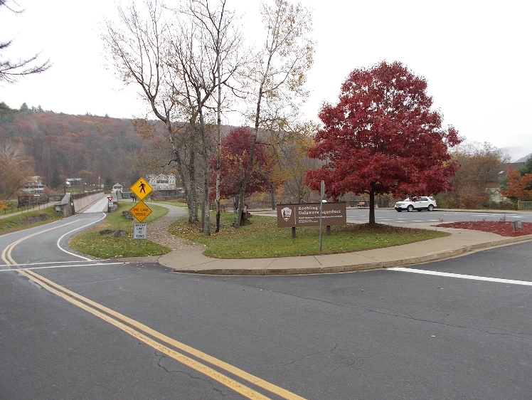.
NPS photo/Lackawaxen parking area at the Delaware Aqueduct (Roebling Bridge)

Zane Grey Museum:

Grassy area to the south of the bluestone sidewalk leading to the front entrance of the Zane Grey Museum following along Lackawaxen Drive to the southeast corner of the NPS property (marked by concrete posts). West along the mowed portion of the NPS property to the northwest corner then (east) to the sidewalk at the south side of the Zane Grey Museum. Demonstrators may not obstruct the sidewalks or roadways.

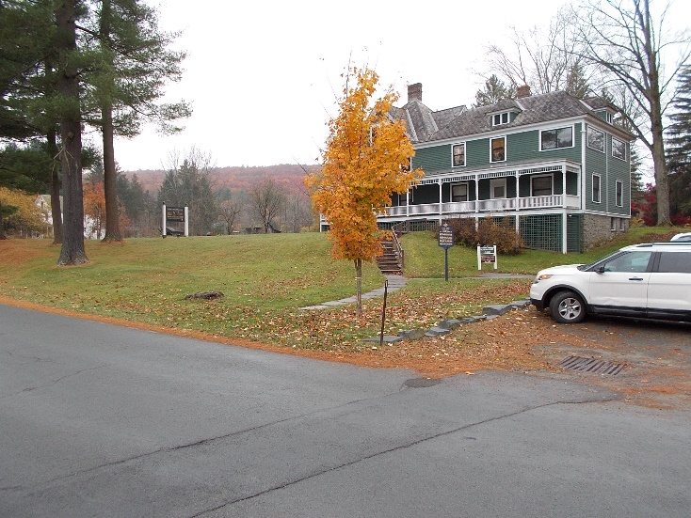
NPS photo/Zane Grey Museum

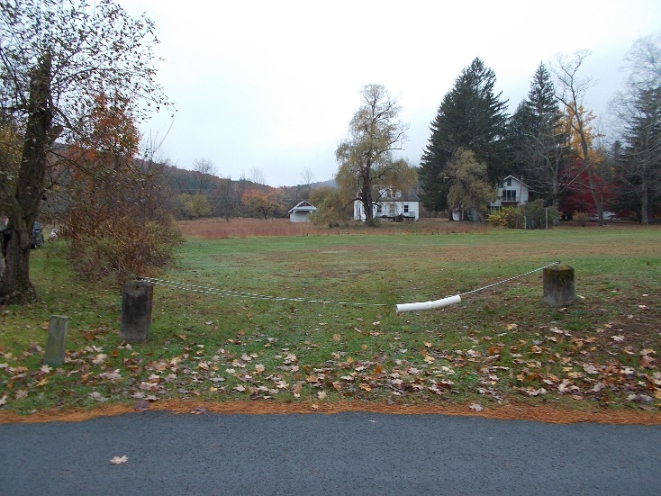
NPS photo/Zane Grey Museum property

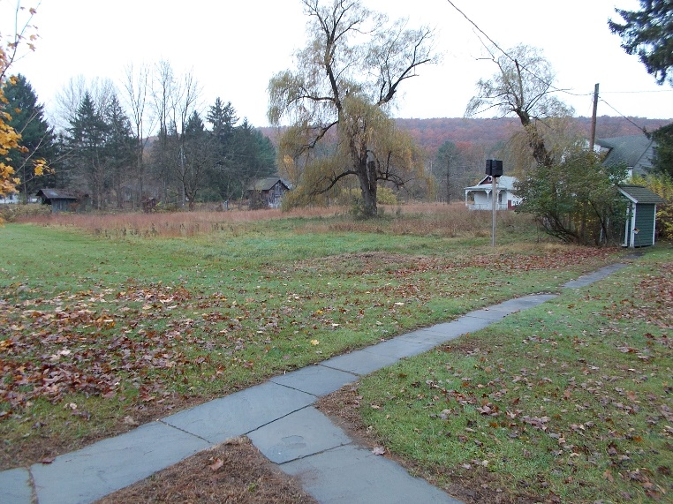
NPS photo/Zane Grey Museum property

