Scientific Research & Collection Permits
Prior approval in the form of a permit is required to conduct scientific research or collecting at Timpanogos Cave National Monument. Timpanogos Cave has a long history of supporting scientific research. A Presidential proclamation in 1922 established it as a national monument and cites its ‘scientific interest and importance’. Subsequent research has been important both to park management and to the general body of scientific knowledge. The park would like to continue that tradition and provide the information below to help researchers navigate the permitting process.
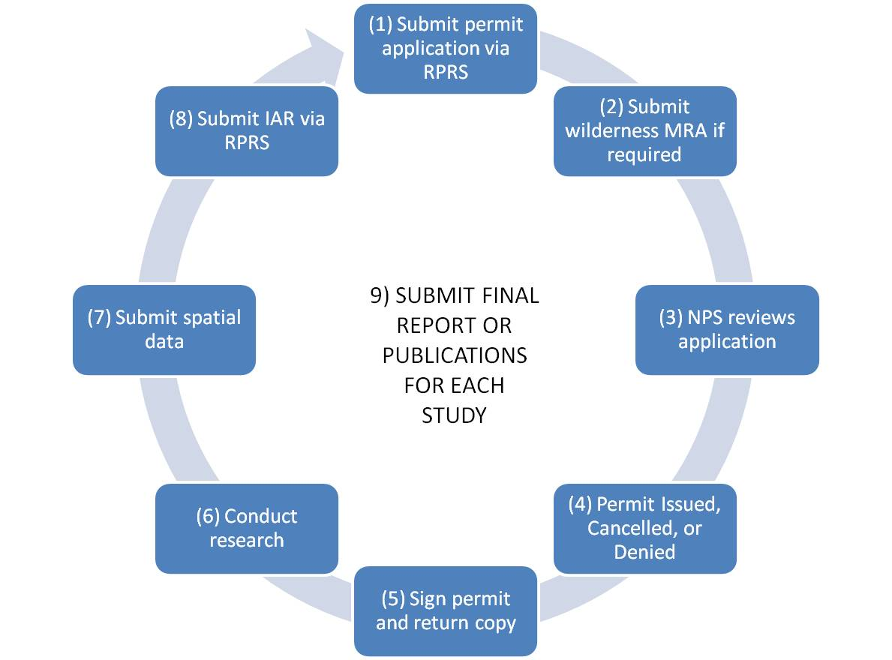

Permit applications are available through the NPS Research Permit and Reporting System website. This is a national website that tracks applications and permits. Researchers apply for permits via this website, but if you want to discuss your research permit application with someone at Timpanogos Cave, contact the Timpanogos Cave Resource Management Specialist at (801) 756-5239 extension 502.

