You must submit completed worksheet two weeks prior to your museum visit.
Contact: Education Director, Mark Lozo: mlozo@trsite.org, 716.884.0095

In accord with BSA policy, all scouts must be supervised by an adult during their visit.
______________________________________________________________________________________________________________________________________________
- Explain what citizenship in the world means to you and what you think it takes to be a good world citizen.

Fill out these sections, and be prepared to discuss this requirement during your visit to the TR Inaugural Site for Merit Badge Day.

2. Explain how one becomes a citizen in the United States, and explain the rights, duties, and obligations of U.S. citizenship.

How:

Rights:

Duties: (Things you should do, though not legally required to do so.)

Obligations: (Things you must do under force of law.)

Discuss the similarities and differences between the rights, duties, and obligations of U.S. citizens and the citizens of two other countries.
Country:

Rights:

Duties: (Things you should do, though not legally required to do so.)

Obligations: (Things you must do under force of law.)

Country:

Rights:

Duties: (Things you should do, though not legally required to do so.)

Obligations: (Things you must do under force of law.)

3. Do the following:
a. Pick a current world event based on ONE of the following categories: immigration, labor reform, conservation/environmentalism, urban poverty, racial or social inequality, role of the United States in foreign affairs.
In relation to this current event, discuss how a country's national interest and its relationship with other countries might affect areas such as its security, its economy, its values, and the health of its citizens.
World Event:___________________________________________________________________________________

Security:

Economy:

Values:

Public health:

b. Research the Panama Canal. Discuss how Panama's geography, natural resources, and climate influence its economy and its global partnerships with other countries.

Geography:

Natural Resources:

Climate:

4. You will complete BOTH options (b) and (c) here.
b. Using resources such as major daily newspapers, the Internet (with your parent's permission), and news magazines, observe a current issue that involves international trade, foreign exchange, balance of payments, tariffs, and free trade. Choose a current issue based on ONE the following categories: immigration, labor reform, conservation /environmentalism, urban poverty, racial or social inequality, role of the United States in foreign affairs.

Current Issue:

International Trade:

Foreign Exchange:

Balance of Payments:

Tariffs:

Free Trade:

Explain what you have learned:

Include in your discussion an explanation of why countries must cooperate in order for world trade and global competition to thrive:

c. Describe the following organizations and their roles in the world.
- World Organization of the Scout Movement
- CARE

Fill out these sections, and be prepared to discuss this requirement during your visit to the TR Inaugural Site for Merit Badge Day.

Organization: World Organization of the Scout Movement

Role in the international system:

Organization: CARE

Role in the international system:

How does CARE provide services for: clean water, economic development, poverty and social justice, climate change?
Clean water:

Economic Development:

Poverty/Social Justice:

Climate Change:

5. Do the following:

Fill out these sections, and be prepared to discuss this requirement during your visit to the TR Inaugural Site for Merit Badge Day.
- Discuss the differences between constitutional and non-constitutional governments.

- Name at least five different types of governments currently in power in the world.

  - __________________________________________________________________

  - __________________________________________________________________

  - __________________________________________________________________

  - __________________________________________________________________

  - __________________________________________________________________

c. Show on a world map countries that use each of these five different forms of government.

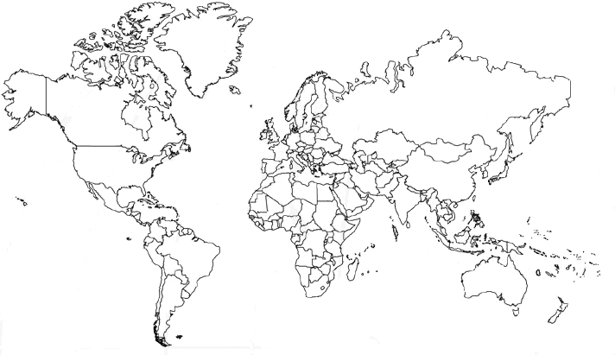
6. Do the following:
a. Explain how a government is represented abroad and how the United States government is accredited to international organizations.
Representation abroad:

Accreditation to international organizations.

- Describe the roles of the following in the conduct of foreign relations.

- Ambassador______________________________________________________________________________

________________________________________________________________________________________

- Consul__________________________________________________________________________________

________________________________________________________________________________________

- Bureau of International Information Programs________________________________________________________________________________

________________________________________________________________________________________

- Agency for International Development______________________________________________________________________________

________________________________________________________________________________________

- United States and Foreign Commercial Service_________________________________________________________________________________

________________________________________________________________________________________

- Explain the purpose of a passport and visa for international travel.

7. You will complete BOTH options (a) and (b).
a. Visit the Web site of the U.S. State Department. Learn more about an issue you find interesting that is discussed on this Web site. Select an issue based on ONE of the following categories: immigration, labor reform, conservation/environmentalism, urban poverty, racial or social inequality, role of the United States in foreign affair.

Issue:_______________________________________________________

Briefly describe the issue.

- Visit the Web site of an international news organization or foreign government, OR examine a foreign newspaper available at your local library, bookstore, or newsstand. Find a news story about a human right realized in the United States that is not recognized in another country.
News Story topic:____________________________________________________

Briefly describe the news story:

Requirement resources can be found here:
http://www.meritbadge.org/wiki/index.php/Citizenship in the World#Requirement resources

Resources

Scouting Literature
American Business, American Cultures, American Labor, Citizenship in the Community, Citizenship in the Nation, Citizenship in the World, Genealogy, Journalism, Law, and Scouting Heritage merit badge pamphlets

Books
- Bjornlund, Lydia. The U.S. Constitution: Blueprint for Democracy. Lucent Books Inc., 1999.
- Carnes, Mark, ed. Past Imperfect: History According to the Movies. Holt and Company, 1995.
- Finlayson, Reggie, ed. We Shall Overcome: The History of the American Civil Rights Movement. Lerner Publishing Group, 2002.
- Freedman, Russell. Give Me Liberty! The Story of the Declaration of Independence. Holiday House, 2002.
- Hoose, Phillip M. We Were There, Too!: Young People in U.S. History. Farrar, Straus, and Giroux, 2001.
- Jaffe, Steven H. Who Were the Founding Fathers? Two Hundred Years of Reinventing American History. Henry Holt and Co., 1996.
- Kassinger, Ruth. U.S. Census: A Mirror of America. Raintree Steck-Vaughn Publishers, 2000.
- McIntire, Suzanne, ed. American Heritage Book of Great American Speeches for Young People. Wiley, 2001.
- Panchyk, Richard. Keys to American History: Understanding Our Most Important Historic Documents. Chicago Review Press, 2009.
- Time Magazine editors. Time America: An Illustrated History. Time, 2007.
- Torricelli, Robert, and Andrew Carroll, eds. In Our Own Words: Extraordinary Speeches of the American Century. Kodansha International, 1999.
- Wilson, Richard Guy, ed. A Guide to Popular U.S. Landmarks as Listed in the National Register of Historic Places. Franklin Watts Inc., 2003.
- Zeinert, Karen. Free Speech: From Newspapers to Music Lyrics. Enslow Publishers, 1995.

Periodicals
American History and Civil War Times
Website: http://www.historynet.com
Early American Life
Telephone: 440-543-8566
Website: http://www.ealonline.com
Preservation
Telephone: 202-588-6388
Website: http://www.nationaltrust.org/magazine

Organizations and Websites
Academy of Achievement
Website: http://www.achievement.org
America Singing: 19th Century Song Sheets
Website: http://memory.loc.gov/ammem/amsshtml/amsshome.html
America's Library
Website: http://www.americaslibrary.gov
The American Family Immigration History Center
Telephone: 212-561-4588
Website: http://www.ellisisland.org
American Memory
Website: http://memory.loc.gov/ammem/index.html
American Veterans (AMVETS)
Toll-free telephone: 877-726-8387
Website: http://www.amvets.org
Family Search Internet Genealogy Service
Website: https://www.familysearch.org
Genealogy.com
Website: http://www.genealogy.com
HistoryNet.com
Telephone: 703-771-9400
Website: http://www.historynet.com
The Lester S. Levy Sheet Music Collection
Johns Hopkins University
Website: http://levysheetmusic.mse.jhu.edu
Library of Congress
Telephone: 202-707-5000
Website: http://www.loc.gov
National Constitution Center
Telephone: 215-409-6600
Website: http://constitutioncenter.org
National Park Service
Telephone: 202-208-3818
Website: http://www.nps.gov
National Register of Historic Places
Telephone: 202-354-2211
Website: http://www.nps.gov/nr/
Smithsonian Institution
Telephone: 202-633-1000
Website: http://www.si.edu
U.S. Census Bureau
Telephone: 301-763-4636
Website: http://www.census.gov
U.S. Government Printing Office
Telephone: 202-512-0000
Website: http://www.gpoaccess.gov
U.S. History.org
Website: http://www.ushistory.org/us/
The White House
Telephone: 202-456-1414
Website: http://www.whitehouse.gov
Veterans of Foreign Wars (VFW)
Website: http://www.vfw.org

