Travel Backpack

Imagine you want to work as a game programmer. The only job available is located in another country, far away, where you do not speak the language. You must consider all the changes to your life, and the life of your family, that making this move will require. Furthermore, you can take only one large backpack with you. Everything of importance that you think you will need must fit inside.
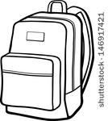

As a Group: What to Bring?
- In the backpack below, select 8 items to bring with you to your new life and job in a far away country. Write or draw those eight items in the backpack to the right

On Your Own: Why those items?
- Why did you choose the to pack the specific items shown/listed above to pack in your backpack to help you in your new home? Explain each item and its significance personally or to help you prepare for the new job.

