The March In: A Reflection – Name_______________________________________ Date____

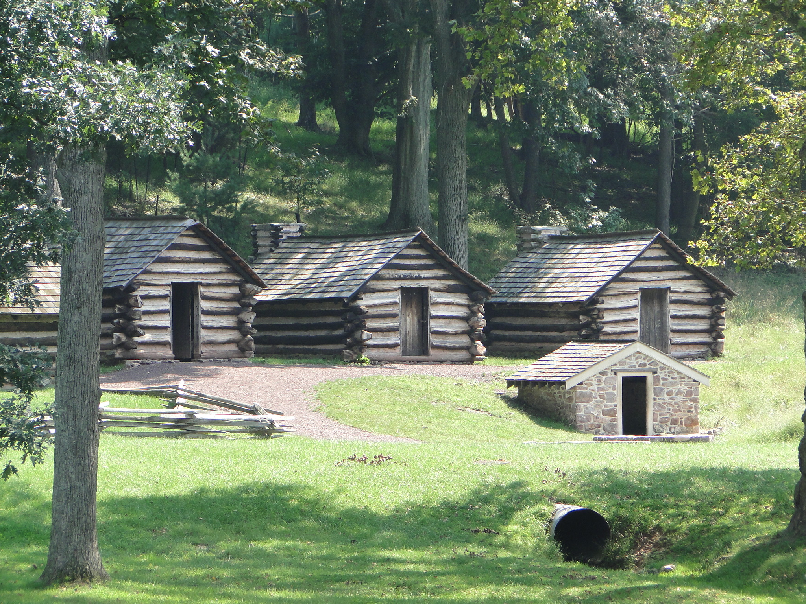
Directions: You’ve looked at secondary texts and maps to try and answer the question: Why did General George Washington choose Valley Forge as the site for the Army’s winter encampment? Use the graphic organizer below to explain and evaluate General Washington’s decision.
Why did General Washington choose Valley Forge as the site for the Army’s winter encampment?

Source: ______________________
Evidence:

Source: ______________________
Evidence:

Source: ______________________
Evidence:

Source: ______________________
Evidence:

Reason Three:

Do you agree or disagree with General Washington’s choice of Valley Forge? ________________
Why?
Source: ______________________
Evidence:

Source: ______________________
Evidence:

Reason One:

Reason Two:

