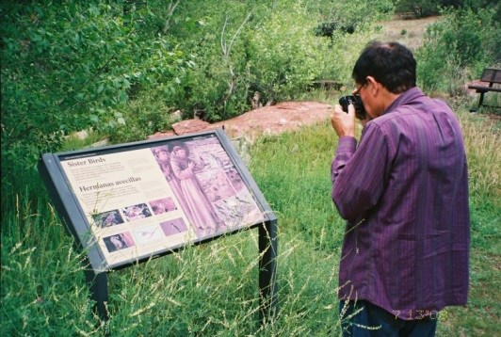
International Migratory Bird Day 2014
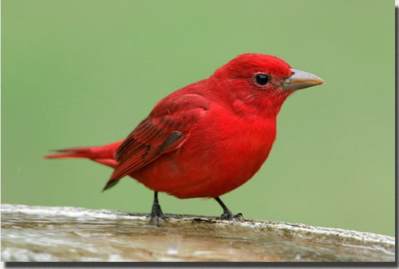
By Hart R. Schwarz, Neotropical Bird Specialist For the Cibola
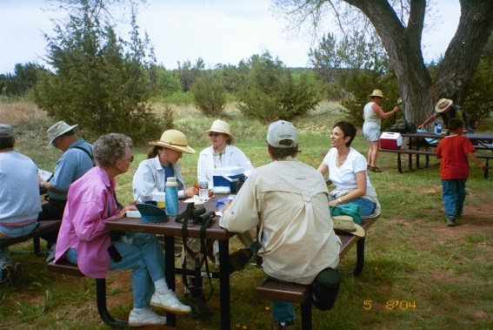
May 10, 2014: Another International Migratory Bird Day; it comes every year on the second Saturday in May, hopefully at the exact moment when migration peaks—or close to it. Our timing has sometimes been very good, as in the year 2000 when 67 species were recorded at Quarai, or in 2005 when the number of birds reached 271. However, during the last several years, the situation as become bleak with only 38 species and a mere 74 individual birds in 2014. People participation has also dropped off a little: about a dozen this year. One reason for this shocking decline in birds is, in part, due to the absence of a key local birder, who would diligently search for birds from sunrise to sunset and then combine his list with ours. But the awesome drought in recent years probably accounts more than anything else for the lack of birds, not only here, but on many of my breeding bird surveys in NM.
The photos above are from prior years except the tanager (l to r): 1. Noontime break from birding under the cottonwoods. 2. Visitor photographing the wayside display of birds and St Francis preaching to them, although, as a rule, the birds preach to us. 3. An adult male Summer Tanager, resplendent in fiery red, whereas most sightings at Quarai are immatures with blotchy red/yellow plumage. This tanager does not breed at Quarai, but does so in the cottonwoods of the lower Rio Grande not far away. Although everybody loves this beautiful tanager, the beekeeper might be an exception because his bees are a favorite item on the tanager’s menu.
Among the staples of IMBD is the Great Horned Owl that reliably nests in one of the viga holes that once anchored the massive roof beams of the old church four centuries ago. We did glimpse one of the little ones, still all in white, but the park staff had counted three on an earlier occasion. So—another successful year!
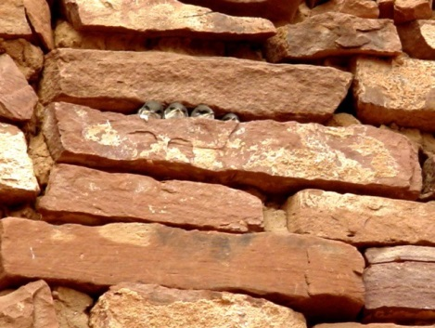
For years, swallows have been a conspicuous and delightful presence at Quarai, especially the Violet-green Swallow that nested as a colony of about fifteen pair in the walls of the old church, wherever there were spaces separating the rocks. The photo here shows young swallows on the “front porch” of their nest, just a few days before fledging. But all good things sometimes must end—even for swallows. The end came in 2012 after stabilization crews had been at work for two seasons, filling in these crevices to prevent the church from gradually collapsing; thus nesting came to an end that year, but the church has another lease on life.
Barn Swallows, however, have taken up the slack somewhat and are busy getting something started on the portico beams just outside the visitors center. An earlier nest of theirs was taken over by a pair of Say’s Phoebes, who already are feeding their young in the swallow’s nest, a not uncommon usurpation that I have observed elsewhere.

