National Park Service  U.S. Department of the Interior | Saint-Gaudens  National Historic Site  Use the complete site name here (e.g. Palo Alto Battlefield Historic Site). |  | 139 Saint-Gaudens Road  Cornish, New Hampshire  03745  603-675-2175 phone  603-675-2701 fax
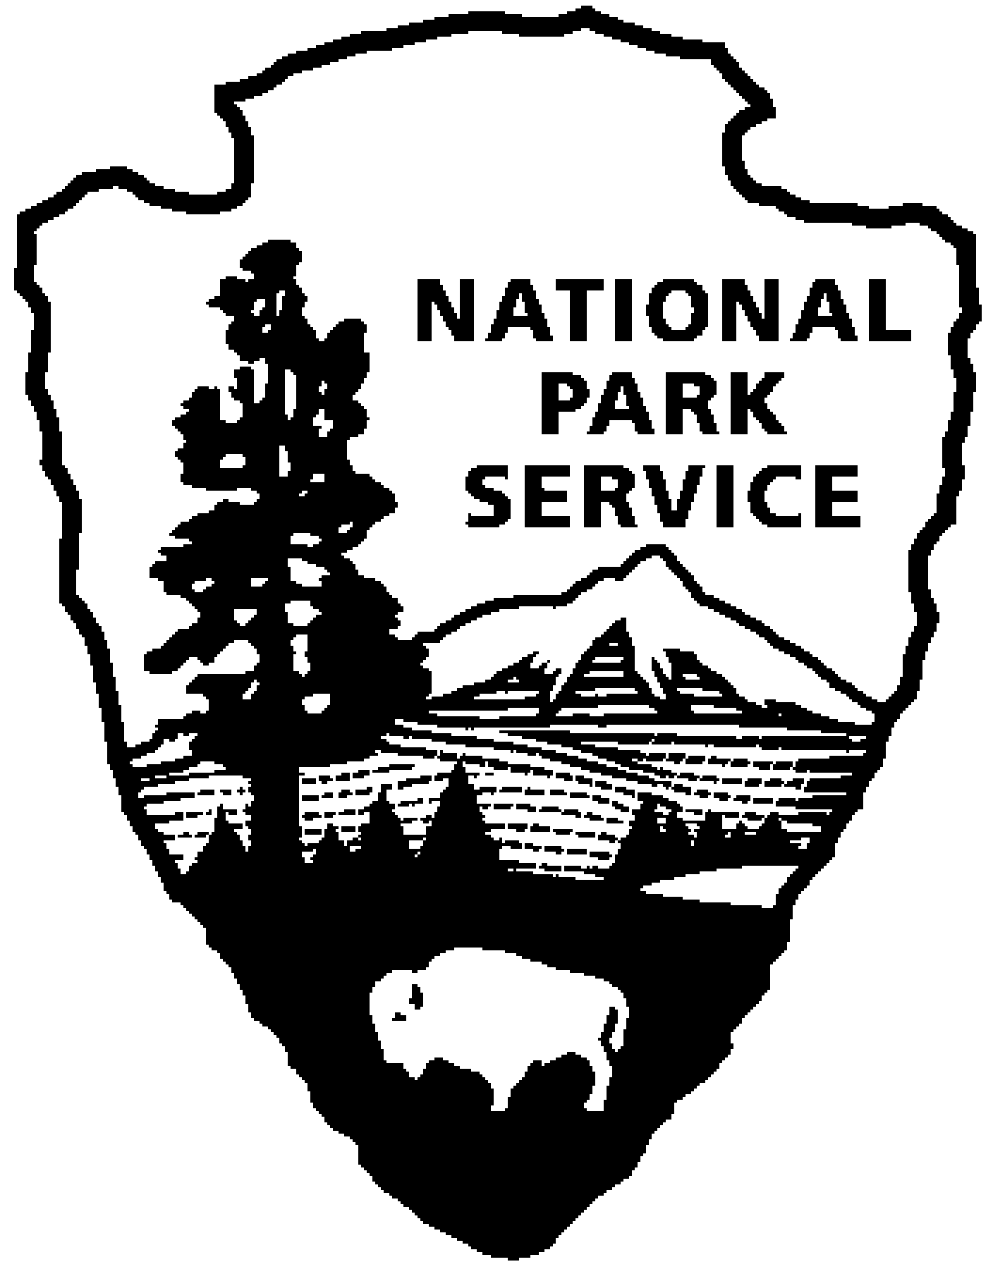
Saint-Gaudens National Historic Site
News Release
Use a “short-hand” version of the site name here (e.g. Palo Alto Battlefield not Palo Alto Battlefield National Historical Site).

FOR IMMEDIATE RELEASE Contact: Gregory Schwarz (603) 675-2175 x107

Outside (Light), In
Exhibition by artist, Mary Temple
At Saint-Gaudens National Historic Site

Cornish, NH –The Picture Gallery at Saint-Gaudens National Historic Site, will highlight works by painter, Mary Temple, the 2010 Saint-Gaudens Fellow. The public is invited to an opening reception in the Picture Gallery, Saturday, July 9, 2011, from 4:30-6:00 p.m., with a talk by the artist at 5:00 p.m. The reception and artist talk are free and open to the public. The exhibition will be on view daily 9:00 a.m. to 4:30 p.m. from July 9 through August 28, 2011.

Mary Temple, born in Arizona, now lives and works in Brooklyn, New York. She holds a BFA in Painting, and an MFA in Painting and Drawing, from Arizona State University, and has exhibited in many places across the country. Recent solo project venues include the Museum of Arts and Design, New York City, the Brooklyn Museum, Brooklyn, New York, and the Rice University Art Gallery in Houston, Texas. Temple is the recipient of the 2010 Saint-Gaudens Memorial Fellowship, the 2010 Basil Alkazzi Award for Excellence in Painting, and a 2010 Fellow in Painting from NYFA. She recently finished a large public commission for a New York City school and a New York City subway station. In 2012, she will complete a commission for the lobby of the Mickey Leland Federal Building, in Houston, Texas.

The work, Outside (Light) In, is one of Mary Temple’s site-specific series, Light Installations, (2002-Present). Light and shadow from nearby windows seem to be raking the walls of the gallery. The illusion, however, is a hand-painted trompe l’oeil shard, often situated in rooms with little or no natural light. In this work, Temple relies on the viewer’s knowledge and memory of light intersecting space to raise questions of belief and doubt. These pieces are meant to give the viewer time to enjoy not knowing, and to privilege questions over answers.

The Fellowship of the Saint-Gaudens Memorial was established in 1977 to assist artists of promise. A Fellow is selected annually by the Saint-Gaudens Memorial, from a pool of candidates put forward by the Fellowship Committee and advisors, and is awarded to artists who have completed a body of work that demonstrates exceptional talent, and who may benefit from the recognition and financial grant that accompany the Fellowship. The year following the Fellowship, the artist submits works for installation, as part of the Saint-Gaudens Memorial exhibition series at the Picture Gallery.

Three exhibits in the Picture Gallery are sponsored annually by the Trustees of the Saint-Gaudens Memorial in cooperation with Saint-Gaudens National Historic Site. The Saint-Gaudens Memorial is a non-profit partner of the National Park Service, helping to support the mission of Saint-Gaudens National Historic Site. For more information about the Saint-Gaudens Memorial and about joining the Friends of Saint-Gaudens, please visit their website: www.sgnhs.org.

Saint-Gaudens National Historic Site is located off NH Route 12A, just north of the Cornish-Windsor covered bridge. The park is open daily 9:00 a.m. to 4:30 p.m., from May 28 through October 31. Admission to the site is $5.00 per person; children 15 and under are admitted free of charge. As a Federal Fee Area, the America the Beautiful Annual, Senior and Access passes, are honored. An annual park pass for Saint-Gaudens NHS is also available for $25. For information on seasonal offerings, write: Saint-Gaudens National Historic Site, 139 Saint-Gaudens Road, Cornish, NH 03745; phone: (603) 675-2175 x 106; or visit the park’s website: www.nps.gov/saga.

