National Park Service  U.S. Department of the Interior | Saint-Gaudens  National Historic Site  Use the complete site name here (e.g. Palo Alto Battlefield Historic Site). |  | 139 Saint-Gaudens Road  Cornish, New Hampshire  03745  603-675-2175 phone  603-675-2701 fax
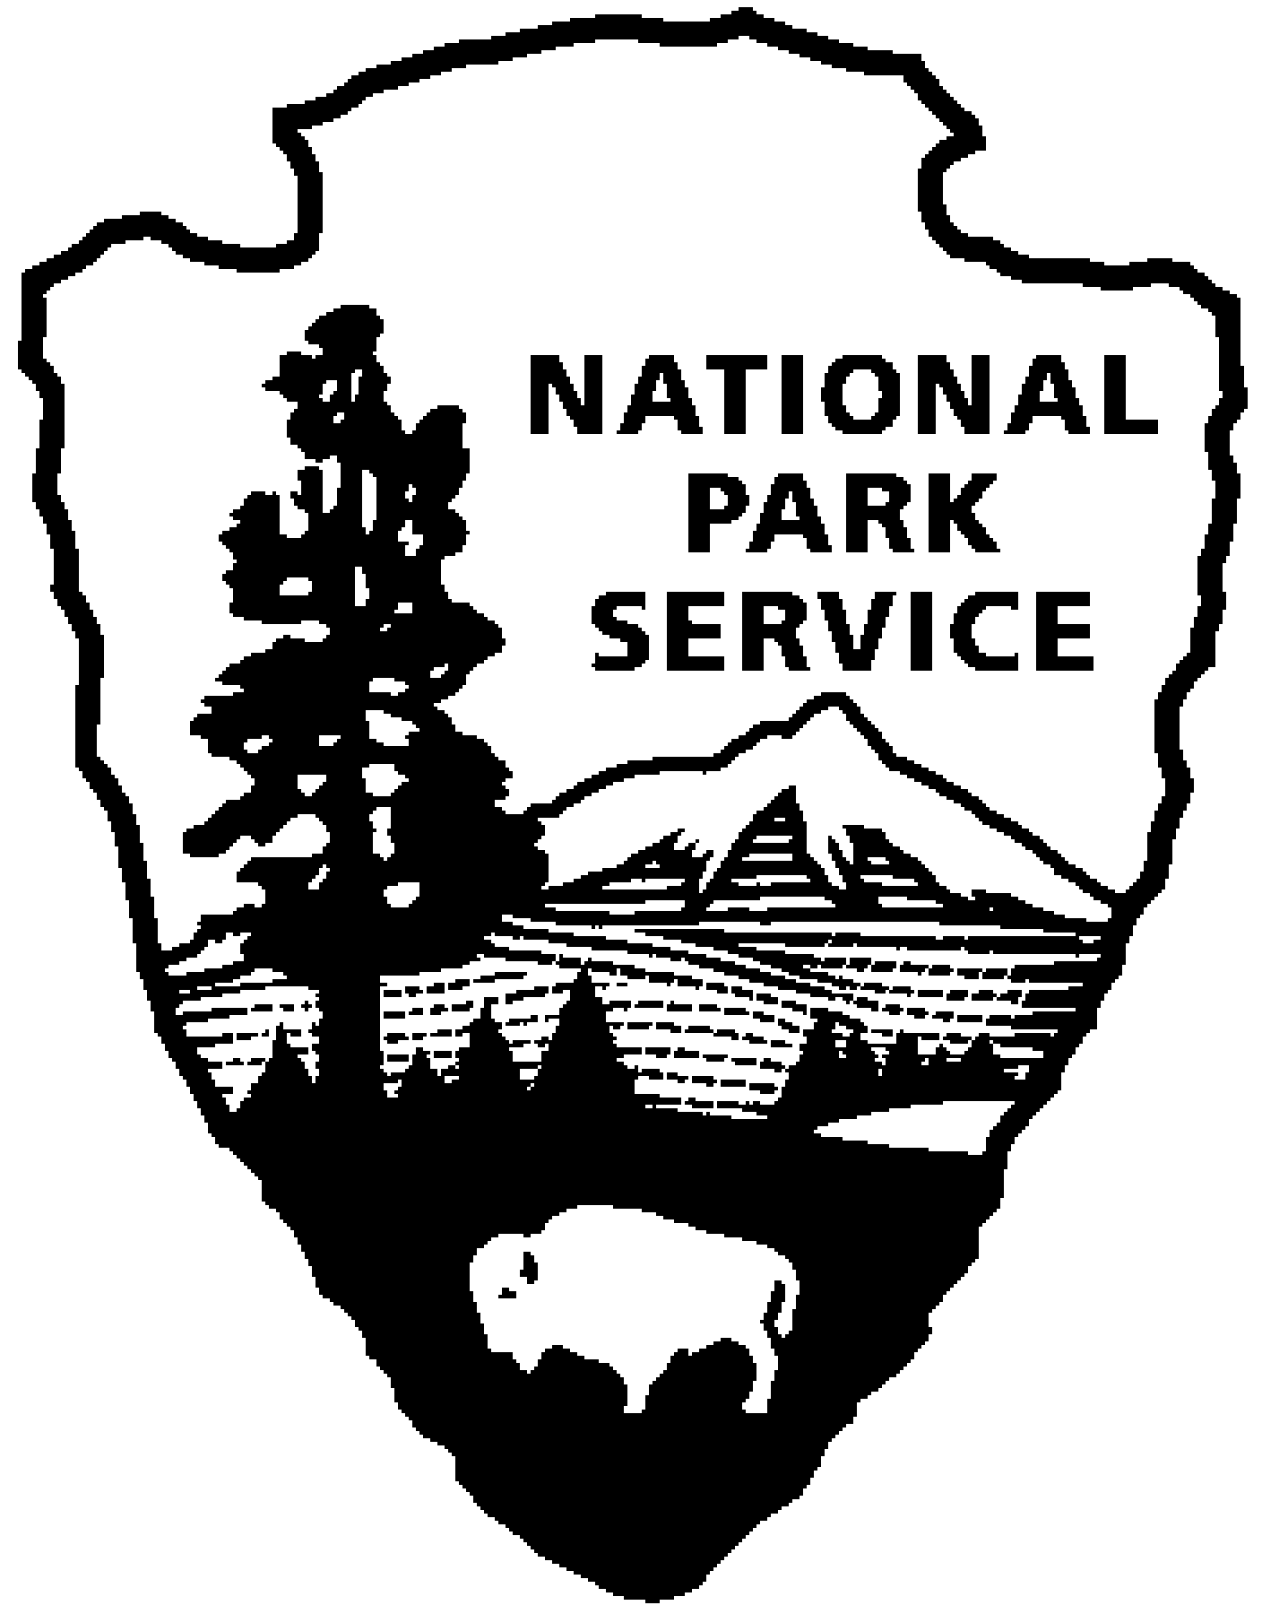
Saint-Gaudens National Historic Site
News Release
Use a “short-hand” version of the site name here (e.g. Palo Alto Battlefield not Palo Alto Battlefield National Historical Site).

FOR IMMEDIATE RELEASE Contact: Gregory Schwarz (603) 675-2175 x107

Civil War Drawings
from the Becker Collection

Saint-Gaudens National Historic Site,
September 4 – October 11

Cornish, NH – The season’s final exhibition highlights a selection of drawings from the Becker Archive, the largest collection of Civil War era drawings in private hands. Often executed in the midst of battle, the drawings are compelling records of historical eyewitness and some of the most concrete and telling artifacts of the Civil War. The public is invited to an opening reception in the Picture Gallery from 4:30-6:30 p.m., Saturday, September 4, 2010, with a talk by the curators, at 5:00 p.m. The reception and talk are free and open to the public.

Between 1861 and 1865, Frank Leslie’s Illustrated Newspaper sent Joseph Becker and other artist-correspondents to travel with the Union armies to make drawings of what they saw. These drawings were then sent back to New York where they were turned into engravings. Embedding Special Artists, as they were called, within the armies was a new practice, and newspaper readers eagerly studied the engravings which were based on the drawings and accompanied the war stories. The forty–four images in this exhibition are original firsthand drawings done on and off the battlefield by Becker and his colleagues. Conveying information and manifesting a vitality often lost in the engraving and publication process, the drawings are testament to the bravery and skill of the Special Artists who rendered their experiences and insights in a strong, clear, and aesthetic manner, often under harrowing conditions.

Prior to the Saint-Gaudens exhibition, Civil War drawings from the Becker Collection have been on public display only once before in the last 150 years, at the McMullen Museum of Fine Art at Boston College in 2009. After Saint-Gaudens, in commemoration of the sesquicentennial of the beginning of the Civil War, selections from the Becker Collection will travel to the Virginia Museum of Fine Arts in 2011. For additional information about the Becker Collection, please link to: http://idesweb.bc.edu/becker/ To schedule school tours, please contact the site (603) 675-2175 x106

Changing exhibitions in the Picture Gallery are sponsored annually by the Trustees of the Saint-Gaudens Memorial in cooperation with Saint-Gaudens National Historic Site. The Saint-Gaudens Memorial is a non-profit partner of the National Park Service, helping to support the mission of Saint-Gaudens National Historic Site. For more information about the Saint-Gaudens Memorial and about joining the Friends of Saint-Gaudens, please visit their website: www.sgnhs.org.

Saint-Gaudens National Historic Site is located off NH Route 12A, just north of the Cornish-Windsor covered bridge. The park is open daily through October 31, from 9:00 a.m. to 4:30 p.m. Admission to the site is $5.00 per person; children 15 and under are admitted free of charge. As a Federal Fee Area, the America the Beautiful Annual, Senior and Access passes are honored. An annual park pass for Saint-Gaudens NHS is also available for $25 and is a very economical way for a family to enjoy repeat visits to the site – including the concerts. For information on seasonal offerings, write: Saint-Gaudens National Historic Site, 139 Saint-Gaudens Road, Cornish, NH 03745; phone:
(603) 675-2175 x 106; or visit the park’s website: www.nps.gov/saga.

