National Park Service  U.S. Department of the Interior | Saint-Gaudens  National Historic Site  Use the complete site name here (e.g. Palo Alto Battlefield Historic Site). |  | 139 Saint-Gaudens Road  Cornish, New Hampshire  03745  603-675-2175 phone  603-675-2701 fax
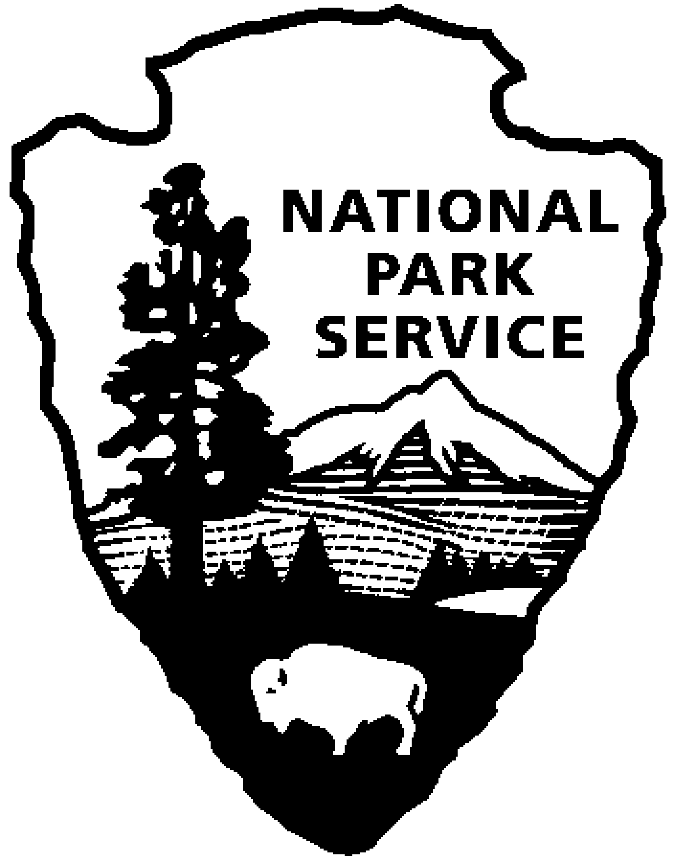
Saint-Gaudens National Historic Site
News Release
Use a “short-hand” version of the site name here (e.g. Palo Alto Battlefield not Palo Alto Battlefield National Historical Site).

FOR IMMEDIATE RELEASE Contact: Greg Schwarz (603) 675-2175 x106

House Blend to Perform

at Saint-Gaudens National Historic Site

Cornish, NH – On Sunday, August 17, 2011 at 2:00 p.m., House Blend will perform at Saint-Gaudens National Historic Site in Cornish, N.H. This year’s program includes pieces from a variety of composers and time periods, from the Renaissance through the 1960s. Concerts are included with normal paid admission to the site.

House Blend, formed in 2006, is an assembly of 23 veteran singers from Vermont and New Hampshire devoted to the collective exploration of a cappella songs drawn through the ages from around the world. House Blend sets itself apart as a marvelous mix of musical expertise, rhythmic precision, dynamic expression and shared leadership. Their love of singing reaches into and lifts the hearts of listeners.

Members include: Sopranos, Charlotte Gifford, Bonnie Kraft, Valerie Kosednar, Betsy Rybeck-Lynd, and Lisa
Stolper; altos, Vicky Arthur, Mary Barron, Jenny Eddy, Alicia LaCour, Cathy MacDonald, Kathy Michel, and
Harriet Tepfer; tenors, Ian Eddy, John Field, Bill LaCour, Lee Lynd, Susan Rugg, Andy Simonds, and Jared
Stolper; bass, Dan Axtell, Alan Blood, Mark Grieco, and Jack Hoffman

This is the sixth of eight concerts in the 2011 Saint-Gaudens Summer Concert Series sponsored annually by the Saint-Gaudens Memorial Trustees. The series continues through August 21, with performances in the Little Studio each Sunday at 2:00 p.m. Concerts are included with normal paid admission to the site.

Saint-Gaudens National Historic Site is located off NH Route 12A, just north of the Cornish-Windsor covered bridge. The park is open daily through October 31, from 9:00 a.m. to 4:30 p.m. Admission to the site is $5.00 per person; children 15 and under are admitted free of charge. As a Federal Fee Area, Federal Golden Passes, and the America the Beautiful Pass are honored. A Saint-Gaudens NHS annual pass is also available for $25. For information on seasonal offerings, write: Saint-Gaudens National Historic Site, 139 Saint-Gaudens Road, Cornish, NH 03745; phone: (603) 675-2175 x 106; or visit the website: www.nps.gov/saga.

-NPS-

