National Park Service  U.S. Department of the Interior | Saint-Gaudens  National Historic Site  Use the complete site name here (e.g. Palo Alto Battlefield Historic Site). |  | 139 Saint-Gaudens Road  Cornish, New Hampshire  03745  603-675-2175 phone  603-675-2701 fax
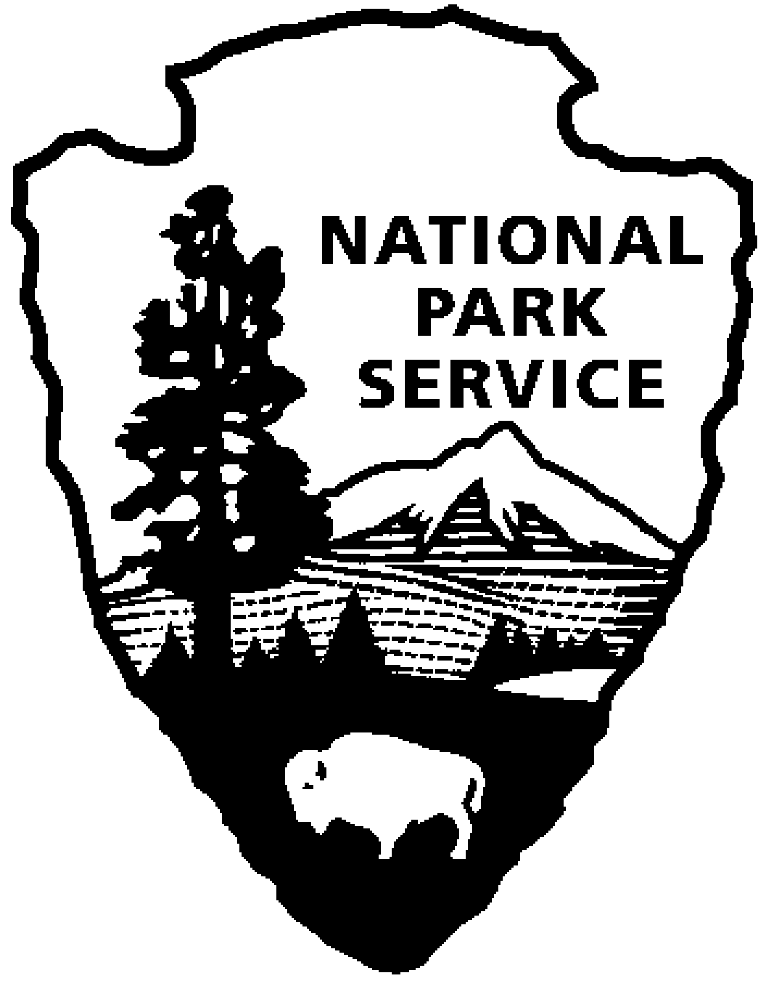
Saint-Gaudens National Historic Site
News Release
Use a “short-hand” version of the site name here (e.g. Palo Alto Battlefield not Palo Alto Battlefield National Historical Site).

FOR IMMEDIATE RELEASE Contact: Greg Schwarz (603) 675-2175 x106

New England Piano Quintet to Perform

at Saint-Gaudens National Historic Site
Cornish, NH – On Sunday, July 31, 2011, at 2:00 p.m., the New England Piano Quintet, will perform at Saint-Gaudens National Historic Site in Cornish, N.H. The program includes works by Gustav Mahler (1860-1911), Bohuslav Martinu (1890-1959) and Antonin Dvorak (1841-1904). The concert is included with normal paid admission to the site.

The members of the New England Piano Quintet are all colleagues who worked with one another for years in organizations such as the Vermont Symphony, the New England Bach Festival, and at Dartmouth College. Their first performance as an ensemble was on the Chamberorks series at Dartmouth in 2009.

Kathy Andrew, violin, has performed with Opera North (Concertmaster), the Vermont Symphony Orchestra (Assistant Concertmaster), and the New England Bach Festival among others. She has played solo violin/piano recitals and chamber music concerts around New England. Ms. Andrew received degrees from the University of New Mexico (BA), and The Peabody Institute (MM) and taught at Bennington College, Keene State College, and coached chamber music at Dartmouth College.

Colleen Jennings, violin, has been performing and teaching for many years. As a member of the Kammerorchester Basel in Switzerland, she toured extensively throughout Western Europe. While in Switzerland, she also co-founded the chamber ensemble, Ex Luce, with soprano, Ana Arnaz. Locally, Colleen performs with the Opera North Orchestra and with the Springfield Symphony. She also teaches private violin lessons and at the Williston Academy in Easthampton. Colleen received a BA in Music from Oberlin Conservatory and an MA in Music from Rice University.

Marcia Cassidy, viola, has performed extensively in the United States, Europe, Canada, and Japan to critical acclaim as a member of the Franciscan String Quartet. Ms. Cassidy pursued her musical training at the University of Texas, University of New Mexico, New England Conservatory, San Francisco Conservatory, and with the Tokyo String Quartet at the Yale School of Music. She participates in numerous summer music festivals and is a member of the Musicians of the Old Post Road (a period performance chamber music ensemble). She is principal violist for Opera North, and serves on the faculty of Dartmouth College.

John Dunlop, cello, has performed in the Northeast for over twenty years as principal cellist with the Vermont Symphony, Burlington Chamber Orchestra, and Opera North. He studied at Oberlin Conservatory and the San Francisco Conservatory, and has also composed and recorded several award-wining film soundtracks for short films.

Gregory Hayes has taught piano and occasionally harpsichord at Dartmouth College since 1991. He is a busy chamber musician and orchestral keyboard player, and has played regularly with the Albany Symphony Orchestra and Arcadia Players. He has also performed with the Vermont Symphony, the Springfield Symphony, and the Orchestra of St. Luke’s (New York). He has participated often in the New England Bach Festival and on the Mohawk Trail Concerts series. A graduate of Amherst College and the Manhattan School of Music, he is longtime music director for the Unitarian Society of Northampton and Florence (Massachusetts). In the summers he teaches at Greenwood Music Camp, near his home in Goshen, Massachusetts.
Gregory Hayes has taught piano and occasionally harpsichord at Dartmouth College since 1991. He is a busy chamber musician and orchestral keyboard player, and has played regularly with the Albany Symphony Orchestra and Arcadia Players. He has also performed with the Vermont Symphony, the Springfield Symphony, and the Orchestra of St. Luke’s (New York). He has participated often in the New England Bach Festival and on the Mohawk Trail Concerts series. A graduate of Amherst College and the Manhattan School of Music, he is longtime music director for the Unitarian Society of Northampton and Florence (Massachusetts). In the summers he teaches at Greenwood Music Camp, near his home in Goshen, Massachusetts.
Gregory Hayes has taught piano and occasionally harpsichord at Dartmouth College since 1991. He is a busy chamber musician and orchestral keyboard player, and has played regularly with the Albany Symphony Orchestra and Arcadia Players. He has also performed with the Vermont Symphony, the Springfield Symphony, and the Orchestra of St. Luke’s (New York). He has participated often in the New England Bach Festival and on the Mohawk Trail Concerts series. A graduate of Amherst College and the Manhattan School of Music, he is longtime music director for the Unitarian Society of Northampton and Florence (Massachusetts). In the summers he teaches at Greenwood Music Camp, near his home in Goshen, Massachusetts.
Gregory Hayes has taught piano and occasionally harpsichord at Dartmouth College since 1991. He is a busy chamber musician and orchestral keyboard player, and has played regularly with the Albany Symphony Orchestra and Arcadia Players. He has also performed with the Vermont Symphony, the Springfield Symphony, and the Orchestra of St. Luke’s (New York). He has participated often in the New England Bach Festival and on the Mohawk Trail Concerts series. A graduate of Amherst College and the Manhattan School of Music, he is longtime music director for the Unitarian Society of Northampton and Florence (Massachusetts). In the summers he teaches at Greenwood Music Camp, near his home in Goshen, Massachusetts.
Gregory Hayes has taught piano and occasionally harpsichord at Dartmouth College since 1991. He is a busy chamber musician and orchestral keyboard player, and has played regularly with the Albany Symphony Orchestra and Arcadia Players. He has also performed with the Vermont Symphony, the Springfield Symphony, and the Orchestra of St. Luke’s (New York). He has participated often in the New England Bach Festival and on the Mohawk Trail Concerts series. A graduate of Amherst College and the Manhattan School of Music, he is longtime music director for the Unitarian Society of Northampton and Florence (Massachusetts). In the summers he teaches at Greenwood Music Camp, near his home in Goshen, Massachusetts.
Gregory Hayes has taught piano and occasionally harpsichord at Dartmouth College since 1991. He is a busy chamber musician and orchestral keyboard player, and has played regularly with the Albany Symphony Orchestra and Arcadia Players. He has also performed with the Vermont Symphony, the Springfield Symphony, and the Orchestra of St. Luke’s (New York). He has participated often in the New England Bach Festival and on the Mohawk Trail Concerts series. A graduate of Amherst College and the Manhattan School of Music, he is longtime music director for the Unitarian Society of Northampton and Florence (Massachusetts). In the summers he teaches at Greenwood Music Camp, near his home in Goshen, Massachusetts.
Gregory Hayes has taught piano and harpsichord at Dartmouth College since 1991. He is a chamber musician and orchestral keyboard player, and performs with the Albany Symphony Orchestra, the Vermont Symphony, and the Springfield Symphony among others. A graduate of Amherst College and the Manhattan School of Music, he is longtime music director for the Unitarian Society of Northampton and Florence (Massachusetts), and in the summer, teaches at Greenwood Music Camp, in Massachusetts

This is the fifth of eight concerts in the 2011 Saint-Gaudens Summer Concert Series sponsored annually by the Saint-Gaudens Memorial Trustees. The series continues through August 21, with performances in the Little Studio each Sunday at 2:00 p.m. Concerts are included with normal paid admission to the site.

Saint-Gaudens National Historic Site is located off NH Route 12A, just north of the Cornish-Windsor covered bridge. The park is open daily through October 31, from 9:00 a.m. to 4:30 p.m. Admission to the site is $5.00 per person; children 15 and under are admitted free of charge. As a Federal Fee Area, Federal America the Beautiful Annal, Senior and Access passes are honored. A Saint-Gaudens NHS annual pass is also available for $25. For information on seasonal offerings, write: Saint-Gaudens National Historic Site, 139 Saint-Gaudens Road, Cornish, NH 03745; phone: (603) 675-2175 x 106; or visit the website: www.nps.gov/saga.

-NPS-

