National Park Service  U.S. Department of the Interior | Saint-Gaudens  National Historic Site  Use the complete site name here (e.g. Palo Alto Battlefield Historic Site). |  | 139 Saint-Gaudens Road  Cornish, New Hampshire  03745  603-675-2175 phone  603-675-2701 fax
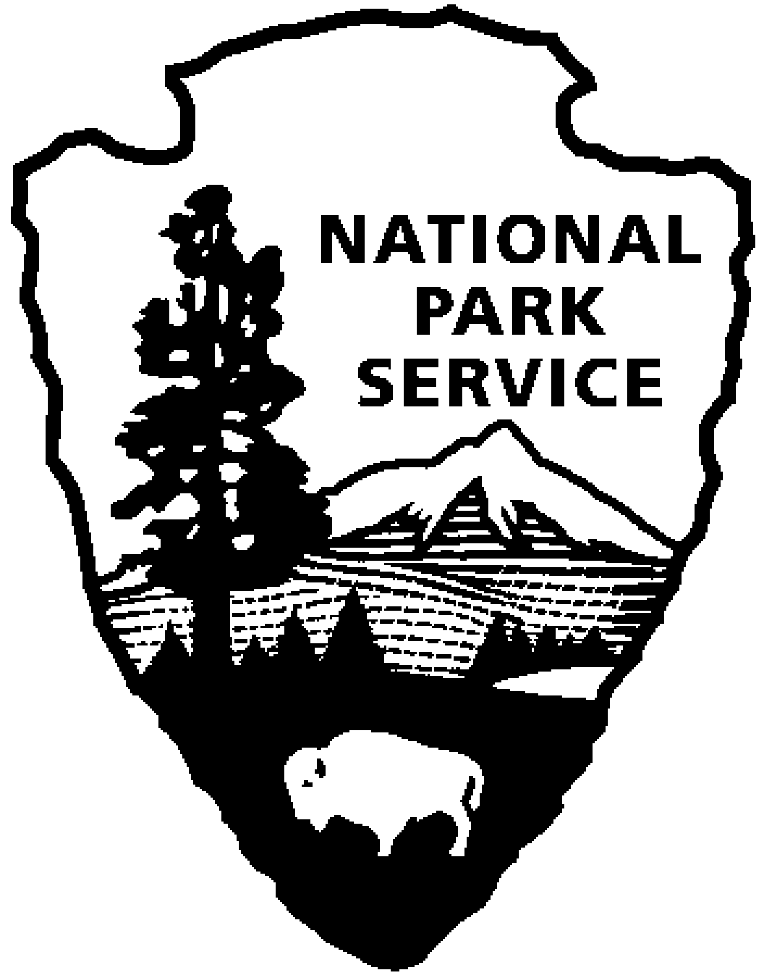
Saint-Gaudens National Historic Site
News Release
Use a “short-hand” version of the site name here (e.g. Palo Alto Battlefield not Palo Alto Battlefield National Historical Site).

FOR IMMEDIATE RELEASE Contact: Greg Schwarz (603) 675-2175 x106

Three By Two to Perform

at Saint-Gaudens National Historic Site

Cornish, NH – On Sunday, July 24, 2011, at 2:00 p.m., the Three By Two, will perform at Saint-Gaudens National Historic Site in Cornish, N.H. The program includes a range of works from 14th century to the present. The concert is included with normal paid admission to the site.

Pianist Jacqueline Schwab, has been heard on a dozen of Ken Burns’ documentaries, including his Civil War, Baseball, Lewis and Clark, and The National Parks: America’s Best Idea. In Ken Burns’ words, “Jacqueline Schwab brings more feeling and intensity to music than anyone I know. Her playing is insistent, physical, heartfelt and ... unusually moving.” She performed at the White House, and recorded and performed with Scottish fiddlers Alasdair Fraser and Laura Risk, Scottish singer Jean Redpath and the English dance music quartet, Bare Necessities among others. Jacqueline also has three solo recordings

Wayne Hankin is a period instrument specialist and has played 400 different instruments over a 30 year career. Specializing in medieval, renaissance and baroque periods, Wayne has mastered instruments played only by a small handful of people in the world, including various bagpipes, hornpipes, flutes, whistles, gemshorns, trumps, bone flutes, double reeds and others. There are also instruments made exclusively for his talents of which he is the sole performer.

With over 4000 concerts to his credit, Wayne has played every major city in the United States and Canada, as well as performing on seven productions with Cirque du Soleil and over 100 performances with Early Music N.Y. Wayne has served as musical director for leading theater companies, and also performed solo on major Hollywood films. He composed over 300 works for period instruments, and has received numerous awards and commissions. His new film, 7 SOLOS, was recently awarded best short subject at The World Music and Independent Film Festival in Washington D.C.

This is the fourth of eight concerts in the 2011 Saint-Gaudens Summer Concert Series sponsored annually by the Saint-Gaudens Memorial Trustees. The series continues through August 21, with performances in the Little Studio each Sunday at 2:00 p.m. Concerts are included with normal paid admission to the site.

Saint-Gaudens National Historic Site is located off NH Route 12A, just north of the Cornish-Windsor covered bridge. The park is open daily through October 31, from 9:00 a.m. to 4:30 p.m. Admission to the site is $5.00 per person; children 15 and under are admitted free of charge. As a Federal Fee Area, Federal America the Beautiful Annal, Senior and Access passes are honored. A Saint-Gaudens NHS annual pass is also available for $25. For information on seasonal offerings, write: Saint-Gaudens National Historic Site, 139 Saint-Gaudens Road, Cornish, NH 03745; phone: (603) 675-2175 x 106; or visit the website: www.nps.gov/saga.

-NPS-

