National Park Service  U.S. Department of the Interior | Saint-Gaudens  National Historic Site  Use the complete site name here (e.g. Palo Alto Battlefield Historic Site). |  | 139 Saint-Gaudens Road  Cornish, New Hampshire  03745  603-675-2175 phone  603-675-2701 fax
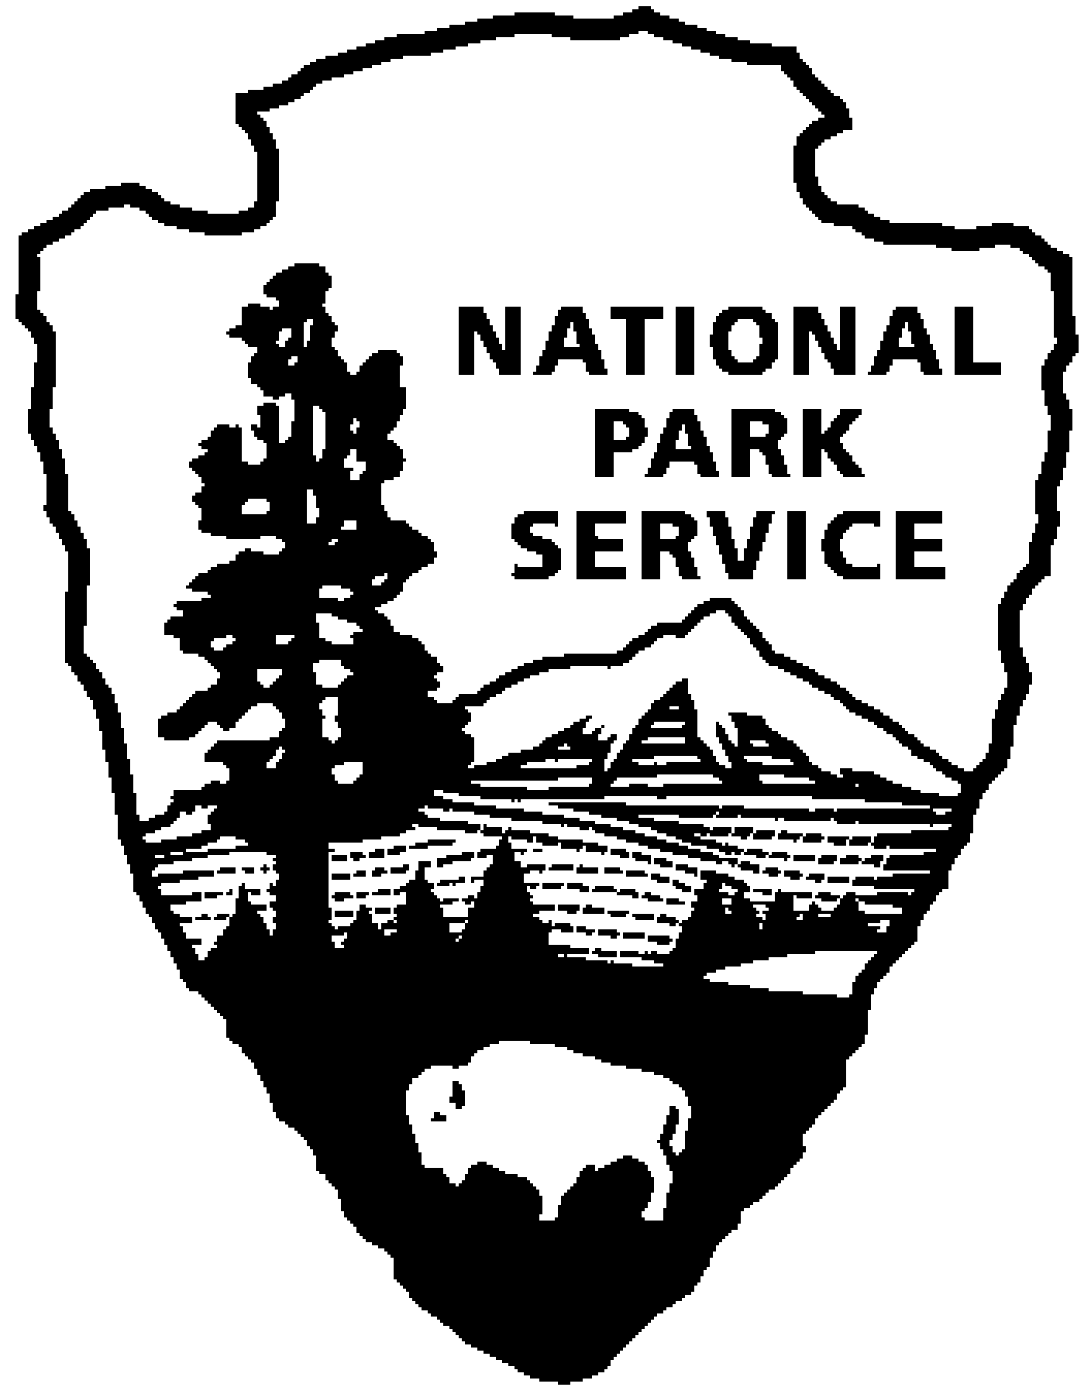
Saint-Gaudens National Historic Site
News Release
Use a “short-hand” version of the site name here (e.g. Palo Alto Battlefield not Palo Alto Battlefield National Historical Site).

FOR IMMEDIATE RELEASE Contact: Greg Schwarz (603) 675-2175 x106

Rogers and Millican to Perform

at Saint-Gaudens National Historic Site

Cornish, NH – On Sunday, July 10, 2011 at 2:00 p.m., Rogers and Millican (flute, piano) will perform at Saint-Gaudens National Historic Site in Cornish, N.H. They will be joined by guest artist, Margaret Gilmore, (cello). The program features works by the often overlooked classical composer Johann Nepomuk Hummel (1778-1837), as well as pieces by Franz Danzi (1763-1826) and Ludwig van Beethoven (1770-1827). The concert is included with normal paid admission to the site.

The Rogers and Millican duo formed in 1992, uniting two well-established New England performers. Since then, they have performed concerts at New England colleges, universities, churches and summer music festivals, presenting programs that combine selections from the solo repertoire of both instruments with collaborative efforts. In 1998, they issued their first CD recording on the Keywind label.

Rebecca Carson Rogers, flutist, has performed in solo recitals and chamber concerts throughout New England with ensembles including SilverWood, VENTUS woodwind quintet, and the Vermont Flute Ensemble. A member of the ALRY National Flute Choir, Ms. Carson Rogers conducted and performed in France both with the American Flute Orchestra and the American Flute Ensemble. Committed to teaching and expanding performance opportunities for flutists, she conducted master classes and multiple flute ensembles at the University of Vermont, the University of New Hampshire and the Greater Boston Flute Association.

Brady Millican’s piano performances have captivated audiences across America, Europe and South America. The New York Times had praise for the “poetry and imagination, pianism of a high order” of his debut recital. It has been followed by numerous career highlights including two appearances at the White House, concerts on the programs of the Boston, Dallas, and Houston Symphony Orchestras, live broadcast performance on National Public Radio, and recordings on the Vox and Keywind labels. Millican is a founding member of the Killington Music Festival in Vermont. Chair of Music at Eastern Nazarene College in Quincy, Massachusetts, he delights in sharing classical music with young people in the classroom as well as on the concert stage. He has given master classes and appeared as guest lecturer at Harvard University, Loyola Merrymount University and the National Academy of Music in Bucharest, Romania.

Margaret Gilmore has played professionally in Europe and the U.S. in solo recitals, chamber music and in many orchestras. Her early training was at the Julliard School, with subsequent training at the Muziek Lyceum in Amsterdam and she holds degrees from LSU, Rice University, and the University of Arizona. She has taught in universities, as well as public and private schools and performs with the Arizona Opera Orchestra, the Sterling String Quartet, and the Presidio Cello Quartet.

This is the second of eight concerts in the 2011 Saint-Gaudens Summer Concert Series sponsored annually by the Saint-Gaudens Memorial Trustees. The series continues through August 21, with performances in the Little Studio each Sunday at 2:00 p.m. Concerts are included with normal paid admission to the site.

Saint-Gaudens National Historic Site is located off NH Route 12A, just north of the Cornish-Windsor covered bridge. The park is open daily through October 31, from 9:00 a.m. to 4:30 p.m. Admission to the site is $5.00 per person; children 15 and under are admitted free of charge. As a Federal Fee Area, America the Beautiful, Annual, Senior and Access passes are honored. A Saint-Gaudens NHS annual pass is also available for $25. For information on seasonal offerings, write: Saint-Gaudens National Historic Site, 139 Saint-Gaudens Road, Cornish, NH 03745; phone: (603) 675-2175 x 106; or visit the website: www.nps.gov/saga.
-NPS-

