National Park Service  U.S. Department of the Interior | Saint-Gaudens  National Historic Site  Use the complete site name here (e.g. Palo Alto Battlefield Historic Site). |  | 139 Saint-Gaudens Road  Cornish, New Hampshire  03745  603-675-2175 phone  603-675-2701 fax
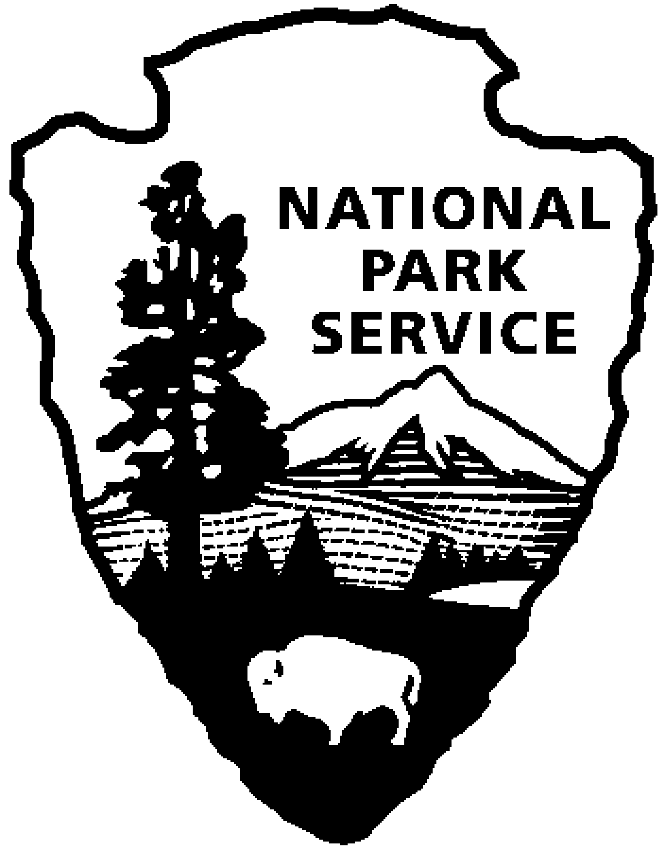
Saint-Gaudens National Historic Site
News Release
Use a “short-hand” version of the site name here (e.g. Palo Alto Battlefield not Palo Alto Battlefield National Historical Site).

FOR IMMEDIATE RELEASE Contact: Greg Schwarz (603) 675-2175 x106

The Jennings to Perform

at Saint-Gaudens National Historic Site

Cornish, NH – On Sunday, July 3, at 2:00 p.m., Andrew and Gail Jennings, violin and piano, will perform at Saint-Gaudens National Historic Site in Cornish, N.H. The program will include works by J.S. Bach (1675-1750), W.A. Mozart (1756-1791), Camille Saint-Saens (1835-1921), Charles Ives (1874-1954) and Arvo Pärt (1935). The concert is included with normal paid admission to the site.

Gail Jennings studied piano at the Mannes College of Music, as well as the Julliard School of Music. She also received a Master of Music in organ performance at The University of Akron where she was formerly faculty member. Ms. Jennings serves as organist for Ann Arbor’s Bethlehem United Church of Christ and has taught piano privately. She teaches at the Ann Arbor School for the Performing Arts and is an active chamber musician and accompanist.

Naumburg-Award winning violinist Andrew Jennings, graduated from the Julliard School of Music, and in 1970, formed the Concord String Quartet. Formerly on the faculty of The University of Akron and concertmaster of the Akron Symphony, he currently holds simultaneous appointments as Professor of violin and chamber music at the University of Michigan in Ann Arbor and the Oberlin College Conservatory. Andrew has been a member of the artist faculty of the Tanglewood Music Center in Massachusetts for the past nineteen years where he holds the Richard Burgin Master Teacher Chair.

This is the first of eight concerts in the 2011 Saint-Gaudens Summer Concert Series sponsored annually by the Saint-Gaudens Memorial Trustees. The concerts take place in the Little Studio, Sundays at 2:00 p.m. through August 21. Concerts are included with normal paid admission to the site.

Saint-Gaudens National Historic Site is located off NH Route 12A, just north of the Cornish-Windsor covered bridge. The park is open daily through October 31, from 9:00 a.m. to 4:30 p.m. Admission to the site is $5.00 per person; children 15 and under are admitted free of charge. As a Federal Fee Area, America the Beautiful, Annual, Senior and Access passes are honored. A Saint-Gaudens NHS annual pass is also available for $25. For information on seasonal offerings, write: Saint-Gaudens National Historic Site, 139 Saint-Gaudens Road, Cornish, NH 03745; phone: (603) 675-2175 x 106; or visit the website: www.nps.gov/saga.

-NPS-

